UNITED STATES
SECURITIES AND EXCHANGE COMMISSION
Washington, D.C. 20549

Form 6-K

REPORT OF FOREIGN PRIVATE ISSUER PURSUANT TO RULE
13a-16 OR 15d-16 UNDER
THE SECURITIES EXCHANGE ACT OF 1934

For the month of October 2026

Commission File Number 001-41401

Prenetics Global Limited

Unit 703-706, K11 Atelier
728 King’s Road, Quarry Bay
Hong Kong

(Address of principal executive office)

Indicate by check mark whether the registrant files or will file annual reports under cover of Form 20-F or Form 40-F.

Form 20-F ☒ Form 40-F ☐

EXPLANATORY NOTE

On October 12, 2026, Prenetics Global Limited (the “Company”) issued a press release announcing a multi-year collaboration with the National Basketball Association (NBA) that makes IM8 the Official Nutrition Partner of the NBA in Australia and Southeast Asia. A copy of the press release is furnished as Exhibit 99.1 to this Report on Form 6-K (this "Report").

The information contained in this Report, including Exhibit 99.1 furnished herewith, shall not be deemed “filed” for purposes of Section 18 of the Securities Exchange Act of 1934, as amended (the “Exchange Act”), or otherwise subject to the liabilities of that section, nor shall it be deemed incorporated by reference into any filing under the Securities Act of 1933, as amended, or the Exchange Act, except as expressly set forth by specific reference in such a filing or in this report.

INCORPORATION BY REFERENCE

This Report, along with Exhibit 99.1, is incorporated by reference into the registration statements on Form F-3 (File Nos. 333-265284, 333-276538 and 333-288824), and registration statements on Form S-8 (File Nos. 333-287017, 333-279019, 333-271552, 333-267956 and 333-298478) of Prenetics Global Limited (including any prospectuses forming a part of such registration statements), including all amendments thereto, filed with the U.S. Securities and Exchange Commission (the "SEC"), to be a part thereof from the date on which this report is submitted, to the extent not superseded by documents or reports subsequently filed or furnished.

EXHIBIT INDEX

Exhibit No. |  |  |  |  |  | Description
99.1 |  |  |  |  |  | Press Release, dated October 12, 2026

SIGNATURES

Pursuant to the requirements of the Securities Exchange Act of 1934, the registrant has duly caused this report to be signed on its behalf by the undersigned, thereunto duly authorized.

 |  |  | Prenetics Global Limited
 |  |  | By: |  |  | /s/ Danny Sheng Wu Yeung
 |  |  | Name: |  |  | Danny Sheng Wu Yeung
 |  |  | Title: |  |  | Chief Executive Officer
Date: October 12, 2026

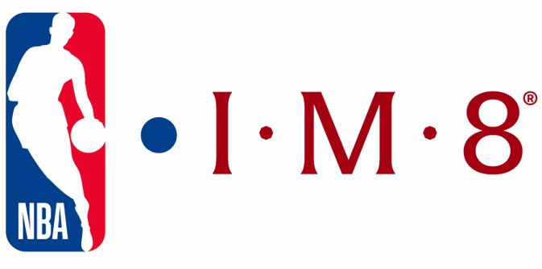

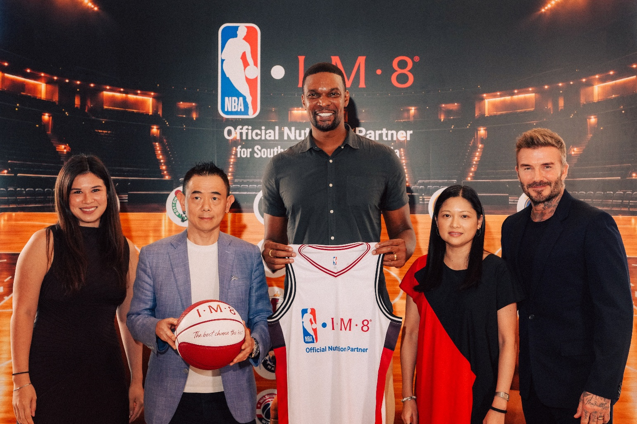

Photo: IM8 co-founder David Beckham; two-time NBA champion Chris Bosh; IM8 chief of staff and brand partnerships Samantha Kwok; and NBA executives (Credit: NBA)

IM8 NAMED OFFICIAL NUTRITION PARTNER
OF THE NBA IN AUSTRALIA AND SOUTHEAST ASIA

– IM8 will Host Fan Activation at an NBA House in the Region in 2027 –

HONG KONG, Oct. 12, 2026 – The National Basketball Association (NBA) and IM8 (US) LLC, a premium health and longevity brand, today announced a multiyear collaboration that makes IM8 the Official Nutrition Partner of the NBA in Australia and eight markets across Southeast Asia (Brunei, Cambodia, Indonesia, Malaysia, the Philippines, Singapore, Thailand and Vietnam).

1

The announcement was made at an exclusive IM8 event at Upper House in Hong Kong by IM8 co-founders David Beckham and Danny Yeung and NBA executives, who were joined by two-time NBA champion and Naismith Basketball Hall of Fame member Chris Bosh.

As the Official Nutrition Partner of the NBA in the region, IM8 will conduct a series of NBA-themed marketing campaigns and fan engagement initiatives across the nine markets. In 2027, IM8 will also host an activation at NBA House, one of the league’s signature events, where fans can experience IM8 firsthand.

IM8, owned by Prenetics Global Limited (NASDAQ: PRE) and co-founded by Beckham, was built on a foundation of elite sport. Its roster of world-class athlete ambassadors includes two-time Kia NBA Most Valuable Player and 2021 NBA Champion Giannis Antetokounmpo.

“A few years ago, IM8 was an idea David Beckham and I sketched out together, with one ambition: to build a global health brand backed by the credibility of the world’s greatest athletes,” said Yeung, CEO of Prenetics and Co-Founder of IM8. “Today, we’re standing alongside the NBA, the most iconic league on the planet and the most powerful sports brand in the region. Together, we’re bringing IM8 to approximately 660 million people across Australia and Southeast Asia, pairing large, basketball-loving communities with a growing demand for premium health and wellness, as IM8 continues to expand globally.”

“Basketball has given me everything, and I’ve seen first-hand how this game brings people together in every corner of the world,” said Antetokounmpo. “I grew up in Athens dreaming about the NBA, so bringing IM8 to basketball fans across Australia and Southeast Asia means a lot to me. Taking care of your body allows you to show up and be your best every single day.”

“Our collaboration with IM8 reflects the NBA’s commitment to promoting the importance of a healthy lifestyle in the communities where we operate,” said NBA Head of Southeast Asia and Asia Marketing Sheila Rasu. “We look forward to working with IM8 to curate new experiences for NBA fans and IM8 consumers in Australia and across Southeast Asia.”

Fans in Australia and Southeast Asia can follow the collaboration and upcoming NBA House details at www.IM8health.com and across the league’s localized social media accounts on Facebook, Instagram, TikTok and X.

About the NBA
The National Basketball Association (NBA) is a global sports and media organization with the mission to inspire and connect people everywhere through the power of basketball. Built around five professional sports leagues: the NBA, WNBA, NBA G League, NBA 2K League and Basketball Africa League, the NBA has established a major international presence with games and programming available in 214 countries and territories in more than 50 languages, and merchandise for sale in more than 200 countries and territories on all seven continents. NBA rosters at the start of the 2025-26 season featured a record 135 international players from a record-tying 43 countries. The NBA’s digital assets include NBA TV, NBA.com, the NBA App and NBA League Pass. The NBA has created one of the largest social media communities in the world, with more than 2.5 billion likes and followers globally across all leagues, team and player platforms. The NBA’s Tap to Watch provides seamless access to local, national and global live game telecasts via the NBA App, NBA.com, third-party digital platforms and
2

NBA partner platforms. NBA Cares, the NBA’s global social impact platform, drives change on issues facing fans and communities in the areas of health and wellness, civic engagement, social justice and inclusion, and sustainability.

About IM8
IM8 is a premium health and longevity brand co-founded by David Beckham and built with an elite team of scientists spanning medicine, academia and space science. Its flagship product, Daily Ultimate Essentials, delivers 90 ingredients in a single daily sachet – engineered to replace 16 different supplements in one drink – and is NSF Certified for Sport, non-GMO, vegan, free from common allergens and contains no artificial flavors, colors or sweeteners. Launched in December 2024, IM8 ships to 46 countries and has delivered more than 57 million servings. The brand is backed by a roster of global partners and ambassadors including Giannis Antetokounmpo, Aryna Sabalenka, Lily Collins, Jay Shetty, Ollie Bearman and Inter Miami CF. IM8 is a wholly owned subsidiary of Prenetics Global Limited (NASDAQ: PRE), a leading global health sciences company dedicated to advancing consumer health. To learn more, visit www.IM8health.com.

Contact
Roger Ong, NBA Asia, +852 6772 8911, rong@nba.com
IM8, press@prenetics.com

Forward-Looking Statements
This press release contains forward-looking statements. These statements are made under the “safe harbor” provisions of the U.S. Private Securities Litigation Reform Act of 1995. Statements that are not historical facts, including statements about Prenetics Global Limited’s (the “Company”) goals, targets, projections, outlooks, beliefs, expectations, strategy, plans, objectives of management for future operations of the Company, and growth opportunities are forward-looking statements. Our guidance reflects management’s current estimates and assumptions as of the date of this press release, is subject to significant risks and uncertainties, and is not a guarantee of future performance. Actual results may differ materially. In some cases, forward-looking statements can be identified by words or phrases such as “may,” “will,” “expect,” “anticipate,” “target,” “aim,” “estimate,” “intend,” “plan,” “believe,” “potential,” “continue,” “is/are likely to,” “guidance,” “outlook,” “forecast,” or other similar expressions. Forward-looking statements are based upon estimates and forecasts and reflect the views, assumptions, expectations, and opinions of the Company, which involve inherent risks and uncertainties, and therefore they should not be relied upon as being necessarily indicative of future results. A number of factors could cause actual results to differ materially from those contained in any forward-looking statement, including but not limited to: the Company may not be able to maintain and enhance its IM8 business and brand if it suffers negative publicity or fails to maintain a strong base of engaged customers and content creators, or otherwise fails to meet customers’ expectations; the Company’s ability to further develop and grow its business, including new products and services; and the Company’s ability to efficiently and effectively deploy financial and management resources towards maintaining and growing the business. In addition to the foregoing factors, you should also carefully consider the other risks and uncertainties described in the “Risk Factors” section of the Company’s most recent registration statement and the prospectus therein, and the other documents filed by the Company from time to time with the U.S. Securities and Exchange Commission. Unless otherwise specified, all information provided in this press release is as of the date of this press release, and the Company does not undertake any duty to update such information, except as required under applicable law. Nothing in this press release constitutes an offer to sell, or the solicitation of an offer to buy, any securities of the Company.
3

