UNITED STATES
SECURITIES AND EXCHANGE COMMISSION
Washington, D.C. 20549

Form 6-K

REPORT OF FOREIGN PRIVATE ISSUER PURSUANT TO RULE
13a-16 OR 15d-16 UNDER
THE SECURITIES EXCHANGE ACT OF 1934

For the month of July 2026

Commission File Number 001-41401

Prenetics Global Limited

Unit 703-706, K11 Atelier
728 King’s Road, Quarry Bay
Hong Kong

(Address of principal executive office)

Indicate by check mark whether the registrant files or will file annual reports under cover of Form 20-F or Form 40-F.

Form 20-F ☒ Form 40-F ☐

EXPLANATORY NOTE

Prenetics Global Limited (the "Company") hereby furnishes the press release announcing the closing of a $1 billion growth financing arrangement with General Catalyst's Customer Value Fund for the Company's IM8 business, which is attached as Exhibit 99.1 to this Report on Form 6-K (this "Report"). A copy of the investor presentation providing additional details on the transaction and IM8's business is attached as Exhibit 99.2 to this Report.

INCORPORATION BY REFERENCE

This Report, along with Exhibits 99.1 and 99.2, is incorporated by reference into the registration statements on Form F-3 (File Nos. 333-294765, 333-274762, 333-276538 and 333-288824) and Form S-8 (File Nos. 333-287017, 333-279019, 333-271552 and 333-267956) of Prenetics Global Limited (including any prospectuses forming a part of such registration statements), including all amendments thereto, filed with the Commission, to be a part thereof from the date on which this report is submitted, to the extent not superseded by documents or reports subsequently filed or furnished.

EXHIBIT INDEX

Exhibit No. |  |  |  |  |  | Description
99.1 |  |  |  |  |  | Press Release - Prenetics’ IM8 Secures $1 Billion Growth Financing from General Catalyst’s Customer Value Fund (CVF)
99.2 |  |  |  |  |  | Investor Presentation - Prenetics × General Catalyst - Customer Value Fund

SIGNATURES

Pursuant to the requirements of the Securities Exchange Act of 1934, the registrant has duly caused this report to be signed on its behalf by the undersigned, thereunto duly authorized.

 |  |  | Prenetics Global Limited
 |  |  | By: |  |  | /s/ Danny Sheng Wu Yeung
 |  |  | Name: |  |  | Danny Sheng Wu Yeung
 |  |  | Title: |  |  | Chief Executive Officer
Date: July 14, 2026

Prenetics’ IM8 Secures $1 Billion Growth Financing from General Catalyst’s Customer Value Fund (CVF)
IM8 is the fastest-growing premium supplement brand ever recorded — over 50 million servings delivered to date, with approximately 200,000 servings currently delivered daily, and an order every 27 seconds
Prenetics raises full-year 2026 IM8 revenue guidance to $210–220 million, up from $190–210 million
IM8 expected to reach $300 million in annualized run-rate revenue by year-end 2026
IM8 expected to deliver $400 million or more in full-year 2027 revenue
Every $1 invested in customer acquisition has returned $1.44 in gross profit, blended across all mature cohorts
NEW YORK, N.Y., July 14, 2026 —Prenetics Global Limited (NASDAQ: PRE) (“Prenetics” or the “Company”), a leading consumer health company and parent of the AI-native direct-to-consumer wellness brand IM8, co-founded by David Beckham, today announced the closing of $1 billion in growth financing from General Catalyst’s Customer Value Fund (“CVF”).
Under the arrangement, General Catalyst’s Customer Value Fund will finance up to 70% of IM8’s marketing spend, with IM8 retaining full discretion over facility utilization. In return, General Catalyst will receive a capped share of income that is tied to the performance of customer cohorts financed through the program, capped at predetermined levels. Once General Catalyst has recovered its investment and capped return on any given monthly cohort, all subsequent value from those customers accrues entirely and permanently to IM8. The arrangement does not involve the issuance of any equity, warrants, or convertible instruments to General Catalyst, and is tracked separately for each monthly cohort of customers.
The financing extends Prenetics’ capital-efficient growth strategy. Prenetics enters this partnership from a position of financial strength, with approximately $139.7 million in combined total of estimated cash balances, current financial assets measured at fair value through profit or loss, and cash consideration held in escrow and holdback as of May 31, 2026, and a disciplined balance sheet demonstrated by the $40 million share repurchase program announced earlier in 2026. The rationale for the CVF partnership is structural rather than liquidity-driven. Historically, high-growth consumer businesses have faced a binary choice when scaling customer acquisition: raise dilutive equity capital, or hold back on growth to preserve cash reserves. The Customer Value Fund represents a third way: no-dilution, risk-aligned, cohort-matched capital that is purpose-built to finance customer acquisition and is repaid only from the revenue those customers generate. This allows IM8 to invest more aggressively in brand and marketing—powered by its AI-driven acquisition engine—while preserving Prenetics’ balance sheet for the product innovation, clinical research, and strategic opportunities where its cash is the appropriate funding source.
The transformational potential of the arrangement goes beyond removing a cash constraint. IM8's customer acquisition investments have consistently returned multiples of their cost in gross profit over the customer lifetime, and because IM8's customers are subscribers, those returns continue to compound month after month. By financing up to 70% of those investments through cohort-matched capital, the CVF structure materially improves the return on Prenetics’ own cash deployed for customer acquisition and enables IM8 to compound growth without depleting the balance sheet. Every IM8 customer cohort since launch has exceeded the contractual performance thresholds defined in the arrangement, and General Catalyst’s $1 billion commitment reflects rigorous cohort-level diligence: every monthly cohort examined at the transaction level.
The $1 billion facility is expected to be deployed across the full breadth of IM8’s sales and marketing investment: digital performance marketing across every major platform, offline and connected-TV media, ambassador and athlete partnerships, brand activations and sponsorships, content production, and retention marketing — in each of IM8’s 43 markets and in the new markets and product categories the brand enters.
IM8 operates as an AI-native organization, with artificial intelligence and machine learning embedded across the company, from marketing and merchandising to customer experience and retention. The brand’s acquisition engine runs continuous, automated experimentation at a scale few consumer companies attempt: at any given time, thousands of ads are live and

being tested across 43 markets; every landing page, funnel, and website experience is subject to always-on A/B and multivariate testing; and predictive models score cohort quality and customer lifetime value in near real time, governing where the next dollar of acquisition spend goes — the same transaction-level cohort data General Catalyst underwrote in its diligence. This is a machine that compounds in efficiency as data accumulates, and it is the engine through which the CVF capital will be deployed.
The structure is designed to preserve Prenetics' financial flexibility: there is no fixed repayment obligation, no maturity date, no financial covenants, and General Catalyst's recovery comes solely from the revenue generated by the funded customer cohorts; repayment simply tracks the revenue those customers produce, with no recourse to Prenetics beyond them. For accounting purposes, and consistent with the accepted treatment of comparable Customer Value Fund arrangements by other publicly traded companies, Prenetics will classify the arrangement as a financial liability on its consolidated balance sheet, with the return component recognized as interest expense below operating income; meaning the arrangement introduces no new operating expense and has no impact on gross margin. 100% of marketing spend will continue to be recorded as sales and marketing expense.
Danny Yeung, Chief Executive Officer of Prenetics and Co-Founder of IM8, said: "Nineteen months ago, IM8 was an idea David Beckham and I were building around one belief: that people deserve premium science-backed products they can trust every day. Today it's the fastest-growing premium supplement brand ever recorded, and General Catalyst's $1 billion commitment validates the strength of the cohort economics we've built. Every mature customer cohort since launch has exceeded the performance thresholds General Catalyst diligenced against, cohort after cohort, in the deepest diligence process I've been through as a founder. That is what has led us here. For a year, investors have asked whether we were spending too much on customer acquisition. Now the proof is public: every dollar we have ever spent acquiring customers has already returned $1.44 in gross profit — and that number rises every month, because these are subscribers. The right question was never whether we were spending too much; it’s whether we were spending enough. With this financing we can now accelerate brand and marketing across our 43 countries without issuing a single share to fund it — a structure that keeps every dollar of shareholder value with our shareholders. Our ambition is to build a multi-billion-dollar global consumer health brand. This partnership materially accelerates that path.”
“IM8 is a category-defining consumer health business, and the underlying cohort economics are among the strongest we’ve seen across the Customer Value Fund portfolio,” said Adit Swarup, Partner at General Catalyst and lead on the CVF partnership with Prenetics. “Their cohort retention data is remarkable: highly consistent across geographies, subscription tenors, and product lines, with quarterly renewal rates setting new industry benchmarks for direct-to-consumer health. When you combine IM8’s best-in-class unit economics, a repeatable customer acquisition engine across 43 countries, and a founding team led by Danny Yeung with the cultural reach of a co-founder like David Beckham, you have exactly the kind of business the CVF was built to accelerate. We believe this partnership can help solidify IM8 as one of the leading global consumer health brands of the coming decade.”
Additional Materials: A detailed investor presentation providing additional context on the transaction, including cohort-level economics, IM8’s business trajectory, and the mechanics of the Customer Value Fund arrangement, is available at www.ir.prenetics.com
IM8 is the fastest-growing premium supplement brand ever recorded. Launched in December 2024 in partnership with global icon and co-founder David Beckham, IM8 has scaled from zero to over $200 million in annualized run-rate revenue within its first nineteen months of operations, a pace of category expansion unprecedented in the direct-to-consumer supplement industry. Through just two flagship products: Daily Ultimate Essentials, a 90-ingredient daily nutrition foundation, and Daily Ultimate Longevity, IM8 has delivered over 50 million total servings to customers since launch and is currently delivering approximately 200,000 servings every day and an order every 27 seconds across its 43-country global footprint, with category-leading gross margins and cohort retention metrics.
IM8 delivered its strongest month in company history in June 2026, with preliminary unaudited monthly revenue of approximately $17 million, and momentum has continued into the third quarter. Prenetics is raising its full-year 2026 IM8 revenue guidance to $210–220 million, up from $190–210 million previously — its second guidance increase this year. In its second full year of operations, IM8 is expected to reach $300 million in annualized run-rate revenue by year-end 2026, and to deliver in excess of $400 million in full-year 2027 revenue. Prenetics’ long-term ambition is to build IM8 into one of the world’s largest premium consumer health and longevity brands, with a strategic path to billion-dollar scale in annual revenue

over the coming years. The brand’s partner and equity-partner roster includes David Beckham, Giannis Antetokounmpo, Aryna Sabalenka, Ollie Bearman, Jay Shetty, and Inter Miami CF.
The below chart shows the growth in IM8’s monthly revenue since December 2024 through June 2026.
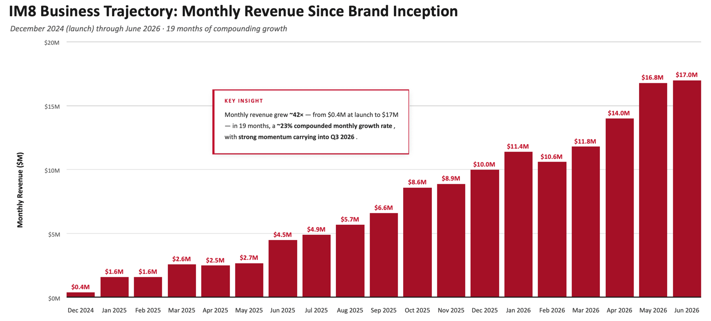
The CVF financing follows a period of significant strategic momentum for Prenetics, including the reclassification of the company as a consumer health business. Following the record scale IM8 has achieved with just its two flagship SKUs, new product launches are planned across Q4 2026 and Q1 2027, including IM8 Hydration in Q4 2026 and a category-first premium gummies line in Q1 2027, meaningfully expanding IM8’s addressable market. IM8 continues to expand its clinical evidence base, with two active randomized controlled trials on gut health and longevity currently underway.
More information on General Catalyst’s Customer Value Fund is available at https://www.generalcatalyst.com/stories/the-unbundling-of-growth-equity.
The below table sets out a summary of certain key commercial terms of the CVF financing:
Total commitment |  |  | $1.0 billion
Funded share of marketing spend |  |  | Up to 70% of IM8’s marketing spend on a monthly cohort basis
General Catalyst return |  |  | Capped share of Reference Income (customer collections multiplied by assumed gross margin) from financed cohorts, subject to a fixed multiple on the funding amount deployed to each cohort
Cohort waterfall |  |  | Once the capped return is reached on any monthly cohort, all subsequent value from those customers accrues entirely and permanently to IM8

Equity issued to General Catalyst |  |  | None. No shares, warrants, or convertible instruments are issued as part of the arrangement
Expected accounting |  |  | Financial liability on the consolidated balance sheet; return component recognized as interest expense below operating income; 100% of marketing spend continues to be recorded as sales and marketing expense

About Prenetics
Prenetics Global Limited (NASDAQ: PRE) is a leading consumer health company on a mission to advance human health and longevity. Its flagship brand, IM8, co-founded with David Beckham, is redefining premium daily nutrition through science-backed formulations — anchored by Daily Ultimate Essentials, a 90-ingredient daily nutrition system that is NSF Certified for Sport and clinically studied. IM8 is the fastest-growing premium supplement brand ever recorded, surpassing $200 million in annualized run-rate revenue within 18 months of launch, shipping to 43 countries, and delivering approximately 200,000 servings daily. IM8's ambassador and equity-partner roster includes David Beckham, Giannis Antetokounmpo, Aryna Sabalenka, Ollie Bearman, Jay Shetty, and Inter Miami CF. Learn more at prenetics.com and im8health.com.
About IM8
IM8 is the pinnacle of premium core nutrition, born from a collaboration between David Beckham as a co-founding partner, and an elite team of scientists spanning medical professionals, academia and space science. Combining cutting-edge science with nature’s most potent ingredients, IM8 delivers a holistic, science-backed approach to health, empowering you to live your most vibrant life. IM8’s flagship product, Daily Ultimate Essentials Pro, is an all-in-one powder supplement engineered to replace 16 different supplements in a delicious drink and is NSF Certified for Sport, non-GMO, vegan, free from common allergens, and contains no artificial flavors, colors or sweeteners. IM8 is a subsidiary of Prenetics (NASDAQ: PRE), a leading global health sciences company dedicated to advancing consumer health. To learn more about IM8, please visit www.IM8health.com.
Investor Relations Contact
investors@prenetics.com
PRE@mzgroup.us

Angela Cheung
Investor Relations / Corporate Finance
angela.hm.cheung@prenetics.com

Note Regarding Preliminary Unaudited Financial Information
The financial information disclosed in this press release is preliminary and unaudited. Unless otherwise indicated, it reflects Prenetics’ current estimate based on information available as of the date of this release and is subject to its customary month-end and quarter-end close procedures. Actual reported results may differ from these preliminary estimates. Prenetics undertakes no obligation to update this preliminary information other than through its regular reporting cycle.
Cautionary Note Regarding Forward-Looking Statements
This press release contains forward-looking statements. These statements are made under the “safe harbor” provisions of the U.S. Private Securities Litigation Reform Act of 1995. Statements that are not historical facts, including statements about the Company’s goals, targets, projections, outlooks, beliefs, expectations, strategy, plans, objectives of management for future operations of the Company, and growth opportunities are forward-looking statements. Our guidance reflects management’s current estimates and assumptions as of the date of this release, is subject to significant risks and uncertainties, and is not a guarantee of future performance. Actual results may differ materially. In some cases, forward-looking statements can be identified by words or phrases such as “may,” “will,” “expect,” “anticipate,” “target,” “aim,” “estimate,” “intend,” “plan,” “believe,” “potential,” “continue,” “is/are likely to,” “guidance,” “outlook,” “forecast,” or other similar expressions. Forward-looking statements are based upon estimates and forecasts and reflect the views, assumptions, expectations, and opinions of the Company, which involve inherent risks and uncertainties, and therefore they should not be relied upon as being necessarily indicative of future results. A number of factors could cause actual results to differ materially from those contained in any forward-looking statement, including but not limited to: the Company may not be able to maintain and enhance its IM8 business and brand if it suffers negative publicity or fails to maintain a strong base of engaged customers and content creators, or otherwise fails to meet customers’ expectations; the Company’s ability to further develop and grow its business, including new products and services; and the Company’s ability to efficiently and effectively deploy financial and management resources towards maintaining and growing the business. In addition to the foregoing factors, you should also carefully consider the other risks and uncertainties described in the “Risk Factors” section of the Company’s most recent registration statement and the prospectus therein, and the other documents filed by the Company from time to time with the U.S. Securities and Exchange Commission. Unless otherwise specified, all information provided in this press release is as of the date of this press release, and the Company does not undertake any duty to update such information, except as required under applicable law. Nothing in this press release constitutes an offer to sell, or the solicitation of an offer to buy, any securities of the Company.
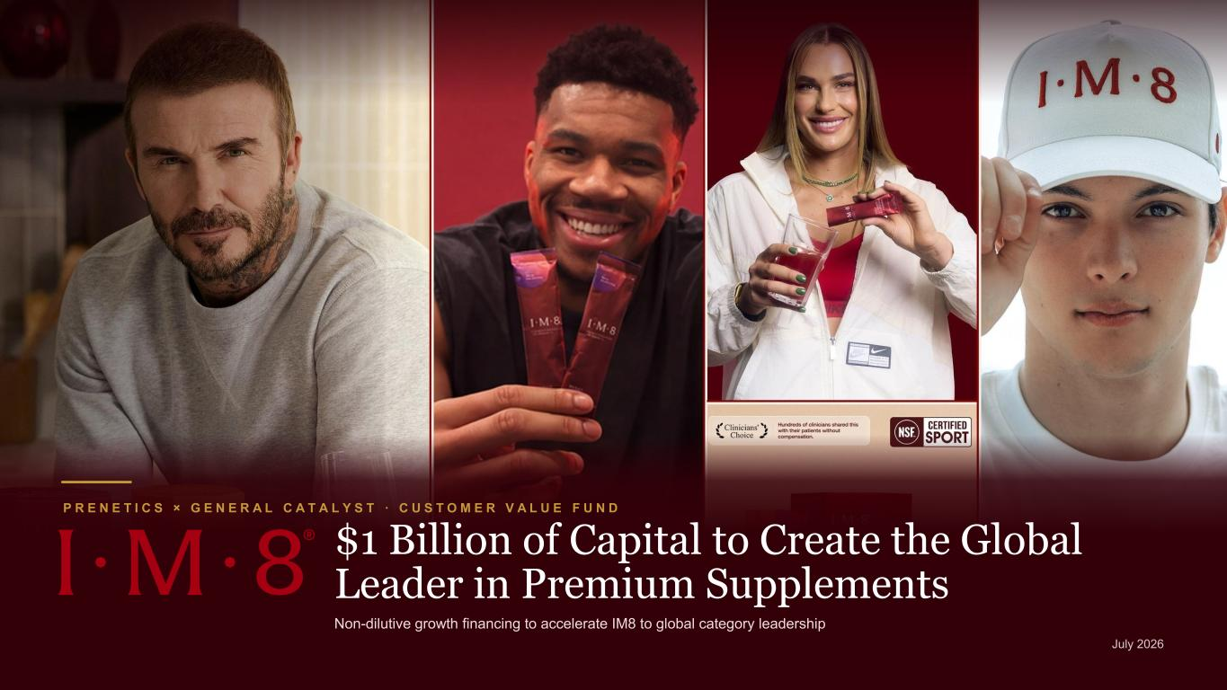

P R E N E T I C S × G E N E R A L C A T A L Y S T · C U S T O M E R V A L U E F U N D $1 Billion of Capital to Create the Global Leader in Premium Supplements Non-dilutive growth financing to accelerate IM8 to global category leadership

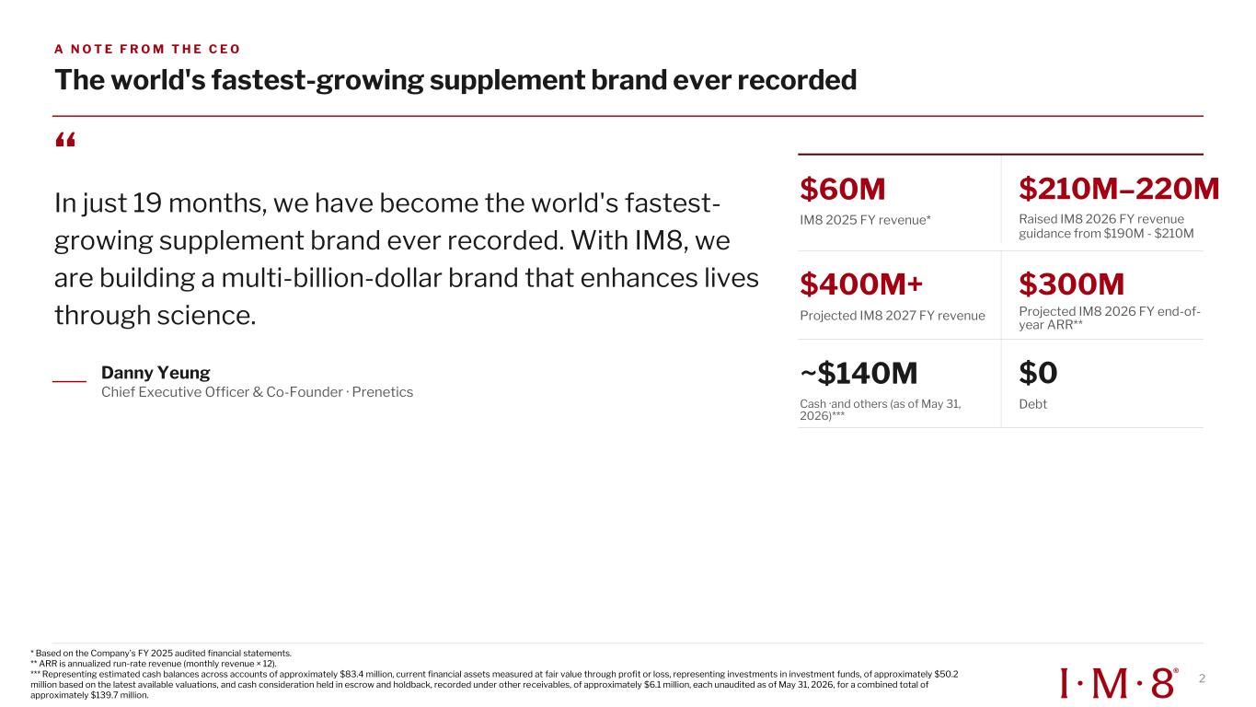
A N O T E F R O M T H E C E O The world's fastest-growing supplement brand ever recorded “ In just 19 months, we have become the world's fastest- growing supplement brand ever recorded. With IM8, we are building a multi-billion-dollar brand that enhances lives through science. Danny Yeung Chief Executive Officer & Co-Founder · Prenetics $60M IM8 2025 FY revenue* $210M–220M Raised IM8 2026 FY revenue guidance from $190M - $210M $400M+ Projected IM8 2027 FY revenue $300M Projected IM8 2026 FY end-of- year ARR** ~$140M Cash ·and others (as of May 31, 2026)*** $0 Debt * Based on the Company’s FY 2025 audited financial statements. ** ARR is annualized run-rate revenue (monthly revenue × 12). *** Representing estimated cash balances across accounts of approximately $83.4 million, current financial assets measured at fair value through profit or loss, representing investments in investment funds, of approximately $50.2 million based on the latest available valuations, and cash consideration held in escrow and holdback, recorded under other receivables, of approximately $6.1 million, each unaudited as of May 31, 2026, for a combined total of approximately $139.7 million. 2

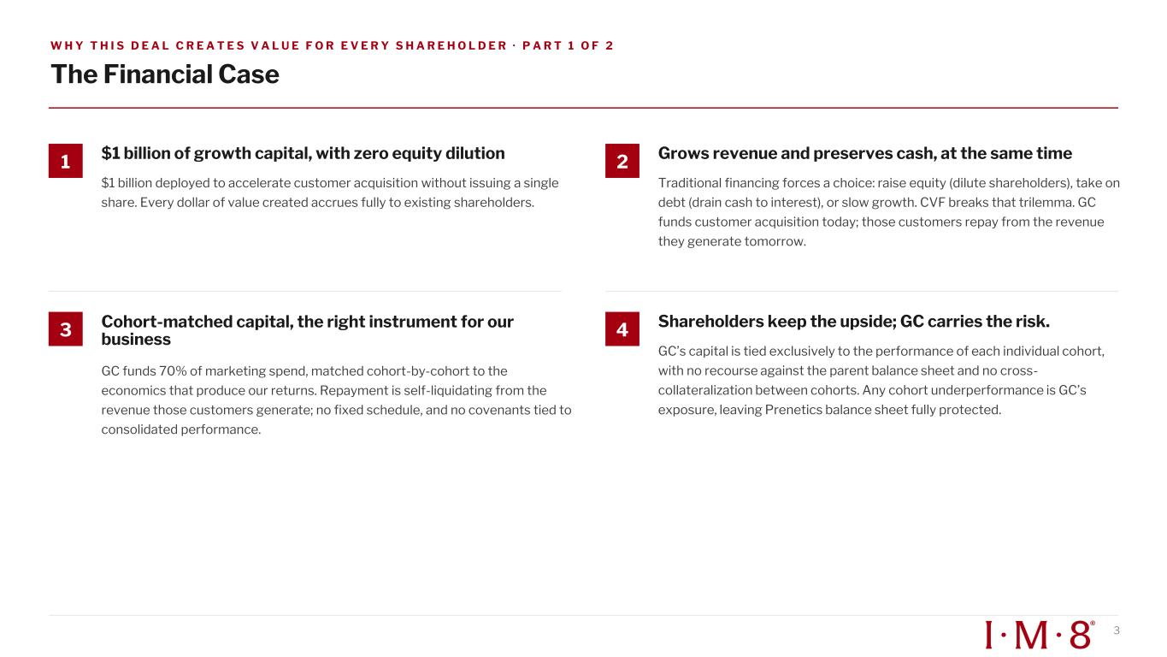
W H Y T H I S D E A L C R E A T E S V A L U E F O R E V E R Y S H A R E H O L D E R · P A R T 1 O F 2 The Financial Case 1 $1 billion of growth capital, with zero equity dilution $1 billion deployed to accelerate customer acquisition without issuing a single share. Every dollar of value created accrues fully to existing shareholders. 2 Grows revenue and preserves cash, at the same time Traditional financing forces a choice: raise equity (dilute shareholders), take on debt (drain cash to interest), or slow growth. CVF breaks that trilemma. GC funds customer acquisition today; those customers repay from the revenue they generate tomorrow. 3 Cohort-matched capital, the right instrument for our business GC funds 70% of marketing spend, matched cohort-by-cohort to the economics that produce our returns. Repayment is self-liquidating from the revenue those customers generate; no fixed schedule, and no covenants tied to consolidated performance. 4 Shareholders keep the upside; GC carries the risk. GC’s capital is tied exclusively to the performance of each individual cohort, with no recourse against the parent balance sheet and no cross- collateralization between cohorts. Any cohort underperformance is GC’s exposure, leaving Prenetics balance sheet fully protected. 3

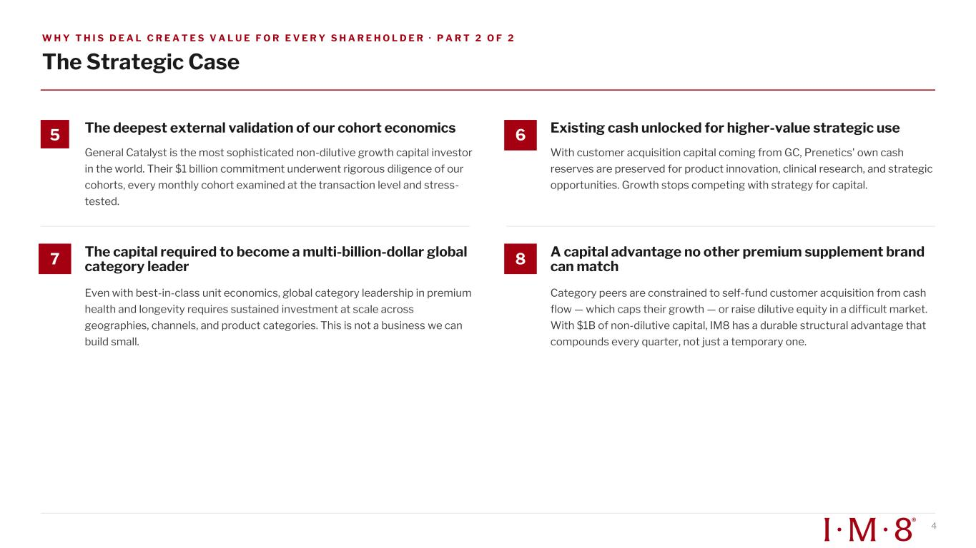
W H Y T H I S D E A L C R E A T E S V A L U E F O R E V E R Y S H A R E H O L D E R · P A R T 2 O F 2 The Strategic Case 5 The deepest external validation of our cohort economics General Catalyst is the most sophisticated non-dilutive growth capital investor in the world. Their $1 billion commitment underwent rigorous diligence of our cohorts, every monthly cohort examined at the transaction level and stress- tested. 6 Existing cash unlocked for higher-value strategic use With customer acquisition capital coming from GC, Prenetics' own cash reserves are preserved for product innovation, clinical research, and strategic opportunities. Growth stops competing with strategy for capital. 7 The capital required to become a multi-billion-dollar global category leader Even with best-in-class unit economics, global category leadership in premium health and longevity requires sustained investment at scale across geographies, channels, and product categories. This is not a business we can build small. 8 A capital advantage no other premium supplement brand can match Category peers are constrained to self-fund customer acquisition from cash flow — which caps their growth — or raise dilutive equity in a difficult market. With $1B of non-dilutive capital, IM8 has a durable structural advantage that compounds every quarter, not just a temporary one. 4

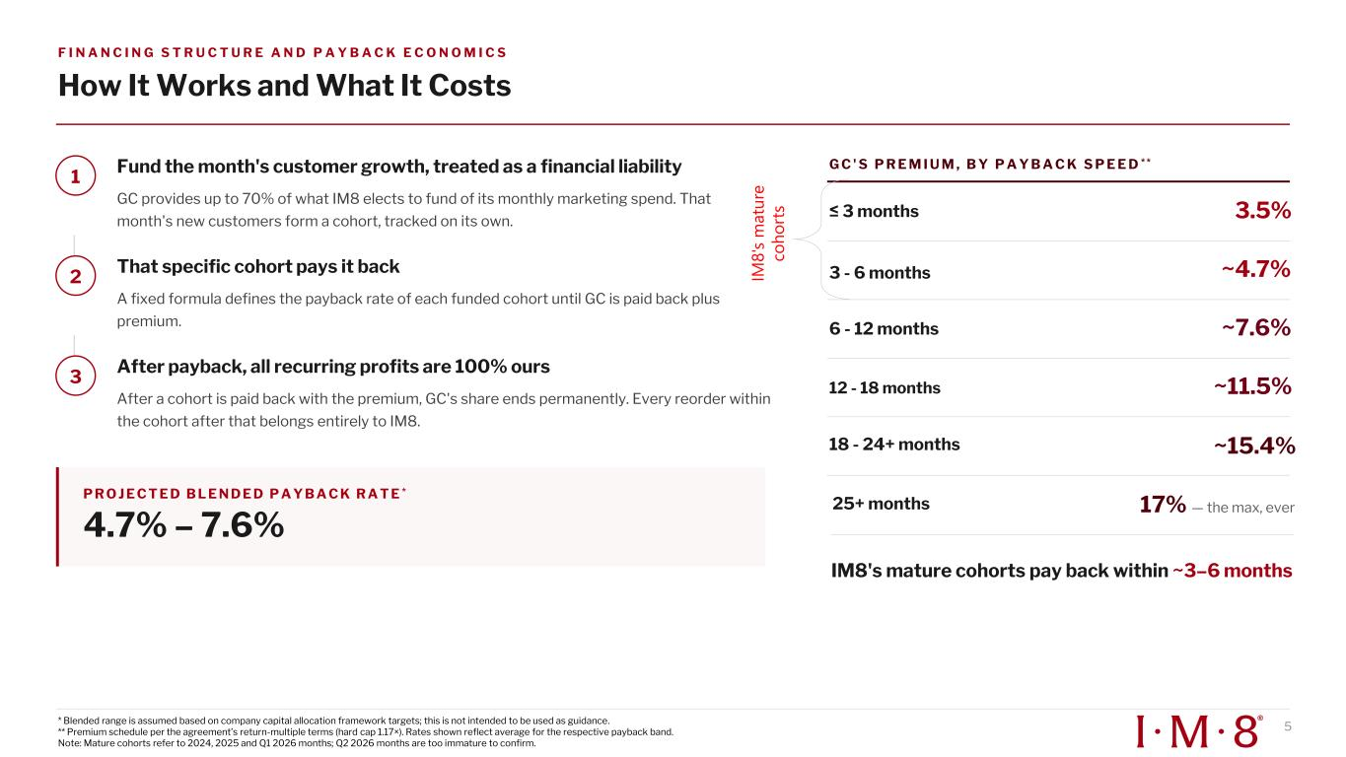
F I N A N C I N G S T R U C T U R E A N D P A Y B A C K E C O N O M I C S How It Works and What It Costs 1 Fund the month's customer growth, treated as a financial liability GC provides up to 70% of what IM8 elects to fund of its monthly marketing spend. That month's new customers form a cohort, tracked on its own. 2 That specific cohort pays it back A fixed formula defines the payback rate of each funded cohort until GC is paid back plus premium. 3 After payback, all recurring profits are 100% ours After a cohort is paid back with the premium, GC's share ends permanently. Every reorder within the cohort after that belongs entirely to IM8. P R O J E C T E D B L E N D E D P A Y B A C K R A T E * 4.7% – 7.6% G C ' S P R E M I U M , B Y P A Y B A C K S P E E D * * ≤ 3 months 3.5% 3 - 6 months ~4.7% 6 - 12 months ~7.6% 12 - 18 months ~11.5% 18 - 24+ months ~15.4% IM8's mature cohorts pay back within ~3–6 months 5 IM 8 's m a tu re co h o rt s * Blended range is assumed based on company capital allocation framework targets; this is not intended to be used as guidance. ** Premium schedule per the agreement’s return-multiple terms (hard cap 1.17×). Rates shown reflect average for the respective payback band. Note: Mature cohorts refer to 2024, 2025 and Q1 2026 months; Q2 2026 months are too immature to confirm. 25+ months 17% — the max, ever

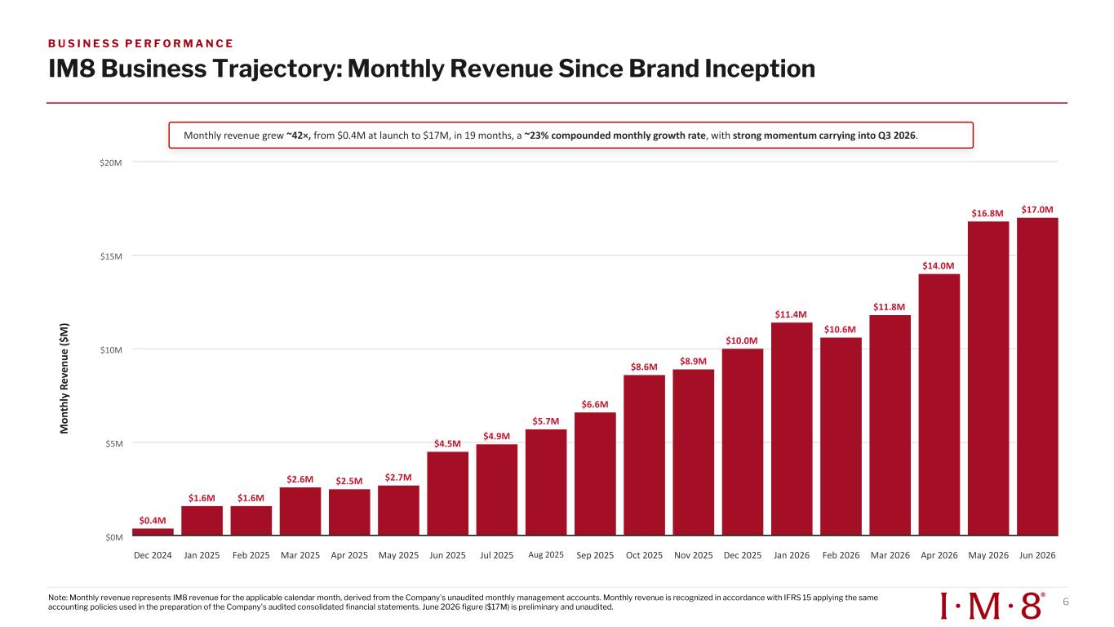
M o n th ly R ev e n u e ( $ M ) $0M $5M $10M $15M $20M $0.4M $1.6M $1.6M $2.6M $2.5M $2.7M $4.5M $4.9M $5.7M $6.6M $8.6M $8.9M $10.0M $11.4M $10.6M $11.8M $14.0M $16.8M $17.0M Monthly revenue grew ~42×, from $0.4M at launch to $17M, in 19 months, a ~23% compounded monthly growth rate, with strong momentum carrying into Q3 2026. Dec 2024 Jan 2025 Feb 2025 Mar 2025 Apr 2025 May 2025 Jun 2025 Jul 2025 Aug 2025 Sep 2025 Oct 2025 Nov 2025 Dec 2025 Jan 2026 Feb 2026 Mar 2026 Apr 2026 May 2026 Jun 2026 IM8 Business Trajectory: Monthly Revenue Since Brand Inception B U S I N E S S P E R F O R M A N C E Note: Monthly revenue represents IM8 revenue for the applicable calendar month, derived from the Company's unaudited monthly management accounts. Monthly revenue is recognized in accordance with IFRS 15 applying the same accounting policies used in the preparation of the Company's audited consolidated financial statements. June 2026 figure ($17M) is preliminary and unaudited. 6

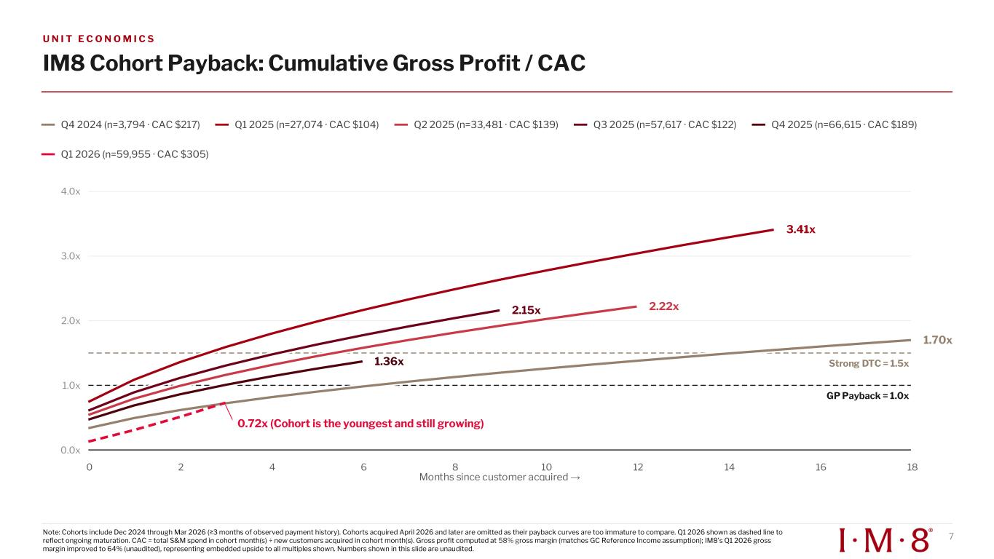
U N I T E C O N O M I C S IM8 Cohort Payback: Cumulative Gross Profit / CAC Q4 2024 (n=3,794 · CAC $217) Q1 2025 (n=27,074 · CAC $104) Q2 2025 (n=33,481 · CAC $139) Q3 2025 (n=57,617 · CAC $122) Q4 2025 (n=66,615 · CAC $189) Q1 2026 (n=59,955 · CAC $305) t on onths since customer ac uired 0.0x 1.0x 2.0x 3.0x 4.0x 1.70x 3.41x 2.22x2.15x 1.36x 0.72x (Cohort is the youngest and still growing) 0 2 4 6 8 10 12 14 16 18 7Note: Cohorts include Dec 2024 through ar 2026 (≥3 months of observed payment history). Cohorts ac uired April 2026 and later are omitted as their payback curves are too immature to compare. Q1 2026 shown as dashed line to reflect ongoing maturation. CAC = total S&M spend in cohort month(s) ÷ new customers acquired in cohort month(s). Gross profit computed at 58% gross margin (matches GC Reference Income assumption); IM8's Q1 2026 gross margin improved to 64% (unaudited), representing embedded upside to all multiples shown. Numbers shown in this slide are unaudited.

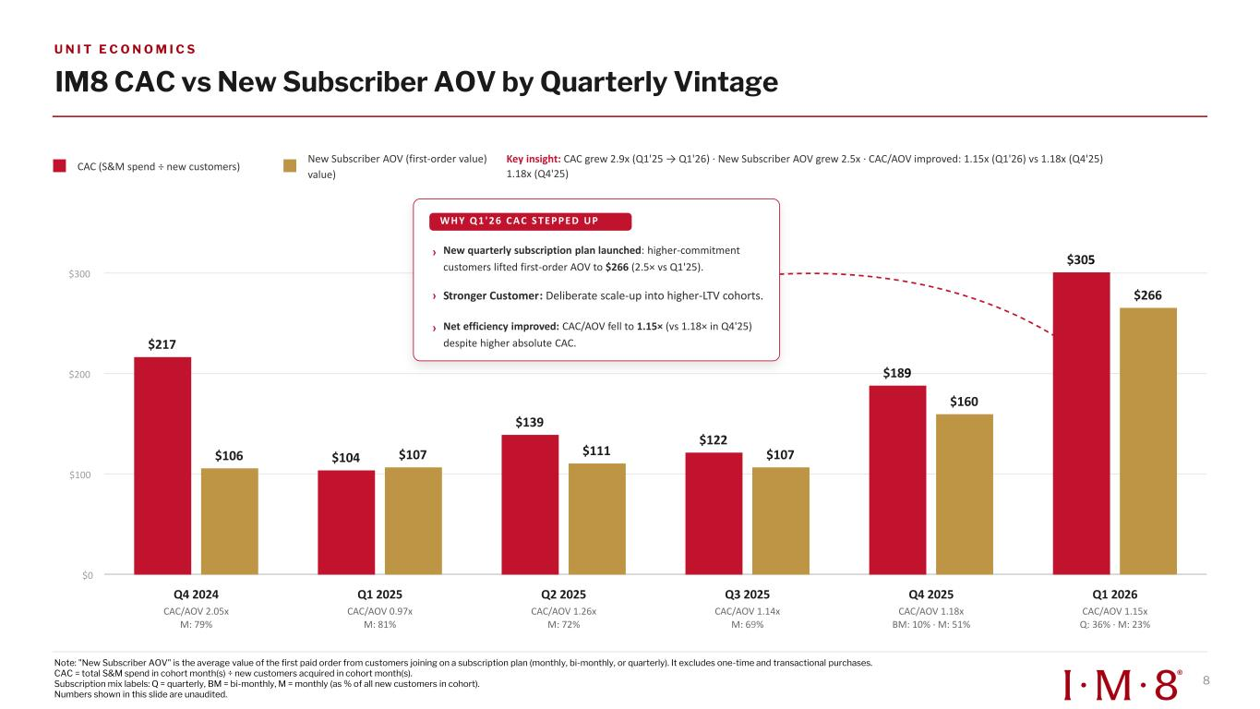
IM8 CAC vs New Subscriber AOV by Quarterly Vintage CAC (S&M spend ÷ new customers) New Subscriber AOV (first-order value) value) Key insight: CAC grew 2.9x (Q1'25 → Q1'26) · New Subscriber AOV grew 2.5x · CAC/AOV improved: 1.15x (Q1'26) vs 1.18x (Q4'25) 1.18x (Q4'25) $0 $100 $200 $300 $217 $106 $104 $107 $139 $111 $122 $107 $189 $160 $305 $266 Q4 2024 CAC/AOV 2.05x M: 79% Q1 2025 CAC/AOV 0.97x M: 81% Q2 2025 CAC/AOV 1.26x M: 72% Q3 2025 CAC/AOV 1.14x M: 69% Q4 2025 CAC/AOV 1.18x BM: 10% · M: 51% Q1 2026 CAC/AOV 1.15x Q: 36% · M: 23% WH Y Q 1' 26 C AC S T EP P ED UP › New quarterly subscription plan launched: higher-commitment customers lifted first-order AOV to $266 (2.5× vs Q1'25). › Stronger Customer: Deliberate scale-up into higher-LTV cohorts. › Net efficiency improved: CAC/AOV fell to 1.15× (vs 1.18× in Q4'25) despite higher absolute CAC. U N I T E C O N O M I C S Note: "New Subscriber AOV" is the average value of the first paid order from customers joining on a subscription plan (monthly, bi-monthly, or quarterly). It excludes one-time and transactional purchases. CAC = total S&M spend in cohort month(s) ÷ new customers acquired in cohort month(s). Subscription mix labels: Q = quarterly, BM = bi-monthly, M = monthly (as % of all new customers in cohort). Numbers shown in this slide are unaudited. 8

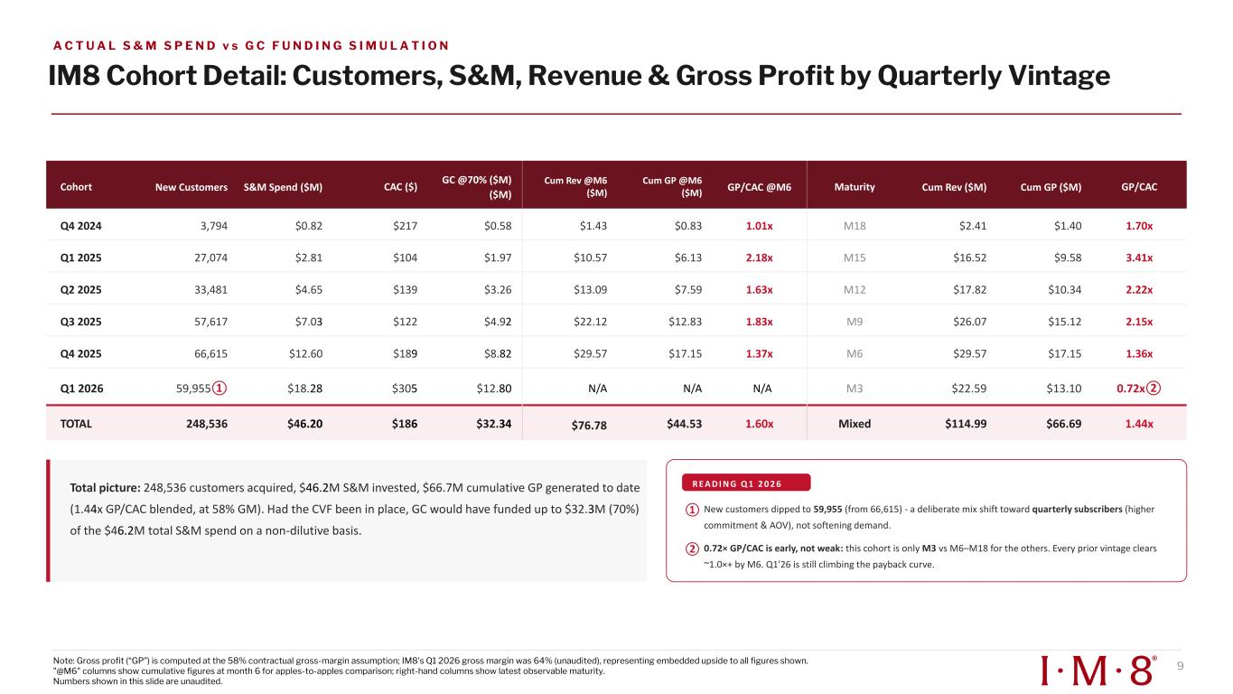
IM8 Cohort Detail: Customers, S&M, Revenue & Gross Profit by Quarterly Vintage Cohort New Customers S&M Spend ($M) CAC ($) GC @70% ($M) ($M) Cum Rev @M6 ($M) Cum GP @M6 ($M) GP/CAC @M6 Maturity Cum Rev ($M) Cum GP ($M) GP/CAC Q4 2024 3,794 $0.82 $217 $0.58 $1.43 $0.83 1.01x M18 $2.41 $1.40 1.70x Q1 2025 27,074 $2.81 $104 $1.97 $10.57 $6.13 2.18x M15 $16.52 $9.58 3.41x Q2 2025 33,481 $4.65 $139 $3.26 $13.09 $7.59 1.63x M12 $17.82 $10.34 2.22x Q3 2025 57,617 $7.03 $122 $4.92 $22.12 $12.83 1.83x M9 $26.07 $15.12 2.15x Q4 2025 66,615 $12.60 $189 $8.82 $29.57 $17.15 1.37x M6 $29.57 $17.15 1.36x Q1 2026 59,955① $18.28 $305 $12.80 N/A N/A M3 $22.59 $13.10 0.72x② TOTAL 248,536 $46.20 $186 $32.34 1.60x Mixed $114.99 $66.69 1.44x Total picture: 248,536 customers acquired, $46.2M S&M invested, $66.7M cumulative GP generated to date (1.44x GP/CAC blended, at 58% GM). Had the CVF been in place, GC would have funded up to $32.3M (70%) of the $46.2M total S&M spend on a non-dilutive basis. R E A D I N G Q 1 2 0 2 6 ① New customers dipped to 59,955 (from 66,615) - a deliberate mix shift toward quarterly subscribers (higher commitment & AOV), not softening demand. ② 0.72× GP/CAC is early, not weak: this cohort is only M3 vs M6–M18 for the others. Every prior vintage clears ~1.0×+ by M6. Q1'26 is still climbing the payback curve. A C T U A L S & M S P E N D v s G C F U N D I N G S I M U L A T I O N N/A $76.78 $44.53 9Note: Gross profit (“GP”) is computed at the 58% contractual gross-margin assumption; IM8's Q1 2026 gross margin was 64% (unaudited), representing embedded upside to all figures shown. "@M6" columns show cumulative figures at month 6 for apples-to-apples comparison; right-hand columns show latest observable maturity. Numbers shown in this slide are unaudited.

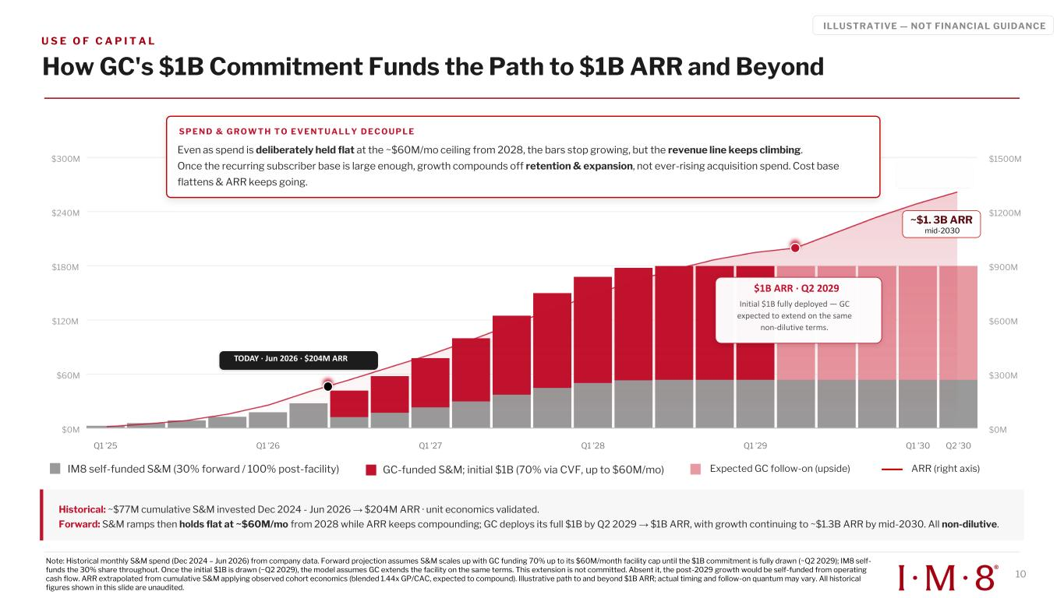
U S E O F C A P I T A L ILLUSTRATIVE — NOT FINANCIAL GUIDANCE How GC's $1B Commitment Funds the Path to $1B ARR and Beyond IM8 self-funded S&M (30% forward / 100% post-facility) GC-funded S&M; initial $1B (70% via CVF, up to $60M/mo) Expected GC follow-on (upside) ARR (right axis) $0M $60M $120M $180M $240M $300M $0M $300M $600M $900M $1200M $1500M S P E N D & G R O W T H T O E V E N T U A L L Y D E C O U P L E Even as spend is deliberately held flat at the ~$60M/mo ceiling from 2028, the bars stop growing, but the revenue line keeps climbing. Once the recurring subscriber base is large enough, growth compounds off retention & expansion, not ever-rising acquisition spend. Cost base flattens & ARR keeps going. Q1 ’25 Q1 ’26 Q1 ’27 Q1 ’28 Q1 ’29 Q1 ’30 Q2 ’30 Historical: ~$77M cumulative S&M invested Dec 2024 - Jun 2026 → $204M ARR · unit economics validated. Forward: S&M ramps then holds flat at ~$60M/mo from 2028 while ARR keeps compounding; GC deploys its full $1B by Q2 2029 → $1B ARR, with growth continuing to ~$1.3B ARR by mid-2030. All non-dilutive. 10 Note: Historical monthly S&M spend (Dec 2024 – Jun 2026) from company data. Forward projection assumes S&M scales up with GC funding 70% up to its $60M/month facility cap until the $1B commitment is fully drawn (~Q2 2029); IM8 self- funds the 30% share throughout. Once the initial $1B is drawn (~Q2 2029), the model assumes GC extends the facility on the same terms. This extension is not committed. Absent it, the post-2029 growth would be self-funded from operating cash flow. ARR extrapolated from cumulative S&M applying observed cohort economics (blended 1.44x GP/CAC, expected to compound). Illustrative path to and beyond $1B ARR; actual timing and follow-on quantum may vary. All historical figures shown in this slide are unaudited. ~$1. 3B ARR mid-2030 $1B ARR · Q2 2029 Initial $1B fully deployed — GC expected to extend on the same non-dilutive terms. TODAY · Jun 2026 · $204M ARR

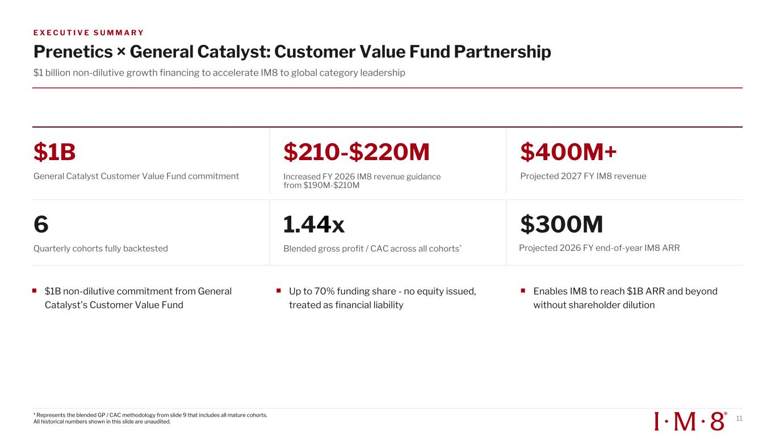
E X E C U T I V E S U M M A R Y Prenetics × General Catalyst: Customer Value Fund Partnership $1 billion non-dilutive growth financing to accelerate IM8 to global category leadership $1B General Catalyst Customer Value Fund commitment $210-$220M Increased FY 2026 IM8 revenue guidance from $190M-$210M $400M+ Projected 2027 FY IM8 revenue 6 Quarterly cohorts fully backtested 1.44x Blended gross profit / CAC across all cohorts* $300M $1B non-dilutive commitment from General Catalyst's Customer Value Fund Up to 70% funding share - no equity issued, treated as financial liability Enables IM8 to reach $1B ARR and beyond without shareholder dilution 11* Represents the blended GP / CAC methodology from slide 9 that includes all mature cohorts. All historical numbers shown in this slide are unaudited. Projected 2026 FY end-of-year IM8 ARR

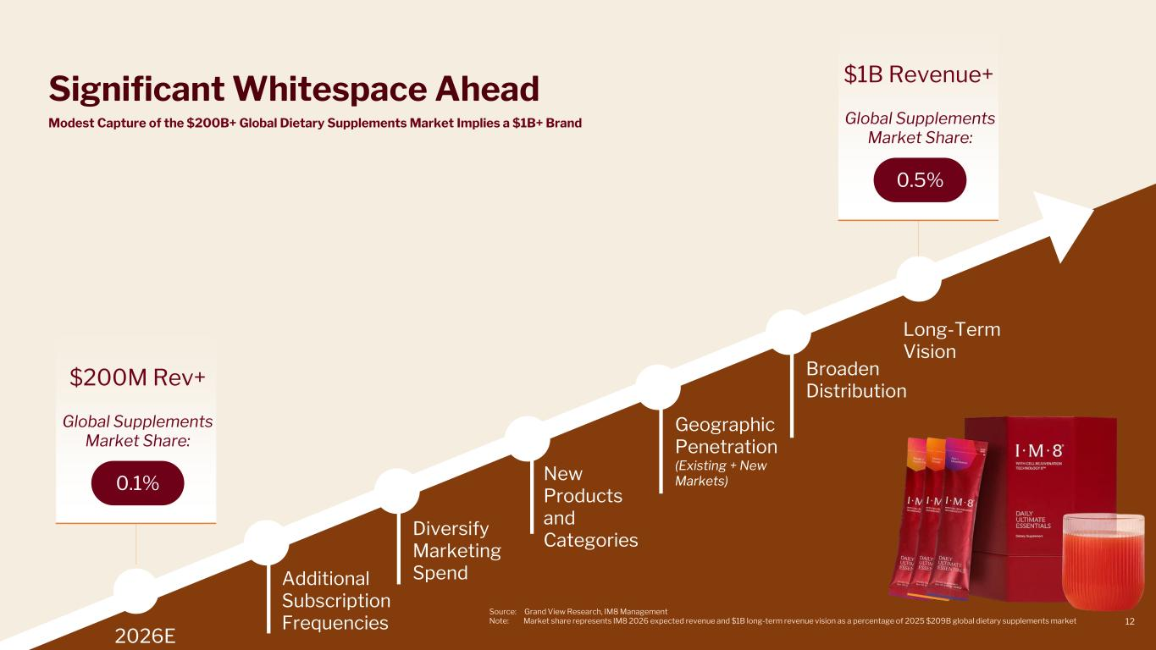
Significant Whitespace Ahead 2026E Long-Term Vision $200M Rev+ Global Supplements Market Share: 0.1% $1B Revenue+ Global Supplements Market Share: 0.5% Modest Capture of the $200B+ Global Dietary Supplements Market Implies a $1B+ Brand Additional Subscription Frequencies Diversify Marketing Spend Geographic Penetration (Existing + New Markets)New Products and Categories Source: Grand View Research, IM8 Management Note: Market share represents IM8 2026 expected revenue and $1B long-term revenue vision as a percentage of 2025 $209B global dietary supplements market 12 Broaden Distribution

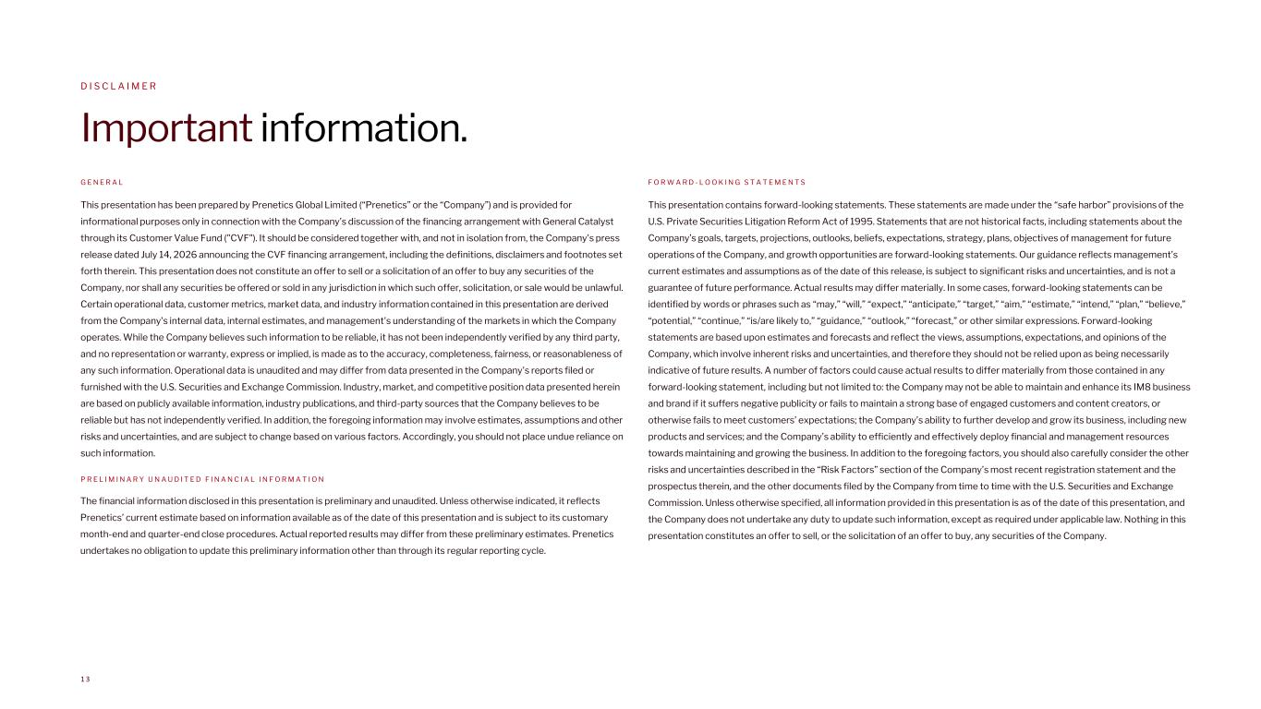
D I S C L A I M E R Important information. G E N E R A L This presentation has been prepared by Prenetics Global Limited (“Prenetics” or the “Company”) and is provided for informational purposes only in connection with the Company’s discussion of the financing arrangement with General Catalyst through its Customer Value Fund ("CVF"). It should be considered together with, and not in isolation from, the Company's press release dated July 14, 2026 announcing the CVF financing arrangement, including the definitions, disclaimers and footnotes set forth therein. This presentation does not constitute an offer to sell or a solicitation of an offer to buy any securities of the Company, nor shall any securities be offered or sold in any jurisdiction in which such offer, solicitation, or sale would be unlawful. Certain operational data, customer metrics, market data, and industry information contained in this presentation are derived from the Company's internal data, internal estimates, and management's understanding of the markets in which the Company operates. While the Company believes such information to be reliable, it has not been independently verified by any third party, and no representation or warranty, express or implied, is made as to the accuracy, completeness, fairness, or reasonableness of any such information. Operational data is unaudited and may differ from data presented in the Company's reports filed or furnished with the U.S. Securities and Exchange Commission. Industry, market, and competitive position data presented herein are based on publicly available information, industry publications, and third-party sources that the Company believes to be reliable but has not independently verified. In addition, the foregoing information may involve estimates, assumptions and other risks and uncertainties, and are subject to change based on various factors. Accordingly, you should not place undue reliance on such information. P R E L I M I N A R Y U N A U D I T E D F I N A N C I A L I N F O R M A T I O N F O R W A R D - L O O K I N G S T A T E M E N T S This presentation contains forward-looking statements. These statements are made under the “safe harbor” provisions of the U.S. Private Securities Litigation Reform Act of 1995. Statements that are not historical facts, including statements about the Company’s goals, targets, projections, outlooks, beliefs, expectations, strategy, plans, objectives of management for future operations of the Company, and growth opportunities are forward-looking statements. Our guidance reflects management’s current estimates and assumptions as of the date of this release, is subject to significant risks and uncertainties, and is not a guarantee of future performance. Actual results may differ materially. In some cases, forward-looking statements can be identified by words or phrases such as “may,” “will,” “expect,” “anticipate,” “target,” “aim,” “estimate,” “intend,” “plan,” “believe,” “potential,” “continue,” “is/are likely to,” “guidance,” “outlook,” “forecast,” or other similar expressions. Forward-looking statements are based upon estimates and forecasts and reflect the views, assumptions, expectations, and opinions of the Company, which involve inherent risks and uncertainties, and therefore they should not be relied upon as being necessarily indicative of future results. A number of factors could cause actual results to differ materially from those contained in any forward-looking statement, including but not limited to: the Company may not be able to maintain and enhance its IM8 business and brand if it suffers negative publicity or fails to maintain a strong base of engaged customers and content creators, or otherwise fails to meet customers’ expectations; the Company’s ability to further develop and grow its business, including new products and services; and the Company’s ability to efficiently and effectively deploy financial and management resources towards maintaining and growing the business. In addition to the foregoing factors, you should also carefully consider the other risks and uncertainties described in the “Risk Factors” section of the Company’s most recent registration statement and the prospectus therein, and the other documents filed by the Company from time to time with the U.S. Securities and Exchange Commission. Unless otherwise specified, all information provided in this presentation is as of the date of this presentation, and the Company does not undertake any duty to update such information, except as required under applicable law. Nothing in this presentation constitutes an offer to sell, or the solicitation of an offer to buy, any securities of the Company. 1 3 The financial information disclosed in this presentation is preliminary and unaudited. Unless otherwise indicated, it reflects Prenetics’ current estimate based on information available as of the date of this presentation and is subject to its customary month-end and quarter-end close procedures. Actual reported results may differ from these preliminary estimates. Prenetics undertakes no obligation to update this preliminary information other than through its regular reporting cycle.

