SEC Form 3
FORM 3 | UNITED STATES SECURITIES AND EXCHANGE COMMISSION  Washington, D.C. 20549  INITIAL STATEMENT OF BENEFICIAL OWNERSHIP OF SECURITIES  Filed pursuant to Section 16(a) of the Securities Exchange Act of 1934  or Section 30(h) of the Investment Company Act of 1940
  OMB APPROVAL
  OMB Number: | 3235-0104
  Estimated average burden
  hours per response: | 0.5
1. Name and Address of Reporting Person*  (Street)  (Country) | 2. Date of Event Requiring Statement (Month/Day/Year)  08/17/2026 | 3. Issuer Name and Ticker or Trading Symbol  Prenetics Global Ltd [ PRE ]  Foreign Trading Symbol
  Levy Caroline S
  (Last) | (First) | (Middle)
  UNIT 703-706, K11 ATELIER
  728 KINGS ROAD, QUARRY BAY
  HONG KONG
  (City) | (State) | (Zip)
  HONG KONG
 |  | 4. Relationship of Reporting Person(s) to Issuer  (Check all applicable) | 5. If Amendment, Date of Original Filed (Month/Day/Year)
   | Director |  | 10% Owner
   | Officer (give title below) |  | Other (specify below)
6. Individual or Joint/Group Filing (Check Applicable Line)
Form filed by One Reporting Person
Form filed by More than One Reporting Person

Table I - Non-Derivative Securities Beneficially Owned
1. Title of Security (Instr. 4) | 2. Amount of Securities Beneficially Owned (Instr. 4) | 3. Ownership Form: Direct (D) or Indirect (I) (Instr. 5) | 4. Nature of Indirect Beneficial Ownership (Instr. 5)
Table II - Derivative Securities Beneficially Owned
(e.g., puts, calls, warrants, options, convertible securities)
1. Title of Derivative Security (Instr. 4) | 2. Date Exercisable and Expiration Date (Month/Day/Year) |  | 3. Title and Amount of Securities Underlying Derivative Security (Instr. 4) |  | 4. Conversion or Exercise Price of Derivative Security | 5. Ownership Form: Direct (D) or Indirect (I) (Instr. 5) | 6. Nature of Indirect Beneficial Ownership (Instr. 5)
1. Title of Derivative Security (Instr. 4) | Date Exercisable | Expiration Date | Title | Amount or Number of Shares | 4. Conversion or Exercise Price of Derivative Security | 5. Ownership Form: Direct (D) or Indirect (I) (Instr. 5) | 6. Nature of Indirect Beneficial Ownership (Instr. 5)
Restricted Stock Unit | (1) | 08/17/2033 | Class A Ordinary Share, par value $0.0015 per share | 7,595 | 0 | D
Explanation of Responses:
1. Each Restricted Stock Unit ("RSU"), granted under the Issuer's 2022 Share Incentive Plan, represents a contingent right to receive one Class A Ordinary Share. 7,595 RSUs vest on August 17, 2027, subject to continued service. Upon vesting, the RSUs are settled and delivered in shares.
Remarks:
Exhibit 24 - Power of Attorney
 | s/ Stephen Hoi Chun Lo, as attorney-in-fact for Caroline Shan Levy | 08/26/2026
 | ** Signature of Reporting Person | Date
Reminder: Report on a separate line for each class of securities beneficially owned directly or indirectly.
* If the form is filed by more than one reporting person, see Instruction 5 (b)(v).
** Intentional misstatements or omissions of facts constitute Federal Criminal Violations See 18 U.S.C. 1001 and 15 U.S.C. 78ff(a).
Note: File three copies of this Form, one of which must be manually signed. If space is insufficient, see Instruction 6 for procedure.
Persons who respond to the collection of information contained in this form are not required to respond unless the form displays a currently valid OMB Number.
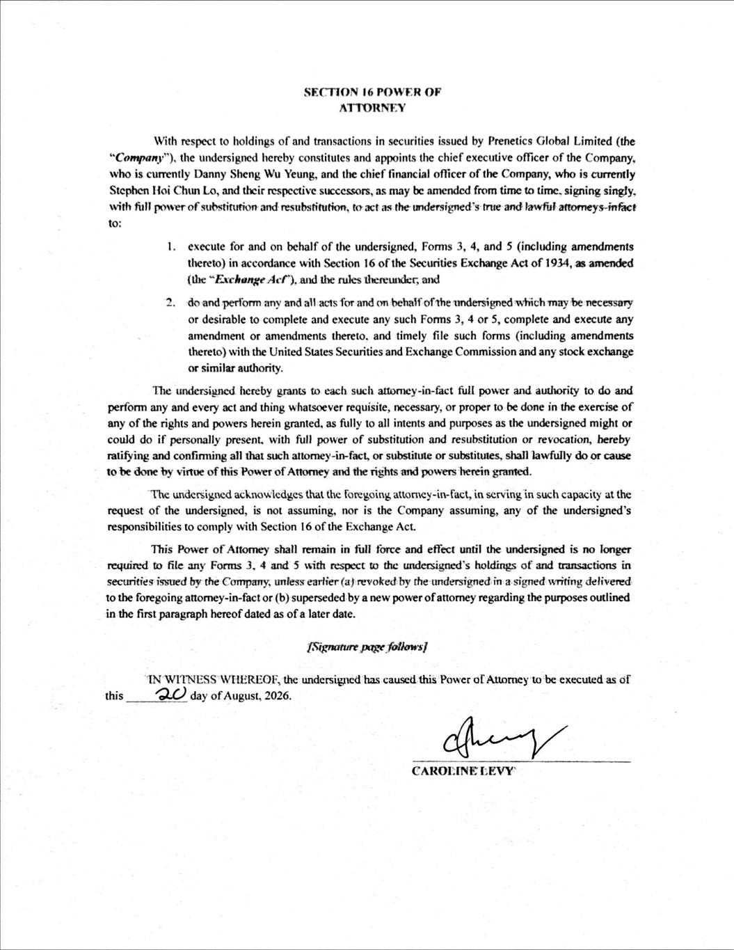
SECTION 16 POWER OF ATTORNEY With respect to holdings of and transactions in securities issued by Prenetics Global Limited (the "Company"), the undersigned hereby constitutes and appoints the chief executive officer of the Company, who is currently Danny Sheng Wu Yeung, and the chief financial officer of the Company, who is currently Stephen Hoi Chun Lo, and their respcctive successors,as may be amendcd from time to time, signing singly. with full power of substitutionand resubstitution, to act as theundersigned's trueand lawful attorneys-infact to: 1. execute for and on behalf of the undersigned, Forms 3, 4, and 5 (including amendments thereto) in accordance with Section 16 of the Securities Exchange Act of 1934, as amended (the “Exchange Acf"), and the rules thereunder, and do and perform any and all acts for and on behaif ofthe undersigned which may be necessary or desirable to complete and execute any such Foms 3, 4 or 5, complete and execute any amendment or amendments thereto, and timely file such forms (including amendments thereto) with the United States Securities and Exchange Commission and any stock exchange 2 or similar authority. The undersigned hereby grants to cach such attormey-in-fact full power and authority to do and perform any and every act and thing whatsoever requisite, necessary, or proper to be done in the exercise of any of the rights and powers herein granted, as fully to all intents and purposes as the undersigned might or could do if personally present, with full power of substitution and resubstitution or revocation, bereby ratifying and confiming all that suchattormey-in-fact, or substitute or substiutes, shall lawfully do or cause to bedorneby virtue of this Power of Attorney and the rights and powers herein granted. The undersigned acknowledges that the foregoing attorney-in-fact, in serving in such capacity at the request of the undersigned, is not assuming, nor is the Company assuming, any of the undersigned's responsibilities to comply with Section 16of the ExchangeAct. This Power of Attomey shall remain in full force and effect until the undersigned is no longer required to file any Forrns 3, 4 and 5 with respect to the undersigned's holdings of and transactions in securities issued by the Company, uniesseartier (a} revoked by theundersigned in a signed writing delivered to the foregoing attomey-in-fact or (b) supersededby a new power of attorney regarding thepurposes outlined in the first paragraph hereof dated as of a later date. [Signaturepage follows] IN WITNESS WEEREOF, the undersigncdhas causcdthis Power of Attorney to be executedas of 2 dayofAugust,2026. CAROLINELEVY this

