UNITED STATES
SECURITIES AND EXCHANGE COMMISSION
Washington, D.C. 20549

Form 6-K

REPORT OF FOREIGN PRIVATE ISSUER PURSUANT TO RULE
13a-16 OR 15d-16 UNDER
THE SECURITIES EXCHANGE ACT OF 1934

For the month of August 2026

Commission File Number 001-41401

Prenetics Global Limited

Unit 703-706, K11 Atelier
728 King’s Road, Quarry Bay
Hong Kong

(Address of principal executive office)

Indicate by check mark whether the registrant files or will file annual reports under cover of Form 20-F or Form 40-F.

Form 20-F ☒ Form 40-F ☐

DISCLOSURE OF RESULTS OF OPERATIONS

Prenetics Global Limited (the "Company") hereby furnishes the press release, dated August 18, 2026, announcing its unaudited financial results for the second quarter ended June 30, 2026, which is attached as Exhibit 99.1 to this Report on Form 6-K (this "Report").

On August 18, 2026, the Company issued a shareholder letter (the “Letter”) and investor presentation (the "Presentation") regarding its unaudited financial results for the second quarter ended June 30, 2026. A copy of each of the Letter and Presentation is attached hereto as Exhibit 99.2 and 99.3, respectively.

The information contained in this Report, including Exhibits 99.1, 99.2 and 99.3 furnished herewith, shall not be deemed “filed” for purposes of Section 18 of the Securities Exchange Act of 1934, as amended (the “Exchange Act”), or otherwise subject to the liabilities of that section, nor shall it be deemed incorporated by reference into any filing under the Securities Act of 1933, as amended, or the Exchange Act, except as expressly set forth by specific reference in such a filing or in this report.

INCORPORATION BY REFERENCE

This Report, along with Exhibits 99.1, 99.2 and 99.3, is incorporated by reference into the registration statement on Form F-1 (File No. 333-294765), registration statements on Form F-3 (File Nos. 333-265284, 333-276538 and 333-288824), and registration statements on Form S-8 (File Nos. 333-287017, 333-279019, 333-271552 and 333-267956) of Prenetics Global Limited (including any prospectuses forming a part of such registration statements), including all amendments thereto, filed with the U.S. Securities and Exchange Commission (the "SEC"), to be a part thereof from the date on which this report is submitted, to the extent not superseded by documents or reports subsequently filed or furnished.

EXHIBIT INDEX

Exhibit No. |  |  |  |  |  | Description
99.1 |  |  |  |  |  | Press Release, dated August 18, 2026
99.2 |  |  |  |  |  | Shareholder Letter, dated August 18, 2026
99.3 |  |  |  |  |  | Investor Presentation, dated August 18, 2026

SIGNATURES

Pursuant to the requirements of the Securities Exchange Act of 1934, the registrant has duly caused this report to be signed on its behalf by the undersigned, thereunto duly authorized.

 |  |  | Prenetics Global Limited
 |  |  | By: |  |  | /s/ Danny Sheng Wu Yeung
 |  |  | Name: |  |  | Danny Sheng Wu Yeung
 |  |  | Title: |  |  | Chief Executive Officer
Date: August 18, 2026

EX 99.1

Prenetics’ IM8 Reports Q2 2026 Revenue Growth of 288% YoY; Raises FY 2026 IM8 Revenue Guidance to $220–230 Million; July Was the First Month of Positive Consolidated Adjusted Free Cash Flow and Expected to Remain Positive for Q3 and Beyond
•Total revenue of $46.5 million, up ~288% YoY (~3.9x); within the Company’s guidance of $46-48 million
•IM8 revenue of $45.0 million, up ~359% YoY (~4.6x); within the Company’s guidance of $44-46 million, marking the sixth consecutive record quarter
•July: strongest month ever at IM8 with $20.9 million — $251 million annualized revenue run-rate1
•Initiates FY2027 guidance of $400 million+ in IM8 revenue
Webcast Information
Prenetics will host a live earnings webcast at 8:30 a.m. Eastern time today to discuss the results. To join, please visit https://stocktwits.com/symbol/PRE. A replay will be made available on the Investor Relations website following the call.
NEW YORK, N.Y. – August 18, 2026 (GLOBE NEWSWIRE) – Prenetics Global Limited (NASDAQ: PRE) (“Prenetics” or the “Company”), a leading consumer health company and parent of the AI-native direct-to-consumer wellness brand IM8, co-founded by David Beckham, today reported its second quarter 2026 financial results. The complete results are presented in Prenetics’ Q2 2026 Letter to Shareholders (the "Shareholder Letter") at https://ir.prenetics.com/pdf/2026q2shareholderletter, which includes all financial tables, together with an accompanying Q2 2026 Investor Presentation (the "Investor Presentation") at https://ir.prenetics.com/pdf/2026q2investorpres, each dated August 18, 2026.
Danny Yeung, Chief Executive Officer of Prenetics and Co-Founder of IM8, said: "Twenty months ago, IM8 did not exist. This quarter it carried Prenetics to a sixth consecutive record, July became the biggest month in our history, and consolidated Adjusted Free Cash Flow turned positive for the first time and we expect it to remain positive from here. This is the single most important milestone we have been tracking since before the brand launched, arriving faster than I believed possible. Today we are raising full-year total revenue guidance to $220 to $230 million — and initiating 2027 IM8 revenue guidance of $400 million or more, with nothing from our upcoming product launches assumed."
"And beginning this quarter, we are changing how we report. With twenty months of data behind us, we are opening the books: a detailed Shareholder Letter, a full Investor Presentation with our monthly cohort economics and independent third-party card data, and a live earnings stream where we take questions directly. The reason is simple — a business compounding this fast deserves to be examined, not summarized, and we would rather show you the machine than describe it. Everything is explained, cohort by cohort, in our Shareholder Letter and Investor Presentation — I encourage every investor to read it.”
All financial tables, monthly cohort economics, customer acquisition metrics, independent third-party card data, and management’s full discussion and outlook are contained in the Shareholder Letter and the Investor Presentation, which investors are encouraged to review in full.
1 Annualized Revenue Run-Rate ("ARR") is an operating metric calculated by multiplying IM8 revenue recognized in the applicable month by twelve and includes revenue from both subscription and one-time purchases. ARR is not a financial measure under IFRS, and is not necessarily indicative of revenue for any future period. ARR reflects orders from both new and existing customers and incorporates the effect of cancellations and non-renewals occurring on or before the applicable month; however, it does not adjust for anticipated future cancellations, non-renewals or pauses. ARR annualizes a single month of revenue and assumes that the revenue recognized in that month is maintained for the following twelve months. As a result, ARR is sensitive to the timing of promotional activity, product launches and billing cycles. In particular, the full order value of quarterly subscription plans is recognized upon shipment of the three-month supply, which increases revenue recognized in months when quarterly billings are concentrated. It may therefore differ significantly from actual future revenue.

About Prenetics
Prenetics Global Limited (NASDAQ: PRE) is a leading consumer health company on a mission to advance human health and longevity. Its flagship brand, IM8, co-founded with David Beckham, is redefining premium daily nutrition through science-backed formulations — anchored by Daily Ultimate Essentials, a 90-ingredient daily nutrition system that is NSF Certified for Sport and clinically studied. IM8 is the fastest-growing premium supplement brand ever recorded, reaching approximately $251 million in annualized run-rate revenue within 20 months of launch, shipping to 46 countries, and delivering well over 200,000 servings daily. IM8’s ambassador and equity-partner roster includes David Beckham, Giannis Antetokounmpo, Aryna Sabalenka, Ollie Bearman, Jay Shetty, and Inter Miami CF. Learn more at prenetics.com and im8health.com.
About IM8
IM8 is the pinnacle of premium core nutrition, born from a collaboration between David Beckham as a co-founding partner, and an elite team of scientists spanning medical professionals, academia and space science. Combining cutting-edge science with nature’s most potent ingredients, IM8 delivers a holistic, science-backed approach to health, empowering you to live your most vibrant life. IM8’s flagship product, Daily Ultimate Essentials, is an all-in-one powder supplement engineered to replace 16 different supplements in a delicious drink and is NSF Certified for Sport, non-GMO, vegan, free from common allergens, and contains no artificial flavors, colors or sweeteners. IM8 is a subsidiary of Prenetics (NASDAQ: PRE), a leading global health sciences company dedicated to advancing consumer health. To learn more about IM8, please visit www.IM8health.com. Follow IM8 on Instagram at @im8health for updates.
Investor Relations Contact
investors@prenetics.com
PRE@mzgroup.us
Angela Cheung
Investor Relations / Corporate Finance
angela.hm.cheung@prenetics.com

Forward-Looking Statements and Data Notes
This press release contains forward-looking statements. These statements are made under the “safe harbor” provisions of the U.S. Private Securities Litigation Reform Act of 1995. Statements that are not historical facts, including statements about the Company’s goals, targets, projections, outlooks, beliefs, expectations, strategy, plans, objectives of management for future operations of the Company, and growth opportunities are forward-looking statements. Our guidance reflects management’s current estimates and assumptions as of the date of this press release, is subject to significant risks and uncertainties, and is not a guarantee of future performance. Actual results may differ materially. In some cases, forward-looking statements can be identified by words or phrases such as “may,” “will,” “expect,” “anticipate,” “target,” “aim,” “estimate,” “intend,” “plan,” “believe,” “potential,” “continue,” “is/are likely to,” “guidance,” “outlook,” “forecast,” or other similar expressions. Forward-looking statements are based upon estimates and forecasts and reflect the views, assumptions, expectations, and opinions of the Company, which involve inherent risks and uncertainties, and therefore they should not be relied upon as being necessarily indicative of future results. A number of factors could cause actual results to differ materially from those contained in any forward-looking statement, including but not limited to: the impact of the Customer Investment Agreement with GC Customer Value Arranger, LLC is unpredictable, and the arrangement may not function as expected, and its failure to do so could materially and adversely impact our financial condition and results of operations, we may require additional capital to grow our business, which may not be available on terms acceptable to us or at all, the Company may not be able to maintain and enhance its IM8 business and brand if it suffers negative publicity or fails to maintain a strong base of engaged customers and content creators, or otherwise fails to meet customers’ expectations; the Company’s ability to further develop and grow its business, including new products and services; and the Company’s ability to efficiently and effectively deploy financial and management resources towards maintaining and growing the business. In addition to the foregoing factors, you should also carefully consider the other risks and uncertainties described in the “Risk Factors” section of the Company’s most recent registration statement and the prospectus therein, and the other documents filed by the Company from time to time with the U.S. Securities and Exchange Commission. Unless otherwise specified, all information provided in this press release is as of the date of this press release, and the Company does not undertake any duty to update such information, except as required under applicable law. Nothing in this press release constitutes an offer to sell, or the solicitation of an offer to buy, any securities of the Company.
Basis of Presentation
Figures for prior periods have been re-presented in accordance with IFRS 5 Non-current Assets Held for Sale and Discontinued Operations (“IFRS 5”). As part of the Group’s strategic repositioning to focus its resources and capital allocation on its core consumer health and prevention businesses, the Group has divested or exited certain non-core businesses and investments, including ACT Genomics, Europa and Insighta.
In June 2025, the Group determined that ACT Genomics Holdings Company Limited (“ACT Genomics”) met the criteria to be classified as held for sale and a discontinued operation, following the signing of a definitive sale and purchase agreement with Delta Electronics, Inc. and its results have been excluded from the Group’s continuing operations thereafter. The divestment of ACT Genomics was completed on October 1, 2025.
The Group also completed the divestiture of substantially all of the assets of its Europa business in January 2026 and determined that Europa met the criteria to be classified as held for sale and a discontinued operation. Accordingly, Europa’s results are included in the Group’s financial results only up to the date of completion of the divestiture and are excluded from the Group’s continuing operations thereafter.
In February 2026, the Group completed the disposal of its remaining equity interest in Insighta Holdings Limited (“Insighta”). Accordingly, the Group’s share of results from Insighta is included only up to the date of completion of the disposal. The disposal of remaining equity interest in Insighta was completed on February 13, 2026.
In accordance with IFRS 5, the results of discontinued operations are presented separately from the Group’s continuing operations (comprising IM8 and CircleDNA) in the unaudited consolidated statements of loss and other comprehensive loss, and comparative figures for those statements have been re-presented accordingly.
The financial information presented in this press release is unaudited.
Unaudited Non-IFRS Financial Measures
To supplement the Company’s consolidated financial statements prepared in accordance with International Financial Reporting Standards (IFRS), the Company is providing the following non-IFRS measures: Adjusted Free Cash Flow. These non-IFRS financial measures are not based on any standardized methodology prescribed by IFRS and are not necessarily comparable to similarly-titled measures presented by other companies. Management believes

these non-IFRS financial measures are useful to investors in evaluating the Company’s ongoing operating results and trends and in facilitating period-to-period comparisons of the Company’s performance.
Adjusted Free Cash Flow, a non-IFRS measure, is defined as net cash from operating activities plus net fundings under the General Catalyst Customer Value Fund facility.
In addition, other companies, including companies in the same industry, may not use the same non-IFRS measures or may calculate these metrics in a different manner than management, or may use other financial measures to evaluate their performance, all of which could reduce the usefulness of these non-IFRS measures as comparative measures. Because of these limitations, the Company’s non-IFRS financial measures should not be considered in isolation from, or as a substitute for, financial information prepared in accordance with IFRS Accounting Standards.

EX 99.2





Shareholder Letter — Q2 2026
Prenetics Global Limited (NASDAQ: PRE) · August 2026

Dear Shareholders,

$46.5M |  |  |  |  |  | $45.0M |  |  |  |  |  | ~$251M |  |  |  |  |  | Q3 2026
Q2 2026 REVENUE  +29% QoQ · ~3.9X YoY |  |  |  |  |  | Q2 2026 IM8 REVENUE  +33% QoQ · ~4.6X YoY |  |  |  |  |  | ANNUALIZED REVENUE  RUN-RATE  (JULY 2026) |  |  |  |  |  | POSITIVE CONSOLIDATED ADJUSTED FREE CASH FLOW EXPECTED

The Quarter, Delivered
Twenty months ago, IM8 did not exist. Last month, the business it powers crossed a line that most consumer brands spend years chasing and many never reach: consolidated Adjusted Free Cash Flow1 turned positive. I will come back to what that changes. It is the single most important fact in this letter and in the investor deck that accompanies it. First, the quarter. In Q2, IM8 carried Prenetics to $46.5 million of total revenue, up 29.3% from Q1 and roughly 3.9x from a year ago, with IM8 itself contributing $45.0 million — up 33.2% sequentially, at approximately 65% gross margin, up from 57%. That is five consecutive quarters of sequential growth, compounding at an average of 51% per quarter since the brand’s first full quarter on the market. We are still at the beginning of this, and yet the machine is already behaving the way mature great businesses behave. We nearly doubled acquisition marketing spend, the largest growth investment in our history, and blended Customer Acquisition Cost2 did not rise; it edged down, from about $305 to about $301. Scaling brands almost never get that combination. We did, and we believe we are just getting started. Both revenue figures landed within the guidance we set publicly in May and reaffirmed in June: $46 million to $48 million in total, $44 million to $46 million for IM8. IM8 now ships to 46 countries, and the momentum we are seeing in the business, in the brand, and in the pull from customers around the world is the strongest it has been at any point in our history. And along the way we completed our $40 million share repurchase program, with $26.9 million of it this quarter, because we hold the simple belief that when the market prices what we have built below what we know it to be worth, the right response is to buy.
1 Adjusted Free Cash Flow, a non-IFRS measure, is defined as net cash from operating activities plus net fundings under the General Catalyst Customer Value Fund facility.
2 Customer Acquisition Cost (“CAC”) is an unaudited operating metric calculated as acquisition marketing spend divided by the number of new customers acquired in the period. Acquisition marketing spend comprises advertising and media, influencer, commissions, sponsorships, agency fees and other related working and non-working marketing expenses as incurred; it excludes marketing personnel and licensing and royalty fees. New customers include subscription and one-time orders across all channels, products and plan types.
1
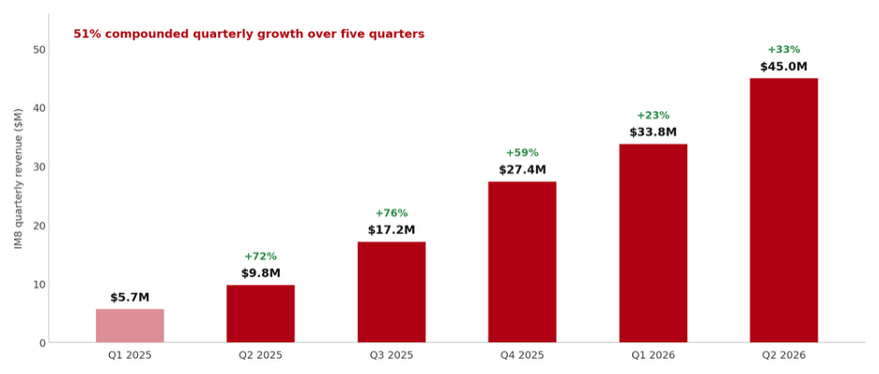

Then came the weeks after the quarter closed, which matters even more. On July 14 we closed $1 billion of non-dilutive growth financing from General Catalyst — underwritten directly against our cohort economics, after months inside our data. That is more than capital: it is independent validation, with a billion dollars at risk behind it, that our unit economics work and that our future revenue and gross profits are predictable enough to finance.

July itself was the strongest month we have ever had: $20.9 million of revenue, an Annualized Revenue Run-Rate3 of roughly $251 million, and our largest single-month cohort ever — acquired 47,373 customers at a CAC that fell roughly 21% further, to approximately $239. And then July delivered the milestone I opened this letter with — the one every consumer company on earth is racing toward from the day it is born: consolidated Adjusted Free Cash Flow turned positive. One month does not make a trend, but this particular month changes what kind of company we are. Every fast-growing consumer brand lives under the same clock — growth consumes cash, and cash eventually forces a choice between slowing down and diluting shareholders. In July, that clock stopped for us. From here, the machine pays for its own growth: cohorts financed at the point of acquisition, repaying from their own receipts, with the surplus funding the next cohort. Our growth plan no longer depends on equity markets, credit markets, or anyone’s patience but our own. For a brand twenty months from launch, still compounding at over 50% per quarter, to be generating cash while growing this fast is nearly unheard of in consumer — most brands at this stage are years from it, and many never arrive. The milestone every young company talks about is no longer in front of us. It is behind us. We expect Q3 to be our first positive Adjusted Free Cash Flow quarter, and we expect to stay positive from there.
3 Annualized Revenue Run-Rate ("ARR") is an operating metric calculated by multiplying IM8 revenue recognized in the applicable month by twelve and includes revenue from both subscription and one-time purchases. ARR is not a financial measure under IFRS, and is not necessarily indicative of revenue for any future period. ARR reflects orders from both new and existing customers and incorporates the effect of cancellations and non-renewals occurring on or before the applicable month; however, it does not adjust for anticipated future cancellations, non-renewals or pauses. ARR annualizes a single month of revenue and assumes that the revenue recognized in that month is maintained for the following twelve months. As a result, ARR is sensitive to the timing of promotional activity, product launches and billing cycles. In particular, the full order value of quarterly subscription plans is recognized upon shipment of the three-month supply, which increases revenue recognized in months when quarterly billings are concentrated. It may therefore differ significantly from actual future revenue.
2
We are running ahead of our own plan. For Q3 we are guiding to $63–64 million of total revenue, with IM8 contributing $61.5–62.5 million — up 38% sequentially at the midpoint, a seventh consecutive record quarter. And we are raising our full-year guidance: total revenue of $220–230 million, with IM8 contributing $215–222 million. The top of the IM8 range implies a fourth quarter of approximately $81 million, roughly 3x the same quarter last year, into our seasonally strongest period. It also means we expect to exit 2026 at an ARR above $300 million. And we are looking further out than that: today we are initiating full-year 2027 guidance of $400 million or more in IM8 revenue. To put that in perspective: IM8 generated roughly $60 million in 2025, its first full year on the market. We are guiding to $215–222 million in its second. And we expect more than $400 million in its third. We do not treat that trajectory as ambition; we treat it as arithmetic, built cohort by cohort from subscribers we already have and the acquisition engine you will see measured throughout this letter. One more thing about both numbers: they include nothing from the new products arriving over the next few quarters. Hydration launches into a $37 billion category this year and our premium gummies line follows; every dollar they generate is upside to the figures above, sold first to the 140,000+ subscribers we already serve at no incremental acquisition cost. We would rather guide on the machine we can measure and let the launches surprise in one direction only. And we will do all of it the way we have built everything so far: as an AI-native company of roughly 70 full-time employees. At this year's guidance, that is more than $3 million of revenue per employee — a level of output per person with almost no precedent in consumer — and it is not a constraint we are tolerating on the way to something bigger. It is the design. The organization that reaches $400 million will look far more like the one we have than the one convention says we should need.

Why a Letter
You have just read the scorecard. Beginning this quarter, everything that follows it changes: we are moving to a shareholder letter in place of the earnings-report format we have used in the past. The change is deliberate, and the scorecard above is the reason. A summary can tell you what happened. It cannot tell you why it happened, whether it will happen again, or what we intend to do about it — and this business has moved from proving it can grow to showing exactly how it grows, in the very quarter it starts generating cash instead of consuming it. You cannot see that in a results table. So from now on, we will write to you every quarter and explain the machine behind the numbers. Plainly, with the data, including the parts we are still watching.

Our earnings event is changing too. This quarter, for the first time, we will present our results in a live stream that anyone can watch. Analysts ask their questions first, as always. Then we answer questions submitted and up-voted by individual shareholders.

Q2 2026 Headlines
•Q2 2026: total revenue of $46.5 million, up 29.3% from Q1 and approximately 3.9x year-over-year. IM8 delivered $45.0 million, up 33.2% sequentially and approximately 4.6x year-over-year, at approximately 65% gross margin (57% a year ago). Both figures within the Company’s guidance of $46–48 million total and $44–46 million for IM8.
3
July 2026 Headlines
•July 2026 (preliminary and unaudited): the strongest month in our history. Revenue of $20.9 million — 4.3x July last year — puts the ARR at roughly $251 million, and the July cohort of 47,373 new customers was the largest we have ever acquired.
◦Efficiency: blended CAC held essentially flat through a near-doubling of Q2 acquisition marketing spend, then fell roughly 21% in July to approximately $239. It is early — one month — but for a scaling consumer brand it is a rare and important signal, and we explain why below.
◦Unit economics: every $1 we have invested in customer acquisition since launch has now returned $1.52 in gross profit — up from the $1.44 General Catalyst underwrote when it committed $1 billion on July 14. The same cohorts, one month later; the figure rises every month as they age, because gross profit keeps accruing on spend that was paid long ago.

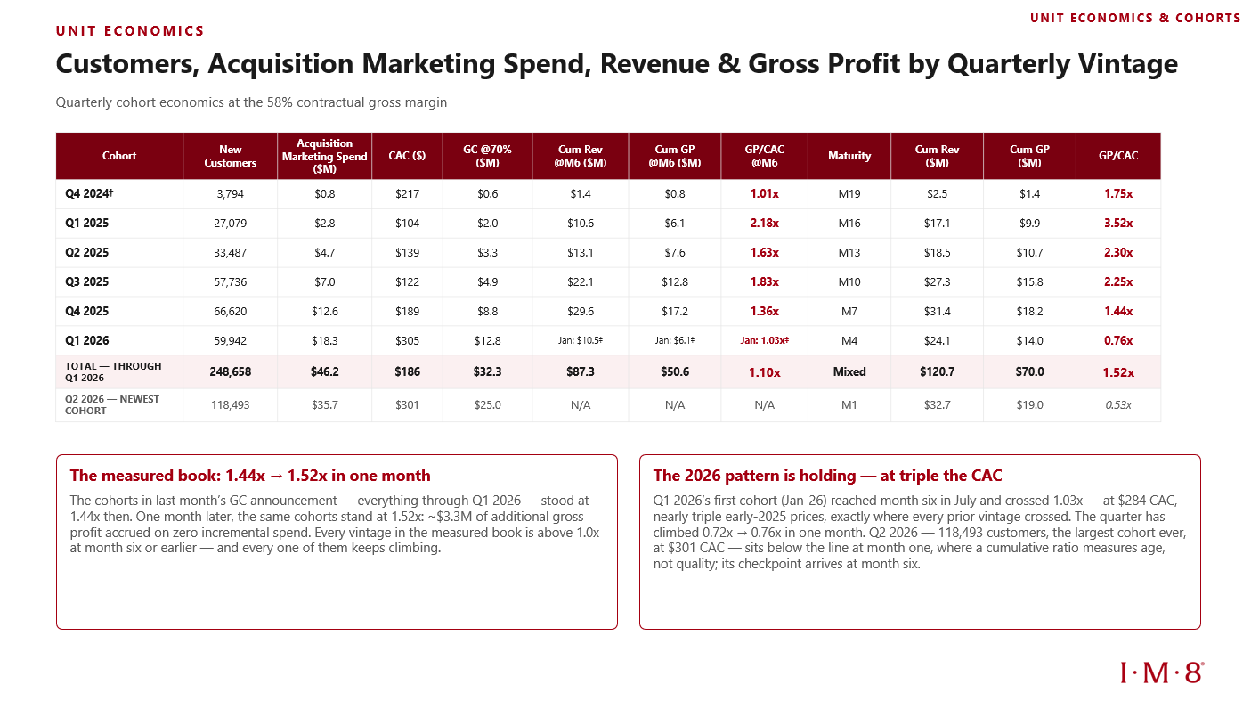
▪Financing (July 14): closed $1 billion in non-dilutive growth financing from General Catalyst's Customer Value Fund (“CVF”), tied for the largest commitment in the CVF's history.
▪The inflection: consolidated Adjusted Free Cash Flow turned positive in July — the first positive month in our history — and is expected to be positive for Q3 2026 and to stay positive from there.
4
The Opportunity In Front of Us
It is worth stating plainly what we are pursuing. The global market for vitamins, minerals, and supplements is roughly $200 billion a year and growing. It is one of the largest consumer categories in the world and one of the least consolidated. No brand owns it. Most of what sells is commodity product: undifferentiated formulations with no clinical evidence, competing on price. That is our opening. A premium, clinically validated, globally distributed brand does not need a large share of a $200 billion category to become a very large company. Twenty months in, IM8 already ships to 46 countries, and approximately 54% of revenue comes from outside the United States. Most consumer brands spend a decade building that kind of international footprint. We built it in under two years, which means growth can now compound in two directions at once: deeper into markets we know, and outward into markets we have barely touched.

That is why we keep investing in growth rather than harvesting early profits. Categories like this get decided once, they are being decided now, and we intend to be the brand that decides ours.
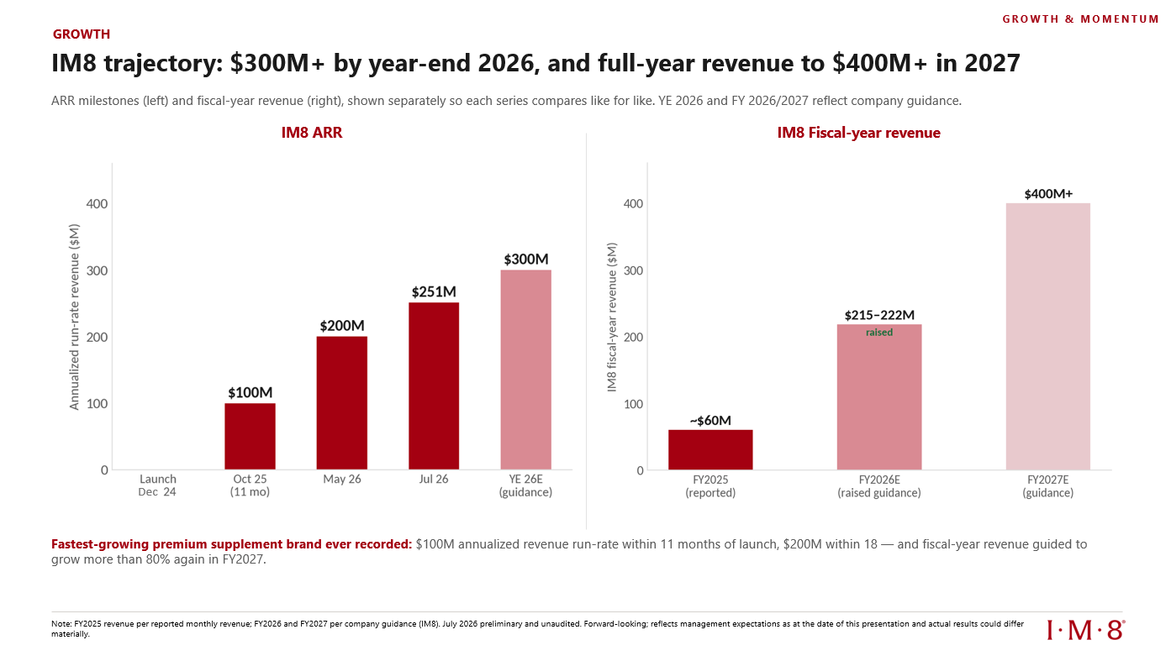
Left: IM8 ARR milestones. Right: IM8 full-year revenue guidance.
5
Twenty Months, and a Record July
IM8 launched in December 2024 with one product and 3,794 customers. Twenty months later, IM8 has delivered more than 57 million servings — over 200,000 every day — and generated roughly $160 million in cumulative revenue. Someone, somewhere, orders IM8 about every 27 seconds. Revenue has set a new record in nearly every month since launch: $13.0 million in April, then approximately $16.0 million in each of May and June, and $20.9 million in July. July's cohort of 47,373 new customers was the largest in our history. Roughly 40% of those customers chose quarterly plans, committing to a full quarter of IM8 on day one.

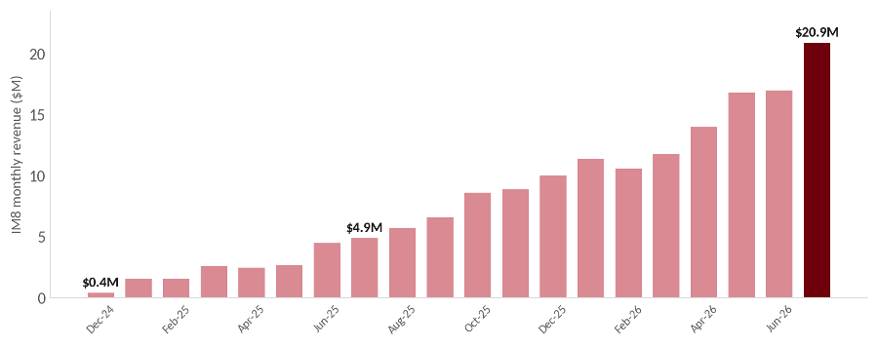
IM8 monthly revenue since launch. Management data; unaudited. July 2026 figures are preliminary.

Now the July observation we consider most important, and the numbers behind it. In Q2 we nearly doubled acquisition marketing spend — from $18.3 million in Q1 to $35.7 million — to acquire 118,493 new customers, the largest quarter in our history. Every playbook says blended CAC should have jumped. It did not. CAC held essentially flat, edging down from about $305 to about $301. Then in July, with spend moderating to $11.3 million but still roughly double any month in 2025, CAC fell about 21% further, to approximately $239, while we acquired the largest single-month cohort we have ever had.
6
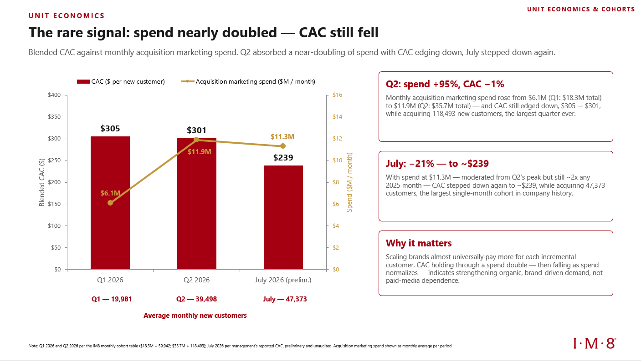
IM8 CAC against monthly acquisition marketing spend. Management data; unaudited. July 2026 figures are preliminary.

Why does this matter so much? Because scaling consumer brands almost universally experience the opposite: each incremental customer costs more than the last, and rising CAC is usually what ends the growth story. Ours holding flat through a spend double — and then falling — tells us demand is compounding through channels we do not pay for by the click: the ambassador platform, organic content, word of mouth, and a brand that increasingly walks in the door on its own. At our current pace of new customers, every ten dollars of durable CAC improvement is worth several hundred thousand dollars a month.

We want to be equally clear about what this is not. It is one quarter of flat and one month of falling. July is preliminary and unaudited, and a single month does not make a trend. We are not building our plan on CAC staying at $239, and if it reverts, you will read it here first. But we watch this number more closely than any other in the business, and what it did in July is, on the evidence so far, immensely positive.
7
What Our Cohorts Tell Us
We manage IM8 cohort by cohort: every month's new customers are tracked as a distinct vintage from their first order onward. Two findings from that data matter most to shareholders.

First, our cohorts endure. The chart below stacks each month's billings by the vintage of the customers who generated them. Notice that the layers persist. Customers acquired at launch and through the first half of 2025 were still billing about $3 million in July, twelve to twenty months after we acquired them, while newer and larger layers stack on top. Older cohorts continue to generate meaningful revenue while newer and larger cohorts are added on top. Retention behavior has held consistent across every vintage since launch, through an 18x scaling of monthly volume. That consistency is what makes future revenue from existing customers largely forecastable. It is also, as we explain below, what makes it financeable.
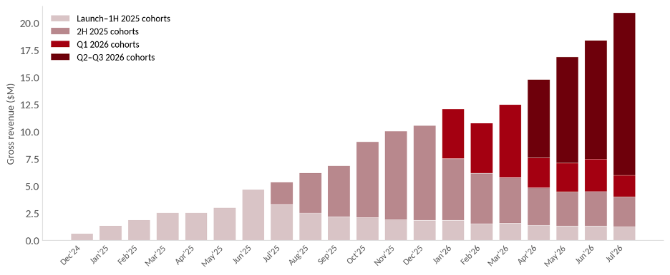
IM8 monthly gross billings by acquisition-cohort group. Management billings data, preliminary and unaudited.

Second, each new cohort is worth more than the last. A customer acquired in 2026 generates about 50% more billings in their first month than a customer acquired in 2025: roughly $212 for the July cohort against a 2025 average of $142. The biggest driver is commitment mix. Quarterly plans, introduced in November, now account for about 40% of new customers, at an average first order around $321. Customers are arriving in record numbers and arriving with more conviction. Richer cohorts on a consistent retention curve mean faster cost recovery and more future revenue per dollar invested. This is the quiet engine underneath everything else in this letter.
8
The commitment shift is now the majority of the business. Quarterly plans crossed monthly plans in March 2026 and reached 54.8% of July revenue — from zero last October. Active subscriptions ended July at roughly 140,000, about six times the level of fifteen months ago, and the base has grown every single month on record. Approximately 87% of revenue is recurring and about 95% of revenue runs through our own store rather than marketplaces — which means the customer relationship, the data, and the margin stay with us.
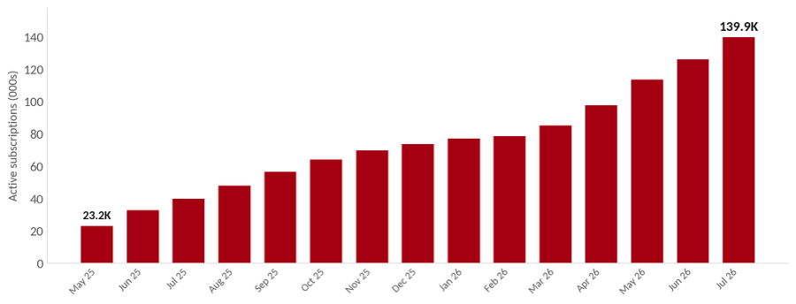
Active subscriptions at month-end since the April 2025 platform migration. Management data, preliminary and unaudited.
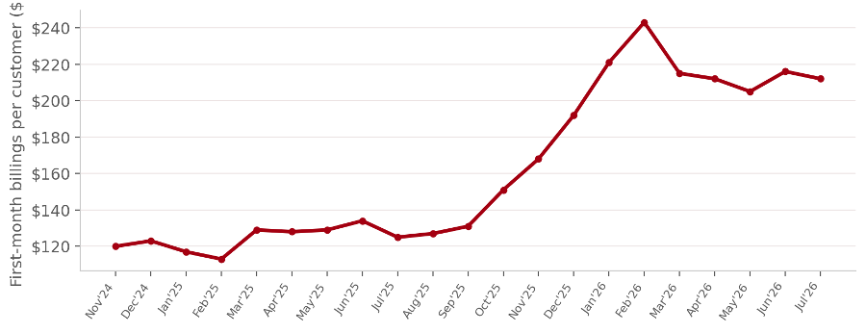
First-month billings per new customer, by monthly cohort. Management billings data, preliminary and unaudited.
9
What a Third Party Sees: Independent Card Data
Everything above comes from our own systems, so we want to close the cohort discussion with numbers nobody at IM8 produced. Indagari, an independent analytics firm, tracks US consumer credit- and debit-card transactions across brand panels — including IM8 and the three most prominent brands in our category: AG1, Thorne, and Grüns. The data covers the United States only, is transaction-based rather than company-reported, and we cite it precisely because we cannot touch it.

Start with the picture that needs no caption. Since December 2024 when IM8 launched, US direct card spend on IM8 has grown roughly 25-fold — while over the same period AG1 declined 36%, Grüns declined 48%, and Thorne grew 51%. Two of the three most prominent brands in the category are shrinking in their home market’s direct channel, the third is growing modestly — and the category’s growth is concentrating in one brand. And the United States is not even our largest market: roughly 54% of IM8 revenue is generated outside it.

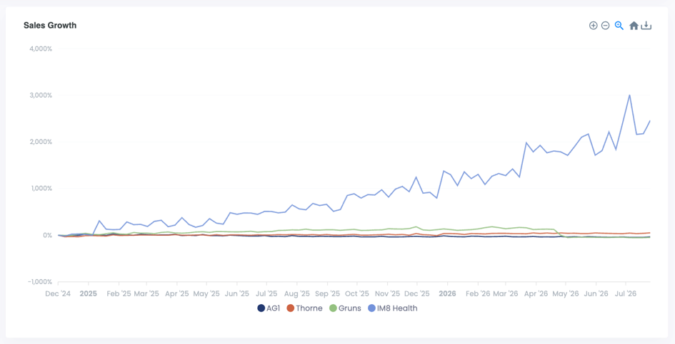
Indexed US card-spend growth since December 2024, through late July 2026. IM8’s index benefits from a small launch-month base; the direction and divergence, not the multiple, are the point. Source: Indagari US card panel.
10
Second, retention — the claim skeptics test hardest, answered by a third party. Twenty months after first purchase, Indagari’s panel shows IM8 retaining 14.2% of customers still transacting — 25% more than Thorne (11.4%), 31% more than AG1 (10.8%), and nearly six times Grüns (2.4%). Card panels count monthly transactions, and the majority of IM8 revenue is on quarterly plans that transact once every three months — which mechanically understates IM8 across the curve. Even measured that way, IM8 finishes highest, and is the only brand whose curve is rising at the tail as early cohorts’ quarterly renewals land.
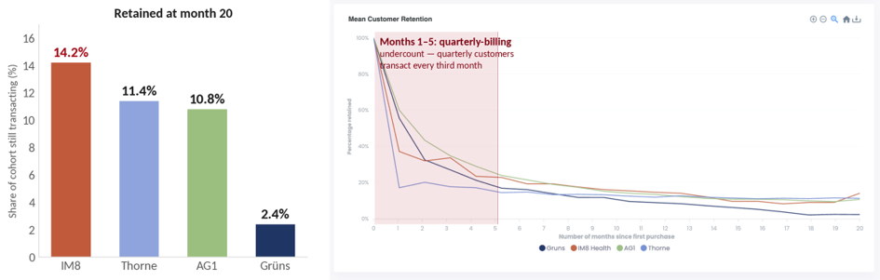
Left: share of each cohort still transacting at month 20. Right: the full curve, months 0–20 — the shaded band marks months 1–5, where quarterly-billed IM8 customers transact only every third month and the monthly panel mechanically undercounts IM8. Cohorts from December 2024, data through July 2026. Source: Indagari US card panel.

Third, the premium is on the card statements: IM8’s average transaction reached $181 in July against $100 for AG1, $83 for Grüns, and $71 for Thorne — 1.8 to 2.5 times the category on every swipe, with the divergence beginning precisely when quarterly plans launched. Growing fastest, retaining longest, at nearly double the price per transaction — measured by someone who has never set foot in our office.

The General Catalyst Partnership: Validation, and Fuel
On July 14, we closed $1 billion in growth financing from General Catalyst's Customer Value Fund, tied for the largest commitment in the CVF's history. We want shareholders to understand what this represents beyond the capital. General Catalyst spent months inside our cohort data before committing. They studied the same vintages, curves, and billing records described above, and their underwriting reduced to a single number: blended across all mature cohorts, every $1 we have invested in customer acquisition has returned $1.44 in gross profit. That was the number at underwriting. One month later, the same cohorts stand at $1.52 — and the figure rises every month, because gross profit keeps accruing on acquisition marketing spend that was paid long ago. Every historical monthly cohort continues to exceed the performance thresholds in their underwriting. A billion dollars from one of the world's premier growth investors, secured against the performance of our customer economics, is the strongest external validation our model has received. It arrived without a single share of dilution. The plain-terms effect: a significantly larger business, sooner, with more cash in the bank and a higher return on capital.

11
The mechanics matter as much as the amount. General Catalyst finances up to 70% of IM8's marketing spend on a monthly cohort basis, and IM8 keeps full discretion over how much of the facility to use. In return, General Catalyst receives a capped share of income tied to the cohorts it finances. Once that capped return is recovered on any cohort, every remaining dollar of lifetime value belongs to IM8 permanently. No shares were issued, and none can be issued under the facility. The largest use of cash in our business is now substantially funded by a partner whose return depends on the same cohort quality we already manage the business around.

There is precedent for what this structure does to a company, and it is public. Lemonade (NYSE: LMND) partnered with the same General Catalyst platform in mid-2023 to finance up to 80% of its customer acquisition. Within twelve months it was reporting net-cash-flow-positive quarters while tripling growth spend year over year; within eighteen it posted its first full year of positive Adjusted Free Cash Flow, with its earliest funded cohorts repaid in full. Its market capitalization has roughly increased from ~$1bn to now more than $4bn since the partnership began. We are not Lemonade, and our categories differ. But the mechanism now working underneath IM8 is the same one — and our cohorts pay back materially faster than insurance customers do.

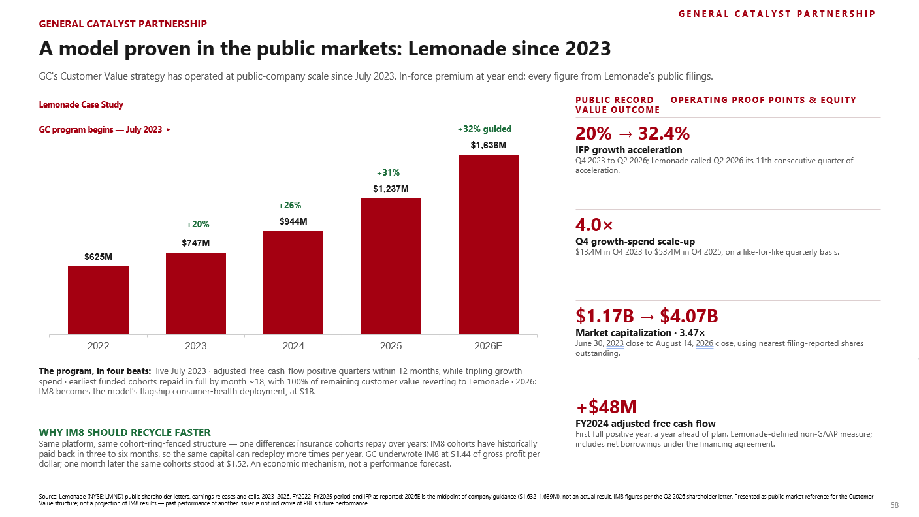

12
The Inflection: Consolidated Adjusted Free Cash Flow Turned Positive, and the Full P&L Behind It
In July, consolidated Adjusted Free Cash Flow — which includes fundings under the General Catalyst facility — turned positive for the first time in our history. This is the milestone we have been tracking since before the brand existed. It was in the founding model on day one: the point where growth stops consuming our cash. And I will say something honestly here, because this letter is built on transparency: it arrived far faster than I ever believed we could reach it. Two things made that possible, and they are connected. The cohorts came first — customers who stay, spend more over time, and return their acquisition cost in months rather than years. And it was those cohorts that earned the second thing: a billion dollars of General Catalyst’s capital, committed after months inside our data, which now funds acquisition so that our own cash no longer has to. Strong cohorts attracted the capital; the capital freed the cash flow; and the cohorts’ repayment speed is why it happened in July — rather than years from now. We expect Q3 to be our first positive quarter, and we expect to stay positive from there. This is a change of state, not a one-quarter event: the difference between a business that consumes cash to grow and one that grows on its own receipts and its partners’ conviction.

Why does this matter so much? Because it ends the defining trade-off of high-growth consumer companies. Until now, every dollar of growth we bought showed up first as cash out the door. The faster we grew, the more cash we consumed. From Q3, that reverses. The existing subscriber base generates the cash, the CVF funds the growth, and the funded cohorts repay from their own receipts. We now control our own destiny. We never have to raise equity into a bad market. We never have to slow down to conserve cash. It negotiates partnerships, launches, and expansion from strength.

The economies of scale are now visible across the P&L. Gross margin for IM8 tells the story most directly. We started at roughly 57% a year ago and reached approximately 65% in Q2, more than 800 basis points of expansion earned while revenue grew about 4.6x. We see further room over time as manufacturing volumes, shipping density, and product mix keep working in our favor. Scale is compounding on the cost line the same way brand is compounding on the demand line.

The same shift shows up in Adjusted EBITDA4. The first-half loss of $24.6 million was the deliberate investment that bought our largest cohorts ever. And here it is worth pausing on something unusual about Q2, because it says a great deal about how we report: our Adjusted EBITDA loss of $19.0 million is larger than our actual net loss for the Q2 under IFRS Accounting Standards of $9.0 million. That is not a typo. This quarter included $10.0 million of net fair value gains and other related items, and our adjustment convention strips them out — exactly as it stripped out losses of the same kind in Q1. We adjust against ourselves, in both directions. On the statutory line, the one no convention touches, net loss per share improved to $(0.52) from (0.94) a year ago — 45% better while revenue grew 3.9x. The second half should look very different, and July has already shown you what it looks like. On preliminary figures, July’s consolidated Adjusted EBITDA loss was approximately $2.4 million — about 11% of revenue, versus 41% in Q2 — with a preliminary net loss for the period of approximately $3.6 million. Our second-half guidance of an $8 to $12 million Adjusted EBITDA loss, an improvement of more than 50% even as we keep investing at record levels, is not a promise about a distant future; it is a description of the run-rate the first month of the half already delivered. Both views — the consolidated P&L all the way down to earnings per share, and the IM8 engine with July standalone, every partner cost named, including royalty at its stepped-down 3.5% — are reproduced from the investor deck directly below. And one thing said directly, because we would rather you hear it from us than reconstruct it: in May we spoke about a full-year Adjusted EBITDA loss of roughly $15–20 million. The first half alone came to $24.6 million, and our second-half guidance implies a full year beyond that old range. What changed is not discipline; it is the capital model. When we discussed that range, every dollar of EBITDA loss was a dollar of our
4 Adjusted EBITDA is defined as EBITDA further adjusted to exclude amortization of deferred expenses, equity-settled share-based payment expenses, transaction-related expenses associated with acquisition, disposal and fundraising activities, strategic realignment and discontinued products impact, exchange gains or losses, net, fair value gains or losses on financial assets at fair value through profit or loss, warrant liabilities and digital assets, and profit or loss from discontinued operations, net of tax. EBITDA is defined as loss for the period, adjusted to exclude depreciation and amortization, interest income, other finance costs, and income tax expense or credit.
13
own cash. The General Catalyst facility broke that link. So when Q2 presented the largest cohorts in our history at flat CAC, we bought them, at a measured $1.52 of gross profit per dollar and rising, and the proof the trade worked sits on the cash line: consolidated Adjusted Free Cash Flow turned positive in July, the very month the facility went live. We spent more, reported a larger EBITDA loss, and burned less cash than the old plan would have. Going forward you have both dials from us, guided: second-half Adjusted EBITDA loss of $(8)–(12) million5, and Adjusted Free Cash Flow positive from Q3. EBITDA tells you how hard we are pressing the accelerator; cash flow tells you whether we can afford to.

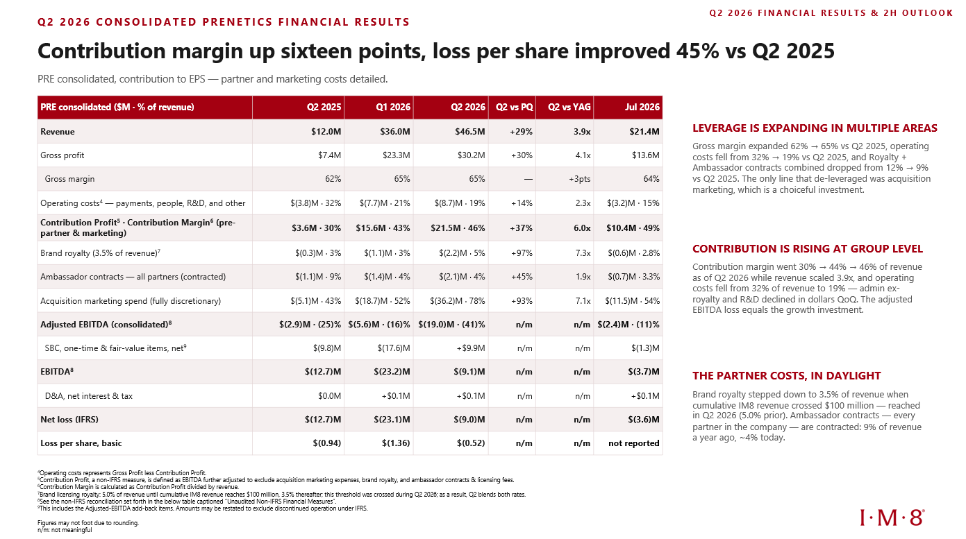

14
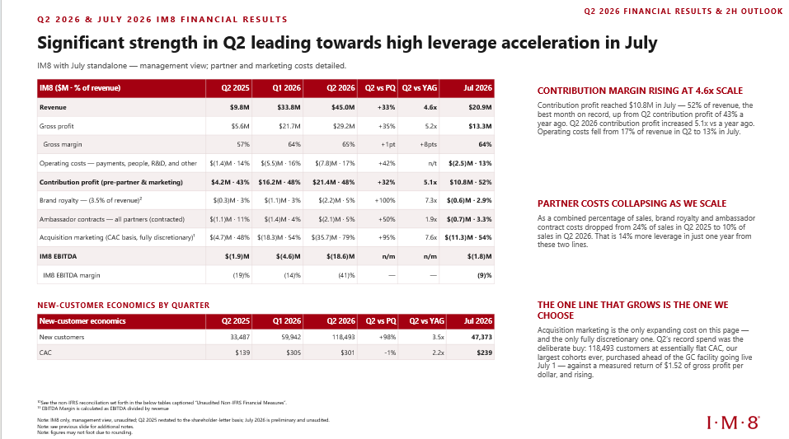

The Three Questions We Hear Most
Depending on who is asking, we are apparently either burning too much money or not spending nearly enough. Three questions come up in almost every investor conversation we have. Here they are, answered plainly.

1. “When will you be profitable?”

The direct answer: we could be profitable tomorrow if we chose to be. Roughly 140,000 active subscriptions renew on a schedule at approximately 65% gross margin — that recurring engine already produces more than enough gross profit to cover our entire cost structure. What would go is the growth investment, and that is precisely the trap. Every dollar we have invested in acquiring customers has returned $1.44 in gross profit at underwriting — already $1.52 today; cutting that investment to print a profit today would trade compounding value for cosmetics. I say it inside the company the same way I will say it here: profitability is a choice, not a destination. And the major step has already arrived: consolidated Adjusted Free Cash Flow turned positive in July, we expect Q3
15
to be our first positive quarter, and the business now funds its own ambitions. A self-funding company gets to pick its moment of profitability. We will pick ours when slowing down costs you less than speeding up, and not a quarter before.

2. “Can you be more aggressive? Why not spend more?”

It surprises people that we hear this at least as often as the first question — and almost always from the investors with the deepest experience in direct-to-consumer businesses. They quote our own numbers back at us: the gross-profit multiple on acquisition, the ~3-6 month payback, a projected 3:1 LTV / CAC5 ratio — lifetime value on a gross-profit basis over 36 months, extending observed cohort curves beyond our oldest vintage of twenty months, with no contribution from future product launches assumed. With those economics, they argue, the expensive mistake is under-spending. They are right about the math, and candidly, we share the instinct.

What governs our throttle is no longer capital — the CVF removed that constraint. It is cohort quality, expressed as three gates. The marginal cohort must clear our payback thresholds. Creative and audience depth must support the next dollar as well as they supported the last. And the operation — fulfillment, service, the product experience itself — must absorb the growth without degrading what customers feel. In Q2 all three gates were green, and we nearly doubled spend. In July we acquired our largest single-month cohort ever — on somewhat less spend than Q2’s monthly peak — and CAC fell a further 21%. When the gates are green, expect us to be every bit as aggressive as these investors want us to be. The moment one turns amber, expect us to hold. Spend is an output of cohort quality, not a target — which is also the honest answer to question one: we are not protecting a profit number, and we are not chasing a spend number. We are following the cohorts.

3. “What gives you conviction the growth is sustainable?”

Five things, each of them checkable. First, the record: since its first full quarter, IM8 revenue has compounded at 51% per quarter — $5.7 million to $45.0 million in five quarters — and our Q3 guidance implies a sixth. Second, the cohorts: nineteen consecutive monthly vintages, every one retaining along the same curve through an eighteen-fold scaling of monthly volume, with newer cohorts worth roughly 70% more in their first month than last year’s. Growth built on a leaky bucket shows the leak by the third vintage. Ours has held through nineteen.

5 LTV/CAC is defined as cumulative gross profit per customer over 36 months divided by CAC.
16
Note: Q2 2026 IM8 revenue has been updated from previously disclosed preliminary amounts to exclude certain taxes collected on behalf of tax authorities in accordance with IFRS 15. As a result, previously disclosed Q2 2026 revenue of approximately $47.8 million was revised to $45.0 million.

Third, the nature of the demand. The CAC pattern described earlier in this letter is the signature of demand arriving through doors no one can buy — ambassadors, word of mouth, a brand that walks in on its own. Growth that depends on one algorithm is fragile; growth arriving through a dozen doors is not.

Fourth, the runway — and the arithmetic of the path. We hold roughly a tenth of one percent of the $200 billion category, ship to 46 countries most of which we have barely begun to develop, and have entered neither US retail nor China. And the path to our 2027 guidance is shorter than it looks: as of July we were already at a $251 million annualized run-rate, and our Q4 guidance implies we exit 2026 above $300 million. From that exit rate, $400 million-plus in 2027 does not ask the machine to accelerate. It asks the machine to keep doing what nineteen consecutive cohorts show it does — and considerably less than it did this year, when revenue grew nearly 4x. On top of all that sits the pipeline: Hydration launches in Q4 and our premium gummies line follows in the first half of 2027, and we hold both to the same promise as the flagship — we believe each will be the best product in its category at launch, clinically studied and NSF certified, selling into an active base whose acquisition cost is already paid, with none of that revenue in guidance. Our conviction does not require the next act to be lucky. The next act is already built.

And fifth, our conviction has been independently audited by General Catalyst who spent months inside the same cohort data before putting a billion dollars behind the conclusion. Is that certainty? No. Certainty is not available in business. It is conviction with tripwires — the “What We Are Watching” section below lists exactly what would change our posture, and we will report those indicators whether they flatter us or not.
17
A Balance Sheet Built for This Moment
The CVF partnership was negotiated from strength, and the balance sheet shows it. As of June 30, 2026, the Company had $59.1 million in cash and cash equivalents and $50.3 million in current financial assets at fair value through profit or loss, representing an aggregate balance of approximately $109.4 million. Net current assets were $111.1 million, up from $106.5 million at March 31, 2026. A company that carries this balance sheet with zero debt, completes $40 million of share repurchases, and runs its largest investment quarter ever — all at once — did not take a billion dollars because it needed rescue. It took the capital because the cohort math says deploy more.

One housekeeping note on the capital structure. Approximately 2.36 million Class C Warrants remain outstanding at an $18.00 exercise price; exercised in full, they would bring roughly $42.5 million of additional cash into the company. We also hold a forced-exercise right: if our shares trade at or above $21.60 for ten consecutive trading days following registration, we can require the warrants to be exercised.

On capital allocation, our priorities are simple and in this order: product and clinical investment, growth investment wherever cohort economics clear our bar, and opportunistic capital returns when the market prices us below what the model is worth. The $40 million repurchase program is complete, and management separately put $2.75 million of personal capital into open-market purchases this year.

Science: The Bar That Builds the Moat
In a $200 billion category built mostly on marketing claims, clinical evidence is the scarcest asset and the hardest to copy. Our flagship, Daily Ultimate Essentials, is backed by a completed randomized controlled trial. Three further randomized, placebo-controlled trials are underway — one at the Mayo Clinic, and two double-blind, IRB-registered studies at an independent U.S. research institute — and their designs are worth describing, because in clinical research, the design tells you how serious a company is long before any result arrives. Start with the Mayo Clinic study, because it sets the highest bar: at Mayo Clinic in Florida, investigators led by Dr. George Pujalte are running a randomized, placebo-controlled trial of Daily Ultimate Essentials in 100 healthcare workers — the people who deliver medicine, at one of the most respected medical institutions in the world. Over eight weeks, with a four-week supplement washout before baseline, the study measures objective physical performance — a six-minute walk test, body composition, grip strength — alongside weekly well-being and bloodwork drawn at baseline and repeated at week eight: vitamins, minerals, inflammatory markers including CRP and IL-6, and cardiometabolic measures including ApoB. The study is investigator-initiated, designed and run by Mayo Clinic investigators under Mayo Clinic research protocols. The longevity study enrolls 180 participants across four arms — placebo, a single dose of IM8 Longevity, a double dose, and the full Beckham Stack of Longevity taken together with Daily Ultimate Essentials — 45 per arm over 90 days, with every participant wearing the same standardized wearable, analyzed centrally, so sleep and recovery physiology are measured rather than self-reported. The co-primary endpoints are the two most validated short-horizon biomarkers in longevity research: hsCRP for systemic inflammation and HOMA-IR for insulin resistance — the processes that sit upstream of most age-related disease. The fourth arm is the one we consider most telling: it tests the actual regimen our customers buy, head-to-head against its own components and against placebo, with the comparison pre-specified. The gut health study enrolls 135 participants across three arms — placebo, single dose, double dose — over eight weeks, a dose-response design that strengthens causal inference well beyond a simple two-arm comparison. Its co-primary endpoints measure exactly what the product promises: the GSRS, the validated gold-standard instrument for digestive symptom burden, and microbiome diversity measured by shotgun metagenomic sequencing of stool samples at baseline and week eight — we sequence the microbiome; we do not merely survey it. The protocol excludes recent antibiotic and probiotic use before baseline, the two confounders that quietly invalidate most microbiome studies. Results from the two independent-institute studies are expected by the first quarter of 2027, with the Mayo Clinic study reading out on its own academic timeline, and we will publish what we find. Endpoints are pre-specified objectives, not results — no study’s outcome is assured, and we would not want it any other way. Evidence that cannot fail is not evidence. Beyond these, we are planning additional clinical trials across the product portfolio, because our standard is simple. Every product we launch completes IM8-level clinical validation first, and products already in
18
market keep earning deeper evidence over time. Every IM8 SKU is NSF Certified for Sport, the certification trusted by professional athletes and anti-doping bodies. All of this is slower and more expensive than how the category usually operates. It is also why the category's typical brands fade, and why we expect to endure.

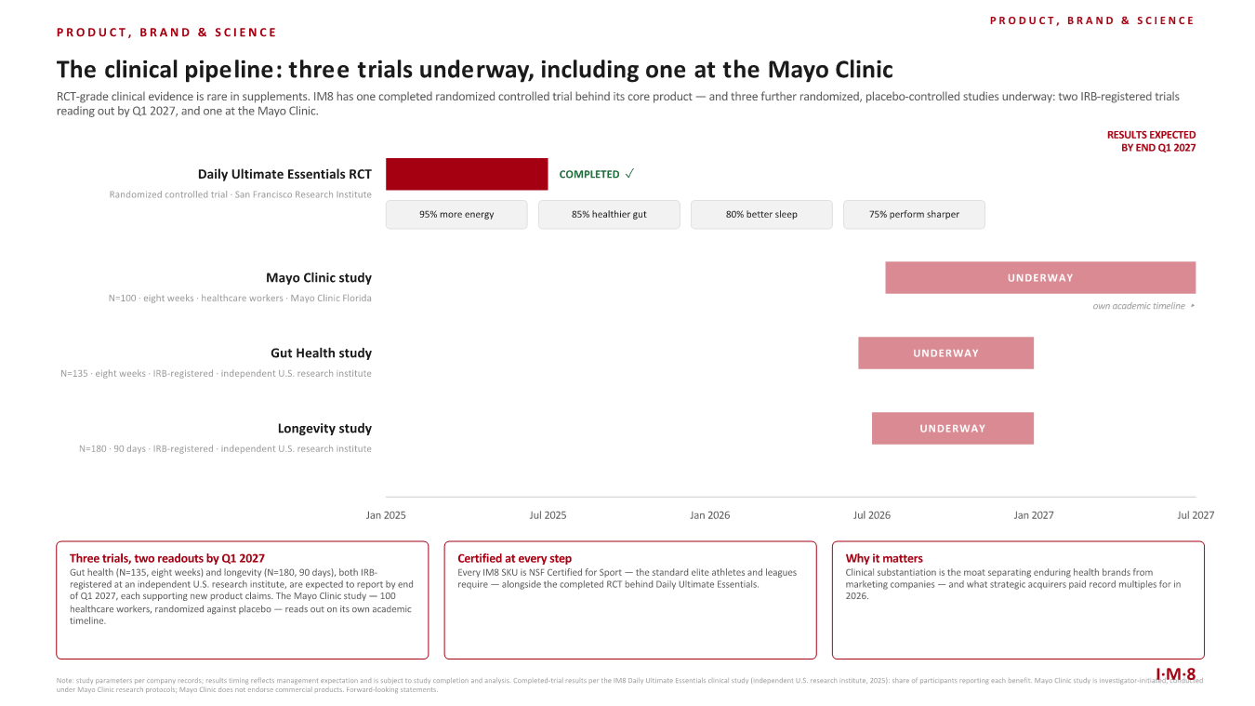

19
The Brand, In Person
And there is a dimension of this that neither the clinical data nor the card panels can capture, so let me report it personally. I spend much of the year traveling for this company, and in every country I land in now, the same thing happens: people come up to me about IM8. Not because they recognize me — because they recognize the sachet. Athletes, surgeons, founders, CEOs — high performers who could buy anything, telling me, unprompted, what the product has done for them. We have now hosted more than 100 offline brand events around the world, and the rooms keep getting fuller. David and I talk about this often, because it is the thing we are proudest of: we set out to build a science-first brand, and somewhere in the last twenty months it became something people carry with them, ask each other about, and hand to the people they care about. I put it in a shareholder letter because it is a business asset with a specific use: a brand people trust travels. It travels into new countries ahead of our marketing, and — as you are about to read — it travels into new products, where an audience that already believes in us is waiting for whatever we make next. You cannot buy that. You can only earn it, one sachet at a time — and it compounds.
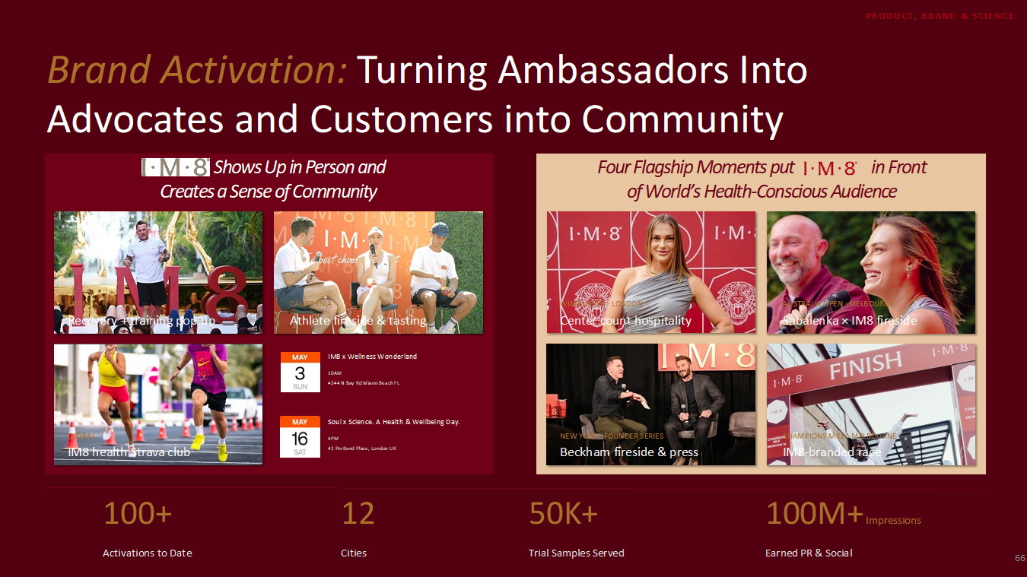

What Comes Next: The Product Pipeline
IM8 today is still, deliberately, close to a one-product company. Everything in this letter was achieved on two hero SKUs. That changes over the coming quarters. IM8 Hydration launches in Q4 2026 and takes our clinical standard into a category worth about $37 billion globally. Our premium gummies line follows in the first half of 2027, opening the roughly $25 billion gummy supplement category. I have seen what is coming out of R&D, and I will admit I find it
20
hard to write about calmly. Both products are in the late stages of development, and I will make you the same promise on each that we made on the first: when they launch, they will be the best products in their categories, and they will arrive the way everything we make arrives — clinically studied, NSF certified, built to the same standard of science and efficacy as the flagship. Each launch gets a dedicated flight and full operational focus. Each sells into an active subscription base of roughly 140,000 whose acquisition cost is already paid, which makes every new product's economics better than the flagship's were on day one. None of this revenue is in our guidance. The pipeline is pure upside to every number in this letter. And I want to be clear that Hydration and gummies are the next act, not the whole story. Think about what the trust we have built actually licenses. A customer who hands our sachet to someone they love is telling us they would trust us in any category where science and quality decide the winner — and the map of those categories is most of consumer health: sleep, cognition, recovery, women’s health, men’s health, healthy aging, sports performance. We will not name what is coming, and we will enter nothing until it can clear the same bar as the flagship — best in category, clinically studied, NSF certified — but the honest way to think about IM8 is not as a supplement company with two launches scheduled. It is a trusted health brand, twenty months old, with most of its categories still ahead of it. And we are in a rare position to pursue that map: a self-funding operating engine from this quarter, a billion dollars of committed capital covering growth spend — which frees our own cash for what compounds longest: R&D, clinical evidence, and the team — and an AI-native organization that can enter a new category without hiring an army. Companies usually get the brand, the capital, or the cost structure. We are sitting on all three, and we intend to use them.

Co-Owners, Not Endorsers
Our ambassador strategy inverts the industry's. We do not rent celebrity attention by the campaign. We make our partners co-owners and this was the quarter that philosophy scaled. On April 2, Giannis Antetokounmpo joined as Global Partner in our first all-equity partnership, becoming the first NBA athlete shareholder in a NASDAQ-listed health and longevity company. On May 7, IM8 became Inter Miami CF's exclusive Official Health Supplements Partner, and the club took an equity stake in Prenetics — the first time Inter Miami has ever taken equity in a brand partner, in a deal that includes group player NIL rights with Lionel Messi. On May 20, Jay Shetty became our first Global Ambassador from outside sport, and a shareholder — a daily customer for nearly a year, on his own doctor's recommendation, before he was ever a partner. They join David Beckham, who co-founded the brand, and Aryna Sabalenka and Ollie Bearman, who extend the roster across tennis and Formula 1. In a single quarter, the ownership roster came to span the four biggest sports in the world plus global wellness media — and every one of them chose equity. Owners behave differently from endorsers. They create more, they stay longer, and they cost less cash. The same alignment runs through management, whose own open-market purchases are described in the capital section above.

The Board We Are Building
The same philosophy now runs through our boardroom: people who have actually done it. This year we added two independent directors, and together they tell you exactly what this company intends to become. Hudson Leogrande, founder and CEO of Comfrt, joined our Board earlier this year. Hudson built Comfrt from a standing start to more than $1 billion of revenue this year — in four years — selling hoodies and blankets direct-to-consumer. He is one of the defining operators of the modern DTC era, and the playbook he executed at the highest level on a product you buy once is the playbook we run on a product people consume every morning, on subscription.

And on August 17 we announced Caroline Levy as an independent director, serving on our Audit, Compensation, and Nominating and Corporate Governance Committees. Caroline spent more than three decades as one of Wall Street’s top-ranked consumer analysts — ranked by Institutional Investor and The Wall Street Journal, leading U.S. consumer research at UBS — and she is a current board member of Celsius Holdings, where she has served since 2020 through one of the great consumer growth stories of our time. Caroline spent her career professionally stress-testing consumer companies. She has seen every playbook in this industry — and she chose ours.
21
The Category Is Being Repriced
While we were building, the strategics moved. In a six-month span this year, three of the world’s largest consumer companies deployed roughly $6.1 billion into supplement and nutrition brands: Danone acquired Huel for approximately $1.1 billion in March, Unilever acquired Grüns for approximately $1.2 billion in April, and in August P&G agreed to acquire Thorne for $3.8 billion — at 5.8x revenue, the highest multiple ever paid for a supplement brand. Thorne is 42 years old. Grüns is three. What buyers paid for in every case was the same profile: a subscription base, a defensible brand, and clinical evidence. Those are the three assets this letter has described.

I want to say something here that I have weighed carefully, because it can easily read as bravado, and I do not mean it that way. Measured against the size of this category, the pace at which we are compounding, and the fact that the youngest company on that list needed only three years to reach a billion-dollar outcome, I genuinely believe IM8 can one day be bigger than all three of those companies combined. A sentence like that deserves your skepticism; it got mine. We will earn the right to it the only way it can be earned — quarter by quarter, cohort by cohort, in these letters, with the numbers attached.

And so there is no ambiguity about why we mention these transactions at all: we have zero interest in selling this company. We are builders, and we are building for the long term. The deals are noted as category context only; they are not a valuation of Prenetics or IM8 and not an indication that any transaction is contemplated. What shareholders should take from them is simpler. The assets we have spent twenty months building — a subscription base, a defensible brand, clinical evidence — are the assets the largest consumer companies in the world just spent six billion dollars to acquire. We intend to keep building them, under this roof, for years.

How We Will Measure Ourselves
We will report progress each quarter against the milestone that matters most: consolidated Adjusted Free Cash Flow expected to be positive beginning in Q3 2026 and to stay positive from there. When something softens, we will say so in this letter before you read it anywhere else. Credibility compounds like capital does, and we intend to accumulate plenty of both.

What We Are Watching
A letter like this should also tell you what could go wrong, so here is what has our attention. First, our newest cohorts are our largest, and they are young. Everything we know says they will mature like the twenty cohorts before them, and the early readings support that, but we hold our conviction to the same standard we hold everything else: the data, as it comes in. Second, execution density. Over the next twelve months we will launch two product lines, run multiple clinical studies, and scale a business that is doubling, all at once. We have built the team and the operating cadence deliberately around that load. If either develops in a way you should know about, you will read it here before you read it anywhere else.

2027: Why We Guide to $400 Million or More
A number like $400 million deserves one more piece of reasoning that the rest of this letter has not yet given you: how much of it we already own. Approximately 87% of our revenue is recurring, and every vintage since launch has retained along the same curve — which means the subscribers on the books today will carry a substantial share of 2027 revenue before we acquire a single customer next year. We are not guiding to demand we hope to find; we are guiding, in large part, to renewals we can already see. The rest of the case you have read: the exit ARR above $300 million, the deceleration math, the pipeline and the billion dollars of committed capital held entirely outside the numbers. Four hundred million or more is comfortably in range. It requires the continued execution of what we have done for twenty months — nothing more, and we intend nothing less.
22
Outlook
•Q3 2026: total revenue of $63–64 million, with IM8 contributing $61.5–62.5 million — approximately +38% sequentially at the midpoint, with July’s $20.9 million already representing more than a third of the quarter.
•FY2026 total revenue: raising full-year guidance to $220–230 million, with IM8 contributing $215–222 million.
•Implied Q4: the top of the IM8 range implies a fourth quarter of approximately $81 million, roughly +31% sequentially, in our seasonally strongest period — the same quarter grew +59% sequentially last year — with IM8 Hydration launching in the quarter and contributing none of this revenue.
•Adjusted EBITDA for 2H: to be in the range of $(8)-(12) million6, representing an improvement of more than 50% compared with the Adjusted EBITDA loss in 1H of 2026.
•Year-end 2026 (IM8 December ARR): $300 million or more.
•FY2027 IM8 revenue: in excess of $400 million.
•Cash flow: consolidated Adjusted Free Cash Flow turns positive beginning Q3 2026 and expected to remain positive.

Twenty months ago we set out to build the defining consumer health brand of this generation. Today the growth is proven, the customer economics are underwritten by a billion-dollar institutional partner, the balance sheet is strong, and the cash-flow inflection is no longer ahead of us: it happened in July, and we expect this quarter to be our first consolidated adjusted free cash flow positive quarter, with every quarter after it. We hope this letter has shown you the machine and not just its output. We will write to you again in November, and we expect to be reporting that we delivered what this letter promises. Twenty months in, everything you have read is still the beginning.

With Health,

Danny Yeung, CEO Prenetics’ IM8

6 We have not provided the forward-looking IFRS Accounting Standards equivalents for Adjusted EBITDA non-IFRS metrics as a result of the uncertainty regarding, and the potential variability of, reconciling items such as equity-settled share-based payment expenses, exchange gain or loss, net, fair value gain or loss on financial assets at fair value through profit or loss, fair value gain or loss on warrant liabilities, and other charges. Accordingly, the Company has relied upon the exception in item 10(e)(1)(i)(B) of Regulation S-K to exclude such reconciliations, as the reconciliations of these non-IFRS guidance metrics to their corresponding IFRS Accounting Standards equivalents are not available without unreasonable efforts. However, it is important to note that material changes to reconciling items could have a significant effect on future IFRS results. We have provided reconciliations of other historical IFRS Accounting Standards to non-IFRS metrics in tables at the end of this letter, as well as relevant non-IFRS definitions.

23
About Prenetics
Prenetics Global Limited (NASDAQ: PRE) (the “Company”) is a leading consumer health company on a mission to advance human health and longevity. Its flagship brand, IM8, co-founded with David Beckham, is redefining premium daily nutrition through science-backed formulations — anchored by Daily Ultimate Essentials, a 90-ingredient daily nutrition system that is NSF Certified for Sport and clinically studied. IM8 is the fastest-growing premium supplement brand ever recorded, reaching approximately $251 million in annualized revenue run-rate within 20 months of launch, shipping to 46 countries, and delivering well over 200,000 servings daily. IM8's ambassador and equity-partner roster includes David Beckham, Giannis Antetokounmpo, Aryna Sabalenka, Ollie Bearman, Jay Shetty, and Inter Miami CF. Learn more at prenetics.com and im8health.com.

About IM8
IM8 is the pinnacle of premium core nutrition, born from a collaboration between David Beckham as a co-founding partner, and an elite team of scientists spanning medical professionals, academia and space science. Combining cutting-edge science with nature’s most potent ingredients, IM8 delivers a holistic, science-backed approach to health, empowering you to live your most vibrant life. IM8’s flagship product, Daily Ultimate Essentials Pro, is an all-in-one powder supplement engineered to replace 16 different supplements in a delicious drink and is NSF Certified for Sport, non-GMO, vegan, free from common allergens, and contains no artificial flavors, colors or sweeteners. IM8 is a subsidiary of Prenetics (NASDAQ: PRE), a leading global health sciences company dedicated to advancing consumer health. To learn more about IM8, please visit www.IM8health.com.

Investor Relations Contact
investors@prenetics.com
PRE@mzgroup.us

Angela Cheung
Investor Relations / Corporate Finance
angela.hm.cheung@prenetics.com

24
Forward-Looking Statements and Data Notes
This shareholder letter contains forward-looking statements. These statements are made under the “safe harbor” provisions of the U.S. Private Securities Litigation Reform Act of 1995. Statements that are not historical facts, including statements about the Company’s goals, targets, projections, outlooks, beliefs, expectations, strategy, plans, objectives of management for future operations of the Company, and growth opportunities are forward-looking statements. Our guidance reflects management’s current estimates and assumptions as of the date of this shareholder letter, is subject to significant risks and uncertainties, and is not a guarantee of future performance. Actual results may differ materially. In some cases, forward-looking statements can be identified by words or phrases such as “may,” “will,” “expect,” “anticipate,” “target,” “aim,” “estimate,” “intend,” “plan,” “believe,” “potential,” “continue,” “is/are likely to,” “guidance,” “outlook,” “forecast,” or other similar expressions. Forward-looking statements are based upon estimates and forecasts and reflect the views, assumptions, expectations, and opinions of the Company, which involve inherent risks and uncertainties, and therefore they should not be relied upon as being necessarily indicative of future results. A number of factors could cause actual results to differ materially from those contained in any forward-looking statement, including but not limited to: the impact of the Customer Investment Agreement with GC Customer Value Arranger, LLC is unpredictable, and the arrangement may not function as expected, and its failure to do so could materially and adversely impact our financial condition and results of operations, we may require additional capital to grow our business, which may not be available on terms acceptable to us or at all, the Company may not be able to maintain and enhance its IM8 business and brand if it suffers negative publicity or fails to maintain a strong base of engaged customers and content creators, or otherwise fails to meet customers’ expectations; the Company’s ability to further develop and grow its business, including new products and services; and the Company’s ability to efficiently and effectively deploy financial and management resources towards maintaining and growing the business. In addition to the foregoing factors, you should also carefully consider the other risks and uncertainties described in the “Risk Factors” section of the Company’s most recent registration statement and the prospectus therein, and the other documents filed by the Company from time to time with the U.S. Securities and Exchange Commission. Unless otherwise specified, all information provided in this shareholder letter is as of the date of this shareholder letter, and the Company does not undertake any duty to update such information, except as required under applicable law. Nothing in this shareholder letter constitutes an offer to sell, or the solicitation of an offer to buy, any securities of the Company.

Certain operational data, customer metrics, market data, and industry information included in this shareholder letter are derived from management records, internal analyses, third-party sources, and management's understanding of the markets in which the Company operates. Operational data is unaudited and may differ from data presented in the Company's reports filed or furnished with the U.S. Securities and Exchange Commission. Cohort figures are preliminary, unaudited, based on management billing records, and reflect gross billings rather than IFRS revenue. July 2026 figures reflect the period from July 1, 2026 through July 31, 2026. Industry, market, and competitive position data presented herein are based on publicly available information, industry publications, and third-party sources that the Company believes to be reliable but has not independently verified. Market size estimates are based on third-party industry research and involve assumptions and limitations that may affect their accuracy. While the Company believes such information to be reliable, it has not been independently verified by any third party, and no representation or warranty, express or implied, is made as to the accuracy, completeness, fairness, or reasonableness of any such information. In addition, the foregoing information may involve estimates, assumptions and other risks and uncertainties, and are subject to change based on various factors. Accordingly, you should not place undue reliance on such information. This letter also contains non-IFRS financial measures; definitions of these measures and reconciliations to the most directly comparable IFRS measures are provided below.

25
Basis of Presentation
Figures for prior periods have been re-presented in accordance with IFRS 5 Non-current Assets Held for Sale and Discontinued Operations (“IFRS 5”). As part of the Group’s strategic repositioning to focus its resources and capital allocation on its core consumer health and prevention businesses, the Group has divested or exited certain non-core businesses and investments, including ACT Genomics, Europa and Insighta.

In June 2025, the Group determined that ACT Genomics Holdings Company Limited (“ACT Genomics”) met the criteria to be classified as held for sale and a discontinued operation, following the signing of a definitive sale and purchase agreement with Delta Electronics, Inc. and its results have been excluded from the Group’s continuing operations thereafter. The divestment of ACT Genomics was completed on October 1, 2025.

The Group also completed the divestiture of substantially all of the assets of its Europa business in January 2026 and determined that Europa met the criteria to be classified as held for sale and a discontinued operation. Accordingly, Europa’s results are included in the Group’s financial results only up to the date of completion of the divestiture and are excluded from the Group’s continuing operations thereafter.

In February 2026, the Group completed the disposal of its remaining equity interest in Insighta Holdings Limited (“Insighta”). Accordingly, the Group’s share of results from Insighta is included only up to the date of completion of the disposal. The disposal of remaining equity interest in Insighta was completed on February 13, 2026.

In accordance with IFRS 5, the results of discontinued operations are presented separately from the Group’s continuing operations (comprising IM8 and CircleDNA) in the unaudited consolidated statements of loss and other comprehensive loss, and comparative figures for those statements have been re-presented accordingly.

The financial information presented in this shareholder letter is unaudited. Unaudited non-IFRS financial measures have been provided in this shareholder letter. An explanation of these measures is also included below under the heading “Unaudited Non-IFRS Financial Measures”.

Unaudited Non-IFRS Financial Measures
To supplement the Company’s consolidated financial statements prepared in accordance with International Financial Reporting Standards (IFRS), the Company is providing the following non-IFRS measures: EBITDA, adjusted EBITDA, Contribution Profit, Contribution Margin, and Adjusted Free Cash Flow. These non-IFRS financial measures are not based on any standardized methodology prescribed by IFRS and are not necessarily comparable to similarly-titled measures presented by other companies. Management believes these non-IFRS financial measures are useful to investors in evaluating the Company’s ongoing operating results and trends and in facilitating period-to-period comparisons of the Company’s performance.

EBITDA is defined as net loss before (1) depreciation and amortization, (2) interest income, (3) other finance costs, and (4) income tax expense.

Adjusted EBITDA is defined as EBITDA further adjusted to exclude (1) amortization of deferred expenses, (2) equity-settled share-based payment expenses, (3) transaction-related expenses associated with acquisition, disposal and fundraising activities, (4) strategic realignment and discontinued products impact, (5) exchange gain or loss, net, (6) fair value (gain)/loss on financial assets at fair value through profit or loss, (7) fair value (gain)/loss on warrant liabilities, (8) unrealized and realized fair value (gain)/loss on digital assets, and (9) (profit)/loss from discontinued operations, net of tax.

Contribution Profit, a non-IFRS measure, is defined as EBITDA further adjusted to exclude acquisition marketing expenses, brand royalty, and ambassador contracts and licensing fees.

Contribution Margin is calculated as Contribution Profit divided by revenue.

Adjusted Free Cash Flow, a non-IFRS measure, is defined as net cash from operating activities plus net fundings under the General Catalyst Customer Value Fund facility.
26

In addition, other companies, including companies in the same industry, may not use the same non-IFRS measures or may calculate these metrics in a different manner than management, or may use other financial measures to evaluate their performance, all of which could reduce the usefulness of these non-IFRS measures as comparative measures. Because of these limitations, the Company’s non-IFRS financial measures should not be considered in isolation from, or as a substitute for, financial information prepared in accordance with IFRS Accounting Standards.

Investors are encouraged to review the breakdown provided in the non-IFRS reconciliation set forth in the below table captioned “Reconciliation of loss for the period under IFRS Accounting Standards and adjusted EBITDA (Non-IFRS).”, “Reconciliation of adjusted EBITDA (Non-IFRS) and Contribution Profit (Non-IFRS)”, and “Reconciliation of loss for the period under IFRS Accounting Standards and IM8 Adjusted EBITDA and IM8 Contribution Profit (Non-IFRS)”.

The following applicable financial items have been added back to or subtracted from loss for the period under IFRS Accounting Standards when calculating EBITDA or Adjusted EBITDA:

a.Depreciation and amortization. Depreciation and amortization expenses are excluded primarily because it is a non-cash expense. This amount may be useful to investors because it generally represents the consumption of the cost of our long-lived assets used in operations, including the wear and tear on our property, plant and equipment and the amortization of intangible assets.
b.Interest income. Interest income is excluded because it does not reflect our ongoing business and operating results. This amount may be useful to investors for determining current cash flow.
c.Other finance costs. Other finance costs are excluded because they relate primarily to finance cost on lease liabilities rather than the operating performance of our business. Management believe excluding these amounts enhances comparability of operating results across periods.
d.Income tax expense. Income tax expense is excluded because it is affected by jurisdictional and tax-specific factors that may not directly reflect operating performance.
e.Amortization of deferred expenses. These expenses are excluded because it relates to the amortization of advance retention bonuses paid to a director and certain employees under discrete, fixed-term retention arrangements. These arrangements were outside the Company’s ordinary salary and annual bonus programs, were fully amortized by June 2025, and have not been renewed. The Company excludes these expenses because they are not representative of its ordinary recurring compensation structure.
f.Equity-settled share-based payment expenses. These expenses consist primarily of equity-based compensation expense related to employees, directors, and non-employees who provide services to the Company. The Company excludes these non-cash expenses primarily because their amount and timing are affected by the structure and fair value of the restricted share units and may vary significantly between periods, thereby affecting comparability of operating performance.
g.Transaction-related expenses associated with acquisition, disposal and fundraising activities. These expenses consist primarily of costs incurred in connection with acquisitions, disposals, strategic transactions, and financing activities, including legal, advisory, professional, due diligence, registration, waiver, and other transaction-related fees. The tables below present the major components of the expenses:

27
 |  |  | Three Months Ended
 |  |  | June 30, |  |  |  |  |  | March 31, |  |  |  |  |  | June 30,
 |  |  | 2026 |  |  |  |  |  | 2026 |  |  |  |  |  | 2025
 |  |  | (Unaudited) |  |  |  |  |  | (Unaudited) |  |  |  |  |  | (Unaudited)
 |  |  | (in thousands of U.S. dollars)
Disposals (ACT Genomics and Insighta) related legal and professional fees |  |  | $ | 66 |  |  |  |  | $ | 950 |  |  |  |  | $ | 1,548
Amortization of prepaid retainer on strategic transaction over engagement term |  |  | — |  |  |  |  |  | — |  |  |  |  |  | 126
Others |  |  | — |  |  |  |  |  | 3 |  |  |  |  |  | —
Total transaction-related expenses associated with acquisition, disposal and fundraising activities |  |  | $ | 66 |  |  |  |  | $ | 953 |  |  |  |  | $ | 1,674

 |  |  | Six Months Ended
 |  |  | June 30, |  |  |  |  |  | June 30,
 |  |  | 2026 |  |  |  |  |  | 2025
 |  |  | (Unaudited) |  |  |  |  |  | (Unaudited)
 |  |  | (in thousands of U.S. dollars)
Disposals (ACT Genomics and Insighta) related legal and professional fees |  |  | $ | 1,016 |  |  |  |  | $ | 1,548
Amortization of prepaid retainer on strategic transaction over engagement term |  |  | — |  |  |  |  |  | 251
Others |  |  | 3 |  |  |  |  |  | —
Total transaction-related expenses associated with acquisition, disposal and fundraising activities |  |  | $ | 1,019 |  |  |  |  | $ | 1,799

The Company excludes these expenses because they arise from discrete transactions and are not representative of the costs required to operate its continuing business on an ongoing basis.

h.Strategic realignment and discontinued products impact. These expenses consist primarily of costs associated with strategic realignment activities. The tables below present the major components of the expenses:
 |  |  | Three Months Ended
 |  |  | June 30, |  |  |  |  |  | March 31, |  |  |  |  |  | June 30,
 |  |  | 2026 |  |  |  |  |  | 2026 |  |  |  |  |  | 2025
 |  |  | (Unaudited) |  |  |  |  |  | (Unaudited) |  |  |  |  |  | (Unaudited)
 |  |  | (in thousands of U.S. dollars)
Product discontinuation and India operations closure costs |  |  | $ | — |  |  |  |  | $ | — |  |  |  |  | $ | 8
Contingent incentive compensation on completion of equity fundraising and disposal of ACT Genomics |  |  | — |  |  |  |  |  | 1,252 |  |  |  |  |  | —
Total strategic realignment and discontinued products impact |  |  | $ | — |  |  |  |  | $ | 1,252 |  |  |  |  | $ | 8

28
 |  |  | Six Months Ended
 |  |  | June 30, |  |  |  |  |  | June 30,
 |  |  | 2026 |  |  |  |  |  | 2025
 |  |  | (Unaudited) |  |  |  |  |  | (Unaudited)
 |  |  | (in thousands of U.S. dollars)
Product discontinuation and India operations closure costs |  |  | $ | — |  |  |  |  | $ | 10
Contingent incentive compensation on completion of equity fundraising and disposal of ACT Genomics |  |  | 1,252 |  |  |  |  |  | —
Total strategic realignment and discontinued products impact |  |  | $ | 1,252 |  |  |  |  | $ | 10

The Company excludes these expenses because they are not representative of the ongoing costs of operating its continuing business.

i.Exchange gain or loss, net. Exchange gains and losses are excluded because they result from fluctuations in foreign currency exchange rates. These amounts do not necessarily reflect the underlying operating performance of the business and may vary significantly between periods.
j.Fair value (gain)/loss on financial assets at fair value through profit or loss. Fair value gains or losses on financial assets at fair value through profit or loss are excluded because they relate to changes in the fair value of financial assets and are driven by market conditions and valuation assumptions rather than operating performance of its underlying business.
k.Fair value (gain)/loss on warrant liabilities. Fair value gains or losses on warrant liabilities are excluded because they arise from changes in the fair value of warrant liabilities, which are primarily driven by movements in the Company's share price, market volatility, and other valuation inputs. The Company excludes these non-cash valuation changes because they do not reflect the operating performance of its underlying businesses.
l.Unrealized and realized fair value (gain)/loss on digital assets. Fair value gains or losses on digital assets are excluded because they result from changes in the fair value of digital asset holdings. The Company excludes these valuation changes because they are driven primarily by movements in digital asset markets and do not reflect the operating performance of its underlying businesses.
m.(Profit)/loss from discontinued operation, net of tax. Profit or loss from discontinued operations is excluded because it relates to post-tax results of operations classified as discontinued under IFRS 5. The Company excludes these results because the underlying operations have been disposed of otherwise discontinued and are not part of its continued business.

29
Q2 2026 Financial Results

The tables below present our unaudited results for the second quarter and first half of 2026. All amounts are in thousands of U.S. dollars unless otherwise indicated.

Quarterly Results

 |  |  | Three Months Ended (Unaudited)
 |  |  | June 30, |  |  |  |  |  | March 31, |  |  |  |  |  | June 30,
 |  |  | 2026 |  |  |  |  |  | 2026 |  |  |  |  |  | 2025
 |  |  | (in thousands of U.S. dollars)
Continuing operations
Revenue |  |  | $ | 46,488 |  |  |  |  | $ | 35,954 |  |  |  |  | $ | 11,964
Gross profit |  |  | 30,203 |  |  |  |  |  | 23,283 |  |  |  |  |  | 7,367
Loss from operations |  |  | (20,978) |  |  |  |  |  | (8,865) |  |  |  |  |  | (8,575)
EBITDA |  |  | (9,110) |  |  |  |  |  | (23,177) |  |  |  |  |  | (12,741)
Adjusted EBITDA |  |  | (19,028) |  |  |  |  |  | (5,599) |  |  |  |  |  | (2,947)

Revenue and Gross Profit by Business Unit - Three Months Ended

 |  |  | Three Months Ended
 |  |  | June 30, 2026 (Unaudited)
 |  |  | Revenue |  |  |  |  |  | Gross profit |  |  |  |  |  | Gross margin
 |  |  | (in thousands of U.S. dollars)
Continuing operations
CircleDNA |  |  | $ | 1,480 |  |  |  |  | $ | 983 |  |  |  |  | 66 |  | %
IM8 |  |  | 45,008 |  |  |  |  |  | 29,220 |  |  |  |  |  | 65 |  | %
 |  |  | $ | 46,488 |  |  |  |  | $ | 30,203 |  |  |  |  | 65 |  | %

 |  |  | Three Months Ended
 |  |  | March 31, 2026 (Unaudited)
 |  |  | Revenue |  |  |  |  |  | Gross profit |  |  |  |  |  | Gross margin
 |  |  | (in thousands of U.S. dollars)
Continuing operations
CircleDNA |  |  | $ | 2,172 |  |  |  |  | $ | 1,555 |  |  |  |  | 72 |  | %
IM8 |  |  | 33,782 |  |  |  |  |  | 21,728 |  |  |  |  |  | 64 |  | %
 |  |  | $ | 35,954 |  |  |  |  | $ | 23,283 |  |  |  |  | 65 |  | %

 |  |  | Three Months Ended
 |  |  | June 30, 2025 (Unaudited)
 |  |  | Revenue |  |  |  |  |  | Gross profit |  |  |  |  |  | Gross margin
 |  |  | (in thousands of U.S. dollars)
Continuing operations
CircleDNA |  |  | $ | 2,210 |  |  |  |  | $ | 1,804 |  |  |  |  | 82 |  | %
IM8 |  |  | 9,754 |  |  |  |  |  | 5,563 |  |  |  |  |  | 57 |  | %
 |  |  | $ | 11,964 |  |  |  |  | $ | 7,367 |  |  |  |  | 62 |  | %

30
First-Half Year Results

 |  |  | Six Months Ended (Unaudited)
 |  |  | June 30, |  |  |  |  |  | June 30,
 |  |  | 2026 |  |  |  |  |  | 2025
 |  |  | (in thousands of U.S. dollars)
Continuing operations
Revenue |  |  | $ | 82,442 |  |  |  |  | $ | 20,239
Gross profit |  |  | 53,486 |  |  |  |  |  | 12,974
Loss from operations |  |  | (29,843) |  |  |  |  |  | (14,543)
EBITDA |  |  | (32,287) |  |  |  |  |  | (23,814)
Adjusted EBITDA |  |  | (24,627) |  |  |  |  |  | (5,382)

Revenue and Gross Profit by Business Unit - Six Months Ended

 |  |  | Six Months Ended
 |  |  | June 30, 2026 (Unaudited)
 |  |  | Revenue |  |  |  |  |  | Gross profit |  |  |  |  |  | Gross margin
 |  |  | (in thousands of U.S. dollars)
Continuing operations
CircleDNA |  |  | $ | 3,653 |  |  |  |  | $ | 2,539 |  |  |  |  | 70 |  | %
IM8 |  |  | 78,789 |  |  |  |  |  | 50,947 |  |  |  |  |  | 65 |  | %
 |  |  | $ | 82,442 |  |  |  |  | $ | 53,486 |  |  |  |  | 65 |  | %

 |  |  | Six Months Ended
 |  |  | June 30, 2025 (Unaudited)
 |  |  | Revenue |  |  |  |  |  | Gross profit |  |  |  |  |  | Gross margin
 |  |  | (in thousands of U.S. dollars)
Continuing operations
CircleDNA |  |  | $ | 4,753 |  |  |  |  | $ | 3,996 |  |  |  |  | 84 |  | %
IM8 |  |  | 15,486 |  |  |  |  |  | 8,978 |  |  |  |  |  | 58 |  | %
 |  |  | $ | 20,239 |  |  |  |  | $ | 12,974 |  |  |  |  | 64 |  | %
31
IM8 – Key Performance Indicators

Metric |  |  |  |  |  | Q2 2026 |  |  |  |  |  | Q1 2026 |  |  |  |  |  | Growth
Monthly Revenue (End of Period) |  |  |  |  |  | $15.9 million |  |  |  |  |  | $11.8 million |  |  |  |  |  | +35%
Quarterly Revenue |  |  |  |  |  | $45.0 million |  |  |  |  |  | $33.8 million |  |  |  |  |  | +33%
New Customers |  |  |  |  |  | 118,493 |  |  |  |  |  | 59,942 |  |  |  |  |  | +98%
Total Servings Delivered |  |  |  |  |  | 16 million+ |  |  |  |  |  | 12 million + |  |  |  |  |  | +33%
New Customer Average Order Value |  |  |  |  |  | $ | 207 |  |  |  |  | 217 |  |  |  |  |  | (5) |  | %
New Customer Subscription Rate |  |  |  |  |  | ~76% |  |  |  |  |  | ~79% |  |  |  |  |  | (3) |  | %
Gross Margin |  |  |  |  |  | ~65% |  |  |  |  |  | ~64% |  |  |  |  |  | +1%

Top Five IM8 Markets

Market |  |  |  |  |  | Q2 2026 IM8 Revenue |  |  |  |  |  | % of Total Q2 2026 IM8 Revenue
United States |  |  |  |  |  | $20.8M |  |  |  |  |  | 46.2 |  | %
Canada |  |  |  |  |  | $6.2M |  |  |  |  |  | 13.8 |  | %
United Kingdom |  |  |  |  |  | $3.6M |  |  |  |  |  | 8.0 |  | %
Australia |  |  |  |  |  | $2.5M |  |  |  |  |  | 5.6 |  | %
Singapore |  |  |  |  |  | $1.8M |  |  |  |  |  | 4.0 |  | %

32
PRENETICS GLOBAL LIMITED
Unaudited consolidated statements of financial position
(All amounts in thousands of U.S. dollars (“$”))

 |  |  | June 30, |  |  |  |  |  | March 31, |  |  |  |  |  | December 31,
 |  |  | 2026 |  |  |  |  |  | 2026 |  |  |  |  |  | 2025
 |  |  | (Unaudited) |  |  |  |  |  | (Unaudited) |  |  |  |  |  | (Audited)
Assets
Property, plant and equipment |  |  | $ | 753 |  |  |  |  | $ | 594 |  |  |  |  | $ | 1,763
Intangible assets |  |  | 22 |  |  |  |  |  | 40 |  |  |  |  |  | 66
Digital assets |  |  | — |  |  |  |  |  | 34,799 |  |  |  |  |  | 44,629
Goodwill |  |  | — |  |  |  |  |  | — |  |  |  |  |  | 1,379
Interests in equity-accounted investees |  |  | — |  |  |  |  |  | — |  |  |  |  |  | 66,109
Financial assets at fair value through profit or loss - non-current |  |  | 4,639 |  |  |  |  |  | 2,338 |  |  |  |  |  | 252
Other non-current assets |  |  | 562 |  |  |  |  |  | 5,423 |  |  |  |  |  | 6,678
Non-current assets |  |  | 5,976 |  |  |  |  |  | 43,194 |  |  |  |  |  | 120,876
Inventories |  |  | 13,991 |  |  |  |  |  | 14,198 |  |  |  |  |  | 7,032
Trade receivables |  |  | 5,131 |  |  |  |  |  | 2,529 |  |  |  |  |  | 2,978
Deposits, prepayments and other receivables |  |  | 19,165 |  |  |  |  |  | 9,346 |  |  |  |  |  | 11,860
Amount due from a related company |  |  | — |  |  |  |  |  | — |  |  |  |  |  | 4
Financial assets at fair value through profit or loss - current |  |  | 50,342 |  |  |  |  |  | 50,018 |  |  |  |  |  | 31,192
Cash and cash equivalents |  |  | 59,050 |  |  |  |  |  | 56,017 |  |  |  |  |  | 32,131
Current assets |  |  | 147,679 |  |  |  |  |  | 132,108 |  |  |  |  |  | 85,197
Total assets |  |  | $ | 153,655 |  |  |  |  | $ | 175,302 |  |  |  |  | $ | 206,073
Liabilities
Deferred tax liabilities |  |  | $ | 8 |  |  |  |  | $ | 8 |  |  |  |  | $ | 8
Warrant liabilities |  |  | 23,792 |  |  |  |  |  | 28,354 |  |  |  |  |  | 20,319
Lease liabilities - non-current |  |  | 144 |  |  |  |  |  | 50 |  |  |  |  |  | 437
Other non-current liabilities |  |  | 228 |  |  |  |  |  | 228 |  |  |  |  |  | 230
Non-current liabilities |  |  | 24,172 |  |  |  |  |  | 28,640 |  |  |  |  |  | 20,994
Trade payables |  |  | 1,030 |  |  |  |  |  | 1,961 |  |  |  |  |  | 3,142
Accrued expenses and other current liabilities |  |  | 30,821 |  |  |  |  |  | 20,293 |  |  |  |  |  | 21,124
Contract liabilities |  |  | 4,140 |  |  |  |  |  | 2,948 |  |  |  |  |  | 3,086
Lease liabilities - current |  |  | 538 |  |  |  |  |  | 407 |  |  |  |  |  | 1,330
Tax payable |  |  | 31 |  |  |  |  |  | 31 |  |  |  |  |  | 31
Current liabilities |  |  | 36,560 |  |  |  |  |  | 25,640 |  |  |  |  |  | 28,713
Total liabilities |  |  | 60,732 |  |  |  |  |  | 54,280 |  |  |  |  |  | 49,707
Equity
Class A ordinary shares |  |  | 24 |  |  |  |  |  | 23 |  |  |  |  |  | 23
Class B ordinary shares |  |  | 2 |  |  |  |  |  | 2 |  |  |  |  |  | 2
Reserves |  |  | 92,987 |  |  |  |  |  | 121,090 |  |  |  |  |  | 156,434
Total equity attributable to equity shareholders of the Company |  |  | 93,013 |  |  |  |  |  | 121,115 |  |  |  |  |  | 156,459
Non-controlling interests |  |  | (90) |  |  |  |  |  | (93) |  |  |  |  |  | (93)
Total equity |  |  | 92,923 |  |  |  |  |  | 121,022 |  |  |  |  |  | 156,366
Total equity and liabilities |  |  | $ | 153,655 |  |  |  |  | $ | 175,302 |  |  |  |  | $ | 206,073

33
PRENETICS GLOBAL LIMITED
Unaudited consolidated statements of profit or loss and other comprehensive loss
(All amounts in thousands of U.S. dollars (“$”) unless otherwise indicated)

 |  |  | Three Months Ended
 |  |  | June 30, |  |  |  |  |  | March 31, |  |  |  |  |  | June 30,
 |  |  | 2026 |  |  |  |  |  | 2026 |  |  |  |  |  | 2025
 |  |  | (Unaudited) |  |  |  |  |  | (Unaudited) |  |  |  |  |  | (Unaudited)
 |  |  |  |  |  |  |  |  |  |  |  |  |  |  | (Restated)
Continuing operations
Revenue |  |  | $ | 46,488 |  |  |  |  | $ | 35,954 |  |  |  |  | $ | 11,964
Direct costs |  |  | (16,285) |  |  |  |  |  | (12,671) |  |  |  |  |  | (4,597)
Gross profit |  |  | 30,203 |  |  |  |  |  | 23,283 |  |  |  |  |  | 7,367
Other income and other net gain |  |  | 941 |  |  |  |  |  | 840 |  |  |  |  |  | (196)
Selling and marketing expenses7 |  |  | (41,300) |  |  |  |  |  | (22,205) |  |  |  |  |  | (5,448)
Research and development expenses7 |  |  | (757) |  |  |  |  |  | (1,443) |  |  |  |  |  | (1,211)
Administrative and other operating expenses7 |  |  | (10,065) |  |  |  |  |  | (9,340) |  |  |  |  |  | (9,087)
Loss from operations |  |  | (20,978) |  |  |  |  |  | (8,865) |  |  |  |  |  | (8,575)
Fair value gain/(loss) on financial assets at fair value through profit or loss |  |  | 2,624 |  |  |  |  |  | (568) |  |  |  |  |  | (100)
Fair value gain/(loss) on warrant liabilities |  |  | 2,745 |  |  |  |  |  | (8,035) |  |  |  |  |  | (637)
Unrealized fair value loss on digital assets |  |  | — |  |  |  |  |  | (9,830) |  |  |  |  |  | —
Realized fair value gain on digital assets |  |  | 6,539 |  |  |  |  |  | — |  |  |  |  |  | —
Other finance costs |  |  | (13) |  |  |  |  |  | (9) |  |  |  |  |  | (16)
Loss before taxation |  |  | (9,083) |  |  |  |  |  | (27,307) |  |  |  |  |  | (9,328)
Income tax expense |  |  | (5) |  |  |  |  |  | (28) |  |  |  |  |  | 33
Loss from continuing operations |  |  | (9,088) |  |  |  |  |  | (27,335) |  |  |  |  |  | (9,295)
Discontinued operation
Profit/(loss) from discontinued operation, net of tax8 |  |  | 108 |  |  |  |  |  | 4,231 |  |  |  |  |  | (3,432)
Loss for the period |  |  | (8,980) |  |  |  |  |  | (23,104) |  |  |  |  |  | (12,727)
Other comprehensive (loss)/income for the period
Items that will not be reclassified subsequently to profit or loss:
Share of other comprehensive loss of equity-accounted investees |  |  | — |  |  |  |  |  | (167) |  |  |  |  |  | (258)
Unrealized fair value gain on digital asset |  |  | — |  |  |  |  |  | — |  |  |  |  |  | 285
Item that may be reclassified subsequently to profit or loss:
Exchange difference on translation of foreign operations |  |  | 80 |  |  |  |  |  | (199) |  |  |  |  |  | 294
Other comprehensive income/(loss) for the period |  |  | 80 |  |  |  |  |  | (366) |  |  |  |  |  | 321
Total comprehensive loss for the period |  |  | $ | (8,900) |  |  |  |  | $ | (23,470) |  |  |  |  | $ | (12,406)
Loss attributable to:
Equity shareholders of Prenetics |  |  | $ | (8,983) |  |  |  |  | $ | (23,104) |  |  |  |  | $ | (12,410)
Non-controlling interests |  |  | 3 |  |  |  |  |  | — |  |  |  |  |  | (317)
 |  |  | $ | (8,980) |  |  |  |  | $ | (23,104) |  |  |  |  | $ | (12,727)
Total comprehensive (loss)/income attributable to:
Equity shareholders of Prenetics |  |  | $ | (8,903) |  |  |  |  | $ | (23,470) |  |  |  |  | $ | (12,180)
Non-controlling interests |  |  | 3 |  |  |  |  |  | — |  |  |  |  |  | (226)
 |  |  | $ | (8,900) |  |  |  |  | $ | (23,470) |  |  |  |  | $ | (12,406)
Loss per share:
Basic |  |  | $ | (0.52) |  |  |  |  | $ | (1.36) |  |  |  |  | $ | (0.94)
Diluted |  |  | (0.52) |  |  |  |  |  | (1.36) |  |  |  |  |  | (0.94)
Loss per share - Continuing operations:
Basic |  |  | (0.53) |  |  |  |  |  | (1.61) |  |  |  |  |  | (0.69)
Diluted |  |  | (0.53) |  |  |  |  |  | (1.61) |  |  |  |  |  | (0.69)
Weighted average number of common shares:
Basic |  |  | 17,266,182 |  |  |  |  |  | 16,982,575 |  |  |  |  |  | 13,247,315
Diluted |  |  | 17,266,182 |  |  |  |  |  | 16,982,575 |  |  |  |  |  | 13,247,315

34
PRENETICS GLOBAL LIMITED
Unaudited consolidated statements of profit or loss and other comprehensive loss
(All amounts in thousands of U.S. dollars (“$”) unless otherwise indicated)

 |  |  | Six Months Ended
 |  |  | June 30, |  |  |  |  |  | June 30,
 |  |  | 2026 |  |  |  |  |  | 2025
 |  |  | (Unaudited) |  |  |  |  |  | (Unaudited)
 |  |  |  |  |  |  |  |  | (Restated)
Continuing operations
Revenue |  |  | $ | 82,442 |  |  |  |  | $ | 20,239
Direct costs |  |  | (28,956) |  |  |  |  |  | (7,265)
Gross profit |  |  | 53,486 |  |  |  |  |  | 12,974
Other income and other net gain |  |  | 1,781 |  |  |  |  |  | 8
Selling and marketing expenses7 |  |  | (63,505) |  |  |  |  |  | (9,575)
Research and development expenses7 |  |  | (2,200) |  |  |  |  |  | (3,219)
Administrative and other operating expenses7 |  |  | (19,405) |  |  |  |  |  | (14,731)
Loss from operations |  |  | (29,843) |  |  |  |  |  | (14,543)
Fair value gain/(loss) on financial assets at fair value through profit or loss |  |  | 2,056 |  |  |  |  |  | (100)
Fair value loss on warrant liabilities |  |  | (5,290) |  |  |  |  |  | (701)
Unrealized fair value loss on digital assets |  |  | (9,830) |  |  |  |  |  | —
Realized fair value gain on digital assets |  |  | 6,539 |  |  |  |  |  | —
Other finance costs |  |  | (22) |  |  |  |  |  | (35)
Loss before taxation |  |  | (36,390) |  |  |  |  |  | (15,379)
Income tax (expense)/credit |  |  | (33) |  |  |  |  |  | 13
Loss from continuing operations |  |  | (36,423) |  |  |  |  |  | (15,366)
Discontinued operation
Profit/(loss) from discontinued operation, net of tax8 |  |  | 4,339 |  |  |  |  |  | (8,377)
Loss for the period |  |  | (32,084) |  |  |  |  |  | (23,743)
Other comprehensive (loss)/income for the period
Items that will not be reclassified subsequently to profit or loss:
Share of other comprehensive loss of equity-accounted investees |  |  | (167) |  |  |  |  |  | (294)
Unrealized fair value gain on digital asset |  |  | — |  |  |  |  |  | 285
Item that may be reclassified subsequently to profit or loss:
Exchange difference on translation of foreign operations |  |  | (119) |  |  |  |  |  | 397
Other comprehensive (loss)/income for the period |  |  | (286) |  |  |  |  |  | 388
Total comprehensive loss for the period |  |  | $ | (32,370) |  |  |  |  | $ | (23,355)
Loss attributable to:
Equity shareholders of Prenetics |  |  | $ | (32,087) |  |  |  |  | $ | (22,800)
Non-controlling interests |  |  | 3 |  |  |  |  |  | (943)
 |  |  | $ | (32,084) |  |  |  |  | $ | (23,743)
Total comprehensive (loss)/income attributable to:
Equity shareholders of Prenetics |  |  | $ | (32,373) |  |  |  |  | $ | (22,423)
Non-controlling interests |  |  | 3 |  |  |  |  |  | (932)
 |  |  | $ | (32,370) |  |  |  |  | $ | (23,355)
Loss per share:
Basic |  |  | (1.87) |  |  |  |  |  | (1.74)
Diluted |  |  | (1.87) |  |  |  |  |  | (1.74)
Loss per share - Continuing operations:
Basic |  |  | (2.13) |  |  |  |  |  | (1.13)
Diluted |  |  | (2.13) |  |  |  |  |  | (1.13)
Weighted average number of common shares:
Basic |  |  | 17,125,162 |  |  |  |  |  | 13,126,271
Diluted |  |  | 17,125,162 |  |  |  |  |  | 13,126,271

35
PRENETICS GLOBAL LIMITED
Unaudited consolidated statements of cash flows
(All amounts in thousands of U.S. dollars (“$”))

 |  |  | Six Months Ended
 |  |  | June 30, |  |  |  |  |  | June 30,
 |  |  | 2026 |  |  |  |  |  | 2025
 |  |  | (Unaudited) |  |  |  |  |  | (Unaudited)
Cash flows from operating activities
Loss for the period |  |  | $ | (32,084) |  |  |  |  | $ | (23,743)
Adjustments for:
Bank interest income |  |  | (635) |  |  |  |  |  | (768)
Depreciation |  |  | 333 |  |  |  |  |  | 1,813
Amortization of intangible assets |  |  | 43 |  |  |  |  |  | 876
Other finance costs |  |  | 22 |  |  |  |  |  | 147
Fair value (gain)/loss on financial assets at fair value through profit or loss |  |  | (2,056) |  |  |  |  |  | 100
Fair value loss on warrant liabilities |  |  | 5,290 |  |  |  |  |  | 701
Unrealized fair value loss on digital assets |  |  | 9,830 |  |  |  |  |  | —
Realized fair value gain on digital assets |  |  | (6,539) |  |  |  |  |  | —
Net foreign exchange losses |  |  | 56 |  |  |  |  |  | 233
Gain on disposal of assets |  |  | (253) |  |  |  |  |  | (5)
Write-off on inventories |  |  | 96 |  |  |  |  |  | 689
Gain on disposal of an equity-accounted investee |  |  | (4,172) |  |  |  |  |  | —
Share of loss of equity-accounted investees |  |  | 113 |  |  |  |  |  | 419
Equity-settled share-based payment expenses |  |  | 2,963 |  |  |  |  |  | 2,996
Income tax expense/(credit) |  |  | 33 |  |  |  |  |  | (170)
 |  |  | (26,960) |  |  |  |  |  | (16,712)
Changes in:
Decrease in deferred expenses |  |  | — |  |  |  |  |  | 3,549
Increase in inventories |  |  | (7,054) |  |  |  |  |  | (317)
(Increase)/decrease in trade receivables |  |  | (2,151) |  |  |  |  |  | 739
Increase in deposits, prepayments and other receivables |  |  | (6,946) |  |  |  |  |  | (1,082)
Decrease/(increase) in amounts due from related companies |  |  | 4 |  |  |  |  |  | (18)
Decrease in other non-current assets |  |  | 6,116 |  |  |  |  |  | 74
(Decrease)/increase in trade payables |  |  | (2,109) |  |  |  |  |  | 2,234
Increase in accrued expenses and other current liabilities |  |  | 10,164 |  |  |  |  |  | 2,127
Increase in contract liabilities |  |  | 1,054 |  |  |  |  |  | 151
Decrease in other non-current liabilities |  |  | (4) |  |  |  |  |  | (1)
Cash used in operating activities |  |  | (27,886) |  |  |  |  |  | (9,256)
Income taxes paid |  |  | (33) |  |  |  |  |  | —
Net cash used in operating activities |  |  | (27,919) |  |  |  |  |  | (9,256)

36
PRENETICS GLOBAL LIMITED
Unaudited consolidated statements of cash flows
(All amounts in thousands of U.S. dollars (“$”))

 |  |  | Six Months Ended
 |  |  | June 30, |  |  |  |  |  | June 30,
 |  |  | 2026 |  |  |  |  |  | 2025
 |  |  | (Unaudited) |  |  |  |  |  | (Unaudited)
Cash flows from investing activities
Payment for purchase of financial assets at fair value through profit or loss |  |  | (19,876) |  |  |  |  |  | —
Payment for purchase of digital assets |  |  | — |  |  |  |  |  | (20,000)
Proceeds from disposal of digital assets |  |  | 41,338 |  |  |  |  |  | —
Net cash inflow from disposal of an equity-accounted investee |  |  | 69,000 |  |  |  |  |  | —
Proceeds from disposal of fixed assets |  |  | — |  |  |  |  |  | 5
Interest received |  |  | 635 |  |  |  |  |  | 768
Net cash from/(used in) investing activities |  |  | 91,097 |  |  |  |  |  | (19,227)
Cash flows from financing activities
Issuance of share capital |  |  | 2,064 |  |  |  |  |  | 1
Capital element of lease rentals paid |  |  | (252) |  |  |  |  |  | (1,204)
Interest element of lease rentals paid |  |  | (22) |  |  |  |  |  | (147)
Repurchase of shares |  |  | (40,037) |  |  |  |  |  | —
Proceeds from public placement |  |  | 2,120 |  |  |  |  |  | —
Net cash used in financing activities |  |  | (36,127) |  |  |  |  |  | (1,351)
Net increase/(decrease) in cash and cash equivalents |  |  | 27,051 |  |  |  |  |  | (29,834)
Cash and cash equivalents at the beginning of the period |  |  | 32,131 |  |  |  |  |  | 52,251
Effect of foreign exchange rate changes |  |  | (132) |  |  |  |  |  | (407)
Cash and cash equivalents at the end of the period |  |  | $ | 59,050 |  |  |  |  | $ | 22,010

37
PRENETICS GLOBAL LIMITED
Unaudited Non-IFRS Financial Measures
(All amounts in thousands of U.S. dollars (“$”))

Reconciliation of loss for the period under IFRS Accounting Standards and adjusted EBITDA (Non-IFRS)

 |  |  | Three Months Ended
 |  |  | June 30, |  |  |  |  |  | March 31, |  |  |  |  |  | June 30,
 |  |  | 2026 |  |  |  |  |  | 2026 |  |  |  |  |  | 2025
 |  |  | (Unaudited) |  |  |  |  |  | (Unaudited) |  |  |  |  |  | (Unaudited)
 |  |  |  |  |  |  |  |  |  |  |  |  |  |  | (Restated)
Loss for the period under IFRS Accounting Standards |  |  | $ | (8,980) |  |  |  |  | $ | (23,104) |  |  |  |  | $ | (12,727)
Depreciation and amortization |  |  | 193 |  |  |  |  |  | 184 |  |  |  |  |  | 312
Interest income |  |  | (341) |  |  |  |  |  | (294) |  |  |  |  |  | (309)
Other finance costs |  |  | 13 |  |  |  |  |  | 9 |  |  |  |  |  | 16
Income tax expense |  |  | 5 |  |  |  |  |  | 28 |  |  |  |  |  | (33)
EBITDA |  |  | (9,110) |  |  |  |  |  | (23,177) |  |  |  |  |  | (12,741)
Amortization of deferred expenses |  |  | — |  |  |  |  |  | — |  |  |  |  |  | 1,492
Equity-settled share-based payment expenses |  |  | 1,721 |  |  |  |  |  | 1,242 |  |  |  |  |  | 1,887
Transaction-related expenses associated with acquisition, disposal and fundraising activities |  |  | 66 |  |  |  |  |  | 953 |  |  |  |  |  | 1,674
Strategic realignment and discontinued products impact |  |  | — |  |  |  |  |  | 1,252 |  |  |  |  |  | 8
Exchange gain or loss, net |  |  | 311 |  |  |  |  |  | (71) |  |  |  |  |  | 564
Fair value (gain)/loss on financial assets at fair value through profit or loss |  |  | (2,624) |  |  |  |  |  | 568 |  |  |  |  |  | 100
Fair value (gain)/loss on warrant liabilities |  |  | (2,745) |  |  |  |  |  | 8,035 |  |  |  |  |  | 637
Unrealized fair value loss on digital assets |  |  | — |  |  |  |  |  | 9,830 |  |  |  |  |  | —
Realized fair value gain on digital assets |  |  | (6,539) |  |  |  |  |  | — |  |  |  |  |  | —
(Profit)/loss from discontinued operation, net of tax |  |  | (108) |  |  |  |  |  | (4,231) |  |  |  |  |  | 3,432
Adjusted EBITDA |  |  | $ | (19,028) |  |  |  |  | $ | (5,599) |  |  |  |  | $ | (2,947)

 |  |  | Six Months Ended
 |  |  | June 30, |  |  |  |  |  | June 30,
 |  |  | 2026 |  |  |  |  |  | 2025
 |  |  | (Unaudited) |  |  |  |  |  | (Unaudited)
 |  |  |  |  |  |  |  |  | (Restated)
Loss for the period under IFRS Accounting Standards |  |  | $ | (32,084) |  |  |  |  | $ | (23,743)
Depreciation and amortization |  |  | 377 |  |  |  |  |  | 638
Interest income |  |  | (635) |  |  |  |  |  | (731)
Other finance costs |  |  | 22 |  |  |  |  |  | 35
Income tax expense |  |  | 33 |  |  |  |  |  | (13)
EBITDA |  |  | (32,287) |  |  |  |  |  | (23,814)
Amortization of deferred expenses |  |  | — |  |  |  |  |  | 3,549
Equity-settled share-based payment expenses |  |  | 2,963 |  |  |  |  |  | 3,054
Transaction-related expenses associated with acquisition, disposal and fundraising activities |  |  | 1,019 |  |  |  |  |  | 1,799
Strategic realignment and discontinued products impact |  |  | 1,252 |  |  |  |  |  | 10
Exchange gain or loss, net |  |  | 240 |  |  |  |  |  | 842
Fair value (gain)/loss on financial assets at fair value through profit or loss |  |  | (2,056) |  |  |  |  |  | 100
Fair value loss on warrant liabilities |  |  | 5,290 |  |  |  |  |  | 701
Unrealized fair value loss on digital assets |  |  | 9,830 |  |  |  |  |  | —
Realized fair value gain on digital assets |  |  | (6,539) |  |  |  |  |  | —
(Profit)/loss from discontinued operation, net of tax |  |  | (4,339) |  |  |  |  |  | 8,377
Adjusted EBITDA |  |  | $ | (24,627) |  |  |  |  | $ | (5,382)

38
PRENETICS GLOBAL LIMITED
Unaudited Non-IFRS Financial Measures
(All amounts in millions of U.S. dollars (“$”))

Reconciliation of adjusted EBITDA (Non-IFRS) and Contribution Profit (Non-IFRS)

 |  |  | Three Months Ended
 |  |  | June 30, |  |  |  |  |  | March 31, |  |  |  |  |  | June 30,
 |  |  | 2026 |  |  |  |  |  | 2026 |  |  |  |  |  | 2025
 |  |  | (Unaudited) |  |  |  |  |  | (Unaudited) |  |  |  |  |  | (Unaudited)
Adjusted EBITDA |  |  | $ | (19.0) |  |  |  |  | $ | (5.6) |  |  |  |  | $ | (2.9)
Acquisition marketing |  |  | 36.2 |  |  |  |  |  | 18.7 |  |  |  |  |  | 5.1
Brand royalty |  |  | 2.2 |  |  |  |  |  | 1.1 |  |  |  |  |  | 0.3
Ambassador contracts & licensing |  |  | 2.1 |  |  |  |  |  | 1.4 |  |  |  |  |  | 1.1
Contribution Profit9 |  |  | $ | 21.5 |  |  |  |  | $ | 15.6 |  |  |  |  | $ | 3.6

Reconciliation of loss for the period under IFRS Accounting Standards and IM8 Adjusted EBITDA and IM8 Contribution Profit (Non-IFRS)

 |  |  | Three Months Ended
 |  |  | June 30, |  |  |  |  |  | March 31, |  |  |  |  |  | June 30,
 |  |  | 2026 |  |  |  |  |  | 2026 |  |  |  |  |  | 2025
 |  |  | (Unaudited) |  |  |  |  |  | (Unaudited) |  |  |  |  |  | (Unaudited)
Consolidated loss for the period under IFRS |  |  | $ | (9.0) |  |  |  |  | $ | (23.1) |  |  |  |  | $ | (12.7)
Less: results not attributable to IM810 |  |  | (9.5) |  |  |  |  |  | 18.5 |  |  |  |  |  | 10.9
Loss attributable to IM8 |  |  | (18.5) |  |  |  |  |  | (4.6) |  |  |  |  |  | (1.8)
Depreciation and amortization attributable to IM8 |  |  | — |  |  |  |  |  | — |  |  |  |  |  | —
Interest income attributable to IM8 |  |  | (0.1) |  |  |  |  |  | — |  |  |  |  |  | (0.1)
Income tax expense attributable to IM8 |  |  | — |  |  |  |  |  | — |  |  |  |  |  | —
Other finance costs attributable to IM8 |  |  | — |  |  |  |  |  | — |  |  |  |  |  | —
IM8 EBITDA |  |  | (18.6) |  |  |  |  |  | (4.6) |  |  |  |  |  | (1.9)
Equity-settled share-based payment expenses |  |  | 0.1 |  |  |  |  |  | 0.4 |  |  |  |  |  | 0.2
Exchange loss, net |  |  | 0.2 |  |  |  |  |  | 0.1 |  |  |  |  |  | 0.1
IM8 Adjusted EBITDA |  |  | $ | (18.3) |  |  |  |  | $ | (4.1) |  |  |  |  | $ | (1.6)

 |  |  | Three Months Ended
 |  |  | June 30, |  |  |  |  |  | March 31, |  |  |  |  |  | June 30,
 |  |  | 2026 |  |  |  |  |  | 2026 |  |  |  |  |  | 2025
 |  |  | (Unaudited) |  |  |  |  |  | (Unaudited) |  |  |  |  |  | (Unaudited)
IM8 EBITDA |  |  | $ | (18.6) |  |  |  |  | $ | (4.6) |  |  |  |  | $ | (1.9)
Acquisition marketing |  |  | 35.7 |  |  |  |  |  | 18.3 |  |  |  |  |  | 4.7
Brand royalty |  |  | 2.2 |  |  |  |  |  | 1.1 |  |  |  |  |  | 0.3
Ambassador contracts & licensing |  |  | 2.1 |  |  |  |  |  | 1.4 |  |  |  |  |  | 1.1
IM8 Contribution Profit9 |  |  | $ | 21.4 |  |  |  |  | $ | 16.2 |  |  |  |  | $ | 4.2

39
—————————————————————————
7 Includes equity-settled share-based payment expenses from continuing operations as follows:

 |  |  | Three Months Ended
 |  |  | June 30, |  |  |  |  |  | March 31, |  |  |  |  |  | June 30,
 |  |  | 2026 |  |  |  |  |  | 2026 |  |  |  |  |  | 2025
 |  |  | (Unaudited) |  |  |  |  |  | (Unaudited) |  |  |  |  |  | (Unaudited)
 |  |  |  |  |  |  |  |  |  |  |  |  |  |  | (Restated)
Continuing operations
Selling and marketing expenses |  |  | $ | 6 |  |  |  |  | $ | 27 |  |  |  |  | $ | 1
Research and development expenses |  |  | 64 |  |  |  |  |  | 226 |  |  |  |  |  | 111
Administrative and other operating expenses |  |  | 568 |  |  |  |  |  | 305 |  |  |  |  |  | 968
Total employee equity-settled share-based payment expenses |  |  | $ | 638 |  |  |  |  | $ | 558 |  |  |  |  | $ | 1,080

 |  |  | Six Months Ended
 |  |  | June 30, |  |  |  |  |  | June 30,
 |  |  | 2026 |  |  |  |  |  | 2025
 |  |  | (Unaudited) |  |  |  |  |  | (Unaudited)
 |  |  |  |  |  |  |  |  | (Restated)
Continuing operations
Selling and marketing expenses |  |  | $ | 32 |  |  |  |  | $ | 2
Research and development expenses |  |  | 291 |  |  |  |  |  | 578
Administrative and other operating expenses |  |  | 874 |  |  |  |  |  | 1,425
Total employee equity-settled share-based payment expenses |  |  | $ | 1,197 |  |  |  |  | $ | 2,005

8 ACT Genomics, Europa and Insighta are classified as discontinued operations in accordance with IFRS 5. The results of the discontinued operations have been presented separately from the continuing operations in the consolidated statements of profit or loss and other comprehensive income.

9 Contribution Profit, a non-IFRS measure, is defined as EBITDA further adjusted to exclude acquisition marketing expenses, brand royalty, and ambassador contracts & licensing fees.

10 Results not attributable to the IM8 comprise the results of all consolidated entities and operations outside of IM8, together with the related corporate, consolidation and intercompany adjustments not attributable to IM8. The IM8 result includes the results of the entities and operations comprising IM8 and the consolidation and elimination adjustments attributable to those operations.

40
Q2 2026 Investor Presentation 1

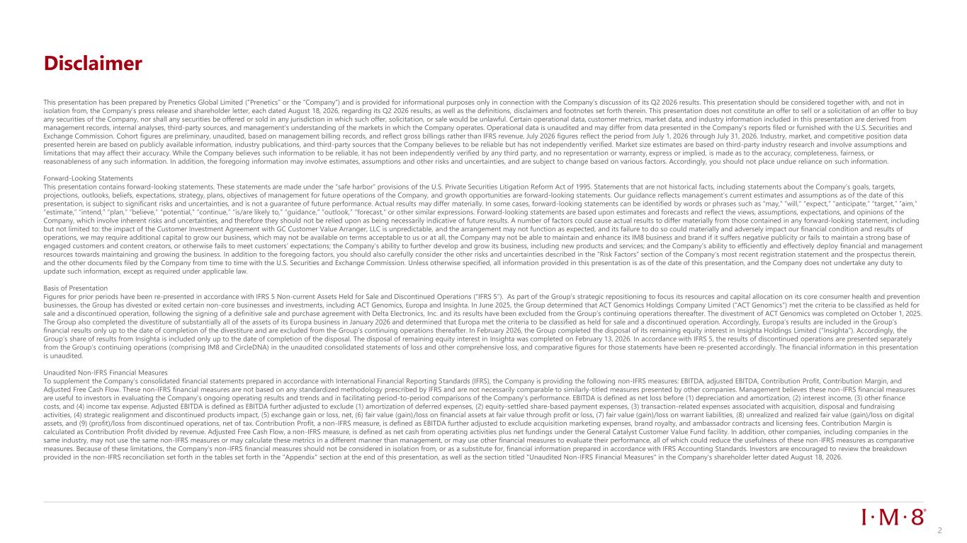
Disclaimer This presentation has been prepared by Prenetics Global Limited (“Prenetics” or the “Company”) and is provided for informational purposes only in connection with the Company’s discussion of its Q2 2026 results. This presentation should be considered together with, and not in isolation from, the Company’s press release and shareholder letter, each dated August 18, 2026, regarding its Q2 2026 results, as well as the definitions, disclaimers and footnotes set forth therein. This presentation does not constitute an offer to sell or a solicitation of an offer to buy any securities of the Company, nor shall any securities be offered or sold in any jurisdiction in which such offer, solicitation, or sale would be unlawful. Certain operational data, customer metrics, market data, and industry information included in this presentation are derived from management records, internal analyses, third-party sources, and management's understanding of the markets in which the Company operates. Operational data is unaudited and may differ from data presented in the Company's reports filed or furnished with the U.S. Securities and Exchange Commission. Cohort figures are preliminary, unaudited, based on management billing records, and reflect gross billings rather than IFRS revenue. July 2026 figures reflect the period from July 1, 2026 through July 31, 2026. Industry, market, and competitive position data presented herein are based on publicly available information, industry publications, and third-party sources that the Company believes to be reliable but has not independently verified. Market size estimates are based on third-party industry research and involve assumptions and limitations that may affect their accuracy. While the Company believes such information to be reliable, it has not been independently verified by any third party, and no representation or warranty, express or implied, is made as to the accuracy, completeness, fairness, or reasonableness of any such information. In addition, the foregoing information may involve estimates, assumptions and other risks and uncertainties, and are subject to change based on various factors. Accordingly, you should not place undue reliance on such information. Forward-Looking Statements This presentation contains forward-looking statements. These statements are made under the “safe harbor” provisions of the U.S. Private Securities Litigation Reform Act of 1995. Statements that are not historical facts, including statements about the Company’s goals, targets, projections, outlooks, beliefs, expectations, strategy, plans, objectives of management for future operations of the Company, and growth opportunities are forward-looking statements. Our guidance reflects management’s current estimates and assumptions as of the date of this presentation, is subject to significant risks and uncertainties, and is not a guarantee of future performance. Actual results may differ materially. In some cases, forward-looking statements can be identified by words or phrases such as “may,” “will,” “expect,” “anticipate,” “target,” “aim,” “estimate,” “intend,” “plan,” “believe,” “potential,” “continue,” “is/are likely to,” “guidance,” “outlook,” “forecast,” or other similar expressions. Forward-looking statements are based upon estimates and forecasts and reflect the views, assumptions, expectations, and opinions of the Company, which involve inherent risks and uncertainties, and therefore they should not be relied upon as being necessarily indicative of future results. A number of factors could cause actual results to differ materially from those contained in any forward-looking statement, including but not limited to: the impact of the Customer Investment Agreement with GC Customer Value Arranger, LLC is unpredictable, and the arrangement may not function as expected, and its failure to do so could materially and adversely impact our financial condition and results of operations, we may require additional capital to grow our business, which may not be available on terms acceptable to us or at all, the Company may not be able to maintain and enhance its IM8 business and brand if it suffers negative publicity or fails to maintain a strong base of engaged customers and content creators, or otherwise fails to meet customers’ expectations; the Company’s ability to further develop and grow its business, including new products and services; and the Company’s ability to efficiently and effectively deploy financial and management resources towards maintaining and growing the business. In addition to the foregoing factors, you should also carefully consider the other risks and uncertainties described in the “Risk Factors” section of the Company’s most recent registration statement and the prospectus therein, and the other documents filed by the Company from time to time with the U.S. Securities and Exchange Commission. Unless otherwise specified, all information provided in this presentation is as of the date of this presentation, and the Company does not undertake any duty to update such information, except as required under applicable law. Basis of Presentation Figures for prior periods have been re-presented in accordance with IFRS 5 Non-current Assets Held for Sale and Discontinued Operations (“IFRS 5”). As part of the Group’s strategic repositioning to focus its resources and capital allocation on its core consumer health and prevention businesses, the Group has divested or exited certain non-core businesses and investments, including ACT Genomics, Europa and Insighta. In June 2025, the Group determined that ACT Genomics Holdings Company Limited (“ACT Genomics”) met the criteria to be classified as held for sale and a discontinued operation, following the signing of a definitive sale and purchase agreement with Delta Electronics, Inc. and its results have been excluded from the Group’s continuing operations thereafter. The divestment of ACT Genomics was completed on October 1, 2025. The Group also completed the divestiture of substantially all of the assets of its Europa business in January 2026 and determined that Europa met the criteria to be classified as held for sale and a discontinued operation. Accordingly, Europa’s results are included in the Group’s financial results only up to the date of completion of the divestiture and are excluded from the Group’s continuing operations thereafter. In February 2026, the Group completed the disposal of its remaining equity interest in Insighta Holdings Limited (“Insighta”). Accordingly, the Group’s share of results from Insighta is included only up to the date of completion of the disposal. The disposal of remaining equity interest in Insighta was completed on February 13, 2026. In accordance with IFRS 5, the results of discontinued operations are presented separately from the Group’s continuing operations (comprising IM8 and CircleDNA) in the unaudited consolidated statements of loss and other comprehensive loss, and comparative figures for those statements have been re-presented accordingly. The financial information in this presentation is unaudited. Unaudited Non-IFRS Financial Measures To supplement the Company’s consolidated financial statements prepared in accordance with International Financial Reporting Standards (IFRS), the Company is providing the following non-IFRS measures: EBITDA, adjusted EBITDA, Contribution Profit, Contribution Margin, and Adjusted Free Cash Flow. These non-IFRS financial measures are not based on any standardized methodology prescribed by IFRS and are not necessarily comparable to similarly-titled measures presented by other companies. Management believes these non-IFRS financial measures are useful to investors in evaluating the Company’s ongoing operating results and trends and in facilitating period-to-period comparisons of the Company’s performance. EBITDA is defined as net loss before (1) depreciation and amortization, (2) interest income, (3) other finance costs, and (4) income tax expense. Adjusted EBITDA is defined as EBITDA further adjusted to exclude (1) amortization of deferred expenses, (2) equity-settled share-based payment expenses, (3) transaction-related expenses associated with acquisition, disposal and fundraising activities, (4) strategic realignment and discontinued products impact, (5) exchange gain or loss, net, (6) fair value (gain)/loss on financial assets at fair value through profit or loss, (7) fair value (gain)/loss on warrant liabilities, (8) unrealized and realized fair value (gain)/loss on digital assets, and (9) (profit)/loss from discontinued operations, net of tax. Contribution Profit, a non-IFRS measure, is defined as EBITDA further adjusted to exclude acquisition marketing expenses, brand royalty, and ambassador contracts and licensing fees. Contribution Margin is calculated as Contribution Profit divided by revenue. Adjusted Free Cash Flow, a non-IFRS measure, is defined as net cash from operating activities plus net fundings under the General Catalyst Customer Value Fund facility. In addition, other companies, including companies in the same industry, may not use the same non-IFRS measures or may calculate these metrics in a different manner than management, or may use other financial measures to evaluate their performance, all of which could reduce the usefulness of these non-IFRS measures as comparative measures. Because of these limitations, the Company’s non-IFRS financial measures should not be considered in isolation from, or as a substitute for, financial information prepared in accordance with IFRS Accounting Standards. Investors are encouraged to review the breakdown provided in the non-IFRS reconciliation set forth in the tables set forth in the "Appendix" section at the end of this presentation, as well as the section titled "Unaudited Non-IFRS Financial Measures" in the Company's shareholder letter dated August 18, 2026. 2

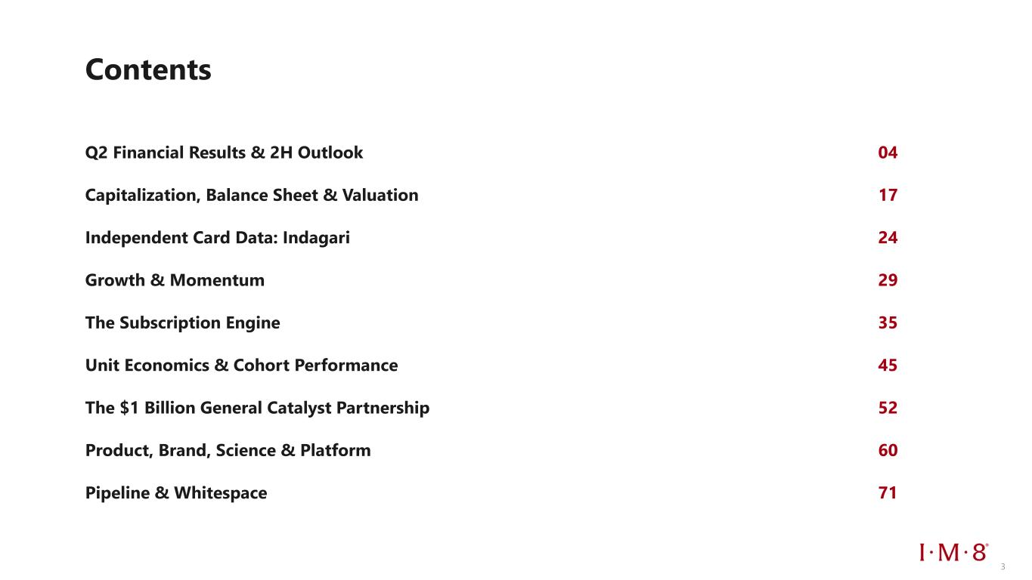
Contents Q2 Financial Results & 2H Outlook 04 Capitalization, Balance Sheet & Valuation 17 Independent Card Data: Indagari 24 Growth & Momentum 29 The Subscription Engine 35 Unit Economics & Cohort Performance 45 The $1 Billion General Catalyst Partnership 52 Product, Brand, Science & Platform 60 Pipeline & Whitespace 71 3

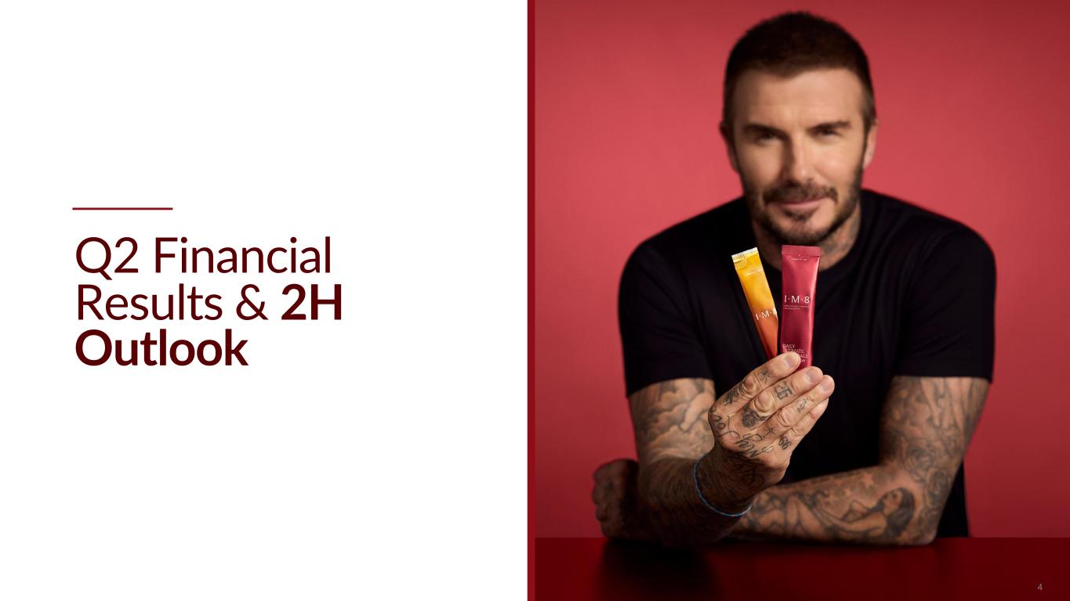
Q2 Financial Results & 2H Outlook 4

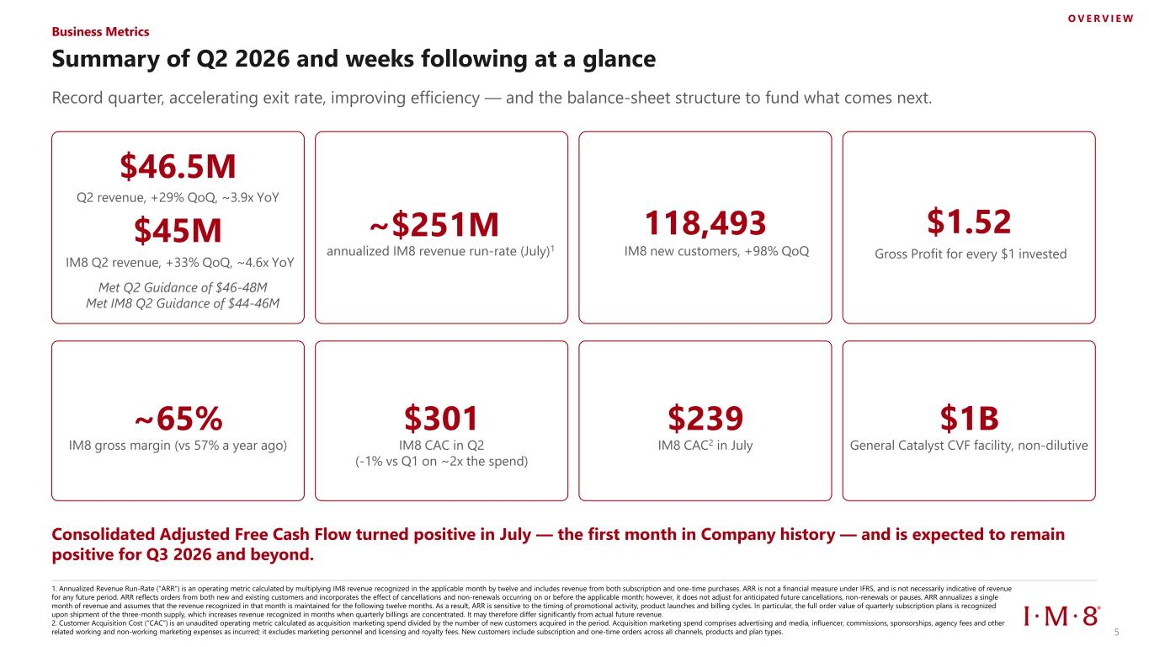
Summary of Q2 2026 and weeks following at a glance Record quarter, accelerating exit rate, improving efficiency — and the balance-sheet structure to fund what comes next. $46.5M IM8 Q2 revenue, +33% QoQ, ~4.6x YoY 118,493 Gross Profit for every $1 invested ~65% IM8 gross margin (vs 57% a year ago) $301 IM8 CAC in Q2 (-1% vs Q1 on ~2x the spend) $239 IM8 CAC2 in July $1B General Catalyst CVF facility, non-dilutive Consolidated Adjusted Free Cash Flow turned positive in July — the first month in Company history — and is expected to remain positive for Q3 2026 and beyond. Business Metrics O V E R V I E W ~$251M annualized IM8 revenue run-rate (July)1 IM8 new customers, +98% QoQ $1.52$45M Q2 revenue, +29% QoQ, ~3.9x YoY 5 1. Annualized Revenue Run-Rate ("ARR") is an operating metric calculated by multiplying IM8 revenue recognized in the applicable month by twelve and includes revenue from both subscription and one-time purchases. ARR is not a financial measure under IFRS, and is not necessarily indicative of revenue for any future period. ARR reflects orders from both new and existing customers and incorporates the effect of cancellations and non-renewals occurring on or before the applicable month; however, it does not adjust for anticipated future cancellations, non-renewals or pauses. ARR annualizes a single month of revenue and assumes that the revenue recognized in that month is maintained for the following twelve months. As a result, ARR is sensitive to the timing of promotional activity, product launches and billing cycles. In particular, the full order value of quarterly subscription plans is recognized upon shipment of the three-month supply, which increases revenue recognized in months when quarterly billings are concentrated. It may therefore differ significantly from actual future revenue. 2. Customer Acquisition Cost (“CAC”) is an unaudited operating metric calculated as acquisition marketing spend divided by the number of new customers acquired in the period. Acquisition marketing spend comprises advertising and media, influencer, commissions, sponsorships, agency fees and other related working and non-working marketing expenses as incurred; it excludes marketing personnel and licensing and royalty fees. New customers include subscription and one-time orders across all channels, products and plan types. Met Q2 Guidance of $46-48M Met IM8 Q2 Guidance of $44-46M

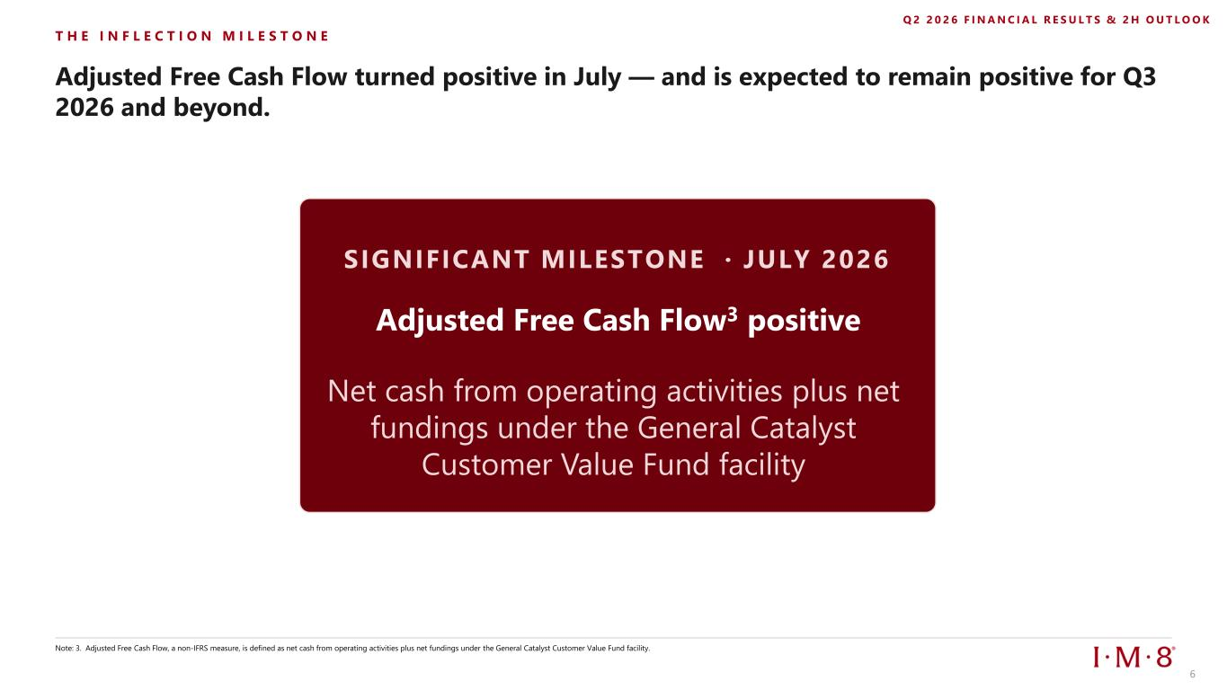
T H E I N F L E C T I O N M I L E S T O N E Adjusted Free Cash Flow turned positive in July — and is expected to remain positive for Q3 2026 and beyond. Note: 3. Adjusted Free Cash Flow, a non-IFRS measure, is defined as net cash from operating activities plus net fundings under the General Catalyst Customer Value Fund facility. Q 2 2 0 2 6 F I N A N C I A L R E S U L T S & 2 H O U T L O O K SIGNIFICANT MILESTONE · JULY 2026 Adjusted Free Cash Flow3 positive 6 Net cash from operating activities plus net fundings under the General Catalyst Customer Value Fund facility

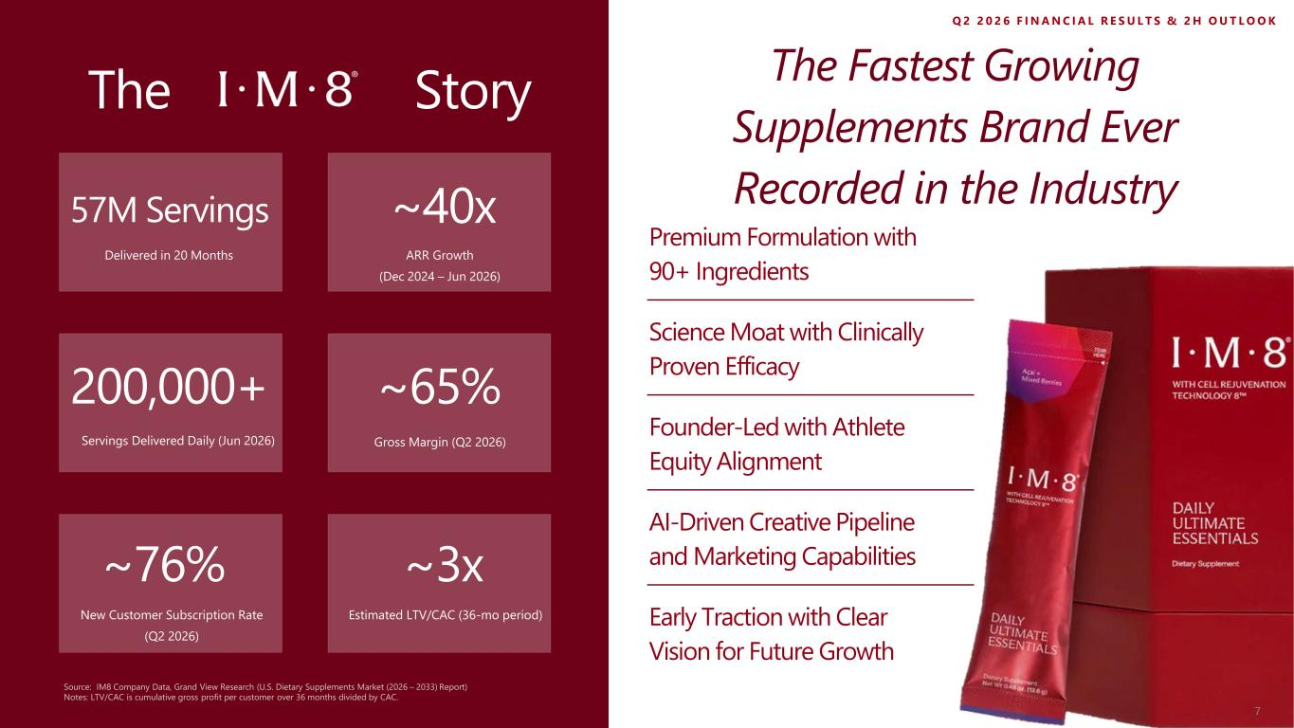
The Story The Fastest Growing Supplements Brand Ever Recorded in the Industry Science Moat with Clinically Proven Efficacy Founder-Led with Athlete Equity Alignment Premium Formulation with 90+ Ingredients 57M Servings Delivered in 20 Months ~40x ARR Growth (Dec 2024 – Jun 2026) Gross Margin (Q2 2026) ~76% New Customer Subscription Rate (Q2 2026) ~3x Estimated LTV/CAC (36-mo period) 200,000+ Servings Delivered Daily (Jun 2026) Early Traction with Clear Vision for Future Growth AI-Driven Creative Pipeline and Marketing Capabilities Source: IM8 Company Data, Grand View Research (U.S. Dietary Supplements Market (2026 – 2033) Report) Notes: LTV/CAC is cumulative gross profit per customer over 36 months divided by CAC. ~65% Q 2 2 0 2 6 F I N A N C I A L R E S U L T S & 2 H O U T L O O K 7

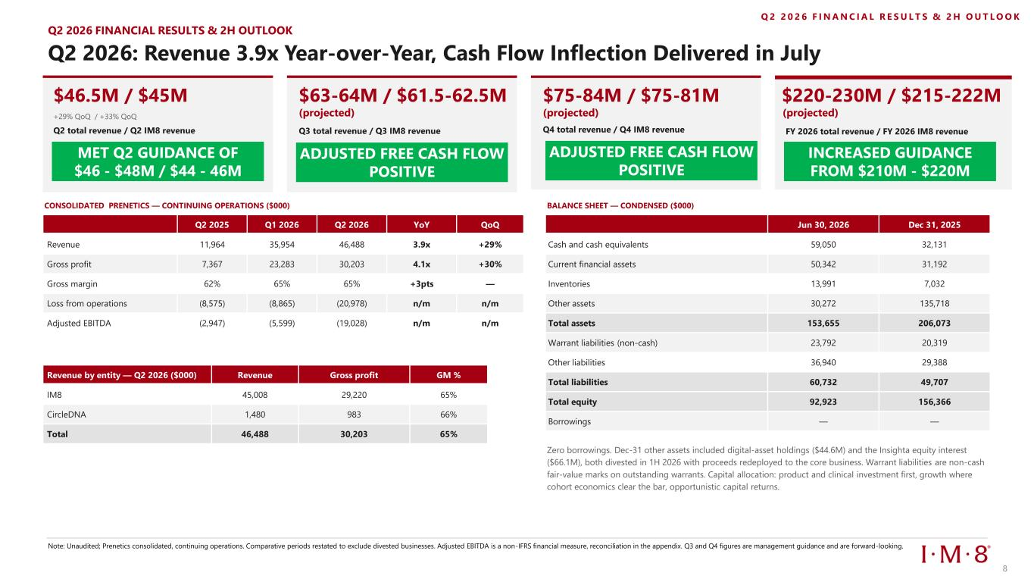
Q2 2026: Revenue 3.9x Year-over-Year, Cash Flow Inflection Delivered in July CONSOLIDATED PRENETICS — CONTINUING OPERATIONS ($000) Note: Unaudited; Prenetics consolidated, continuing operations. Comparative periods restated to exclude divested businesses. Adjusted EBITDA is a non-IFRS financial measure, reconciliation in the appendix. Q3 and Q4 figures are management guidance and are forward-looking. BALANCE SHEET — CONDENSED ($000) Zero borrowings. Dec-31 other assets included digital-asset holdings ($44.6M) and the Insighta equity interest ($66.1M), both divested in 1H 2026 with proceeds redeployed to the core business. Warrant liabilities are non-cash fair-value marks on outstanding warrants. Capital allocation: product and clinical investment first, growth where cohort economics clear the bar, opportunistic capital returns. Q 2 2 0 2 6 F I N A N C I A L R E S U L T S & 2 H O U T L O O K Q2 2025 Q1 2026 Q2 2026 YoY QoQ Revenue 11,964 35,954 46,488 3.9x +29% Gross profit 7,367 23,283 30,203 4.1x +30% Gross margin 62% 65% 65% +3pts — Loss from operations (8,575) (8,865) (20,978) n/m n/m Adjusted EBITDA (2,947) (5,599) (19,028) n/m n/m Revenue by entity — Q2 2026 ($000) Revenue Gross profit GM % IM8 45,008 29,220 65% CircleDNA 1,480 983 66% Total 46,488 30,203 65% Jun 30, 2026 Dec 31, 2025 Cash and cash equivalents 59,050 32,131 Current financial assets 50,342 31,192 Inventories 13,991 7,032 Other assets 30,272 135,718 Total assets 153,655 206,073 Warrant liabilities (non-cash) 23,792 20,319 Other liabilities 36,940 29,388 Total liabilities 60,732 49,707 Total equity 92,923 156,366 Borrowings — — Q2 2026 FINANCIAL RESULTS & 2H OUTLOOK $46.5M / $45M +29% QoQ / +33% QoQ Q2 total revenue / Q2 IM8 revenue $63-64M / $61.5-62.5M (projected) Q3 total revenue / Q3 IM8 revenue $75-84M / $75-81M (projected) Q4 total revenue / Q4 IM8 revenue $220-230M / $215-222M (projected) INCREASED GUIDANCE FROM $210M - $220M FY 2026 total revenue / FY 2026 IM8 revenue MET Q2 GUIDANCE OF $46 - $48M / $44 - 46M 8 ADJUSTED FREE CASH FLOW POSITIVE ADJUSTED FREE CASH FLOW POSITIVE

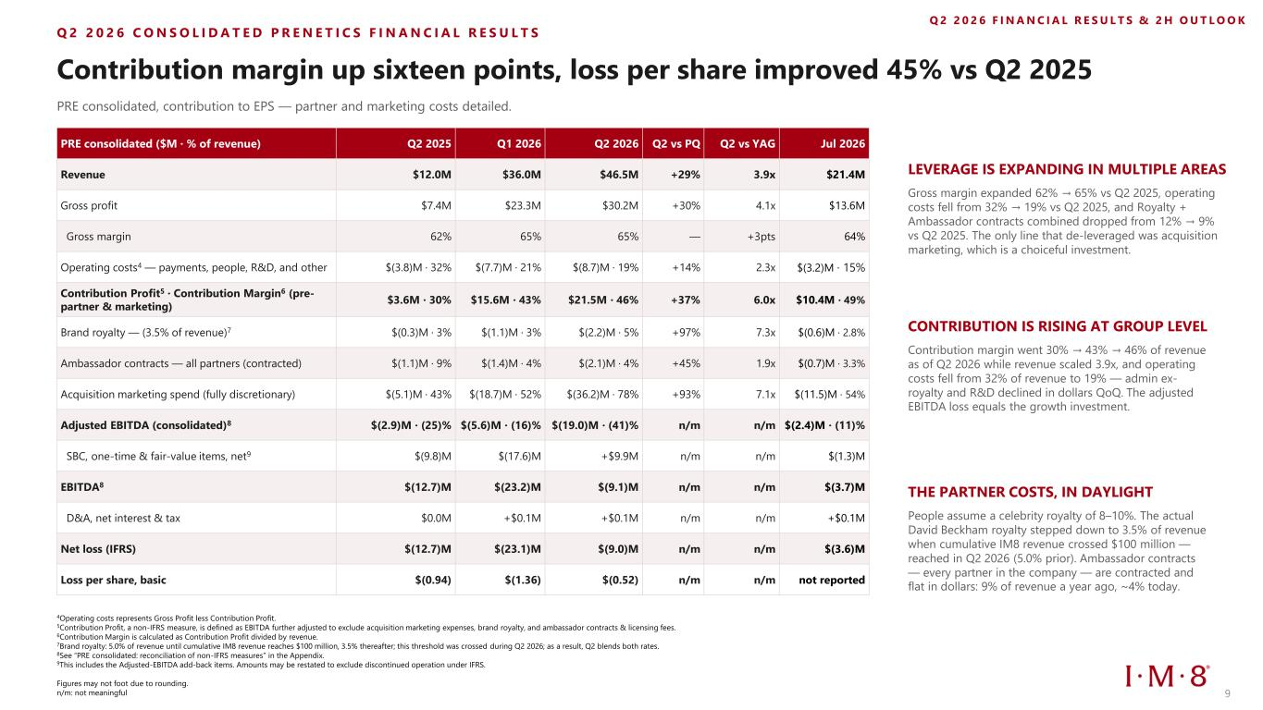
Q 2 2 0 2 6 C O N S O L I D A T E D P R E N E T I C S F I N A N C I A L R E S U L T S Contribution margin up sixteen points, loss per share improved 45% vs Q2 2025 PRE consolidated, contribution to EPS — partner and marketing costs detailed. PRE consolidated ($M · % of revenue) Q2 2025 Q1 2026 Q2 2026 Q2 vs PQ Q2 vs YAG Jul 2026 Revenue $12.0M $36.0M $46.5M +29% 3.9x $21.4M Gross profit $7.4M $23.3M $30.2M +30% 4.1x $13.6M Gross margin 62% 65% 65% — +3pts 64% Operating costs4 — payments, people, R&D, and other $(3.8)M · 32% $(7.7)M · 21% $(8.7)M · 19% +14% 2.3x $(3.2)M · 15% Contribution Profit5 · Contribution Margin6 (pre- partner & marketing) $3.6M · 30% $15.6M · 43% $21.5M · 46% +37% 6.0x $10.4M · 49% Brand royalty — (3.5% of revenue)7 $(0.3)M · 3% $(1.1)M · 3% $(2.2)M · 5% +97% 7.3x $(0.6)M · 2.8% Ambassador contracts — all partners (contracted) $(1.1)M · 9% $(1.4)M · 4% $(2.1)M · 4% +45% 1.9x $(0.7)M · 3.3% Acquisition marketing spend (fully discretionary) $(5.1)M · 43% $(18.7)M · 52% $(36.2)M · 78% +93% 7.1x $(11.5)M · 54% Adjusted EBITDA (consolidated)8 $(2.9)M · (25)% $(5.6)M · (16)% $(19.0)M · (41)% n/m n/m $(2.4)M · (11)% SBC, one-time & fair-value items, net9 $(9.8)M $(17.6)M +$9.9M n/m n/m $(1.3)M EBITDA8 $(12.7)M $(23.2)M $(9.1)M n/m n/m $(3.7)M D&A, net interest & tax $0.0M +$0.1M +$0.1M n/m n/m +$0.1M Net loss (IFRS) $(12.7)M $(23.1)M $(9.0)M n/m n/m $(3.6)M Loss per share, basic $(0.94) $(1.36) $(0.52) n/m n/m not reported Q 2 2 0 2 6 F I N A N C I A L R E S U L T S & 2 H O U T L O O K LEVERAGE IS EXPANDING IN MULTIPLE AREAS Gross margin expanded 62% → 65% vs Q2 2025, operating costs fell from 32% → 19% vs Q2 2025, and Royalty + Ambassador contracts combined dropped from 12% → 9% vs Q2 2025. The only line that de-leveraged was acquisition marketing, which is a choiceful investment. CONTRIBUTION IS RISING AT GROUP LEVEL Contribution margin went 30% → 43% → 46% of revenue as of Q2 2026 while revenue scaled 3.9x, and operating costs fell from 32% of revenue to 19% — admin ex- royalty and R&D declined in dollars QoQ. The adjusted EBITDA loss equals the growth investment. THE PARTNER COSTS, IN DAYLIGHT People assume a celebrity royalty of 8–10%. The actual David Beckham royalty stepped down to 3.5% of revenue when cumulative IM8 revenue crossed $100 million — reached in Q2 2026 (5.0% prior). Ambassador contracts — every partner in the company — are contracted and flat in dollars: 9% of revenue a year ago, ~4% today. 9 4Operating costs represents Gross Profit less Contribution Profit. 5Contribution Profit, a non-IFRS measure, is defined as EBITDA further adjusted to exclude acquisition marketing expenses, brand royalty, and ambassador contracts & licensing fees. 6Contribution Margin is calculated as Contribution Profit divided by revenue. 7Brand royalty: 5.0% of revenue until cumulative IM8 revenue reaches $100 million, 3.5% thereafter; this threshold was crossed during Q2 2026; as a result, Q2 blends both rates. 8See “PRE consolidated: reconciliation of non-IFRS measures” in the Appendix. 9This includes the Adjusted-EBITDA add-back items. Amounts may be restated to exclude discontinued operation under IFRS. Figures may not foot due to rounding. n/m: not meaningful

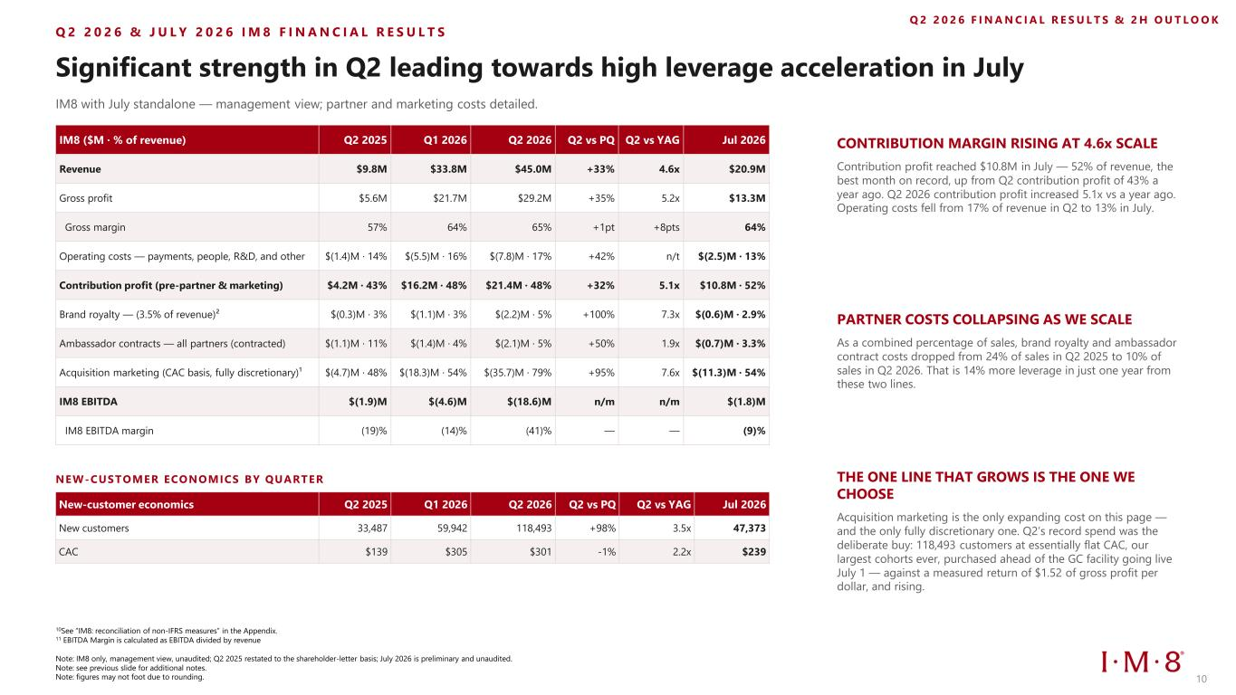
Q 2 2 0 2 6 & J U L Y 2 0 2 6 I M 8 F I N A N C I A L R E S U L T S Significant strength in Q2 leading towards high leverage acceleration in July IM8 with July standalone — management view; partner and marketing costs detailed. NEW-CUSTOMER ECONOMICS BY QUARTER New-customer economics Q2 2025 Q1 2026 Q2 2026 Q2 vs PQ Q2 vs YAG Jul 2026 New customers 33,487 59,942 118,493 +98% 3.5x 47,373 CAC $139 $305 $301 -1% 2.2x $239 Q 2 2 0 2 6 F I N A N C I A L R E S U L T S & 2 H O U T L O O K CONTRIBUTION MARGIN RISING AT 4.6x SCALE Contribution profit reached $10.8M in July — 52% of revenue, the best month on record, up from Q2 contribution profit of 43% a year ago. Q2 2026 contribution profit increased 5.1x vs a year ago. Operating costs fell from 17% of revenue in Q2 to 13% in July. PARTNER COSTS COLLAPSING AS WE SCALE As a combined percentage of sales, brand royalty and ambassador contract costs dropped from 24% of sales in Q2 2025 to 10% of sales in Q2 2026. That is 14% more leverage in just one year from these two lines. THE ONE LINE THAT GROWS IS THE ONE WE CHOOSE Acquisition marketing is the only expanding cost on this page — and the only fully discretionary one. Q2’s record spend was the deliberate buy: 118,493 customers at essentially flat CAC, our largest cohorts ever, purchased ahead of the GC facility going live July 1 — against a measured return of $1.52 of gross profit per dollar, and rising. 10 IM8 ($M · % of revenue) Q2 2025 Q1 2026 Q2 2026 Q2 vs PQ Q2 vs YAG Jul 2026 Revenue $9.8M $33.8M $45.0M +33% 4.6x $20.9M Gross profit $5.6M $21.7M $29.2M +35% 5.2x $13.3M Gross margin 57% 64% 65% +1pt +8pts 64% Operating costs — payments, people, R&D, and other $(1.4)M · 14% $(5.5)M · 16% $(7.8)M · 17% +42% n/t $(2.5)M · 13% Contribution profit (pre-partner & marketing) $4.2M · 43% $16.2M · 48% $21.4M · 48% +32% 5.1x $10.8M · 52% Brand royalty — (3.5% of revenue)² $(0.3)M · 3% $(1.1)M · 3% $(2.2)M · 5% +100% 7.3x $(0.6)M · 2.9% Ambassador contracts — all partners (contracted) $(1.1)M · 11% $(1.4)M · 4% $(2.1)M · 5% +50% 1.9x $(0.7)M · 3.3% Acquisition marketing (CAC basis, fully discretionary)¹ $(4.7)M · 48% $(18.3)M · 54% $(35.7)M · 79% +95% 7.6x $(11.3)M · 54% IM8 EBITDA $(1.9)M $(4.6)M $(18.6)M n/m n/m $(1.8)M IM8 EBITDA margin (19)% (14)% (41)% — — (9)% 10See “IM8: reconciliation of non-IFRS measures” in the Appendix. 11 EBITDA Margin is calculated as EBITDA divided by revenue Note: IM8 only, management view, unaudited; Q2 2025 restated to the shareholder-letter basis; July 2026 is preliminary and unaudited. Note: see previous slide for additional notes. Note: figures may not foot due to rounding.

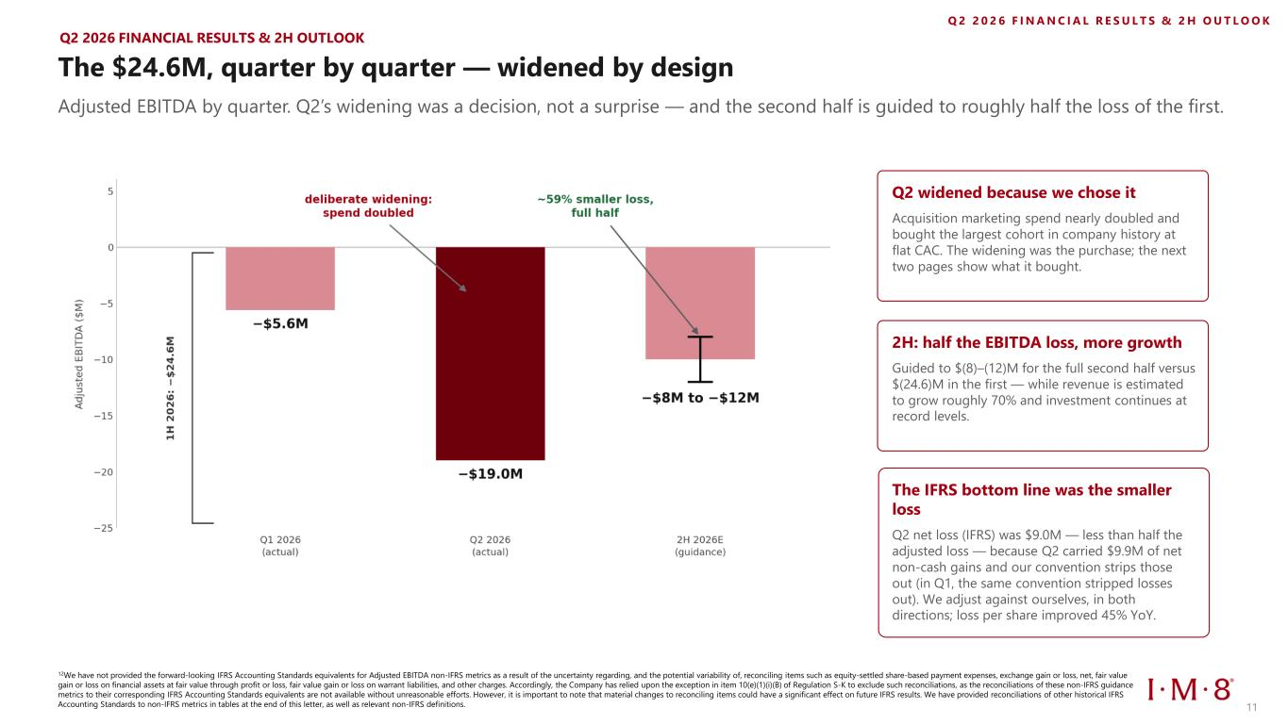
The $24.6M, quarter by quarter — widened by design Adjusted EBITDA by quarter. Q2’s widening was a decision, not a surprise — and the second half is guided to roughly half the loss of the first. Q2 2026 FINANCIAL RESULTS & 2H OUTLOOK Q2 widened because we chose it Acquisition marketing spend nearly doubled and bought the largest cohort in company history at flat CAC. The widening was the purchase; the next two pages show what it bought. 2H: half the EBITDA loss, more growth Guided to $(8)–(12)M for the full second half versus $(24.6)M in the first — while revenue is estimated to grow roughly 70% and investment continues at record levels. Q 2 2 0 2 6 F I N A N C I A L R E S U L T S & 2 H O U T L O O K 11 12We have not provided the forward-looking IFRS Accounting Standards equivalents for Adjusted EBITDA non-IFRS metrics as a result of the uncertainty regarding, and the potential variability of, reconciling items such as equity-settled share-based payment expenses, exchange gain or loss, net, fair value gain or loss on financial assets at fair value through profit or loss, fair value gain or loss on warrant liabilities, and other charges. Accordingly, the Company has relied upon the exception in item 10(e)(1)(i)(B) of Regulation S-K to exclude such reconciliations, as the reconciliations of these non-IFRS guidance metrics to their corresponding IFRS Accounting Standards equivalents are not available without unreasonable efforts. However, it is important to note that material changes to reconciling items could have a significant effect on future IFRS results. We have provided reconciliations of other historical IFRS Accounting Standards to non-IFRS metrics in tables at the end of this letter, as well as relevant non-IFRS definitions. The IFRS bottom line was the smaller loss Q2 net loss (IFRS) was $9.0M — less than half the adjusted loss — because Q2 carried $9.9M of net non-cash gains and our convention strips those out (in Q1, the same convention stripped losses out). We adjust against ourselves, in both directions; loss per share improved 45% YoY.

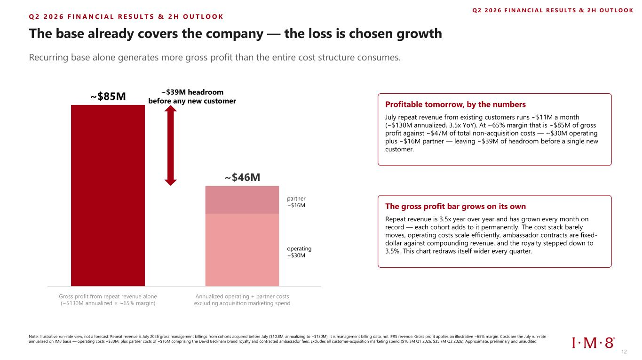
The base already covers the company — the loss is chosen growth Recurring base alone generates more gross profit than the entire cost structure consumes. Note: Illustrative run-rate view, not a forecast. Repeat revenue is July 2026 gross management billings from cohorts acquired before July ($10.8M, annualizing to ~$130M); it is management billing data, not IFRS revenue. Gross profit applies an illustrative ~65% margin. Costs are the July run-rate annualized on IM8 basis — operating costs ~$30M, plus partner costs of ~$16M comprising the David Beckham brand royalty and contracted ambassador fees. Excludes all customer-acquisition marketing spend ($18.3M Q1 2026, $35.7M Q2 2026). Approximate, preliminary and unaudited. Q 2 2 0 2 6 F I N A N C I A L R E S U L T S & 2 H O U T L O O K ~$85M ~$46M operating ~$30M partner ~$16M ~$39M headroom before any new customer Gross profit from repeat revenue alone (~$130M annualized × ~65% margin) Annualized operating + partner costs excluding acquisition marketing spend Profitable tomorrow, by the numbers July repeat revenue from existing customers runs ~$11M a month (~$130M annualized, 3.5x YoY). At ~65% margin that is ~$85M of gross profit against ~$47M of total non-acquisition costs — ~$30M operating plus ~$16M partner — leaving ~$39M of headroom before a single new customer. The gross profit bar grows on its own Repeat revenue is 3.5x year over year and has grown every month on record — each cohort adds to it permanently. The cost stack barely moves, operating costs scale efficiently, ambassador contracts are fixed- dollar against compounding revenue, and the royalty stepped down to 3.5%. This chart redraws itself wider every quarter. Q 2 2 0 2 6 F I N A N C I A L R E S U L T S & 2 H O U T L O O K 12

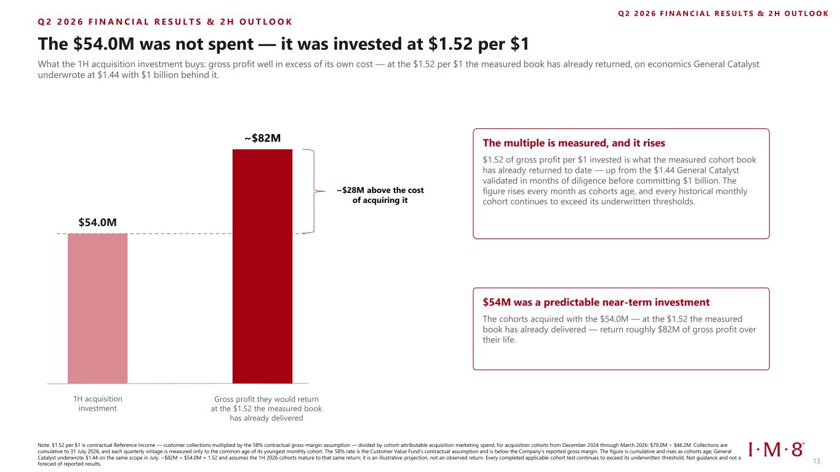
Q 2 2 0 2 6 F I N A N C I A L R E S U L T S & 2 H O U T L O O K The $54.0M was not spent — it was invested at $1.52 per $1 What the 1H acquisition investment buys: gross profit well in excess of its own cost — at the $1.52 per $1 the measured book has already returned, on economics General Catalyst underwrote at $1.44 with $1 billion behind it. Note: $1.52 per $1 is contractual Reference Income — customer collections multiplied by the 58% contractual gross-margin assumption — divided by cohort-attributable acquisition marketing spend, for acquisition cohorts from December 2024 through March 2026: $70.0M ÷ $46.2M. Collections are cumulative to 31 July 2026, and each quarterly vintage is measured only to the common age of its youngest monthly cohort. The 58% rate is the Customer Value Fund's contractual assumption and is below the Company's reported gross margin. The figure is cumulative and rises as cohorts age; General Catalyst underwrote $1.44 on the same scope in July. ~$82M = $54.0M × 1.52 and assumes the 1H 2026 cohorts mature to that same return; it is an illustrative projection, not an observed return. Every completed applicable cohort test continues to exceed its underwritten threshold. Not guidance and not a forecast of reported results. Q 2 2 0 2 6 F I N A N C I A L R E S U L T S & 2 H O U T L O O K $54.0M ~$82M 1H acquisition investment Gross profit they would return at the $1.52 the measured book has already delivered ~$28M above the cost of acquiring it The multiple is measured, and it rises $1.52 of gross profit per $1 invested is what the measured cohort book has already returned to date — up from the $1.44 General Catalyst validated in months of diligence before committing $1 billion. The figure rises every month as cohorts age, and every historical monthly cohort continues to exceed its underwritten thresholds. $54M was a predictable near-term investment The cohorts acquired with the $54.0M — at the $1.52 the measured book has already delivered — return roughly $82M of gross profit over their life. 13

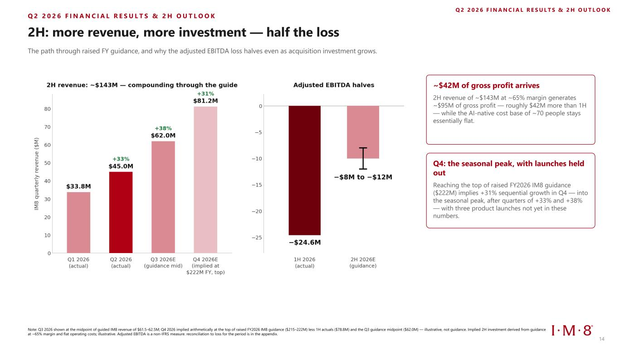
Q 2 2 0 2 6 F I N A N C I A L R E S U L T S & 2 H O U T L O O K 2H: more revenue, more investment — half the loss The path through raised FY guidance, and why the adjusted EBITDA loss halves even as acquisition investment grows. ~$42M of gross profit arrives 2H revenue of ~$143M at ~65% margin generates ~$95M of gross profit — roughly $42M more than 1H — while the AI-native cost base of ~70 people stays essentially flat. Q4: the seasonal peak, with launches held out Reaching the top of raised FY2026 IM8 guidance ($222M) implies +31% sequential growth in Q4 — into the seasonal peak, after quarters of +33% and +38% — with three product launches not yet in these numbers. Note: Q3 2026 shown at the midpoint of guided IM8 revenue of $61.5–62.5M; Q4 2026 implied arithmetically at the top of raised FY2026 IM8 guidance ($215–222M) less 1H actuals ($78.8M) and the Q3 guidance midpoint ($62.0M) — illustrative, not guidance. Implied 2H investment derived from guidance at ~65% margin and flat operating costs; illustrative. Adjusted EBITDA is a non-IFRS measure. reconciliation to loss for the period is in the appendix. Q 2 2 0 2 6 F I N A N C I A L R E S U L T S & 2 H O U T L O O K 14

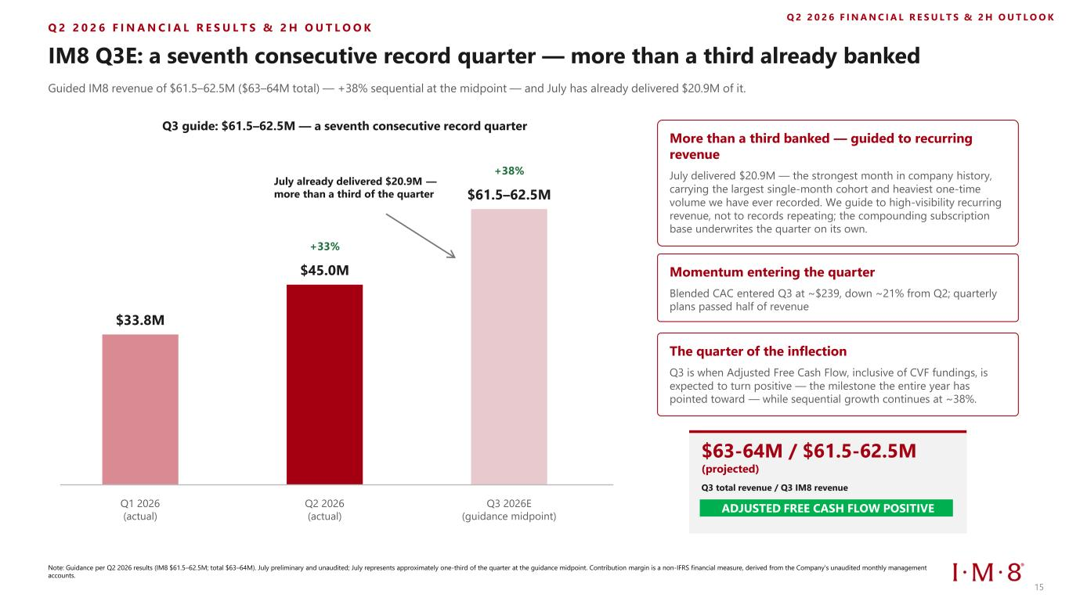
Q 2 2 0 2 6 F I N A N C I A L R E S U L T S & 2 H O U T L O O K IM8 Q3E: a seventh consecutive record quarter — more than a third already banked Guided IM8 revenue of $61.5–62.5M ($63–64M total) — +38% sequential at the midpoint — and July has already delivered $20.9M of it. Q3 guide: $61.5–62.5M — a seventh consecutive record quarter $33.8M $45.0M +33% $61.5–62.5M +38% Q1 2026 (actual) Q2 2026 (actual) Q3 2026E (guidance midpoint) July already delivered $20.9M — more than a third of the quarter More than a third banked — guided to recurring revenue July delivered $20.9M — the strongest month in company history, carrying the largest single-month cohort and heaviest one-time volume we have ever recorded. We guide to high-visibility recurring revenue, not to records repeating; the compounding subscription base underwrites the quarter on its own. Momentum entering the quarter Blended CAC entered Q3 at ~$239, down ~21% from Q2; quarterly plans passed half of revenue The quarter of the inflection Q3 is when Adjusted Free Cash Flow, inclusive of CVF fundings, is expected to turn positive — the milestone the entire year has pointed toward — while sequential growth continues at ~38%. Note: Guidance per Q2 2026 results (IM8 $61.5–62.5M; total $63–64M). July preliminary and unaudited; July represents approximately one-third of the quarter at the guidance midpoint. Contribution margin is a non-IFRS financial measure, derived from the Company's unaudited monthly management accounts. Q 2 2 0 2 6 F I N A N C I A L R E S U L T S & 2 H O U T L O O K $63-64M / $61.5-62.5M (projected) Q3 total revenue / Q3 IM8 revenue ADJUSTED FREE CASH FLOW POSITIVE 15

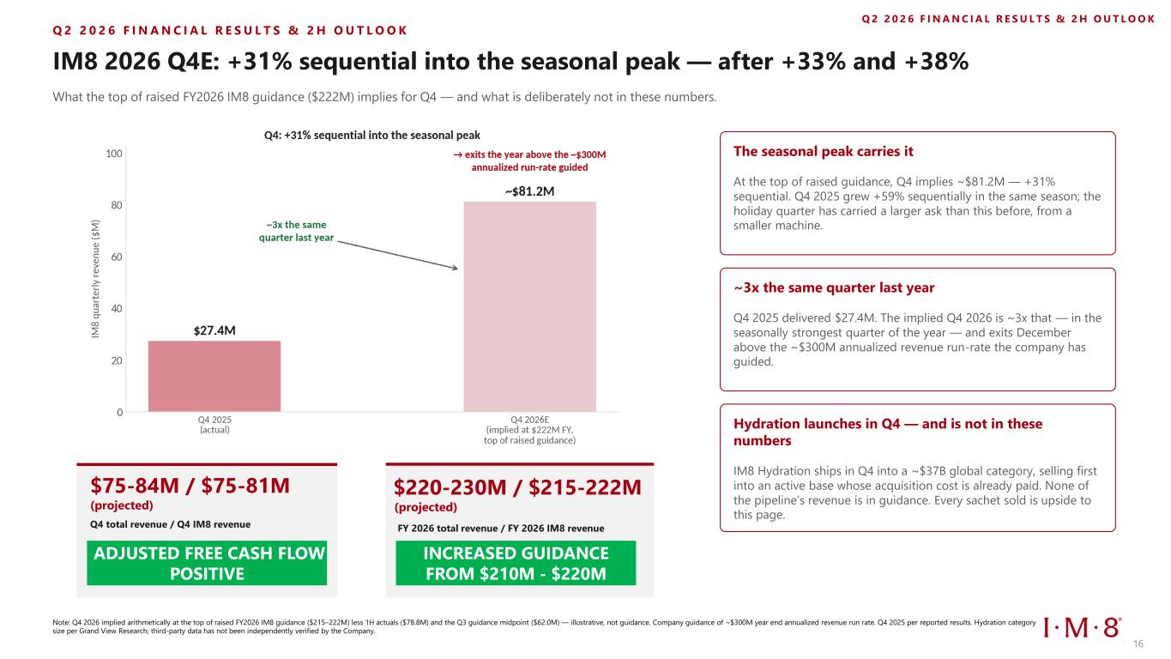
Q 2 2 0 2 6 F I N A N C I A L R E S U L T S & 2 H O U T L O O K IM8 2026 Q4E: +31% sequential into the seasonal peak — after +33% and +38% What the top of raised FY2026 IM8 guidance ($222M) implies for Q4 — and what is deliberately not in these numbers. Note: Q4 2026 implied arithmetically at the top of raised FY2026 IM8 guidance ($215–222M) less 1H actuals ($78.8M) and the Q3 guidance midpoint ($62.0M) — illustrative, not guidance. Company guidance of ~$300M year end annualized revenue run rate. Q4 2025 per reported results. Hydration category size per Grand View Research; third-party data has not been independently verified by the Company. Q 2 2 0 2 6 F I N A N C I A L R E S U L T S & 2 H O U T L O O K The seasonal peak carries it At the top of raised guidance, Q4 implies ~$81.2M — +31% sequential. Q4 2025 grew +59% sequentially in the same season; the holiday quarter has carried a larger ask than this before, from a smaller machine. ~3x the same quarter last year Q4 2025 delivered $27.4M. The implied Q4 2026 is ~3x that — in the seasonally strongest quarter of the year — and exits December above the ~$300M annualized revenue run-rate the company has guided. Hydration launches in Q4 — and is not in these numbers IM8 Hydration ships in Q4 into a ~$37B global category, selling first into an active base whose acquisition cost is already paid. None of the pipeline’s revenue is in guidance. Every sachet sold is upside to this page. $75-84M / $75-81M (projected) Q4 total revenue / Q4 IM8 revenue ADJUSTED FREE CASH FLOW POSITIVE $220-230M / $215-222M (projected) INCREASED GUIDANCE FROM $210M - $220M FY 2026 total revenue / FY 2026 IM8 revenue 16


Capitalization, Balance Sheet & Valuation 17

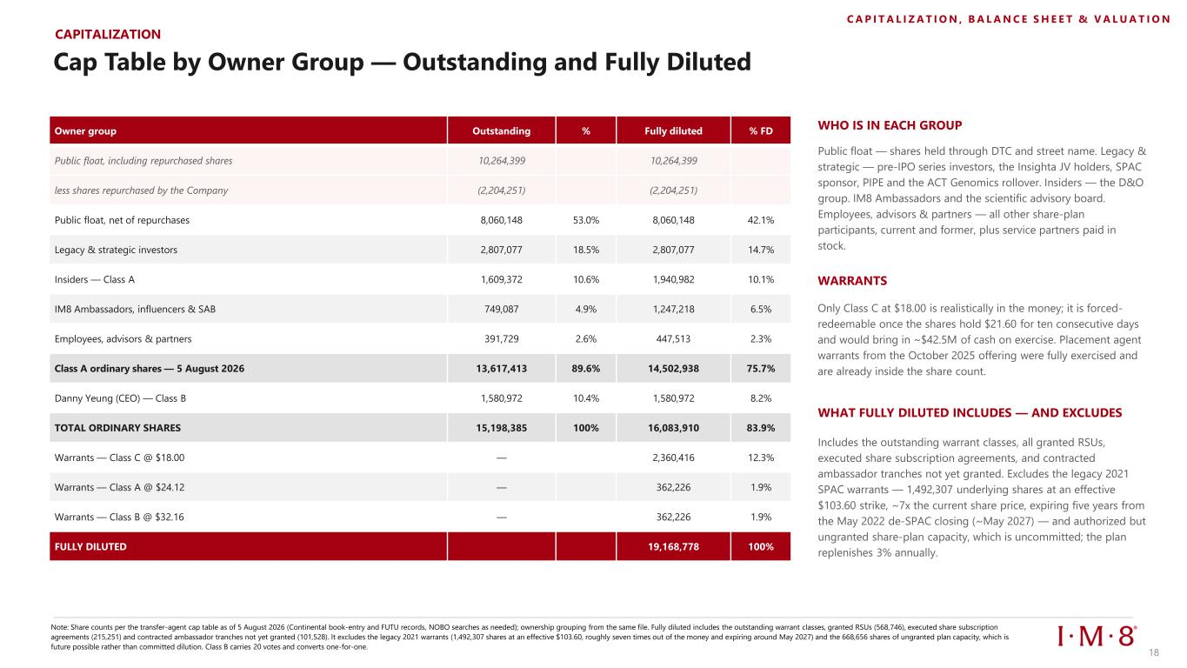
CAPITALIZATION Cap Table by Owner Group — Outstanding and Fully Diluted Owner group Outstanding % Fully diluted % FD Public float, including repurchased shares 10,264,399 10,264,399 less shares repurchased by the Company (2,204,251) (2,204,251) Public float, net of repurchases 8,060,148 53.0% 8,060,148 42.1% Legacy & strategic investors 2,807,077 18.5% 2,807,077 14.7% Insiders — Class A 1,609,372 10.6% 1,940,982 10.1% IM8 Ambassadors, influencers & SAB 749,087 4.9% 1,247,218 6.5% Employees, advisors & partners 391,729 2.6% 447,513 2.3% Class A ordinary shares — 5 August 2026 13,617,413 89.6% 14,502,938 75.7% Danny Yeung (CEO) — Class B 1,580,972 10.4% 1,580,972 8.2% TOTAL ORDINARY SHARES 15,198,385 100% 16,083,910 83.9% Warrants — Class C @ $18.00 — 2,360,416 12.3% Warrants — Class A @ $24.12 — 362,226 1.9% Warrants — Class B @ $32.16 — 362,226 1.9% FULLY DILUTED 19,168,778 100% WHO IS IN EACH GROUP WARRANTS Only Class C at $18.00 is realistically in the money; it is forced- redeemable once the shares hold $21.60 for ten consecutive days and would bring in ~$42.5M of cash on exercise. Placement agent warrants from the October 2025 offering were fully exercised and are already inside the share count. WHAT FULLY DILUTED INCLUDES — AND EXCLUDES Includes the outstanding warrant classes, all granted RSUs, executed share subscription agreements, and contracted ambassador tranches not yet granted. Excludes the legacy 2021 SPAC warrants — 1,492,307 underlying shares at an effective $103.60 strike, ~7x the current share price, expiring five years from the May 2022 de-SPAC closing (~May 2027) — and authorized but ungranted share-plan capacity, which is uncommitted; the plan replenishes 3% annually. Note: Share counts per the transfer-agent cap table as of 5 August 2026 (Continental book-entry and FUTU records, NOBO searches as needed); ownership grouping from the same file. Fully diluted includes the outstanding warrant classes, granted RSUs (568,746), executed share subscription agreements (215,251) and contracted ambassador tranches not yet granted (101,528). It excludes the legacy 2021 warrants (1,492,307 shares at an effective $103.60, roughly seven times out of the money and expiring around May 2027) and the 668,656 shares of ungranted plan capacity, which is future possible rather than committed dilution. Class B carries 20 votes and converts one-for-one. C A P I T A L I Z A T I O N , B A L A N C E S H E E T & V A L U A T I O N Public float — shares held through DTC and street name. Legacy & strategic — pre-IPO series investors, the Insighta JV holders, SPAC sponsor, PIPE and the ACT Genomics rollover. Insiders — the D&O group. IM8 Ambassadors and the scientific advisory board. Employees, advisors & partners — all other share-plan participants, current and former, plus service partners paid in stock. 18

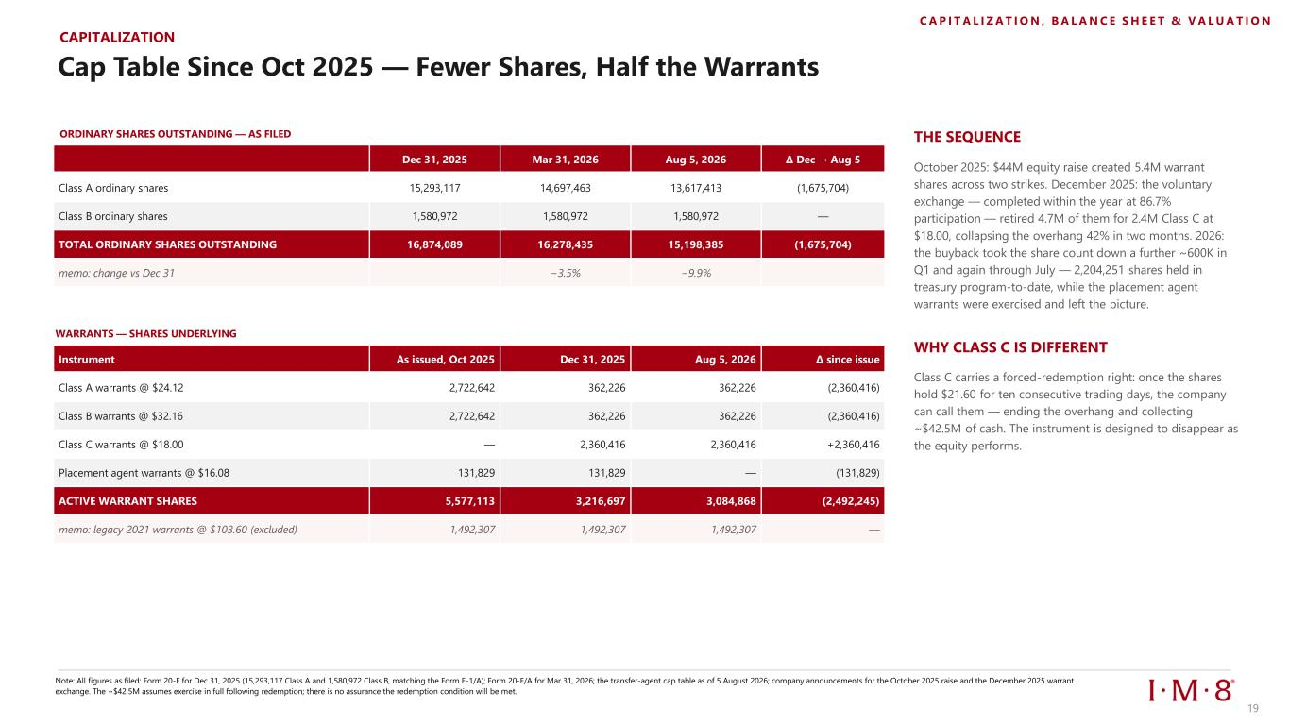
CAPITALIZATION Cap Table Since Oct 2025 — Fewer Shares, Half the Warrants ORDINARY SHARES OUTSTANDING — AS FILED Dec 31, 2025 Mar 31, 2026 Aug 5, 2026 Δ Dec → Aug 5 Class A ordinary shares 15,293,117 14,697,463 13,617,413 (1,675,704) Class B ordinary shares 1,580,972 1,580,972 1,580,972 — TOTAL ORDINARY SHARES OUTSTANDING 16,874,089 16,278,435 15,198,385 (1,675,704) memo: change vs Dec 31 −3.5% −9.9% WARRANTS — SHARES UNDERLYING Instrument As issued, Oct 2025 Dec 31, 2025 Aug 5, 2026 Δ since issue Class A warrants @ $24.12 2,722,642 362,226 362,226 (2,360,416) Class B warrants @ $32.16 2,722,642 362,226 362,226 (2,360,416) Class C warrants @ $18.00 — 2,360,416 2,360,416 +2,360,416 Placement agent warrants @ $16.08 131,829 131,829 — (131,829) ACTIVE WARRANT SHARES 5,577,113 3,216,697 3,084,868 (2,492,245) memo: legacy 2021 warrants @ $103.60 (excluded) 1,492,307 1,492,307 1,492,307 — THE SEQUENCE WHY CLASS C IS DIFFERENT C A P I T A L I Z A T I O N , B A L A N C E S H E E T & V A L U A T I O N Note: All figures as filed: Form 20-F for Dec 31, 2025 (15,293,117 Class A and 1,580,972 Class B, matching the Form F-1/A); Form 20-F/A for Mar 31, 2026; the transfer-agent cap table as of 5 August 2026; company announcements for the October 2025 raise and the December 2025 warrant exchange. The ~$42.5M assumes exercise in full following redemption; there is no assurance the redemption condition will be met. October 2025: $44M equity raise created 5.4M warrant shares across two strikes. December 2025: the voluntary exchange — completed within the year at 86.7% participation — retired 4.7M of them for 2.4M Class C at $18.00, collapsing the overhang 42% in two months. 2026: the buyback took the share count down a further ~600K in Q1 and again through July — 2,204,251 shares held in treasury program-to-date, while the placement agent warrants were exercised and left the picture. Class C carries a forced-redemption right: once the shares hold $21.60 for ten consecutive trading days, the company can call them — ending the overhang and collecting ~$42.5M of cash. The instrument is designed to disappear as the equity performs. 19

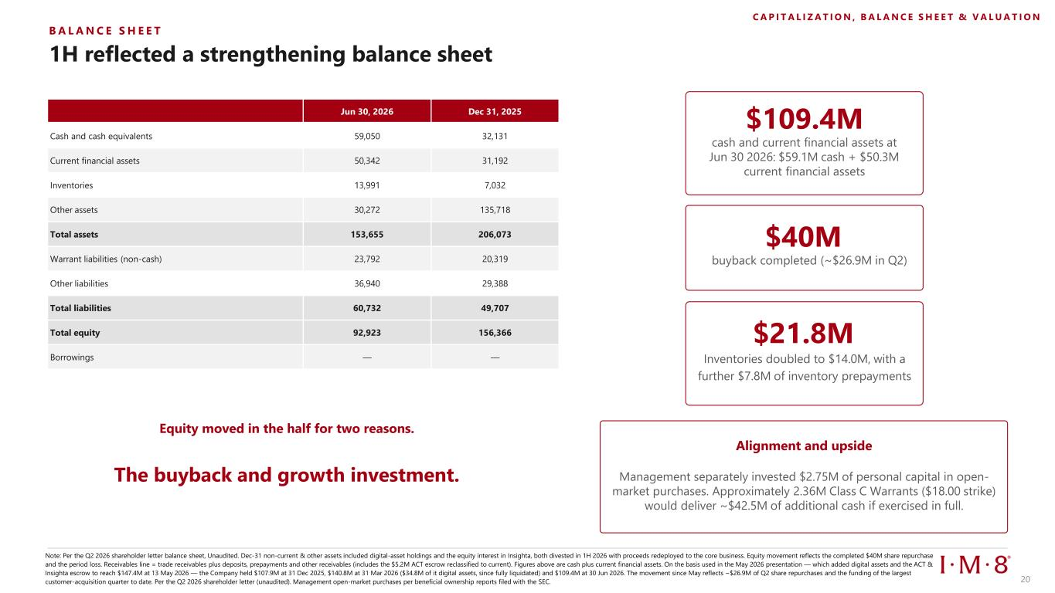
1H reflected a strengthening balance sheet Note: Per the Q2 2026 shareholder letter balance sheet, Unaudited. Dec-31 non-current & other assets included digital-asset holdings and the equity interest in Insighta, both divested in 1H 2026 with proceeds redeployed to the core business. Equity movement reflects the completed $40M share repurchase and the period loss. Receivables line = trade receivables plus deposits, prepayments and other receivables (includes the $5.2M ACT escrow reclassified to current). Figures above are cash plus current financial assets. On the basis used in the May 2026 presentation — which added digital assets and the ACT & Insighta escrow to reach $147.4M at 13 May 2026 — the Company held $107.9M at 31 Dec 2025, $140.8M at 31 Mar 2026 ($34.8M of it digital assets, since fully liquidated) and $109.4M at 30 Jun 2026. The movement since May reflects ~$26.9M of Q2 share repurchases and the funding of the largest customer-acquisition quarter to date. Per the Q2 2026 shareholder letter (unaudited). Management open-market purchases per beneficial ownership reports filed with the SEC. B A L A N C E S H E E T $109.4M cash and current financial assets at Jun 30 2026: $59.1M cash + $50.3M current financial assets $40M buyback completed (~$26.9M in Q2) $21.8M Inventories doubled to $14.0M, with a further $7.8M of inventory prepayments Equity moved in the half for two reasons. The buyback and growth investment. Alignment and upside Management separately invested $2.75M of personal capital in open- market purchases. Approximately 2.36M Class C Warrants ($18.00 strike) would deliver ~$42.5M of additional cash if exercised in full. C A P I T A L I Z A T I O N , B A L A N C E S H E E T & V A L U A T I O N Jun 30, 2026 Dec 31, 2025 Cash and cash equivalents 59,050 32,131 Current financial assets 50,342 31,192 Inventories 13,991 7,032 Other assets 30,272 135,718 Total assets 153,655 206,073 Warrant liabilities (non-cash) 23,792 20,319 Other liabilities 36,940 29,388 Total liabilities 60,732 49,707 Total equity 92,923 156,366 Borrowings — — 20

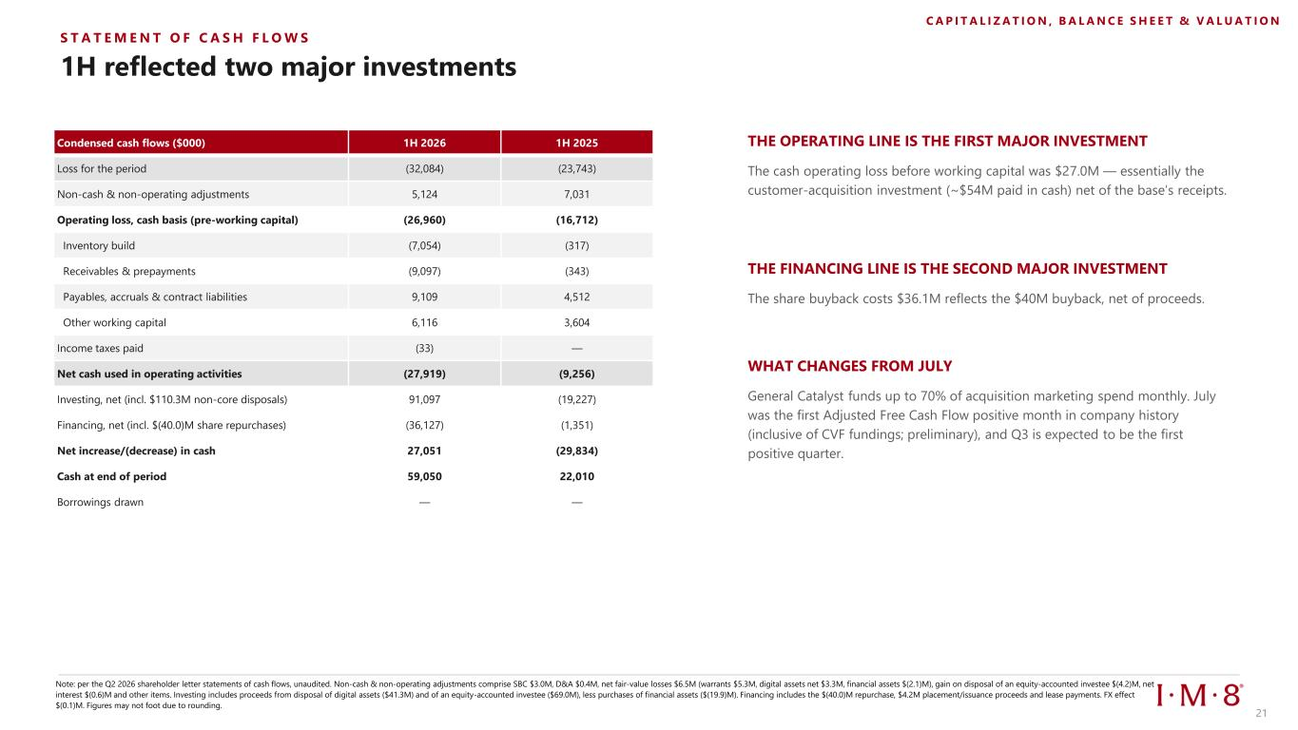
1H reflected two major investments THE OPERATING LINE IS THE FIRST MAJOR INVESTMENT WHAT CHANGES FROM JULY Note: per the Q2 2026 shareholder letter statements of cash flows, unaudited. Non-cash & non-operating adjustments comprise SBC $3.0M, D&A $0.4M, net fair-value losses $6.5M (warrants $5.3M, digital assets net $3.3M, financial assets $(2.1)M), gain on disposal of an equity-accounted investee $(4.2)M, net interest $(0.6)M and other items. Investing includes proceeds from disposal of digital assets ($41.3M) and of an equity-accounted investee ($69.0M), less purchases of financial assets ($(19.9)M). Financing includes the $(40.0)M repurchase, $4.2M placement/issuance proceeds and lease payments. FX effect $(0.1)M. Figures may not foot due to rounding. Condensed cash flows ($000) 1H 2026 1H 2025 Loss for the period (32,084) (23,743) Non-cash & non-operating adjustments 5,124 7,031 Operating loss, cash basis (pre-working capital) (26,960) (16,712) Inventory build (7,054) (317) Receivables & prepayments (9,097) (343) Payables, accruals & contract liabilities 9,109 4,512 Other working capital 6,116 3,604 Income taxes paid (33) — Net cash used in operating activities (27,919) (9,256) Investing, net (incl. $110.3M non-core disposals) 91,097 (19,227) Financing, net (incl. $(40.0)M share repurchases) (36,127) (1,351) Net increase/(decrease) in cash 27,051 (29,834) Cash at end of period 59,050 22,010 Borrowings drawn — — The cash operating loss before working capital was $27.0M — essentially the customer-acquisition investment (~$54M paid in cash) net of the base’s receipts. General Catalyst funds up to 70% of acquisition marketing spend monthly. July was the first Adjusted Free Cash Flow positive month in company history (inclusive of CVF fundings; preliminary), and Q3 is expected to be the first positive quarter. S T A T E M E N T O F C A S H F L O W S C A P I T A L I Z A T I O N , B A L A N C E S H E E T & V A L U A T I O N THE FINANCING LINE IS THE SECOND MAJOR INVESTMENT The share buyback costs $36.1M reflects the $40M buyback, net of proceeds. 21

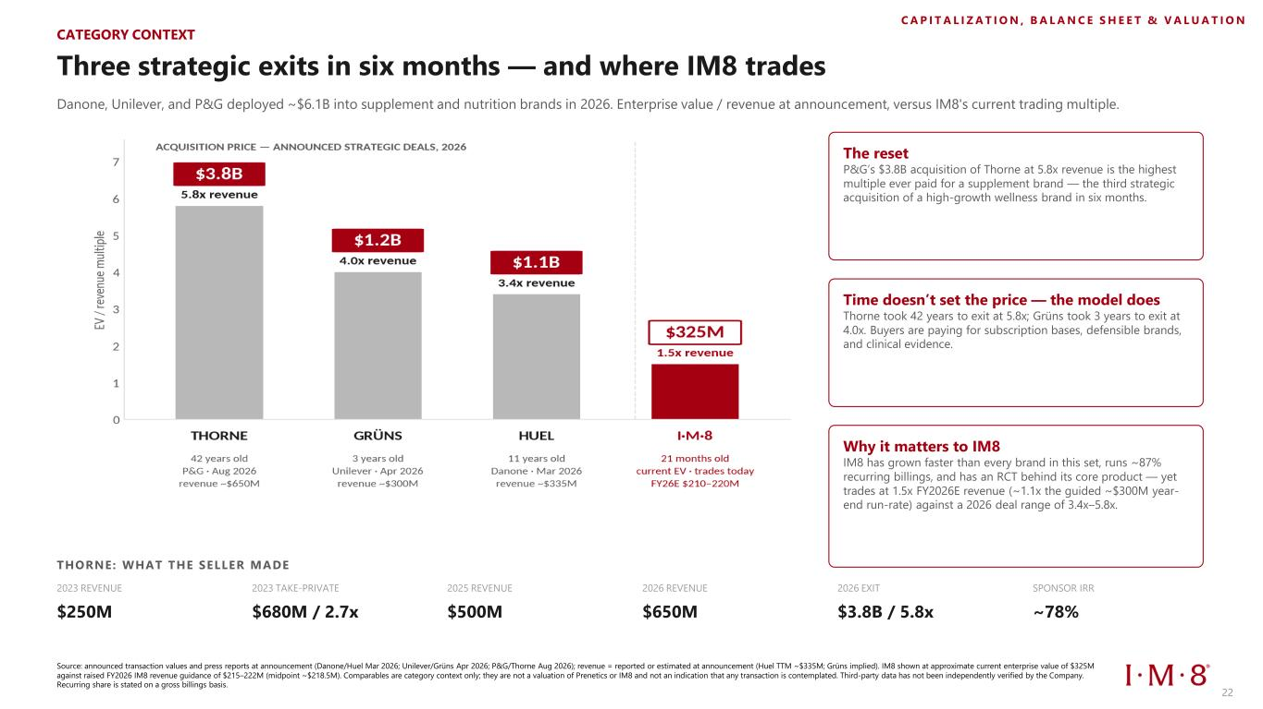
Three strategic exits in six months — and where IM8 trades Danone, Unilever, and P&G deployed ~$6.1B into supplement and nutrition brands in 2026. Enterprise value / revenue at announcement, versus IM8's current trading multiple. The reset P&G’s $3.8B acquisition of Thorne at 5.8x revenue is the highest multiple ever paid for a supplement brand — the third strategic acquisition of a high-growth wellness brand in six months. Time doesn’t set the price — the model does Thorne took 42 years to exit at 5.8x; Grüns took 3 years to exit at 4.0x. Buyers are paying for subscription bases, defensible brands, and clinical evidence. Why it matters to IM8 IM8 has grown faster than every brand in this set, runs ~87% recurring billings, and has an RCT behind its core product — yet trades at 1.5x FY2026E revenue (~1.1x the guided ~$300M year- end run-rate) against a 2026 deal range of 3.4x–5.8x. THORNE: WHAT THE SELLER MADE 2023 REVENUE $250M 2023 TAKE-PRIVATE $680M / 2.7x 2025 REVENUE $500M 2026 REVENUE $650M 2026 EXIT $3.8B / 5.8x SPONSOR IRR ~78% Source: announced transaction values and press reports at announcement (Danone/Huel Mar 2026; Unilever/Grüns Apr 2026; P&G/Thorne Aug 2026); revenue = reported or estimated at announcement (Huel TTM ~$335M; Grüns implied). IM8 shown at approximate current enterprise value of $325M against raised FY2026 IM8 revenue guidance of $215–222M (midpoint ~$218.5M). Comparables are category context only; they are not a valuation of Prenetics or IM8 and not an indication that any transaction is contemplated. Third-party data has not been independently verified by the Company. Recurring share is stated on a gross billings basis. C A P I T A L I Z A T I O N , B A L A N C E S H E E T & V A L U A T I O N CATEGORY CONTEXT 22

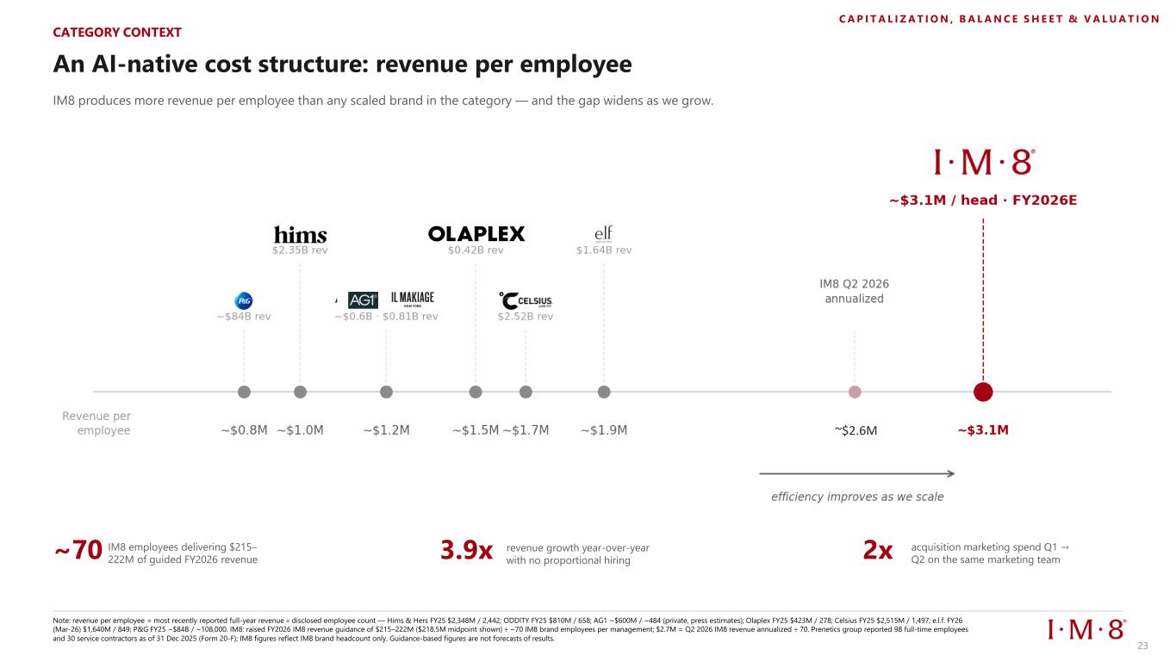
An AI-native cost structure: revenue per employee IM8 produces more revenue per employee than any scaled brand in the category — and the gap widens as we grow. ~70 IM8 employees delivering $215– 222M of guided FY2026 revenue 3.9x revenue growth year-over-year with no proportional hiring 2x acquisition marketing spend Q1 → Q2 on the same marketing team Note: revenue per employee = most recently reported full-year revenue ÷ disclosed employee count — Hims & Hers FY25 $2,348M / 2,442; ODDITY FY25 $810M / 658; AG1 ~$600M / ~484 (private, press estimates); Olaplex FY25 $423M / 278; Celsius FY25 $2,515M / 1,497; e.l.f. FY26 (Mar-26) $1,640M / 849; P&G FY25 ~$84B / ~108,000. IM8: raised FY2026 IM8 revenue guidance of $215–222M ($218.5M midpoint shown) ÷ ~70 IM8 brand employees per management; $2.7M = Q2 2026 IM8 revenue annualized ÷ 70. Prenetics group reported 98 full-time employees and 30 service contractors as of 31 Dec 2025 (Form 20-F); IM8 figures reflect IM8 brand headcount only. Guidance-based figures are not forecasts of results. CATEGORY CONTEXT C A P I T A L I Z A T I O N , B A L A N C E S H E E T & V A L U A T I O N ~$2.6M 23

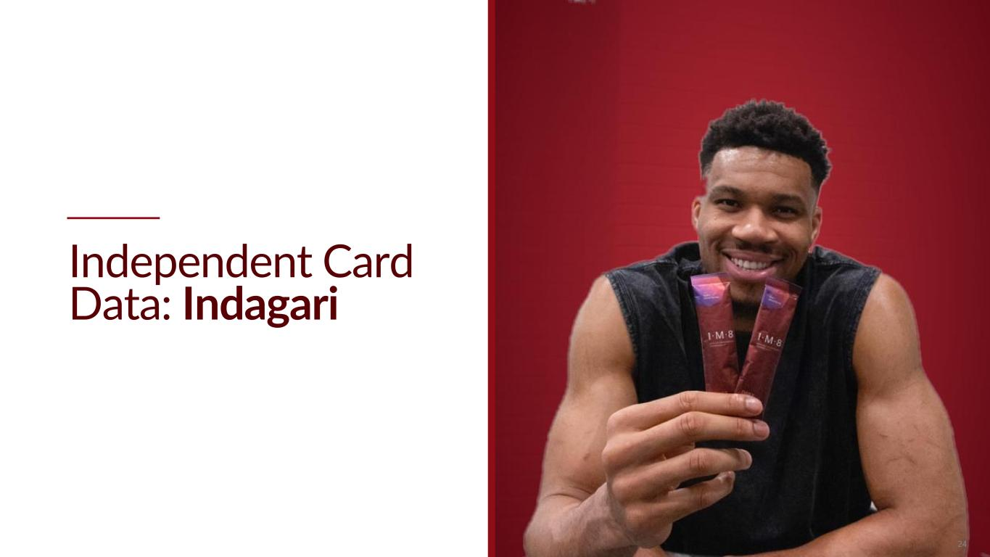
Independent Card Data: Indagari 24 24

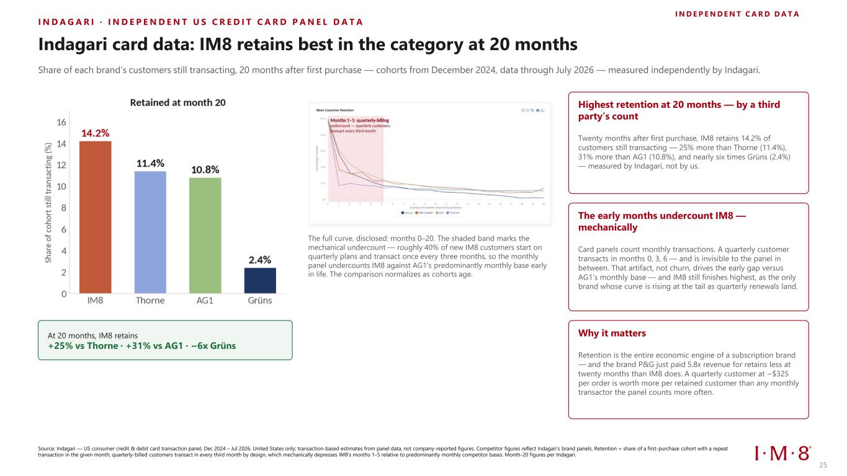
I N D A G A R I · I N D E P E N D E N T U S C R E D I T C A R D P A N E L D A T A I N D E P E N D E N T C A R D D A T A Indagari card data: IM8 retains best in the category at 20 months Share of each brand’s customers still transacting, 20 months after first purchase — cohorts from December 2024, data through July 2026 — measured independently by Indagari. At 20 months, IM8 retains +25% vs Thorne · +31% vs AG1 · ~6x Grüns The full curve, disclosed: months 0–20. The shaded band marks the mechanical undercount — roughly 40% of new IM8 customers start on quarterly plans and transact once every three months, so the monthly panel undercounts IM8 against AG1’s predominantly monthly base early in life. The comparison normalizes as cohorts age. Source: Indagari — US consumer credit & debit card transaction panel, Dec 2024 – Jul 2026. United States only; transaction-based estimates from panel data, not company-reported figures. Competitor figures reflect Indagari’s brand panels. Retention = share of a first-purchase cohort with a repeat transaction in the given month; quarterly-billed customers transact in every third month by design, which mechanically depresses IM8’s months 1–5 relative to predominantly monthly competitor bases. Month-20 figures per Indagari. Highest retention at 20 months — by a third party’s count Twenty months after first purchase, IM8 retains 14.2% of customers still transacting — 25% more than Thorne (11.4%), 31% more than AG1 (10.8%), and nearly six times Grüns (2.4%) — measured by Indagari, not by us. The early months undercount IM8 — mechanically Card panels count monthly transactions. A quarterly customer transacts in months 0, 3, 6 — and is invisible to the panel in between. That artifact, not churn, drives the early gap versus AG1’s monthly base — and IM8 still finishes highest, as the only brand whose curve is rising at the tail as quarterly renewals land. Why it matters Retention is the entire economic engine of a subscription brand — and the brand P&G just paid 5.8x revenue for retains less at twenty months than IM8 does. A quarterly customer at ~$325 per order is worth more per retained customer than any monthly transactor the panel counts more often. 25

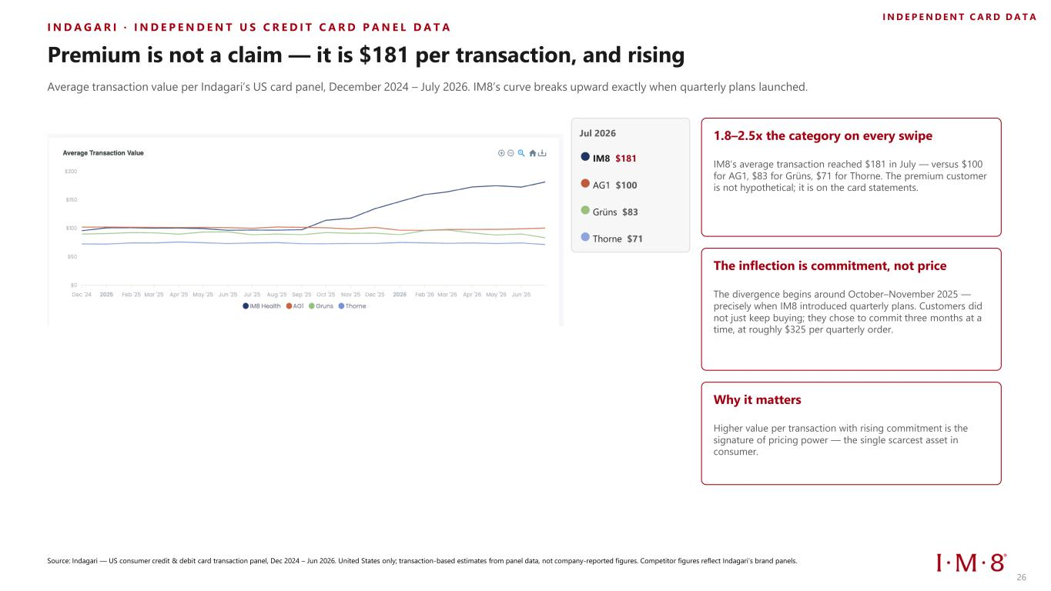
I N D A G A R I · I N D E P E N D E N T U S C R E D I T C A R D P A N E L D A T A Premium is not a claim — it is $181 per transaction, and rising Average transaction value per Indagari’s US card panel, December 2024 – July 2026. IM8’s curve breaks upward exactly when quarterly plans launched. Jul 2026 IM8 $181 AG1 $100 Grüns $83 Thorne $71 Source: Indagari — US consumer credit & debit card transaction panel, Dec 2024 – Jun 2026. United States only; transaction-based estimates from panel data, not company-reported figures. Competitor figures reflect Indagari’s brand panels. I N D E P E N D E N T C A R D D A T A 1.8–2.5x the category on every swipe IM8’s average transaction reached $181 in July — versus $100 for AG1, $83 for Grüns, $71 for Thorne. The premium customer is not hypothetical; it is on the card statements. The inflection is commitment, not price The divergence begins around October–November 2025 — precisely when IM8 introduced quarterly plans. Customers did not just keep buying; they chose to commit three months at a time, at roughly $325 per quarterly order. Why it matters Higher value per transaction with rising commitment is the signature of pricing power — the single scarcest asset in consumer. 26

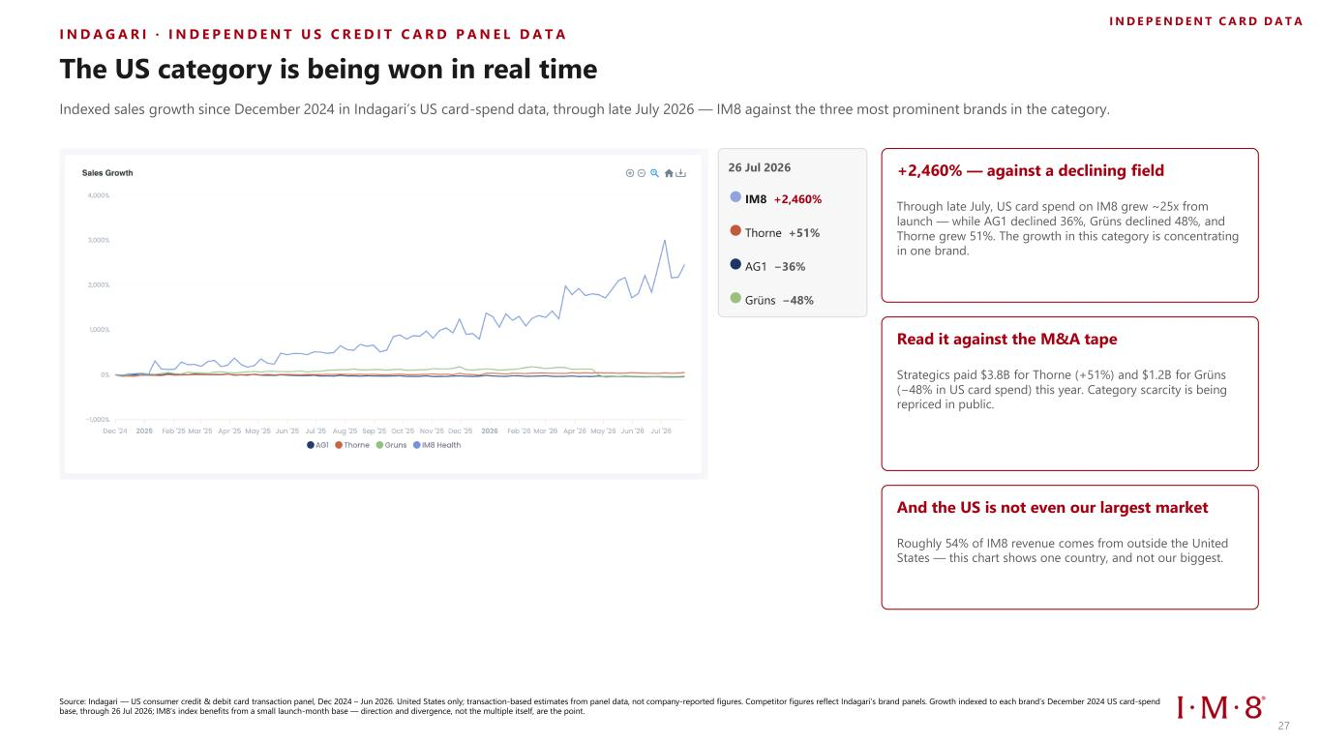
I N D A G A R I · I N D E P E N D E N T U S C R E D I T C A R D P A N E L D A T A The US category is being won in real time Indexed sales growth since December 2024 in Indagari’s US card-spend data, through late July 2026 — IM8 against the three most prominent brands in the category. 26 Jul 2026 IM8 +2,460% Thorne +51% AG1 −36% Grüns −48% Source: Indagari — US consumer credit & debit card transaction panel, Dec 2024 – Jun 2026. United States only; transaction-based estimates from panel data, not company-reported figures. Competitor figures reflect Indagari’s brand panels. Growth indexed to each brand’s December 2024 US card-spend base, through 26 Jul 2026; IM8’s index benefits from a small launch-month base — direction and divergence, not the multiple itself, are the point. I N D E P E N D E N T C A R D D A T A +2,460% — against a declining field Through late July, US card spend on IM8 grew ~25x from launch — while AG1 declined 36%, Grüns declined 48%, and Thorne grew 51%. The growth in this category is concentrating in one brand. Read it against the M&A tape Strategics paid $3.8B for Thorne (+51%) and $1.2B for Grüns (−48% in US card spend) this year. Category scarcity is being repriced in public. And the US is not even our largest market Roughly 54% of IM8 revenue comes from outside the United States — this chart shows one country, and not our biggest. 27

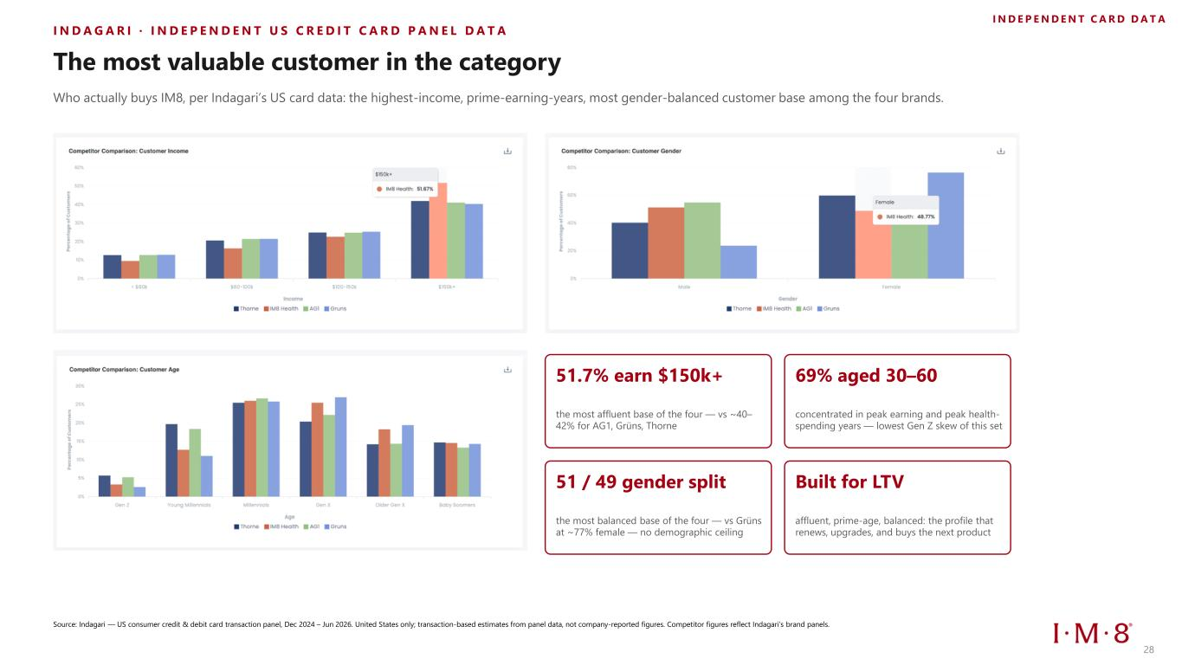
I N D A G A R I · I N D E P E N D E N T U S C R E D I T C A R D P A N E L D A T A The most valuable customer in the category Who actually buys IM8, per Indagari’s US card data: the highest-income, prime-earning-years, most gender-balanced customer base among the four brands. Source: Indagari — US consumer credit & debit card transaction panel, Dec 2024 – Jun 2026. United States only; transaction-based estimates from panel data, not company-reported figures. Competitor figures reflect Indagari’s brand panels. I N D E P E N D E N T C A R D D A T A 51.7% earn $150k+ the most affluent base of the four — vs ~40– 42% for AG1, Grüns, Thorne 69% aged 30–60 concentrated in peak earning and peak health- spending years — lowest Gen Z skew of this set 51 / 49 gender split the most balanced base of the four — vs Grüns at ~77% female — no demographic ceiling Built for LTV affluent, prime-age, balanced: the profile that renews, upgrades, and buys the next product 28


Growth & Momentum 29 29

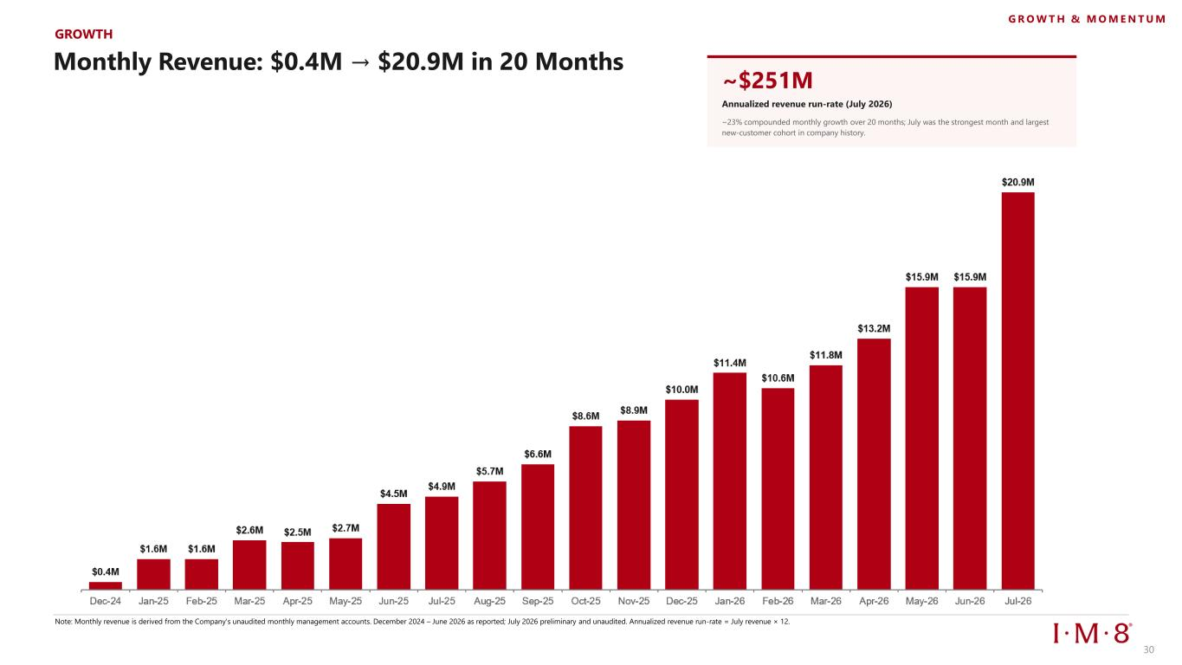
GROWTH Monthly Revenue: $0.4M → $20.9M in 20 Months ~$251M Annualized revenue run-rate (July 2026) ~23% compounded monthly growth over 20 months; July was the strongest month and largest new-customer cohort in company history. Note: Monthly revenue is derived from the Company's unaudited monthly management accounts. December 2024 – June 2026 as reported; July 2026 preliminary and unaudited. Annualized revenue run-rate = July revenue × 12. G R O W T H & M O M E N T U M 30

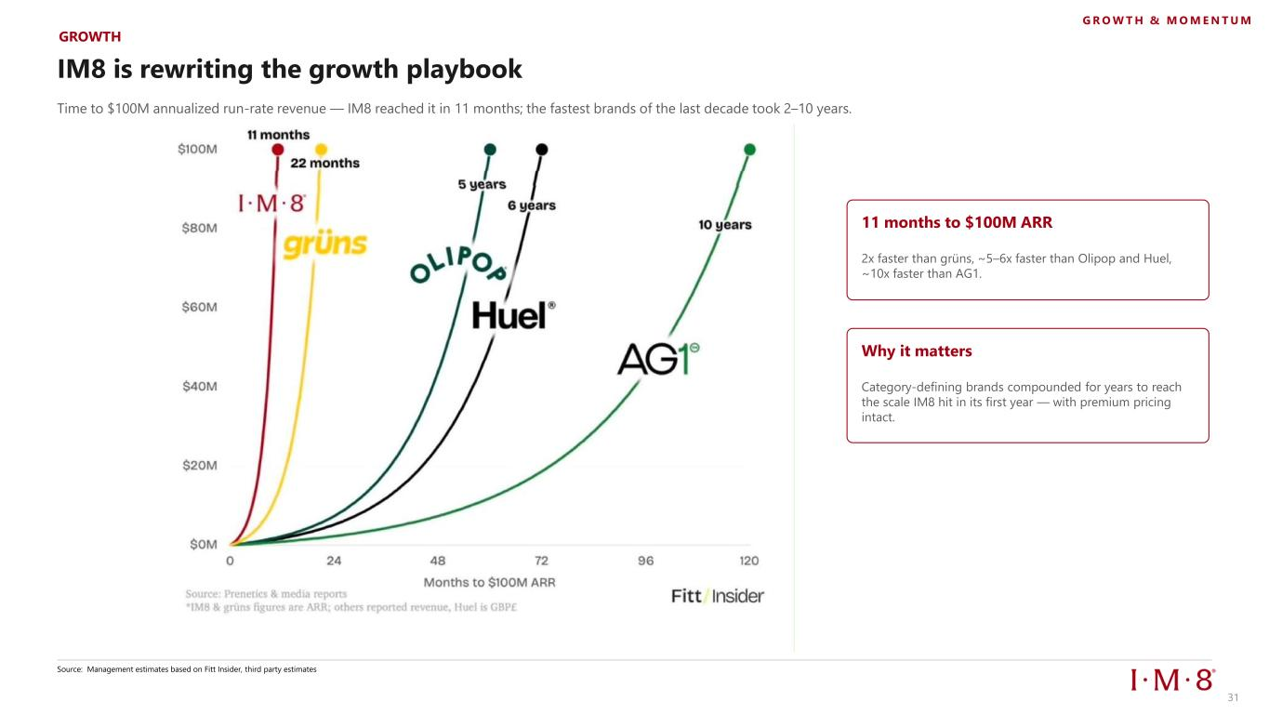
IM8 is rewriting the growth playbook Time to $100M annualized run-rate revenue — IM8 reached it in 11 months; the fastest brands of the last decade took 2–10 years. Source: Management estimates based on Fitt Insider, third party estimates GROWTH G R O W T H & M O M E N T U M 11 months to $100M ARR 2x faster than grüns, ~5–6x faster than Olipop and Huel, ~10x faster than AG1. Why it matters Category-defining brands compounded for years to reach the scale IM8 hit in its first year — with premium pricing intact. 31

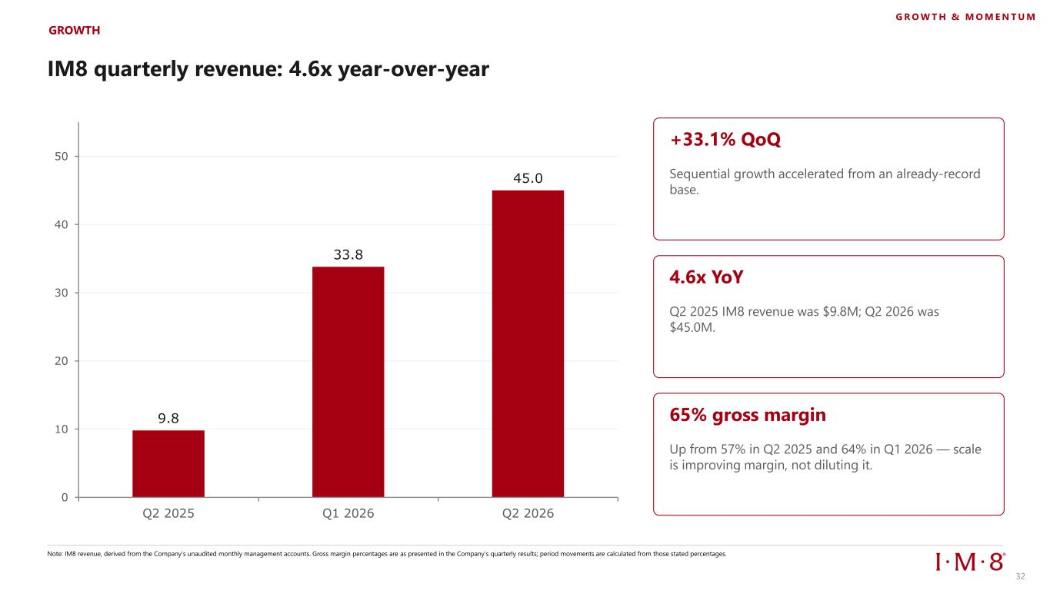
IM8 quarterly revenue: 4.6x year-over-year 9.8 33.8 45.0 0 10 20 30 40 50 Q2 2025 Q1 2026 Q2 2026 GROWTH G R O W T H & M O M E N T U M Note: IM8 revenue, derived from the Company's unaudited monthly management accounts. Gross margin percentages are as presented in the Company's quarterly results; period movements are calculated from those stated percentages. +33.1% QoQ Sequential growth accelerated from an already-record base. 4.6x YoY Q2 2025 IM8 revenue was $9.8M; Q2 2026 was $45.0M. 65% gross margin Up from 57% in Q2 2025 and 64% in Q1 2026 — scale is improving margin, not diluting it. 32

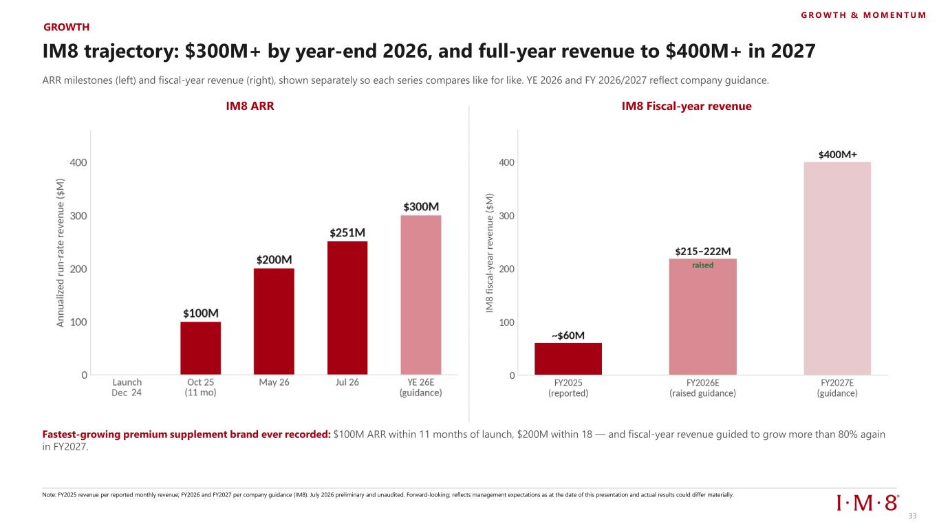
IM8 trajectory: $300M+ by year-end 2026, and full-year revenue to $400M+ in 2027 ARR milestones (left) and fiscal-year revenue (right), shown separately so each series compares like for like. YE 2026 and FY 2026/2027 reflect company guidance. IM8 ARR IM8 Fiscal-year revenue Fastest-growing premium supplement brand ever recorded: $100M ARR within 11 months of launch, $200M within 18 — and fiscal-year revenue guided to grow more than 80% again in FY2027. Note: FY2025 revenue per reported monthly revenue; FY2026 and FY2027 per company guidance (IM8). July 2026 preliminary and unaudited. Forward-looking; reflects management expectations as at the date of this presentation and actual results could differ materially. GROWTH G R O W T H & M O M E N T U M Dec 33

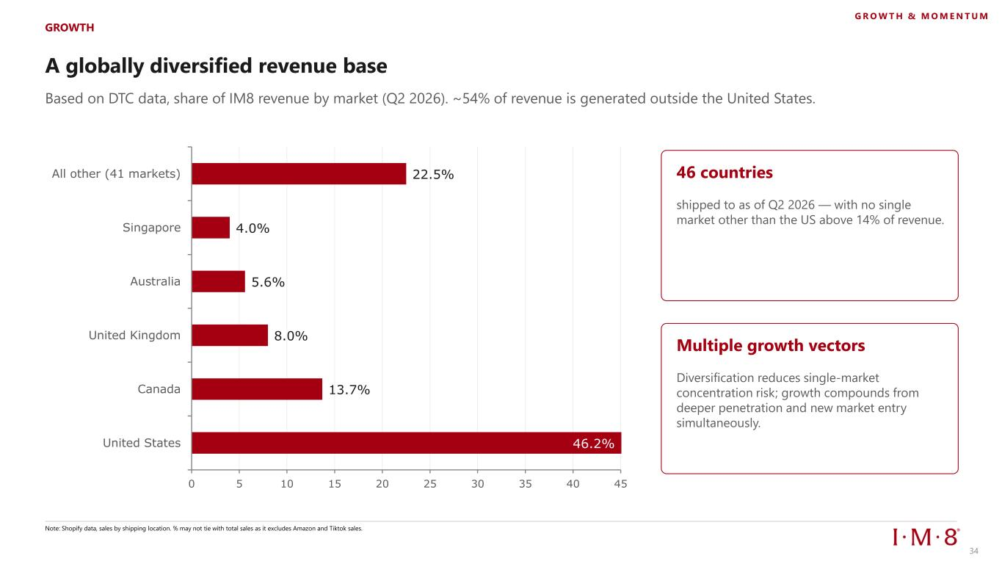
A globally diversified revenue base GROWTH G R O W T H & M O M E N T U M Based on DTC data, share of IM8 revenue by market (Q2 2026). ~54% of revenue is generated outside the United States. 46.2% 13.7% 8.0% 5.6% 4.0% 22.5% 0 5 10 15 20 25 30 35 40 45 United States Canada United Kingdom Australia Singapore All other (41 markets) Note: Shopify data, sales by shipping location. % may not tie with total sales as it excludes Amazon and Tiktok sales. 46 countries shipped to as of Q2 2026 — with no single market other than the US above 14% of revenue. Multiple growth vectors Diversification reduces single-market concentration risk; growth compounds from deeper penetration and new market entry simultaneously. 34


Subscription Engine 35

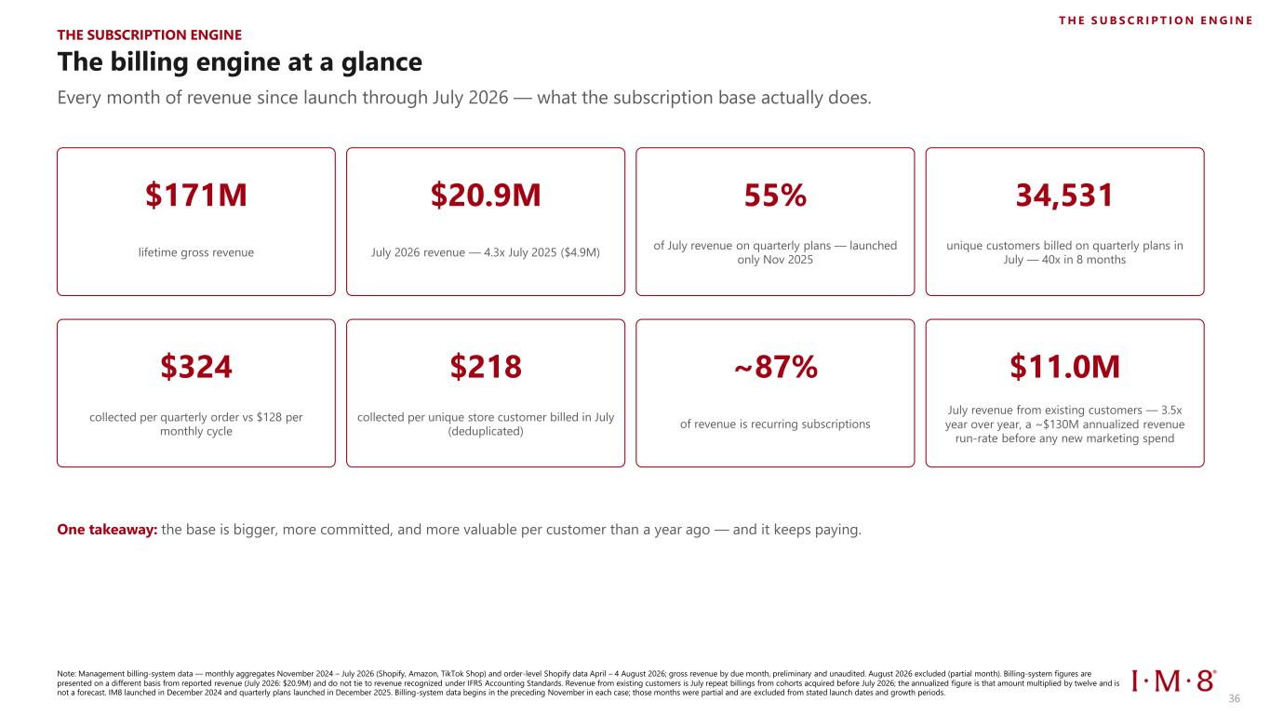
The billing engine at a glance Every month of revenue since launch through July 2026 — what the subscription base actually does. Note: Management billing-system data — monthly aggregates November 2024 – July 2026 (Shopify, Amazon, TikTok Shop) and order-level Shopify data April – 4 August 2026; gross revenue by due month, preliminary and unaudited. August 2026 excluded (partial month). Billing-system figures are presented on a different basis from reported revenue (July 2026: $20.9M) and do not tie to revenue recognized under IFRS Accounting Standards. Revenue from existing customers is July repeat billings from cohorts acquired before July 2026; the annualized figure is that amount multiplied by twelve and is not a forecast. IM8 launched in December 2024 and quarterly plans launched in December 2025. Billing-system data begins in the preceding November in each case; those months were partial and are excluded from stated launch dates and growth periods. $171M lifetime gross revenue $20.9M July 2026 revenue — 4.3x July 2025 ($4.9M) 55% of July revenue on quarterly plans — launched only Nov 2025 34,531 unique customers billed on quarterly plans in July — 40x in 8 months $324 collected per quarterly order vs $128 per monthly cycle $218 collected per unique store customer billed in July (deduplicated) ~87% of revenue is recurring subscriptions $11.0M July revenue from existing customers — 3.5x year over year, a ~$130M annualized revenue run-rate before any new marketing spend One takeaway: the base is bigger, more committed, and more valuable per customer than a year ago — and it keeps paying. THE SUBSCRIPTION ENGINE T H E S U B S C R I P T I O N E N G I N E 36

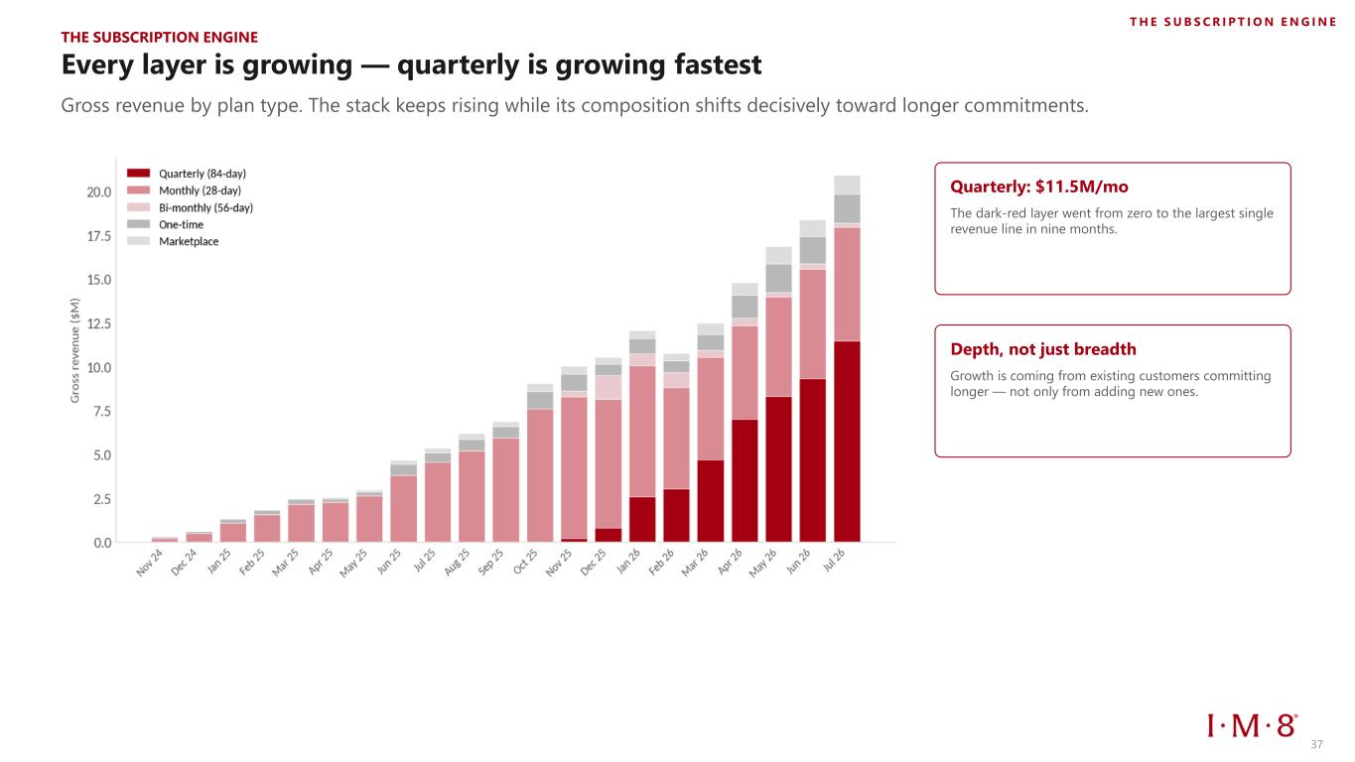
Every layer is growing — quarterly is growing fastest Gross revenue by plan type. The stack keeps rising while its composition shifts decisively toward longer commitments. Quarterly: $11.5M/mo The dark-red layer went from zero to the largest single revenue line in nine months. Depth, not just breadth Growth is coming from existing customers committing longer — not only from adding new ones. THE SUBSCRIPTION ENGINE T H E S U B S C R I P T I O N E N G I N E 37

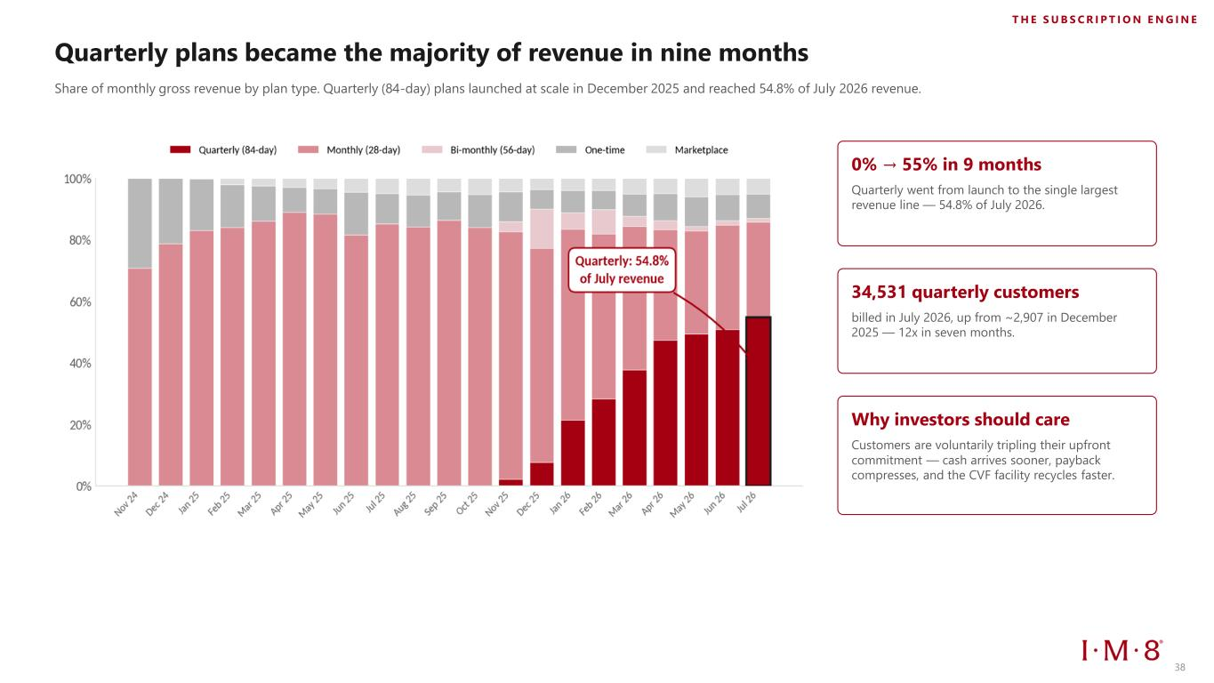
Quarterly plans became the majority of revenue in nine months Share of monthly gross revenue by plan type. Quarterly (84-day) plans launched at scale in December 2025 and reached 54.8% of July 2026 revenue. 0% → 55% in 9 months Quarterly went from launch to the single largest revenue line — 54.8% of July 2026. 34,531 quarterly customers billed in July 2026, up from ~2,907 in December 2025 — 12x in seven months. Why investors should care Customers are voluntarily tripling their upfront commitment — cash arrives sooner, payback compresses, and the CVF facility recycles faster. T H E S U B S C R I P T I O N E N G I N E 38

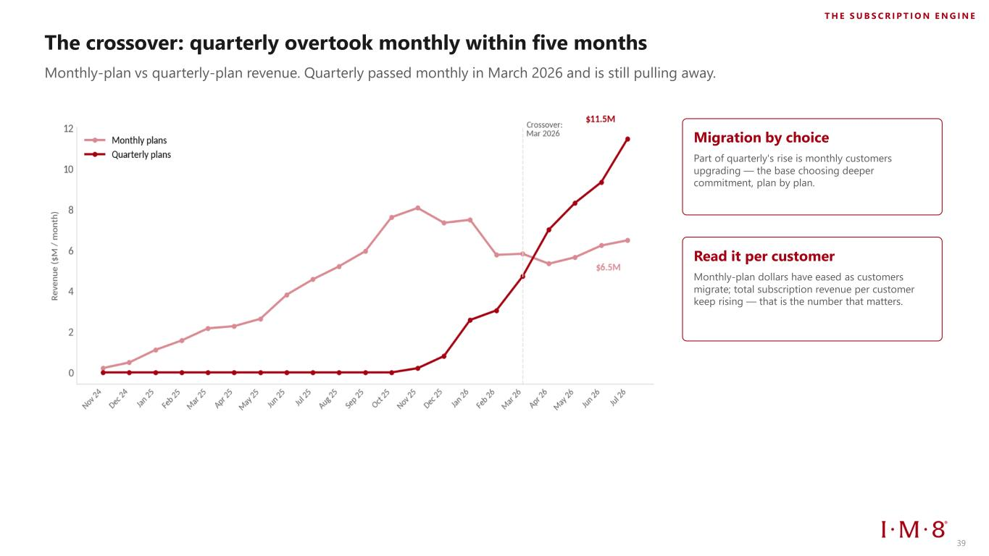
The crossover: quarterly overtook monthly within five months Monthly-plan vs quarterly-plan revenue. Quarterly passed monthly in March 2026 and is still pulling away. Migration by choice Part of quarterly's rise is monthly customers upgrading — the base choosing deeper commitment, plan by plan. Read it per customer Monthly-plan dollars have eased as customers migrate; total subscription revenue per customer keep rising — that is the number that matters. T H E S U B S C R I P T I O N E N G I N E 39

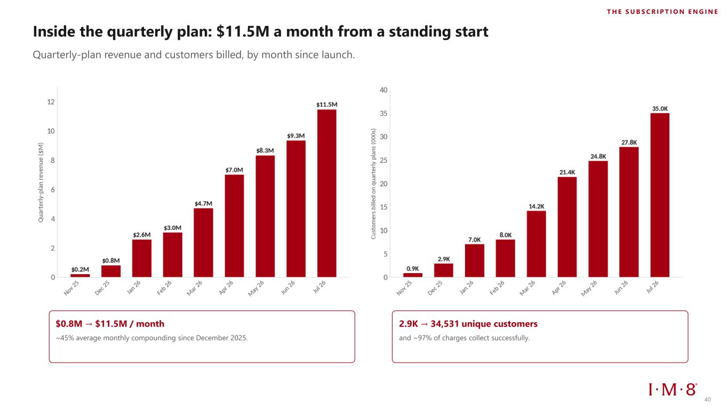
Inside the quarterly plan: $11.5M a month from a standing start Quarterly-plan revenue and customers billed, by month since launch. $0.8M → $11.5M / month ~45% average monthly compounding since December 2025. 2.9K → 34,531 unique customers and ~97% of charges collect successfully. T H E S U B S C R I P T I O N E N G I N E 40

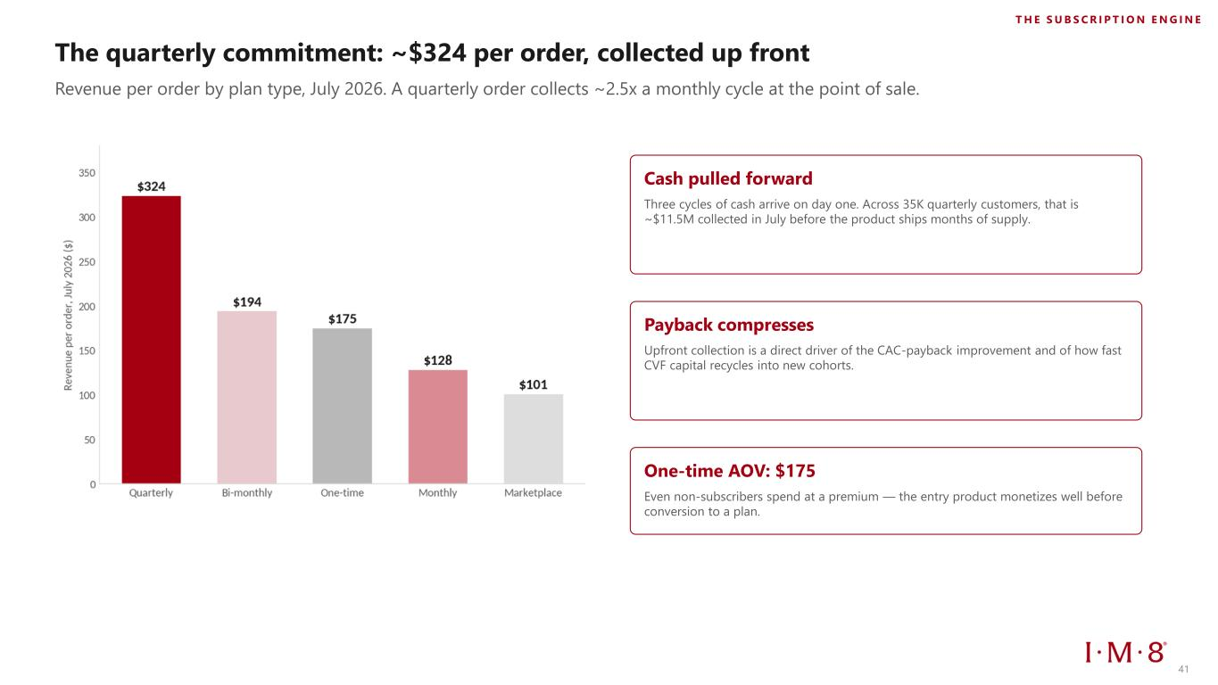
The quarterly commitment: ~$324 per order, collected up front Revenue per order by plan type, July 2026. A quarterly order collects ~2.5x a monthly cycle at the point of sale. Cash pulled forward Three cycles of cash arrive on day one. Across 35K quarterly customers, that is ~$11.5M collected in July before the product ships months of supply. Payback compresses Upfront collection is a direct driver of the CAC-payback improvement and of how fast CVF capital recycles into new cohorts. One-time AOV: $175 Even non-subscribers spend at a premium — the entry product monetizes well before conversion to a plan. T H E S U B S C R I P T I O N E N G I N E 41

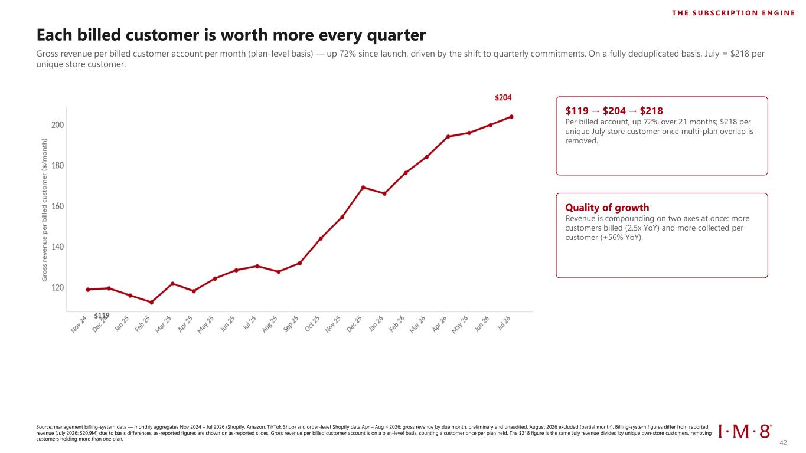
Each billed customer is worth more every quarter Gross revenue per billed customer account per month (plan-level basis) — up 72% since launch, driven by the shift to quarterly commitments. On a fully deduplicated basis, July = $218 per unique store customer. Source: management billing-system data — monthly aggregates Nov 2024 – Jul 2026 (Shopify, Amazon, TikTok Shop) and order-level Shopify data Apr – Aug 4 2026; gross revenue by due month, preliminary and unaudited. August 2026 excluded (partial month). Billing-system figures differ from reported revenue (July 2026: $20.9M) due to basis differences; as-reported figures are shown on as-reported slides. Gross revenue per billed customer account is on a plan-level basis, counting a customer once per plan held. The $218 figure is the same July revenue divided by unique own-store customers, removing customers holding more than one plan. $119 → $204 → $218 Per billed account, up 72% over 21 months; $218 per unique July store customer once multi-plan overlap is removed. Quality of growth Revenue is compounding on two axes at once: more customers billed (2.5x YoY) and more collected per customer (+56% YoY). T H E S U B S C R I P T I O N E N G I N E 42

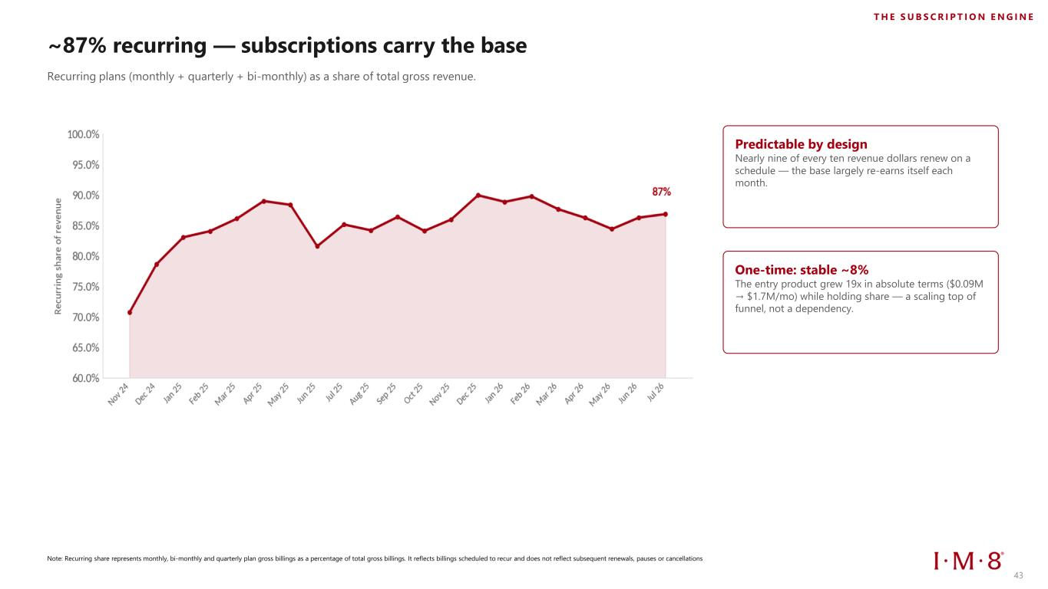
~87% recurring — subscriptions carry the base Recurring plans (monthly + quarterly + bi-monthly) as a share of total gross revenue. Note: Recurring share represents monthly, bi-monthly and quarterly plan gross billings as a percentage of total gross billings. It reflects billings scheduled to recur and does not reflect subsequent renewals, pauses or cancellations Predictable by design Nearly nine of every ten revenue dollars renew on a schedule — the base largely re-earns itself each month. One-time: stable ~8% The entry product grew 19x in absolute terms ($0.09M → $1.7M/mo) while holding share — a scaling top of funnel, not a dependency. T H E S U B S C R I P T I O N E N G I N E 43

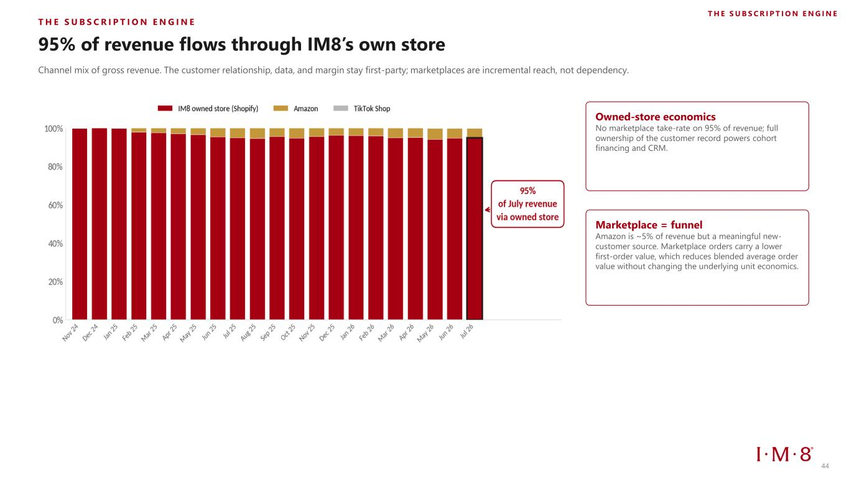
T H E S U B S C R I P T I O N E N G I N E 95% of revenue flows through IM8’s own store Channel mix of gross revenue. The customer relationship, data, and margin stay first-party; marketplaces are incremental reach, not dependency. Owned-store economics No marketplace take-rate on 95% of revenue; full ownership of the customer record powers cohort financing and CRM. Marketplace = funnel Amazon is ~5% of revenue but a meaningful new- customer source. Marketplace orders carry a lower first-order value, which reduces blended average order value without changing the underlying unit economics. T H E S U B S C R I P T I O N E N G I N E 44


Unit Economics & Cohort Performance 45 45

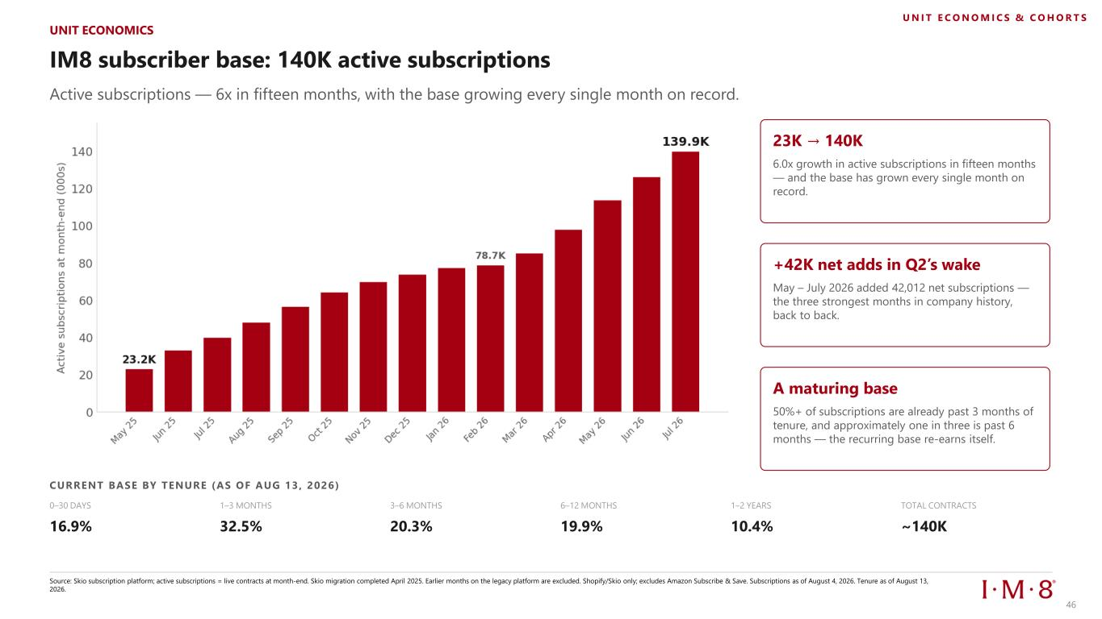
IM8 subscriber base: 140K active subscriptions Active subscriptions — 6x in fifteen months, with the base growing every single month on record. 23K → 140K 6.0x growth in active subscriptions in fifteen months — and the base has grown every single month on record. +42K net adds in Q2’s wake May – July 2026 added 42,012 net subscriptions — the three strongest months in company history, back to back. A maturing base 50%+ of subscriptions are already past 3 months of tenure, and approximately one in three is past 6 months — the recurring base re-earns itself. CURRENT BASE BY TENURE (AS OF AUG 13, 2026) 0–30 DAYS 16.9% 1–3 MONTHS 32.5% 3–6 MONTHS 20.3% 6–12 MONTHS 19.9% 1–2 YEARS 10.4% TOTAL CONTRACTS ~140K Source: Skio subscription platform; active subscriptions = live contracts at month-end. Skio migration completed April 2025. Earlier months on the legacy platform are excluded. Shopify/Skio only; excludes Amazon Subscribe & Save. Subscriptions as of August 4, 2026. Tenure as of August 13, 2026. UNIT ECONOMICS U N I T E C O N O M I C S & C O H O R T S 46

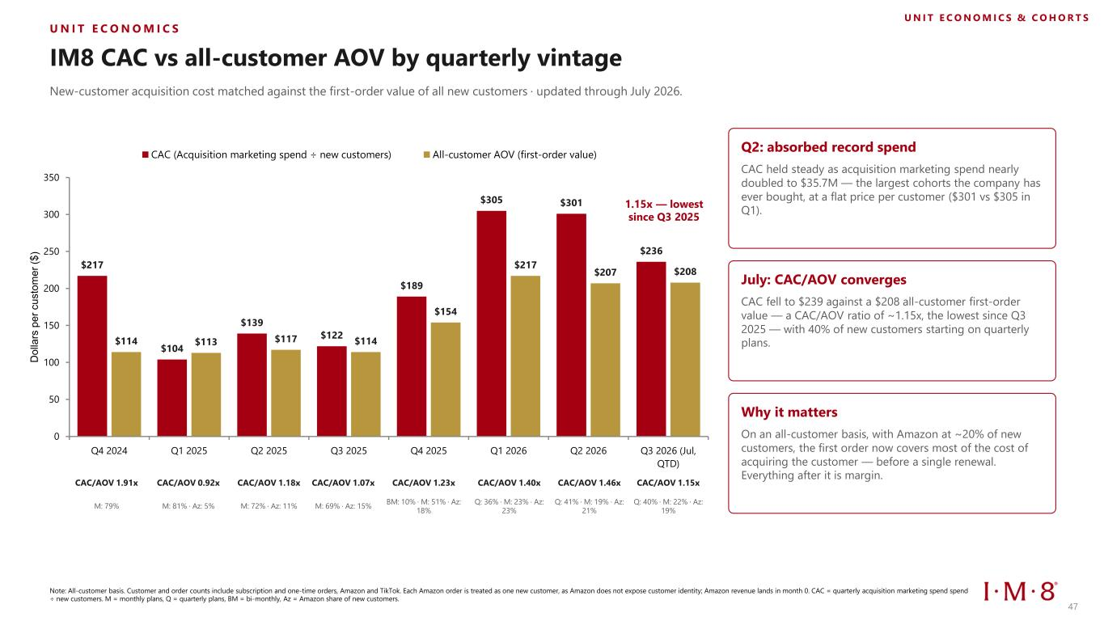
U N I T E C O N O M I C S IM8 CAC vs all-customer AOV by quarterly vintage New-customer acquisition cost matched against the first-order value of all new customers · updated through July 2026. $217 $104 $139 $122 $189 $305 $301 $236 $114 $113 $117 $114 $154 $217 $207 $208 0 50 100 150 200 250 300 350 Q4 2024 Q1 2025 Q2 2025 Q3 2025 Q4 2025 Q1 2026 Q2 2026 Q3 2026 (Jul, QTD) D o lla rs p e r c u s to m e r ($ ) CAC (Acquisition marketing spend ÷ new customers) All-customer AOV (first-order value) CAC/AOV 1.91x M: 79% CAC/AOV 0.92x M: 81% · Az: 5% CAC/AOV 1.18x M: 72% · Az: 11% CAC/AOV 1.07x M: 69% · Az: 15% CAC/AOV 1.23x BM: 10% · M: 51% · Az: 18% CAC/AOV 1.40x Q: 36% · M: 23% · Az: 23% CAC/AOV 1.46x Q: 41% · M: 19% · Az: 21% CAC/AOV 1.15x Q: 40% · M: 22% · Az: 19% 1.15x — lowest since Q3 2025 Q2: absorbed record spend CAC held steady as acquisition marketing spend nearly doubled to $35.7M — the largest cohorts the company has ever bought, at a flat price per customer ($301 vs $305 in Q1). July: CAC/AOV converges CAC fell to $239 against a $208 all-customer first-order value — a CAC/AOV ratio of ~1.15x, the lowest since Q3 2025 — with 40% of new customers starting on quarterly plans. Why it matters On an all-customer basis, with Amazon at ~20% of new customers, the first order now covers most of the cost of acquiring the customer — before a single renewal. Everything after it is margin. Note: All-customer basis. Customer and order counts include subscription and one-time orders, Amazon and TikTok. Each Amazon order is treated as one new customer, as Amazon does not expose customer identity; Amazon revenue lands in month 0. CAC = quarterly acquisition marketing spend spend ÷ new customers. M = monthly plans, Q = quarterly plans, BM = bi-monthly, Az = Amazon share of new customers. U N I T E C O N O M I C S & C O H O R T S 47

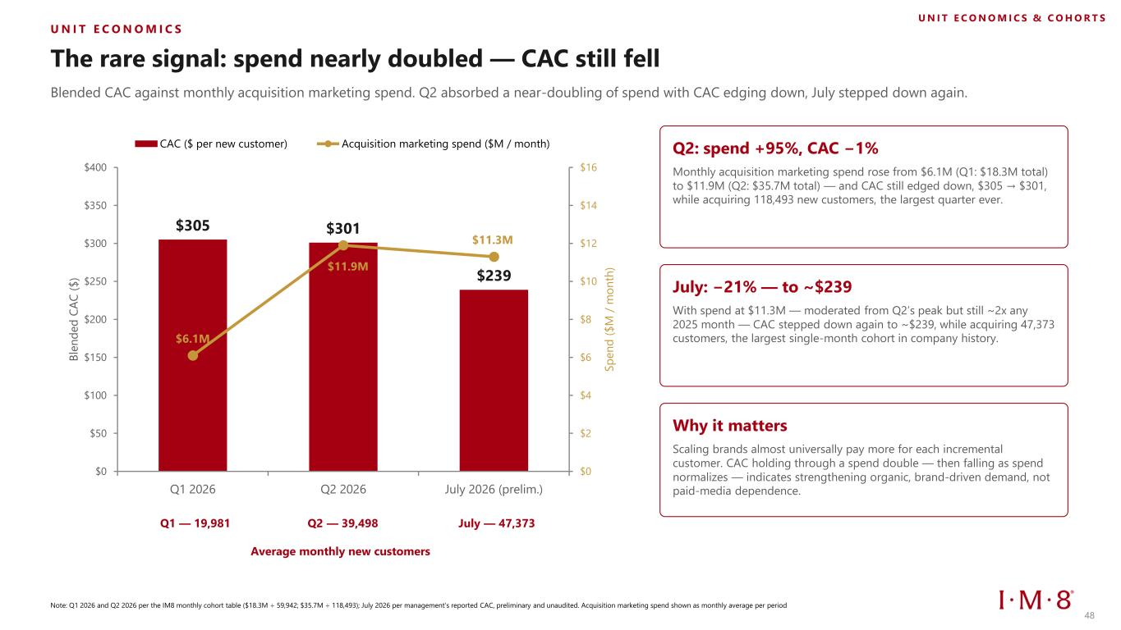
U N I T E C O N O M I C S The rare signal: spend nearly doubled — CAC still fell Blended CAC against monthly acquisition marketing spend. Q2 absorbed a near-doubling of spend with CAC edging down, July stepped down again. $305 $301 $239 $6.1M $11.9M $11.3M $0 $2 $4 $6 $8 $10 $12 $14 $16 $0 $50 $100 $150 $200 $250 $300 $350 $400 Q1 2026 Q2 2026 July 2026 (prelim.) S p e n d ( $ M / m o n th ) B le n d e d C A C ( $ ) CAC ($ per new customer) Acquisition marketing spend ($M / month) Q2: spend +95%, CAC −1% Monthly acquisition marketing spend rose from $6.1M (Q1: $18.3M total) to $11.9M (Q2: $35.7M total) — and CAC still edged down, $305 → $301, while acquiring 118,493 new customers, the largest quarter ever. July: −21% — to ~$239 With spend at $11.3M — moderated from Q2’s peak but still ~2x any 2025 month — CAC stepped down again to ~$239, while acquiring 47,373 customers, the largest single-month cohort in company history. Why it matters Scaling brands almost universally pay more for each incremental customer. CAC holding through a spend double — then falling as spend normalizes — indicates strengthening organic, brand-driven demand, not paid-media dependence. Note: Q1 2026 and Q2 2026 per the IM8 monthly cohort table ($18.3M ÷ 59,942; $35.7M ÷ 118,493); July 2026 per management’s reported CAC, preliminary and unaudited. Acquisition marketing spend shown as monthly average per period U N I T E C O N O M I C S & C O H O R T S Q1 — 19,981 Q2 — 39,498 July — 47,373 Average monthly new customers 48

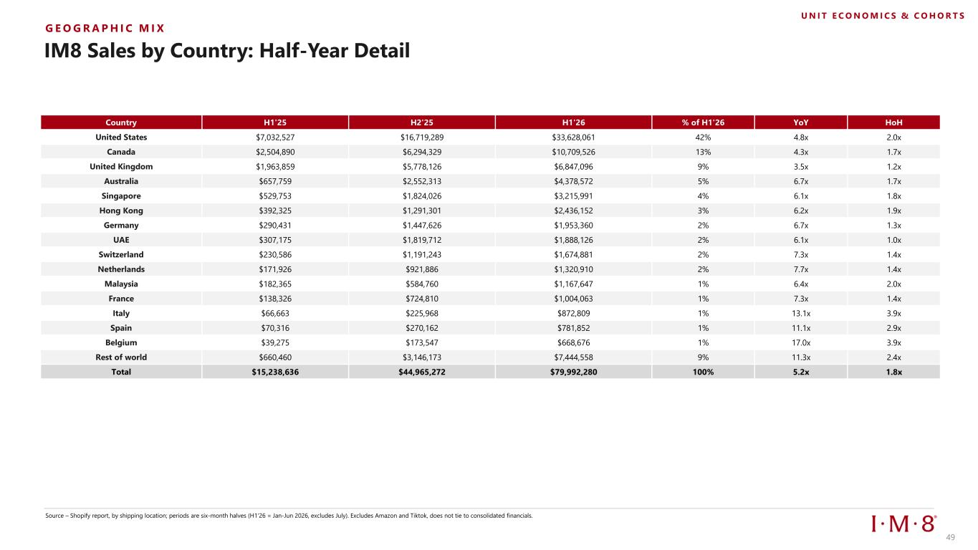
G E O G R A P H I C M I X IM8 Sales by Country: Half-Year Detail Source – Shopify report, by shipping location; periods are six-month halves (H1'26 = Jan-Jun 2026, excludes July). Excludes Amazon and Tiktok, does not tie to consolidated financials. Country H1'25 H2'25 H1'26 % of H1'26 YoY HoH United States $7,032,527 $16,719,289 $33,628,061 42% 4.8x 2.0x Canada $2,504,890 $6,294,329 $10,709,526 13% 4.3x 1.7x United Kingdom $1,963,859 $5,778,126 $6,847,096 9% 3.5x 1.2x Australia $657,759 $2,552,313 $4,378,572 5% 6.7x 1.7x Singapore $529,753 $1,824,026 $3,215,991 4% 6.1x 1.8x Hong Kong $392,325 $1,291,301 $2,436,152 3% 6.2x 1.9x Germany $290,431 $1,447,626 $1,953,360 2% 6.7x 1.3x UAE $307,175 $1,819,712 $1,888,126 2% 6.1x 1.0x Switzerland $230,586 $1,191,243 $1,674,881 2% 7.3x 1.4x Netherlands $171,926 $921,886 $1,320,910 2% 7.7x 1.4x Malaysia $182,365 $584,760 $1,167,647 1% 6.4x 2.0x France $138,326 $724,810 $1,004,063 1% 7.3x 1.4x Italy $66,663 $225,968 $872,809 1% 13.1x 3.9x Spain $70,316 $270,162 $781,852 1% 11.1x 2.9x Belgium $39,275 $173,547 $668,676 1% 17.0x 3.9x Rest of world $660,460 $3,146,173 $7,444,558 9% 11.3x 2.4x Total $15,238,636 $44,965,272 $79,992,280 100% 5.2x 1.8x U N I T E C O N O M I C S & C O H O R T S 49

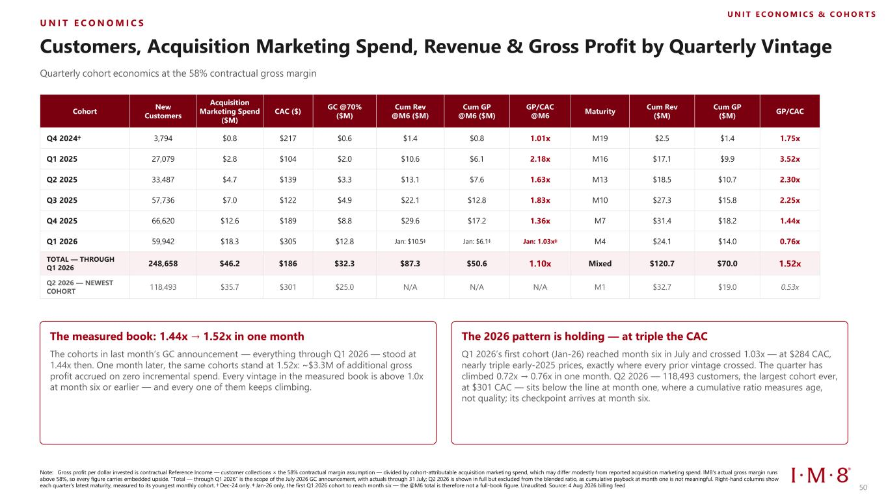
U N I T E C O N O M I C S & C O H O R T S U N I T E C O N O M I C S Customers, Acquisition Marketing Spend, Revenue & Gross Profit by Quarterly Vintage Quarterly cohort economics at the 58% contractual gross margin Cohort New Customers Acquisition Marketing Spend ($M) CAC ($) GC @70% ($M) Cum Rev @M6 ($M) Cum GP @M6 ($M) GP/CAC @M6 Maturity Cum Rev ($M) Cum GP ($M) GP/CAC Q4 2024† 3,794 $0.8 $217 $0.6 $1.4 $0.8 1.01x M19 $2.5 $1.4 1.75x Q1 2025 27,079 $2.8 $104 $2.0 $10.6 $6.1 2.18x M16 $17.1 $9.9 3.52x Q2 2025 33,487 $4.7 $139 $3.3 $13.1 $7.6 1.63x M13 $18.5 $10.7 2.30x Q3 2025 57,736 $7.0 $122 $4.9 $22.1 $12.8 1.83x M10 $27.3 $15.8 2.25x Q4 2025 66,620 $12.6 $189 $8.8 $29.6 $17.2 1.36x M7 $31.4 $18.2 1.44x Q1 2026 59,942 $18.3 $305 $12.8 Jan: $10.5‡ Jan: $6.1‡ Jan: 1.03x‡ M4 $24.1 $14.0 0.76x TOTAL — THROUGH Q1 2026 248,658 $46.2 $186 $32.3 $87.3 $50.6 1.10x Mixed $120.7 $70.0 1.52x Q2 2026 — NEWEST COHORT 118,493 $35.7 $301 $25.0 N/A N/A N/A M1 $32.7 $19.0 0.53x The measured book: 1.44x → 1.52x in one month The cohorts in last month’s GC announcement — everything through Q1 2026 — stood at 1.44x then. One month later, the same cohorts stand at 1.52x: ~$3.3M of additional gross profit accrued on zero incremental spend. Every vintage in the measured book is above 1.0x at month six or earlier — and every one of them keeps climbing. The 2026 pattern is holding — at triple the CAC Q1 2026’s first cohort (Jan-26) reached month six in July and crossed 1.03x — at $284 CAC, nearly triple early-2025 prices, exactly where every prior vintage crossed. The quarter has climbed 0.72x → 0.76x in one month. Q2 2026 — 118,493 customers, the largest cohort ever, at $301 CAC — sits below the line at month one, where a cumulative ratio measures age, not quality; its checkpoint arrives at month six. Note: Gross profit per dollar invested is contractual Reference Income — customer collections × the 58% contractual margin assumption — divided by cohort-attributable acquisition marketing spend, which may differ modestly from reported acquisition marketing spend. IM8's actual gross margin runs above 58%, so every figure carries embedded upside. "Total — through Q1 2026" is the scope of the July 2026 GC announcement, with actuals through 31 July; Q2 2026 is shown in full but excluded from the blended ratio, as cumulative payback at month one is not meaningful. Right-hand columns show each quarter's latest maturity, measured to its youngest monthly cohort. † Dec-24 only. ‡ Jan-26 only, the first Q1 2026 cohort to reach month six — the @M6 total is therefore not a full-book figure. Unaudited. Source: 4 Aug 2026 billing feed 50

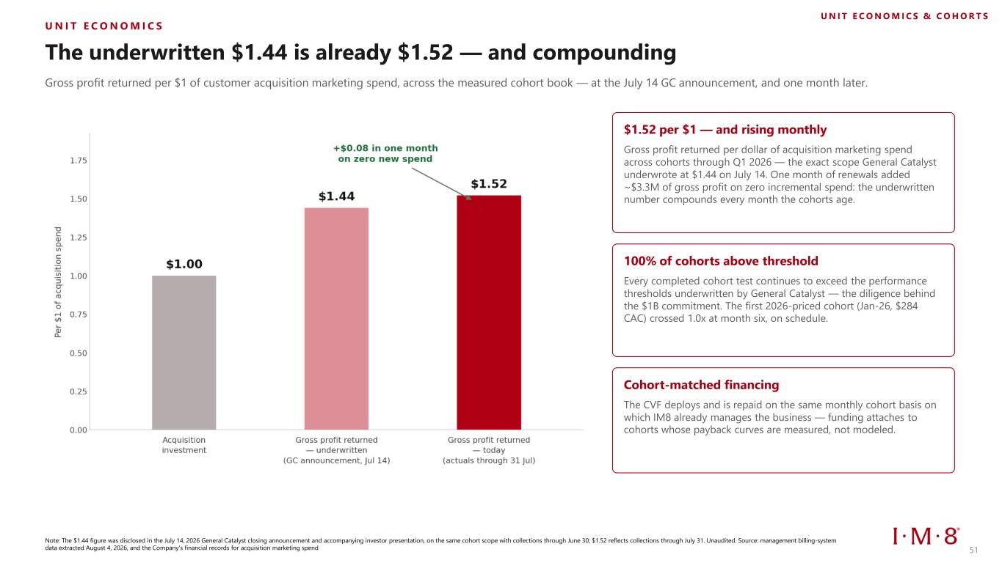
U N I T E C O N O M I C S The underwritten $1.44 is already $1.52 — and compounding Gross profit returned per $1 of customer acquisition marketing spend, across the measured cohort book — at the July 14 GC announcement, and one month later. $1.52 per $1 — and rising monthly Gross profit returned per dollar of acquisition marketing spend across cohorts through Q1 2026 — the exact scope General Catalyst underwrote at $1.44 on July 14. One month of renewals added ~$3.3M of gross profit on zero incremental spend: the underwritten number compounds every month the cohorts age. 100% of cohorts above threshold Every completed cohort test continues to exceed the performance thresholds underwritten by General Catalyst — the diligence behind the $1B commitment. The first 2026-priced cohort (Jan-26, $284 CAC) crossed 1.0x at month six, on schedule. Cohort-matched financing The CVF deploys and is repaid on the same monthly cohort basis on which IM8 already manages the business — funding attaches to cohorts whose payback curves are measured, not modeled. Note: The $1.44 figure was disclosed in the July 14, 2026 General Catalyst closing announcement and accompanying investor presentation, on the same cohort scope with collections through June 30; $1.52 reflects collections through July 31. Unaudited. Source: management billing-system data extracted August 4, 2026, and the Company's financial records for acquisition marketing spend U N I T E C O N O M I C S & C O H O R T S 51


The $1 Billion General Catalyst Partnership 52 52

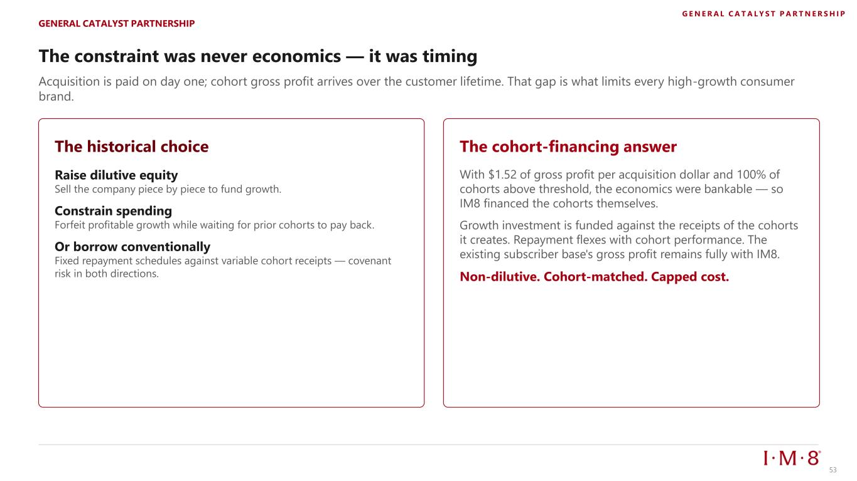
The constraint was never economics — it was timing Acquisition is paid on day one; cohort gross profit arrives over the customer lifetime. That gap is what limits every high-growth consumer brand. The historical choice Raise dilutive equity Sell the company piece by piece to fund growth. Constrain spending Forfeit profitable growth while waiting for prior cohorts to pay back. Or borrow conventionally Fixed repayment schedules against variable cohort receipts — covenant risk in both directions. The cohort-financing answer With $1.52 of gross profit per acquisition dollar and 100% of cohorts above threshold, the economics were bankable — so IM8 financed the cohorts themselves. Growth investment is funded against the receipts of the cohorts it creates. Repayment flexes with cohort performance. The existing subscriber base's gross profit remains fully with IM8. Non-dilutive. Cohort-matched. Capped cost. GENERAL CATALYST PARTNERSHIP G E N E R A L C A T A L Y S T P A R T N E R S H I P 53

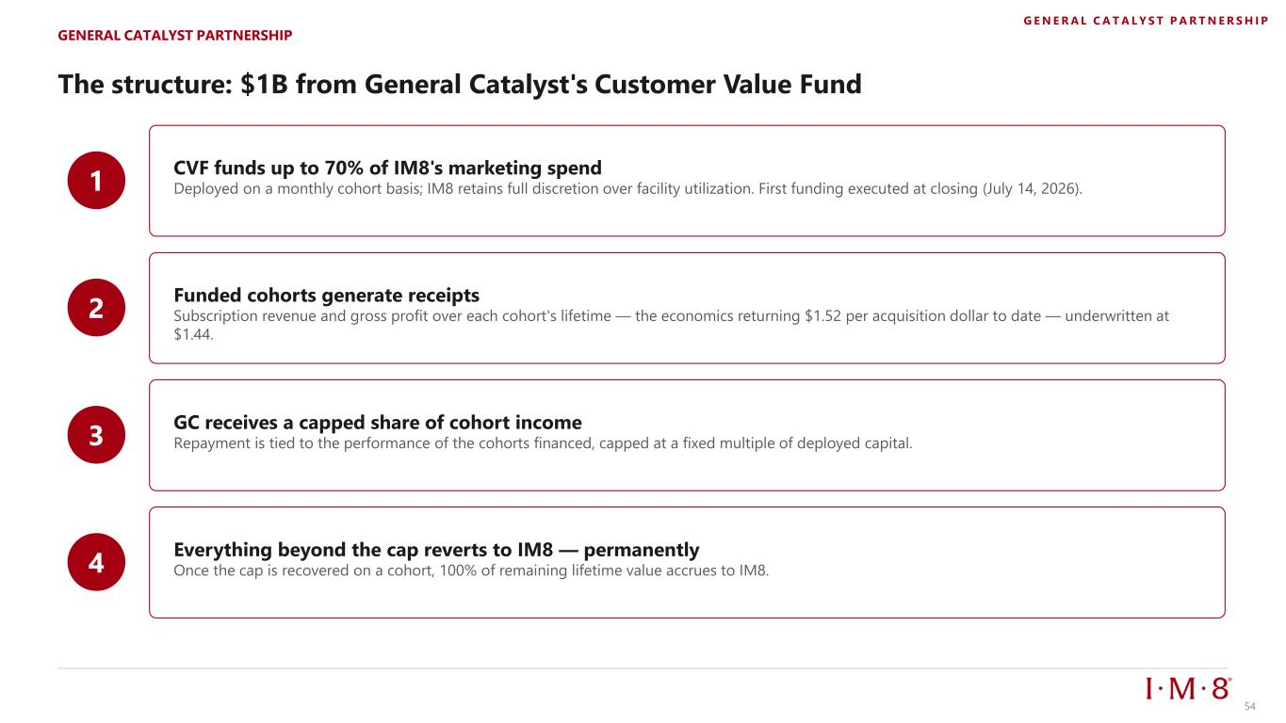
The structure: $1B from General Catalyst's Customer Value Fund 1 CVF funds up to 70% of IM8's marketing spend Deployed on a monthly cohort basis; IM8 retains full discretion over facility utilization. First funding executed at closing (July 14, 2026). 2 Funded cohorts generate receipts Subscription revenue and gross profit over each cohort's lifetime — the economics returning $1.52 per acquisition dollar to date — underwritten at $1.44. 3 GC receives a capped share of cohort income Repayment is tied to the performance of the cohorts financed, capped at a fixed multiple of deployed capital. 4 Everything beyond the cap reverts to IM8 — permanently Once the cap is recovered on a cohort, 100% of remaining lifetime value accrues to IM8. GENERAL CATALYST PARTNERSHIP G E N E R A L C A T A L Y S T P A R T N E R S H I P 54

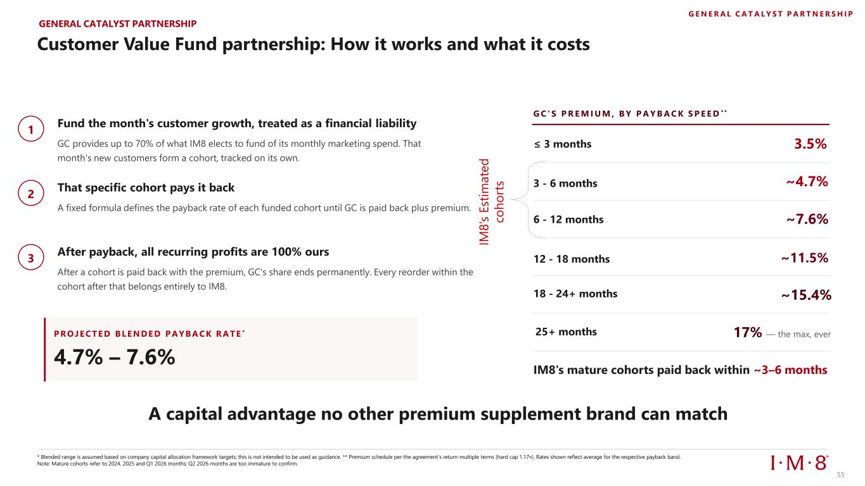
Fund the month's customer growth, treated as a financial liability GC provides up to 70% of what IM8 elects to fund of its monthly marketing spend. That month's new customers form a cohort, tracked on its own. That specific cohort pays it back A fixed formula defines the payback rate of each funded cohort until GC is paid back plus premium. After payback, all recurring profits are 100% ours After a cohort is paid back with the premium, GC's share ends permanently. Every reorder within the cohort after that belongs entirely to IM8. P R O JECTED B LENDED P A Y B A CK R A TE * 4.7% – 7.6% G C ' S P R E M I U M , B Y P A Y B A C K S P E E D * * ≤ 3 months 3.5% 3 - 6 months ~4.7% 6 - 12 months ~7.6% 12 - 18 months ~11.5% 18 - 24+ months ~15.4% IM8's mature cohorts paid back within ~3–6 months IM 8 ’s E st im a te d co h o rt s * Blended range is assumed based on company capital allocation framework targets; this is not intended to be used as guidance. ** Premium schedule per the agreement’s return-multiple terms (hard cap 1.17×). Rates shown reflect average for the respective payback band. Note: Mature cohorts refer to 2024, 2025 and Q1 2026 months; Q2 2026 months are too immature to confirm. 25+ months 17% — the max, ever A capital advantage no other premium supplement brand can match 1 2 3 Customer Value Fund partnership: How it works and what it costs GENERAL CATALYST PARTNERSHIP G E N E R A L C A T A L Y S T P A R T N E R S H I P 55

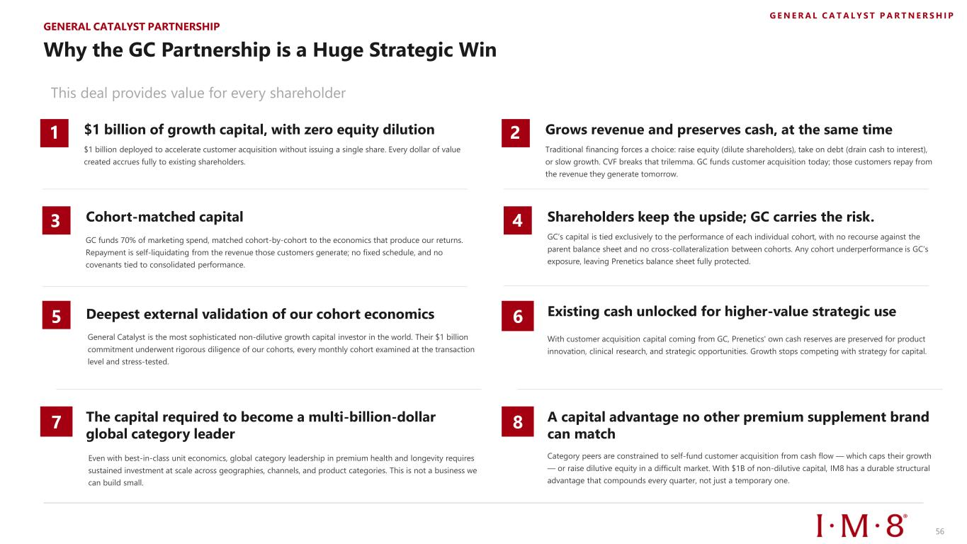
Deepest external validation of our cohort economics General Catalyst is the most sophisticated non-dilutive growth capital investor in the world. Their $1 billion commitment underwent rigorous diligence of our cohorts, every monthly cohort examined at the transaction level and stress-tested. Existing cash unlocked for higher-value strategic use With customer acquisition capital coming from GC, Prenetics' own cash reserves are preserved for product innovation, clinical research, and strategic opportunities. Growth stops competing with strategy for capital. The capital required to become a multi-billion-dollar global category leader Even with best-in-class unit economics, global category leadership in premium health and longevity requires sustained investment at scale across geographies, channels, and product categories. This is not a business we can build small. A capital advantage no other premium supplement brand can match Category peers are constrained to self-fund customer acquisition from cash flow — which caps their growth — or raise dilutive equity in a difficult market. With $1B of non-dilutive capital, IM8 has a durable structural advantage that compounds every quarter, not just a temporary one. Why the GC Partnership is a Huge Strategic Win This deal provides value for every shareholder $1 billion of growth capital, with zero equity dilution $1 billion deployed to accelerate customer acquisition without issuing a single share. Every dollar of value created accrues fully to existing shareholders. Grows revenue and preserves cash, at the same time Traditional financing forces a choice: raise equity (dilute shareholders), take on debt (drain cash to interest), or slow growth. CVF breaks that trilemma. GC funds customer acquisition today; those customers repay from the revenue they generate tomorrow. Cohort-matched capital GC funds 70% of marketing spend, matched cohort-by-cohort to the economics that produce our returns. Repayment is self-liquidating from the revenue those customers generate; no fixed schedule, and no covenants tied to consolidated performance. Shareholders keep the upside; GC carries the risk. GC’s capital is tied exclusively to the performance of each individual cohort, with no recourse against the parent balance sheet and no cross-collateralization between cohorts. Any cohort underperformance is GC’s exposure, leaving Prenetics balance sheet fully protected. 5 6 7 8 3 4 1 2 GENERAL CATALYST PARTNERSHIP G E N E R A L C A T A L Y S T P A R T N E R S H I P 56

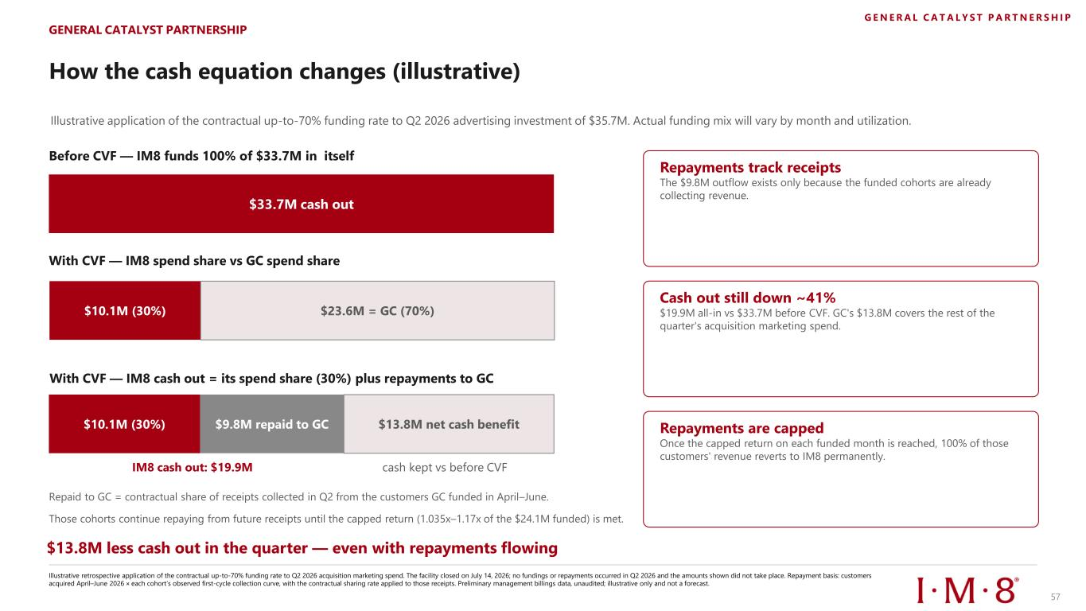
How the cash equation changes (illustrative) Illustrative application of the contractual up-to-70% funding rate to Q2 2026 advertising investment of $35.7M. Actual funding mix will vary by month and utilization. Repayments track receipts The $9.8M outflow exists only because the funded cohorts are already collecting revenue. Cash out still down ~41% $19.9M all-in vs $33.7M before CVF. GC's $13.8M covers the rest of the quarter's acquisition marketing spend. Repayments are capped Once the capped return on each funded month is reached, 100% of those customers' revenue reverts to IM8 permanently. GENERAL CATALYST PARTNERSHIP Before CVF — IM8 funds 100% of $33.7M in itself $33.7M cash out With CVF — IM8 spend share vs GC spend share $10.1M (30%) $9.8M repaid to GC Repaid to GC = contractual share of receipts collected in Q2 from the customers GC funded in April–June. Those cohorts continue repaying from future receipts until the capped return (1.035x–1.17x of the $24.1M funded) is met. $13.8M less cash out in the quarter — even with repayments flowing $13.8M net cash benefit IM8 cash out: $19.9M cash kept vs before CVF Illustrative retrospective application of the contractual up-to-70% funding rate to Q2 2026 acquisition marketing spend. The facility closed on July 14, 2026; no fundings or repayments occurred in Q2 2026 and the amounts shown did not take place. Repayment basis: customers acquired April–June 2026 × each cohort’s observed first-cycle collection curve, with the contractual sharing rate applied to those receipts. Preliminary management billings data, unaudited; illustrative only and not a forecast. $10.1M (30%) $23.6M = GC (70%) With CVF — IM8 cash out = its spend share (30%) plus repayments to GC G E N E R A L C A T A L Y S T P A R T N E R S H I P 57

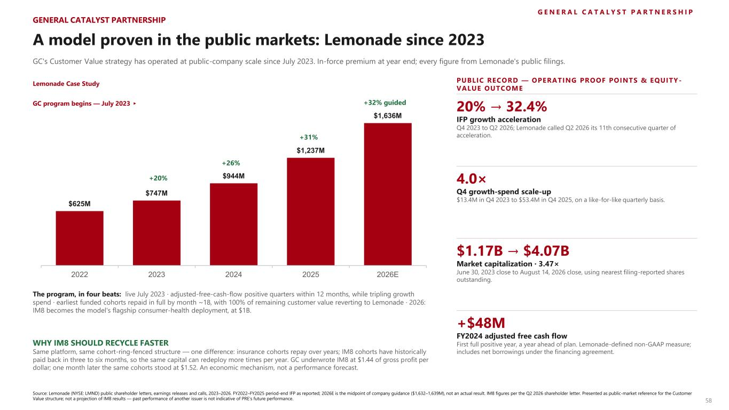
G E N E R A L C A T A L Y S T P A R T N E R S H I P A model proven in the public markets: Lemonade since 2023 GC's Customer Value strategy has operated at public-company scale since July 2023. In-force premium at year end; every figure from Lemonade's public filings. $625M $747M $944M $1,237M $1,636M 2022 2023 2024 2025 2026E GC program begins — July 2023 ▸ +20% The program, in four beats: live July 2023 · adjusted-free-cash-flow positive quarters within 12 months, while tripling growth spend · earliest funded cohorts repaid in full by month ~18, with 100% of remaining customer value reverting to Lemonade · 2026: IM8 becomes the model's flagship consumer-health deployment, at $1B. WHY IM8 SHOULD RECYCLE FASTER Same platform, same cohort-ring-fenced structure — one difference: insurance cohorts repay over years; IM8 cohorts have historically paid back in three to six months, so the same capital can redeploy more times per year. GC underwrote IM8 at $1.44 of gross profit per dollar; one month later the same cohorts stood at $1.52. An economic mechanism, not a performance forecast. PUBLIC RECORD — OPERATING PROOF POINTS & EQUITY - VALUE OUTCOME 20% → 32.4% IFP growth acceleration Q4 2023 to Q2 2026; Lemonade called Q2 2026 its 11th consecutive quarter of acceleration. 4.0× Q4 growth-spend scale-up $13.4M in Q4 2023 to $53.4M in Q4 2025, on a like-for-like quarterly basis. $1.17B → $4.07B Market capitalization · 3.47× June 30, 2023 close to August 14, 2026 close, using nearest filing-reported shares outstanding. +$48M FY2024 adjusted free cash flow First full positive year, a year ahead of plan. Lemonade-defined non-GAAP measure; includes net borrowings under the financing agreement. Source: Lemonade (NYSE: LMND) public shareholder letters, earnings releases and calls, 2023–2026. FY2022–FY2025 period-end IFP as reported; 2026E is the midpoint of company guidance ($1,632–1,639M), not an actual result. IM8 figures per the Q2 2026 shareholder letter. Presented as public-market reference for the Customer Value structure; not a projection of IM8 results — past performance of another issuer is not indicative of PRE’s future performance. GENERAL CATALYST PARTNERSHIP +32% guided +26% +31% 58 Lemonade Case Study

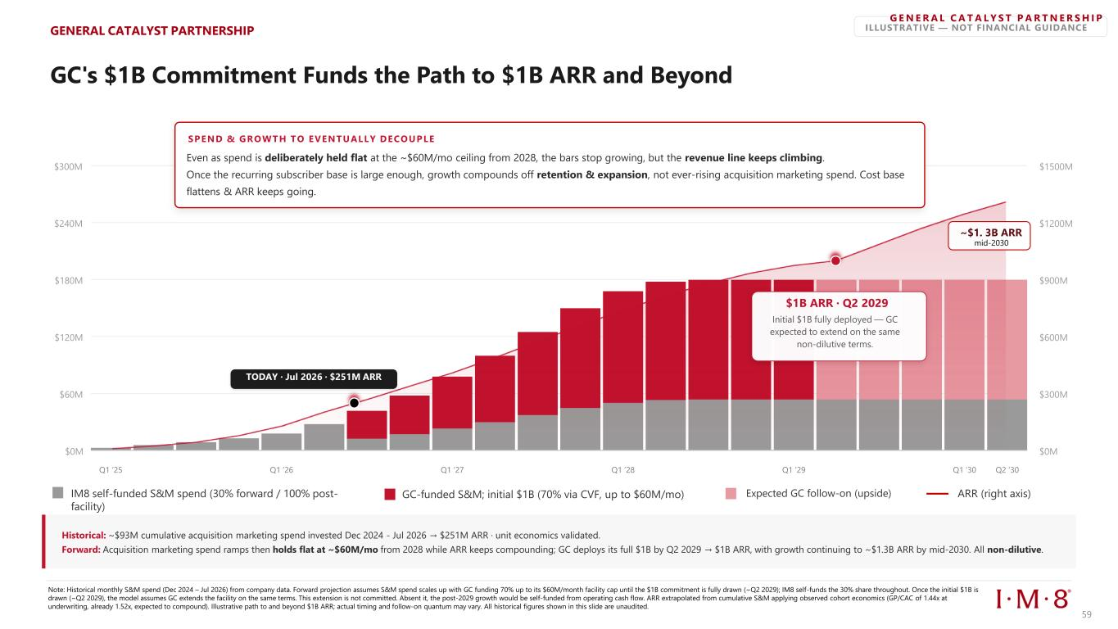
ILLUSTRATIVE — NOT FINANCIAL GUIDANCE IM8 self-funded S&M spend (30% forward / 100% post- facility) GC-funded S&M; initial $1B (70% via CVF, up to $60M/mo) Expected GC follow-on (upside) ARR (right axis) $0M $60M $120M $180M $240M $300M $0M $300M $600M $900M $1200M $1500M SPEND & GROWTH TO EVENTUALLY DECOUPLE Even as spend is deliberately held flat at the ~$60M/mo ceiling from 2028, the bars stop growing, but the revenue line keeps climbing. Once the recurring subscriber base is large enough, growth compounds off retention & expansion, not ever-rising acquisition marketing spend. Cost base flattens & ARR keeps going. Q1 ’25 Q1 ’26 Q1 ’27 Q1 ’28 Q1 ’29 Q1 ’30 Q2 ’30 Historical: ~$93M cumulative acquisition marketing spend invested Dec 2024 - Jul 2026 → $251M ARR · unit economics validated. Forward: Acquisition marketing spend ramps then holds flat at ~$60M/mo from 2028 while ARR keeps compounding; GC deploys its full $1B by Q2 2029 → $1B ARR, with growth continuing to ~$1.3B ARR by mid-2030. All non-dilutive. Note: Historical monthly S&M spend (Dec 2024 – Jul 2026) from company data. Forward projection assumes S&M spend scales up with GC funding 70% up to its $60M/month facility cap until the $1B commitment is fully drawn (~Q2 2029); IM8 self-funds the 30% share throughout. Once the initial $1B is drawn (~Q2 2029), the model assumes GC extends the facility on the same terms. This extension is not committed. Absent it, the post-2029 growth would be self-funded from operating cash flow. ARR extrapolated from cumulative S&M applying observed cohort economics (GP/CAC of 1.44x at underwriting, already 1.52x, expected to compound). Illustrative path to and beyond $1B ARR; actual timing and follow-on quantum may vary. All historical figures shown in this slide are unaudited. ~$1. 3B ARR mid-2030 $1B ARR · Q2 2029 Initial $1B fully deployed — GC expected to extend on the same non-dilutive terms. TODAY · Jul 2026 · $251M ARR GC's $1B Commitment Funds the Path to $1B ARR and Beyond GENERAL CATALYST PARTNERSHIP G E N E R A L C A T A L Y S T P A R T N E R S H I P 59


Product, Brand, Science & Platform 60 60

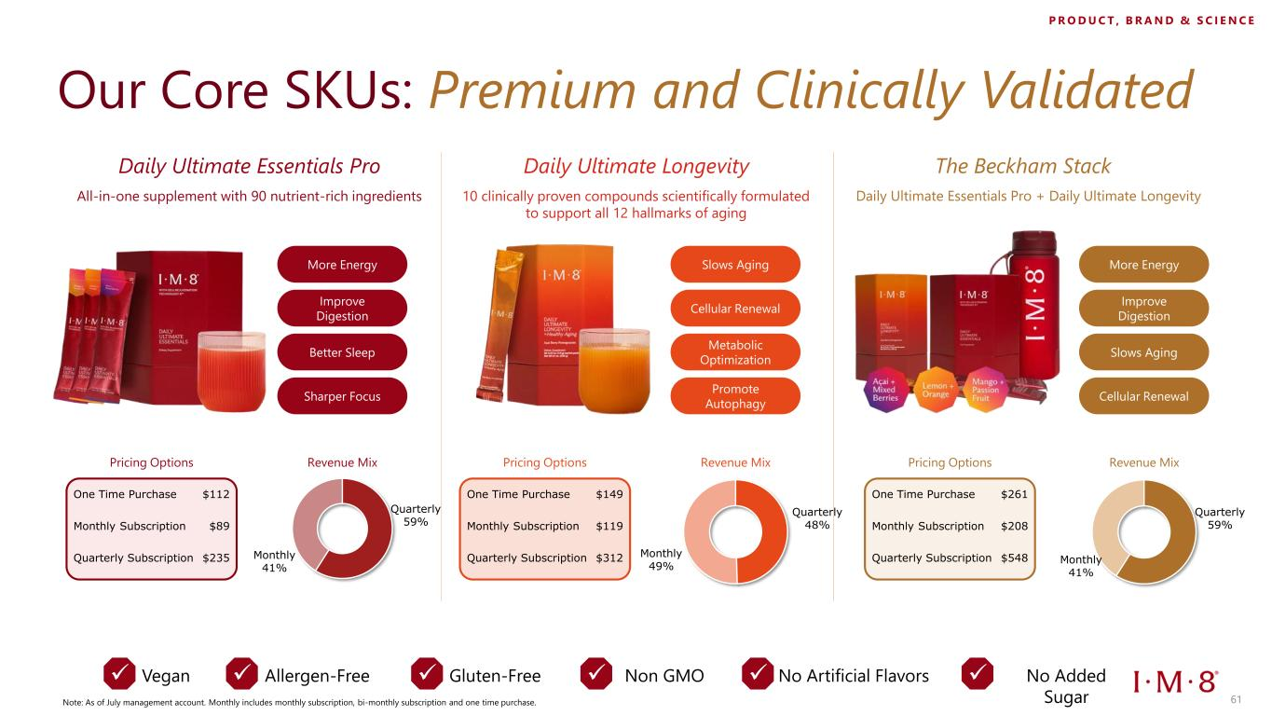
Daily Ultimate Essentials Pro Daily Ultimate Longevity All-in-one supplement with 90 nutrient-rich ingredients 10 clinically proven compounds scientifically formulated to support all 12 hallmarks of aging Slows Aging Cellular Renewal Promote Autophagy Metabolic Optimization ✓ Vegan ✓ Allergen-Free ✓ Gluten-Free ✓ No Artificial Flavors ✓ No Added Sugar Our Core SKUs: Premium and Clinically Validated ✓ Non GMO The Beckham Stack Daily Ultimate Essentials Pro + Daily Ultimate Longevity More Energy Improve Digestion Sharper Focus Better Sleep More Energy Improve Digestion Cellular Renewal Slows Aging Quarterly 59% Monthly 41% One Time Purchase $112 Monthly Subscription $89 Quarterly Subscription $235 Quarterly 48% Monthly 49% Quarterly 59% Monthly 41% Pricing Options Revenue Mix One Time Purchase $149 Monthly Subscription $119 Quarterly Subscription $312 Pricing Options Revenue Mix One Time Purchase $261 Monthly Subscription $208 Quarterly Subscription $548 Pricing Options Revenue Mix Note: As of July management account. Monthly includes monthly subscription, bi-monthly subscription and one time purchase. P R O D U C T , B R A N D & S C I E N C E 61

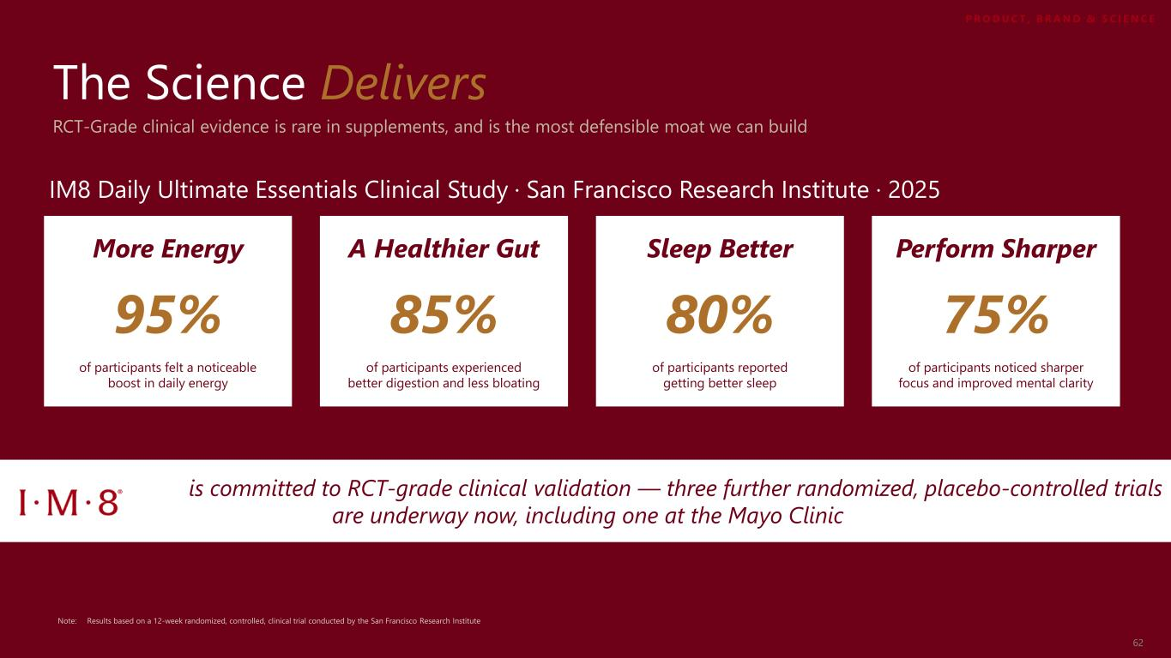
is committed to RCT-grade clinical validation — three further randomized, placebo-controlled trials are underway now, including one at the Mayo Clinic The Science Delivers Note: Results based on a 12-week randomized, controlled, clinical trial conducted by the San Francisco Research Institute More Energy 95% of participants felt a noticeable boost in daily energy RCT-Grade clinical evidence is rare in supplements, and is the most defensible moat we can build A Healthier Gut 85% of participants experienced better digestion and less bloating Sleep Better 80% of participants reported getting better sleep Perform Sharper 75% of participants noticed sharper focus and improved mental clarity IM8 Daily Ultimate Essentials Clinical Study · San Francisco Research Institute · 2025 P R O D U C T , B R A N D & S C I E N C E 62


Nine Experts. Six Disciplines Oncology, microbiome, sports medicine, regenerative medicine, cardiovascular research, and space biology Dr. Pamela Mehta Board Certified Orthopedic Surgeon, Regenerative Medicine Expert Dr. Dawn Mussallem Chief Medical Officer at Fountain Life / Founder of Mayo Clinic Integrative Breast Oncology Center Dr. Amy Shah Double-Board Certified Physician & Host of Podcast “Save Yourself” Dr. James L. Green Former Chief Scientist of NASA Dr. Ara Suppiah Performance Strategist, Sports Physician, Creator of Functional Sports Medicine Dr. Darshan Shah Board Certified Surgeon & Physician, CEO and Founder of Next Health Prof. Suzanne Devkota Director of Cedars-Sinai Human Microbiome Research Institute Simon Hill Nutritionist, Physiologist, and Podcaster Dr. James DiNicolantonio Cardiovascular Research Scientist and Doctor of Pharmacy PRODUCT, BRAND & SCIENCE P R O D U C T , B R A N D & S C I E N C E 63

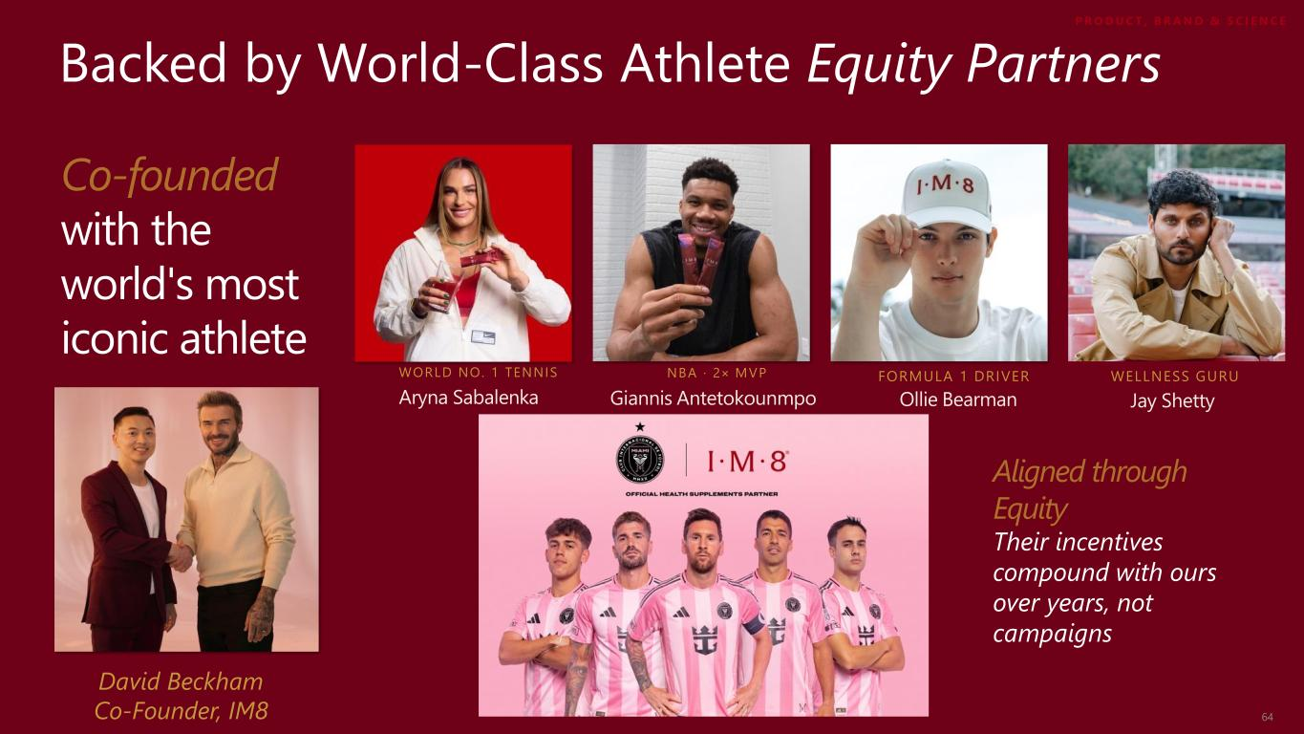
Backed by World-Class Athlete Equity Partners Co-founded with the world's most iconic athlete David Beckham Co-Founder, IM8 NBA · 2× MVP Giannis Antetokounmpo WORLD NO. 1 TENNIS Aryna Sabalenka FORMULA 1 DRIVER Ollie Bearman Aligned through Equity Their incentives compound with ours over years, not campaigns Jay Shetty WELLNESS GURU P R O D U C T , B R A N D & S C I E N C E 64

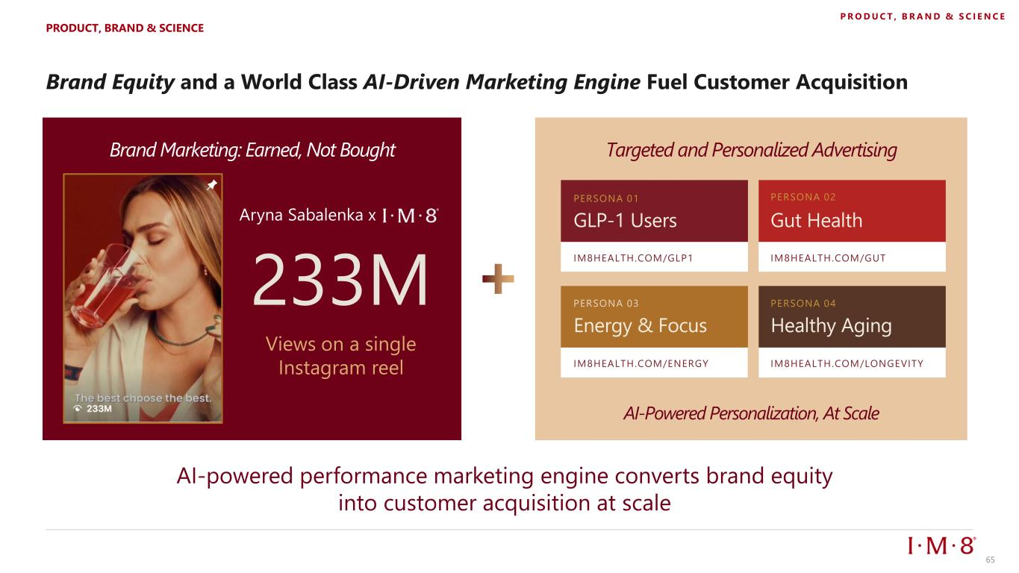
AI-powered performance marketing engine converts brand equity into customer acquisition at scale Brand Equity and a World Class AI-Driven Marketing Engine Fuel Customer Acquisition Brand Marketing: Earned, Not Bought 233M Views on a single Instagram reel Aryna Sabalenka x Targeted and Personalized Advertising PERSONA 01 GLP-1 Users IM8HEALTH.COM/GLP1 IM8HEALTH.COM/GUT IM8HEALTH.COM/ENERGY IM8HEALTH.COM/LONGEVITY PERSONA 02 Gut Health Energy & Focus PERSONA 04 Healthy Aging AI-Powered Personalization, At Scale PRODUCT, BRAND & SCIENCE P R O D U C T , B R A N D & S C I E N C E 65

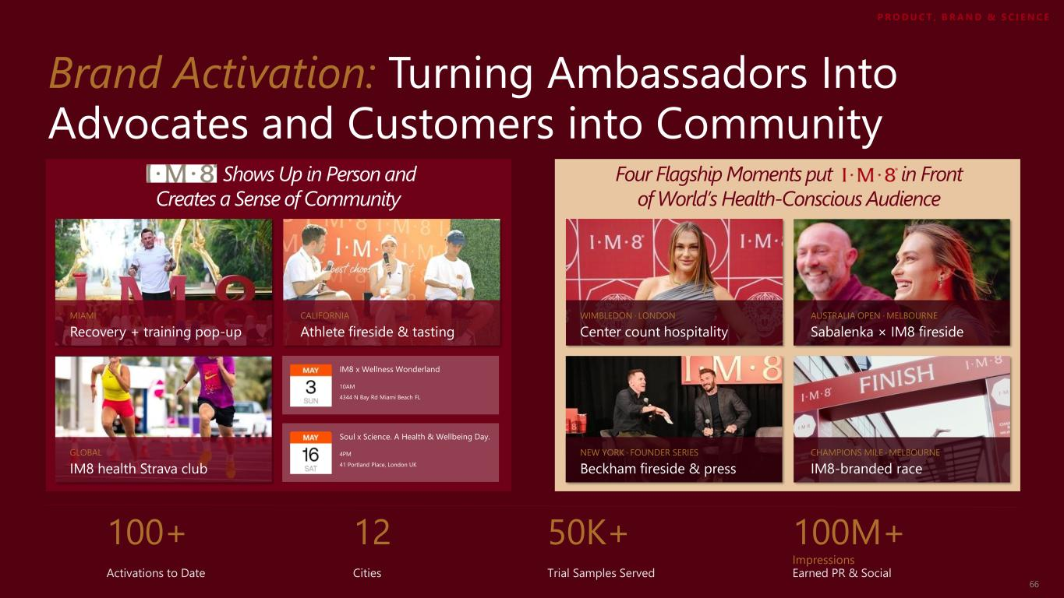
Brand Activation: Turning Ambassadors Into Advocates and Customers into Community Shows Up in Person and Creates a Sense of Community Four Flagship Moments put in Front of World’s Health-Conscious Audience IM8 x Wellness Wonderland 10AM 4344 N Bay Rd Miami Beach FL MIAMI Recovery + training pop-up CALIFORNIA Athlete fireside & tasting GLOBAL IM8 health Strava club Soul x Science. A Health & Wellbeing Day. 4PM 41 Portland Place, London UK WIMBLEDON · LONDON Center count hospitality Sabalenka × IM8 fireside Beckham fireside & press AUSTRALIA OPEN · MELBOURNE NEW YORK · FOUNDER SERIES IM8-branded race CHAMPIONS MILE · MELBOURNE 100+ 12 50K+ 100M+ Impressions Activations to Date Cities Trial Samples Served Earned PR & Social P R O D U C T , B R A N D & S C I E N C E 66

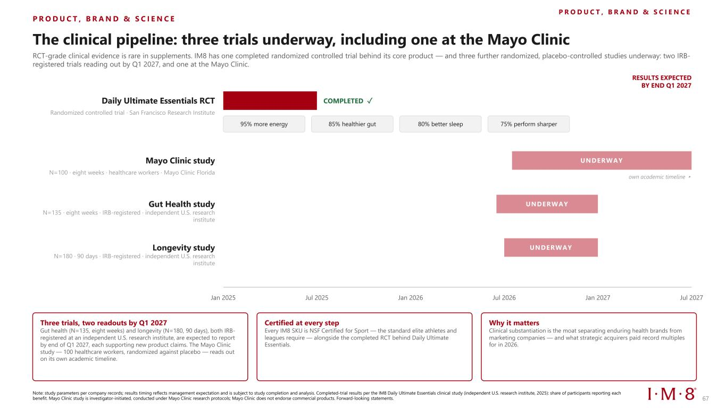
P R O D U C T , B R A N D & S C I E N C E P R O D U C T , B R A N D & S C I E N C E The clinical pipeline: three trials underway, including one at the Mayo Clinic RCT-grade clinical evidence is rare in supplements. IM8 has one completed randomized controlled trial behind its core product — and three further randomized, placebo-controlled studies underway: two IRB- registered trials reading out by Q1 2027, and one at the Mayo Clinic. Jan 2025 Jul 2025 Jan 2026 Jul 2026 Jan 2027 Jul 2027 RESULTS EXPECTED BY END Q1 2027 Daily Ultimate Essentials RCT Randomized controlled trial · San Francisco Research Institute COMPLETED ✓ 95% more energy 85% healthier gut 80% better sleep 75% perform sharper Mayo Clinic study N=100 · eight weeks · healthcare workers · Mayo Clinic Florida UNDERWAY own academic timeline ▸ Gut Health study N=135 · eight weeks · IRB-registered · independent U.S. research institute UNDERWAY Longevity study N=180 · 90 days · IRB-registered · independent U.S. research institute UNDERWAY Three trials, two readouts by Q1 2027 Gut health (N=135, eight weeks) and longevity (N=180, 90 days), both IRB- registered at an independent U.S. research institute, are expected to report by end of Q1 2027, each supporting new product claims. The Mayo Clinic study — 100 healthcare workers, randomized against placebo — reads out on its own academic timeline. Certified at every step Every IM8 SKU is NSF Certified for Sport — the standard elite athletes and leagues require — alongside the completed RCT behind Daily Ultimate Essentials. Why it matters Clinical substantiation is the moat separating enduring health brands from marketing companies — and what strategic acquirers paid record multiples for in 2026. Note: study parameters per company records; results timing reflects management expectation and is subject to study completion and analysis. Completed-trial results per the IM8 Daily Ultimate Essentials clinical study (independent U.S. research institute, 2025): share of participants reporting each benefit. Mayo Clinic study is investigator-initiated, conducted under Mayo Clinic research protocols; Mayo Clinic does not endorse commercial products. Forward-looking statements. 67

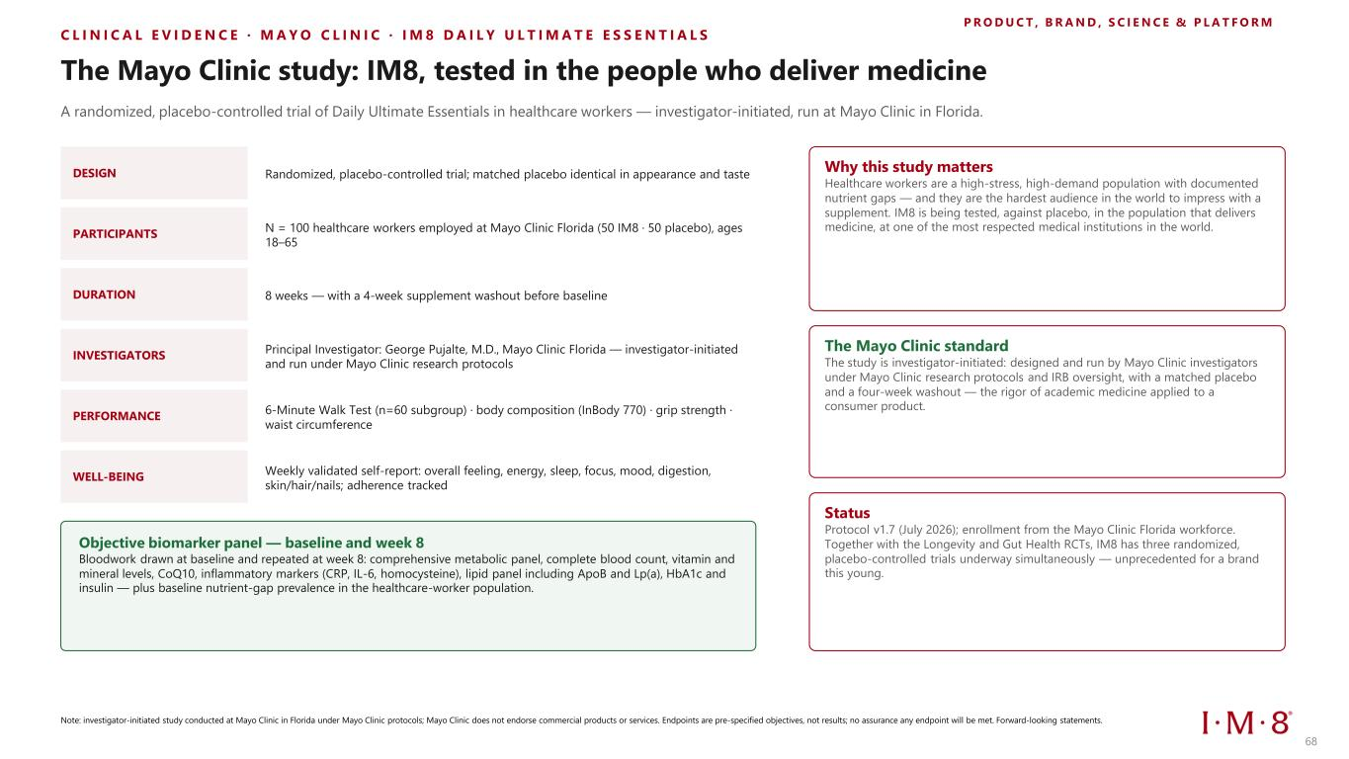
C L I N I C A L E V I D E N C E · M A Y O C L I N I C · I M 8 D A I L Y U L T I M A T E E S S E N T I A L S P R O D U C T , B R A N D , S C I E N C E & P L A T F O R M The Mayo Clinic study: IM8, tested in the people who deliver medicine A randomized, placebo-controlled trial of Daily Ultimate Essentials in healthcare workers — investigator-initiated, run at Mayo Clinic in Florida. DESIGN Randomized, placebo-controlled trial; matched placebo identical in appearance and taste PARTICIPANTS N = 100 healthcare workers employed at Mayo Clinic Florida (50 IM8 · 50 placebo), ages 18–65 DURATION 8 weeks — with a 4-week supplement washout before baseline INVESTIGATORS Principal Investigator: George Pujalte, M.D., Mayo Clinic Florida — investigator-initiated and run under Mayo Clinic research protocols PERFORMANCE 6-Minute Walk Test (n=60 subgroup) · body composition (InBody 770) · grip strength · waist circumference WELL-BEING Weekly validated self-report: overall feeling, energy, sleep, focus, mood, digestion, skin/hair/nails; adherence tracked Objective biomarker panel — baseline and week 8 Bloodwork drawn at baseline and repeated at week 8: comprehensive metabolic panel, complete blood count, vitamin and mineral levels, CoQ10, inflammatory markers (CRP, IL-6, homocysteine), lipid panel including ApoB and Lp(a), HbA1c and insulin — plus baseline nutrient-gap prevalence in the healthcare-worker population. Why this study matters Healthcare workers are a high-stress, high-demand population with documented nutrient gaps — and they are the hardest audience in the world to impress with a supplement. IM8 is being tested, against placebo, in the population that delivers medicine, at one of the most respected medical institutions in the world. The Mayo Clinic standard The study is investigator-initiated: designed and run by Mayo Clinic investigators under Mayo Clinic research protocols and IRB oversight, with a matched placebo and a four-week washout — the rigor of academic medicine applied to a consumer product. Status Protocol v1.7 (July 2026); enrollment from the Mayo Clinic Florida workforce. Together with the Longevity and Gut Health RCTs, IM8 has three randomized, placebo-controlled trials underway simultaneously — unprecedented for a brand this young. Note: investigator-initiated study conducted at Mayo Clinic in Florida under Mayo Clinic protocols; Mayo Clinic does not endorse commercial products or services. Endpoints are pre-specified objectives, not results; no assurance any endpoint will be met. Forward-looking statements. 68

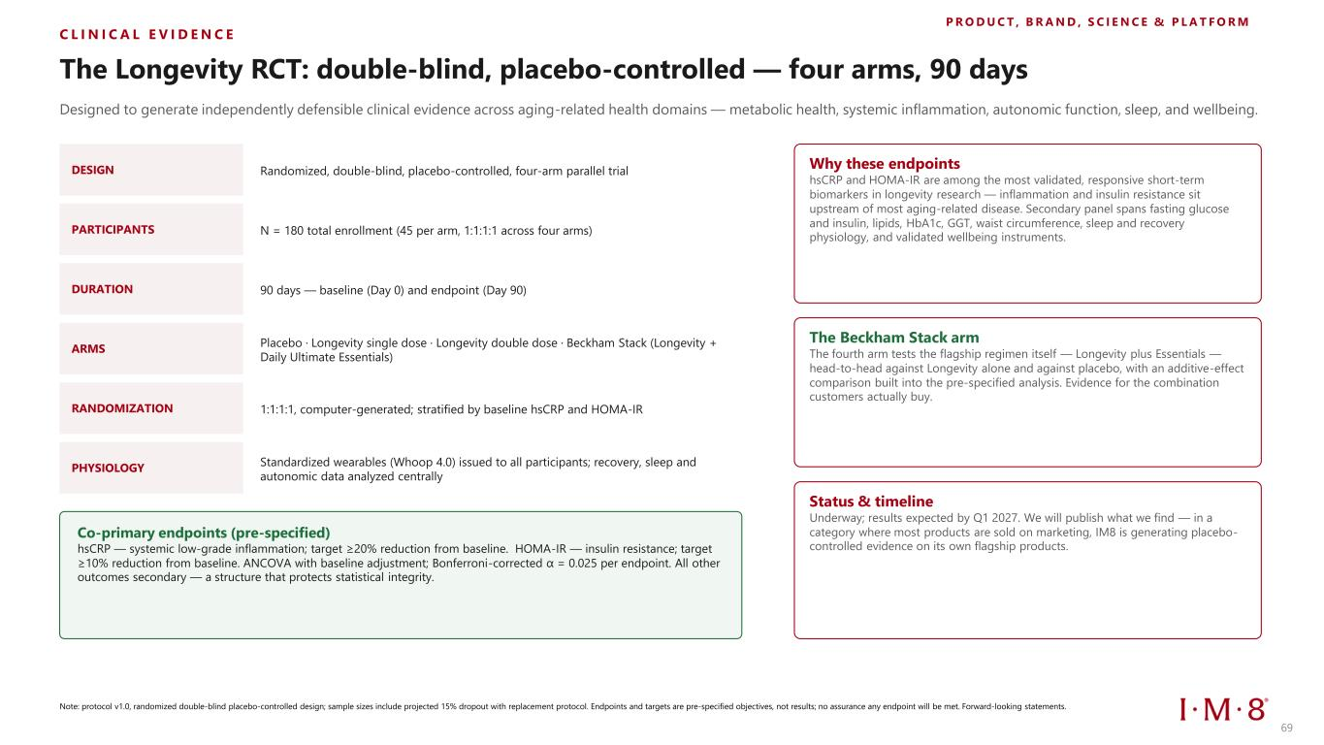
C L I N I C A L E V I D E N C E P R O D U C T , B R A N D , S C I E N C E & P L A T F O R M The Longevity RCT: double-blind, placebo-controlled — four arms, 90 days Designed to generate independently defensible clinical evidence across aging-related health domains — metabolic health, systemic inflammation, autonomic function, sleep, and wellbeing. DESIGN Randomized, double-blind, placebo-controlled, four-arm parallel trial PARTICIPANTS N = 180 total enrollment (45 per arm, 1:1:1:1 across four arms) DURATION 90 days — baseline (Day 0) and endpoint (Day 90) ARMS Placebo · Longevity single dose · Longevity double dose · Beckham Stack (Longevity + Daily Ultimate Essentials) RANDOMIZATION 1:1:1:1, computer-generated; stratified by baseline hsCRP and HOMA-IR PHYSIOLOGY Standardized wearables (Whoop 4.0) issued to all participants; recovery, sleep and autonomic data analyzed centrally Co-primary endpoints (pre-specified) hsCRP — systemic low-grade inflammation; target ≥20% reduction from baseline. HOMA-IR — insulin resistance; target ≥10% reduction from baseline. ANCOVA with baseline adjustment; Bonferroni-corrected α = 0.025 per endpoint. All other outcomes secondary — a structure that protects statistical integrity. Why these endpoints hsCRP and HOMA-IR are among the most validated, responsive short-term biomarkers in longevity research — inflammation and insulin resistance sit upstream of most aging-related disease. Secondary panel spans fasting glucose and insulin, lipids, HbA1c, GGT, waist circumference, sleep and recovery physiology, and validated wellbeing instruments. The Beckham Stack arm The fourth arm tests the flagship regimen itself — Longevity plus Essentials — head-to-head against Longevity alone and against placebo, with an additive-effect comparison built into the pre-specified analysis. Evidence for the combination customers actually buy. Status & timeline Underway; results expected by Q1 2027. We will publish what we find — in a category where most products are sold on marketing, IM8 is generating placebo- controlled evidence on its own flagship products. Note: protocol v1.0, randomized double-blind placebo-controlled design; sample sizes include projected 15% dropout with replacement protocol. Endpoints and targets are pre-specified objectives, not results; no assurance any endpoint will be met. Forward-looking statements. 69

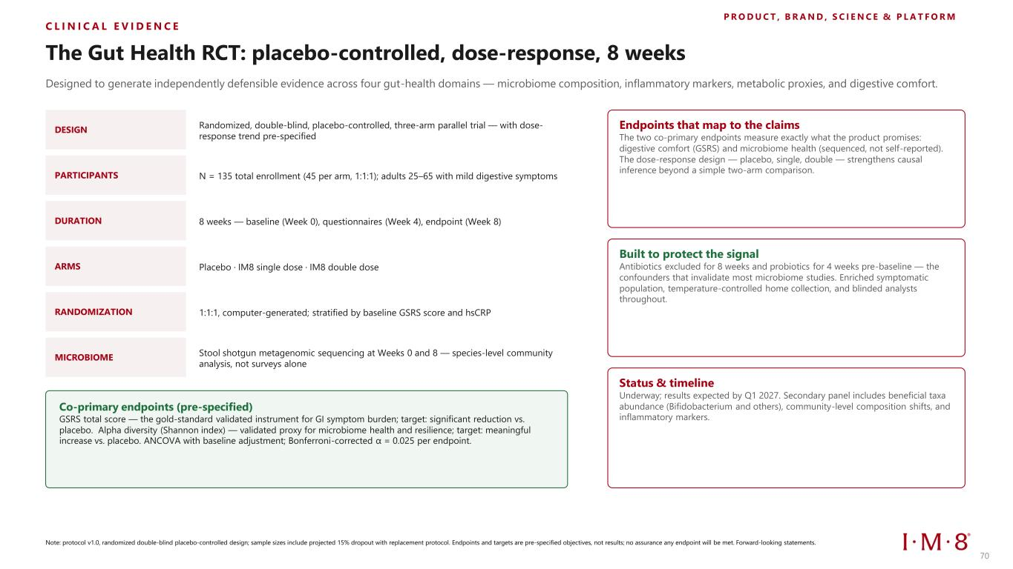
C L I N I C A L E V I D E N C E P R O D U C T , B R A N D , S C I E N C E & P L A T F O R M The Gut Health RCT: placebo-controlled, dose-response, 8 weeks Designed to generate independently defensible evidence across four gut-health domains — microbiome composition, inflammatory markers, metabolic proxies, and digestive comfort. DESIGN Randomized, double-blind, placebo-controlled, three-arm parallel trial — with dose- response trend pre-specified PARTICIPANTS N = 135 total enrollment (45 per arm, 1:1:1); adults 25–65 with mild digestive symptoms DURATION 8 weeks — baseline (Week 0), questionnaires (Week 4), endpoint (Week 8) ARMS Placebo · IM8 single dose · IM8 double dose RANDOMIZATION 1:1:1, computer-generated; stratified by baseline GSRS score and hsCRP MICROBIOME Stool shotgun metagenomic sequencing at Weeks 0 and 8 — species-level community analysis, not surveys alone Co-primary endpoints (pre-specified) GSRS total score — the gold-standard validated instrument for GI symptom burden; target: significant reduction vs. placebo. Alpha diversity (Shannon index) — validated proxy for microbiome health and resilience; target: meaningful increase vs. placebo. ANCOVA with baseline adjustment; Bonferroni-corrected α = 0.025 per endpoint. Endpoints that map to the claims The two co-primary endpoints measure exactly what the product promises: digestive comfort (GSRS) and microbiome health (sequenced, not self-reported). The dose-response design — placebo, single, double — strengthens causal inference beyond a simple two-arm comparison. Built to protect the signal Antibiotics excluded for 8 weeks and probiotics for 4 weeks pre-baseline — the confounders that invalidate most microbiome studies. Enriched symptomatic population, temperature-controlled home collection, and blinded analysts throughout. Status & timeline Underway; results expected by Q1 2027. Secondary panel includes beneficial taxa abundance (Bifidobacterium and others), community-level composition shifts, and inflammatory markers. Note: protocol v1.0, randomized double-blind placebo-controlled design; sample sizes include projected 15% dropout with replacement protocol. Endpoints and targets are pre-specified objectives, not results; no assurance any endpoint will be met. Forward-looking statements. 70

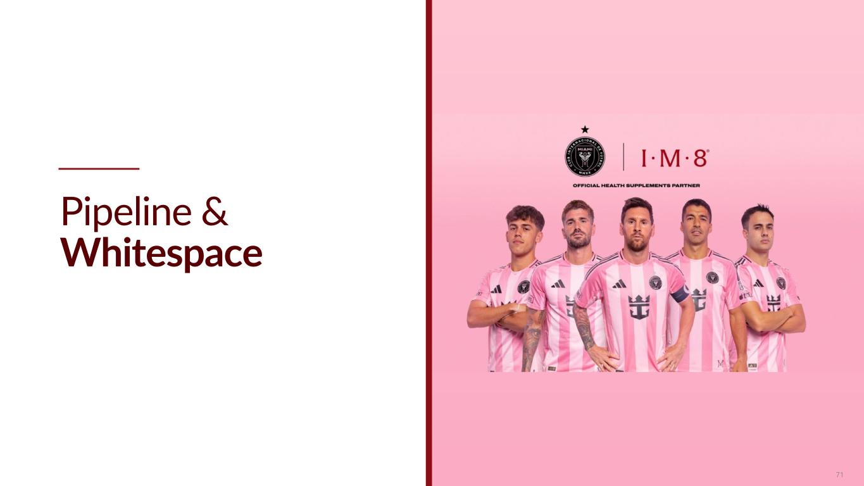
Pipeline & Whitespace 71

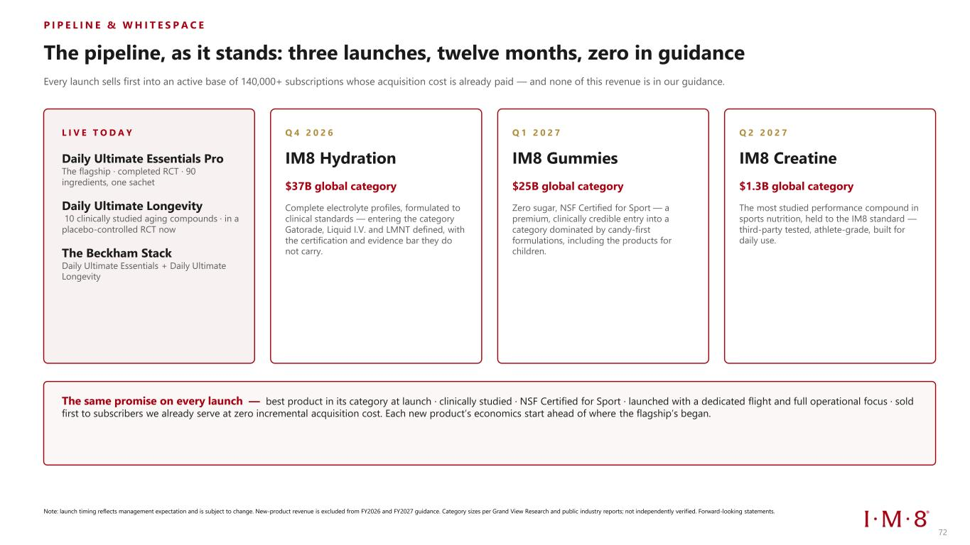
P I P E L I N E & W H I T E S P A C E The pipeline, as it stands: three launches, twelve months, zero in guidance Every launch sells first into an active base of 140,000+ subscriptions whose acquisition cost is already paid — and none of this revenue is in our guidance. L I V E T O D A Y Daily Ultimate Essentials Pro The flagship · completed RCT · 90 ingredients, one sachet Daily Ultimate Longevity 10 clinically studied aging compounds · in a placebo-controlled RCT now The Beckham Stack Daily Ultimate Essentials + Daily Ultimate Longevity Q 4 2 0 2 6 IM8 Hydration $37B global category Complete electrolyte profiles, formulated to clinical standards — entering the category Gatorade, Liquid I.V. and LMNT defined, with the certification and evidence bar they do not carry. Q 1 2 0 2 7 IM8 Gummies $25B global category Zero sugar, NSF Certified for Sport — a premium, clinically credible entry into a category dominated by candy-first formulations, including the products for children. Q 2 2 0 2 7 IM8 Creatine $1.3B global category The most studied performance compound in sports nutrition, held to the IM8 standard — third-party tested, athlete-grade, built for daily use. The same promise on every launch — best product in its category at launch · clinically studied · NSF Certified for Sport · launched with a dedicated flight and full operational focus · sold first to subscribers we already serve at zero incremental acquisition cost. Each new product’s economics start ahead of where the flagship’s began. Note: launch timing reflects management expectation and is subject to change. New-product revenue is excluded from FY2026 and FY2027 guidance. Category sizes per Grand View Research and public industry reports; not independently verified. Forward-looking statements. 72

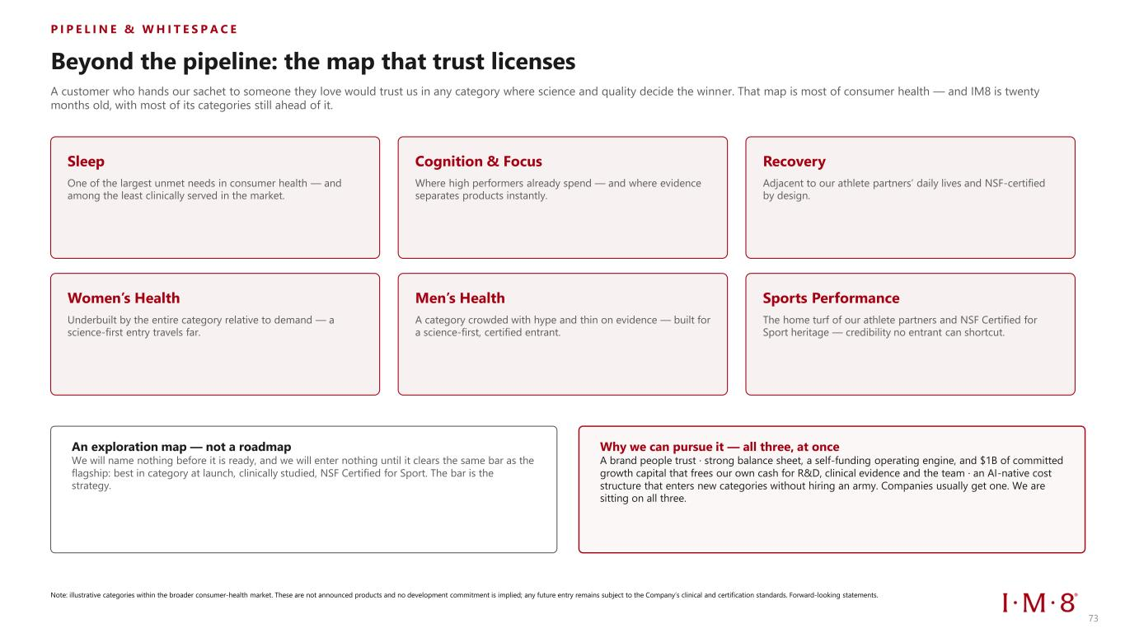
P I P E L I N E & W H I T E S P A C E Beyond the pipeline: the map that trust licenses A customer who hands our sachet to someone they love would trust us in any category where science and quality decide the winner. That map is most of consumer health — and IM8 is twenty months old, with most of its categories still ahead of it. Sleep One of the largest unmet needs in consumer health — and among the least clinically served in the market. Cognition & Focus Where high performers already spend — and where evidence separates products instantly. Recovery Adjacent to our athlete partners’ daily lives and NSF-certified by design. Women’s Health Underbuilt by the entire category relative to demand — a science-first entry travels far. Men’s Health A category crowded with hype and thin on evidence — built for a science-first, certified entrant. Sports Performance The home turf of our athlete partners and NSF Certified for Sport heritage — credibility no entrant can shortcut. An exploration map — not a roadmap We will name nothing before it is ready, and we will enter nothing until it clears the same bar as the flagship: best in category at launch, clinically studied, NSF Certified for Sport. The bar is the strategy. Why we can pursue it — all three, at once A brand people trust · strong balance sheet, a self-funding operating engine, and $1B of committed growth capital that frees our own cash for R&D, clinical evidence and the team · an AI-native cost structure that enters new categories without hiring an army. Companies usually get one. We are sitting on all three. Note: illustrative categories within the broader consumer-health market. These are not announced products and no development commitment is implied; any future entry remains subject to the Company’s clinical and certification standards. Forward-looking statements. 73

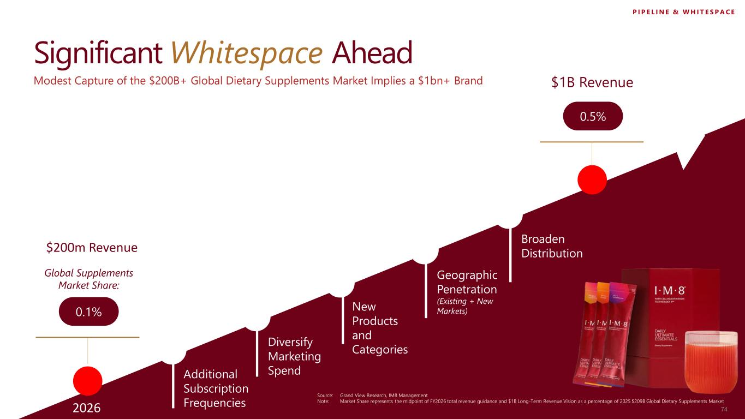
Significant Whitespace Ahead Global Supplements Market Share: 0.1% $1B Revenue 0.5% Modest Capture of the $200B+ Global Dietary Supplements Market Implies a $1bn+ Brand Additional Subscription Frequencies Diversify Marketing Spend Geographic Penetration (Existing + New Markets)New Products and Categories Source: Grand View Research, IM8 Management Note: Market Share represents the midpoint of FY2026 total revenue guidance and $1B Long-Term Revenue Vision as a percentage of 2025 $209B Global Dietary Supplements Market Broaden Distribution P I P E L I N E & W H I T E S P A C E 742026 $200m Revenue

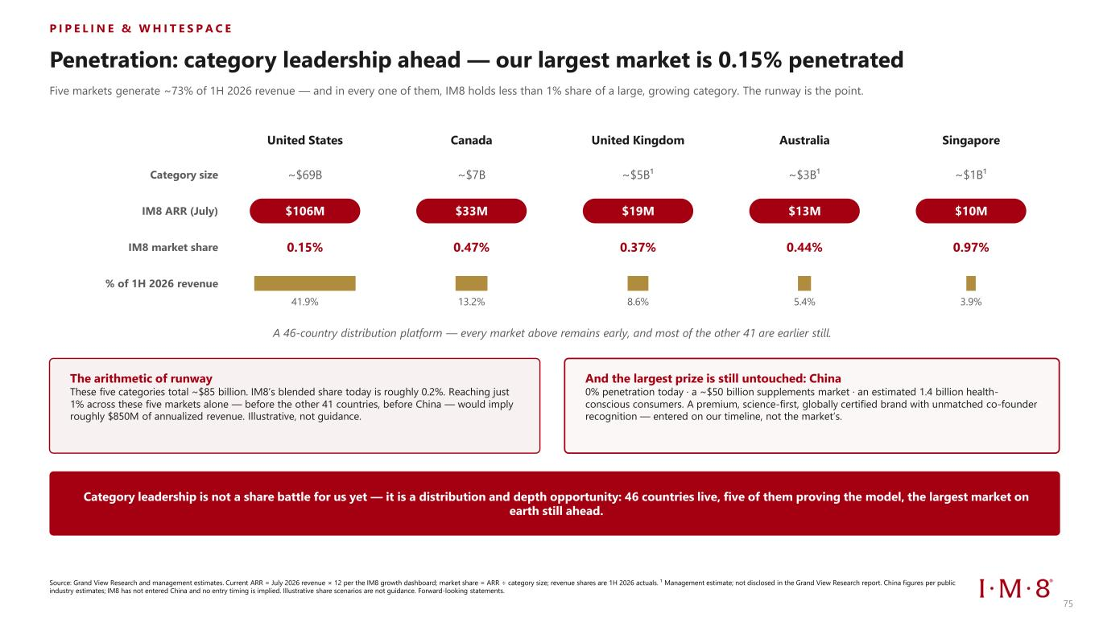
P I P E L I N E & W H I T E S P A C E Penetration: category leadership ahead — our largest market is 0.15% penetrated Five markets generate ~73% of 1H 2026 revenue — and in every one of them, IM8 holds less than 1% share of a large, growing category. The runway is the point. Category size IM8 ARR (July) IM8 market share % of 1H 2026 revenue United States ~$69B $106M 0.15% 41.9% Canada ~$7B $33M 0.47% 13.2% United Kingdom ~$5B¹ $19M 0.37% 8.6% Australia ~$3B¹ $13M 0.44% 5.4% Singapore ~$1B¹ $10M 0.97% 3.9% A 46-country distribution platform — every market above remains early, and most of the other 41 are earlier still. The arithmetic of runway These five categories total ~$85 billion. IM8’s blended share today is roughly 0.2%. Reaching just 1% across these five markets alone — before the other 41 countries, before China — would imply roughly $850M of annualized revenue. Illustrative, not guidance. And the largest prize is still untouched: China 0% penetration today · a ~$50 billion supplements market · an estimated 1.4 billion health- conscious consumers. A premium, science-first, globally certified brand with unmatched co-founder recognition — entered on our timeline, not the market’s. Category leadership is not a share battle for us yet — it is a distribution and depth opportunity: 46 countries live, five of them proving the model, the largest market on earth still ahead. Source: Grand View Research and management estimates. Current ARR = July 2026 revenue × 12 per the IM8 growth dashboard; market share = ARR ÷ category size; revenue shares are 1H 2026 actuals. ¹ Management estimate; not disclosed in the Grand View Research report. China figures per public industry estimates; IM8 has not entered China and no entry timing is implied. Illustrative share scenarios are not guidance. Forward-looking statements. 75

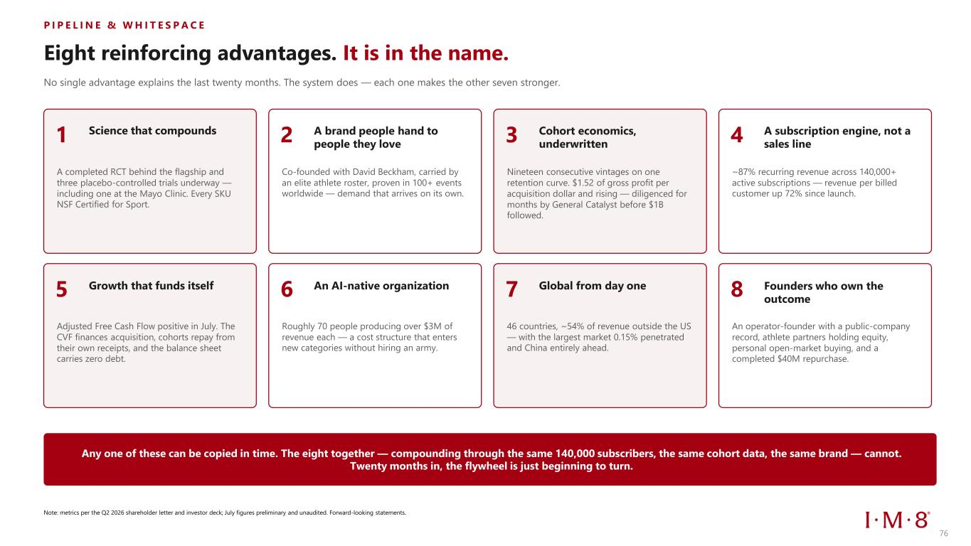
P I P E L I N E & W H I T E S P A C E Eight reinforcing advantages. It is in the name. No single advantage explains the last twenty months. The system does — each one makes the other seven stronger. 1 Science that compounds A completed RCT behind the flagship and three placebo-controlled trials underway — including one at the Mayo Clinic. Every SKU NSF Certified for Sport. 2 A brand people hand to people they love Co-founded with David Beckham, carried by an elite athlete roster, proven in 100+ events worldwide — demand that arrives on its own. 3 Cohort economics, underwritten Nineteen consecutive vintages on one retention curve. $1.52 of gross profit per acquisition dollar and rising — diligenced for months by General Catalyst before $1B followed. 4 A subscription engine, not a sales line ~87% recurring revenue across 140,000+ active subscriptions — revenue per billed customer up 72% since launch. 5 Growth that funds itself Adjusted Free Cash Flow positive in July. The CVF finances acquisition, cohorts repay from their own receipts, and the balance sheet carries zero debt. 6 An AI-native organization Roughly 70 people producing over $3M of revenue each — a cost structure that enters new categories without hiring an army. 7 Global from day one 46 countries, ~54% of revenue outside the US — with the largest market 0.15% penetrated and China entirely ahead. 8 Founders who own the outcome An operator-founder with a public-company record, athlete partners holding equity, personal open-market buying, and a completed $40M repurchase. Any one of these can be copied in time. The eight together — compounding through the same 140,000 subscribers, the same cohort data, the same brand — cannot. Twenty months in, the flywheel is just beginning to turn. Note: metrics per the Q2 2026 shareholder letter and investor deck; July figures preliminary and unaudited. Forward-looking statements. 76


Appendix 77 77

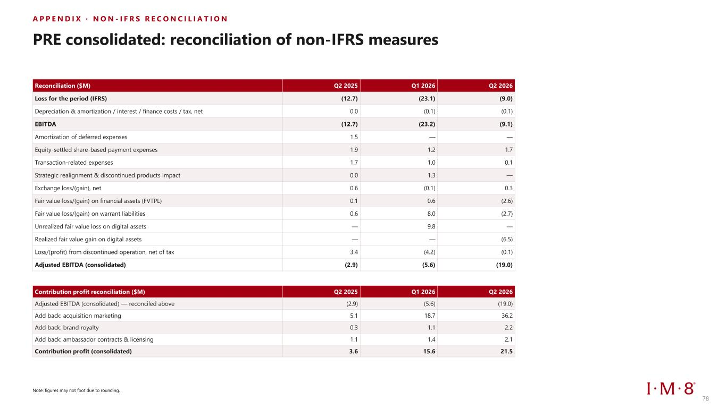
A P P E N D I X · N O N - I F R S R E C O N C I L I A T I O N PRE consolidated: reconciliation of non-IFRS measures Reconciliation ($M) Q2 2025 Q1 2026 Q2 2026 Loss for the period (IFRS) (12.7) (23.1) (9.0) Depreciation & amortization / interest / finance costs / tax, net 0.0 (0.1) (0.1) EBITDA (12.7) (23.2) (9.1) Amortization of deferred expenses 1.5 — — Equity-settled share-based payment expenses 1.9 1.2 1.7 Transaction-related expenses 1.7 1.0 0.1 Strategic realignment & discontinued products impact 0.0 1.3 — Exchange loss/(gain), net 0.6 (0.1) 0.3 Fair value loss/(gain) on financial assets (FVTPL) 0.1 0.6 (2.6) Fair value loss/(gain) on warrant liabilities 0.6 8.0 (2.7) Unrealized fair value loss on digital assets — 9.8 — Realized fair value gain on digital assets — — (6.5) Loss/(profit) from discontinued operation, net of tax 3.4 (4.2) (0.1) Adjusted EBITDA (consolidated) (2.9) (5.6) (19.0) Contribution profit reconciliation ($M) Q2 2025 Q1 2026 Q2 2026 Adjusted EBITDA (consolidated) — reconciled above (2.9) (5.6) (19.0) Add back: acquisition marketing 5.1 18.7 36.2 Add back: brand royalty 0.3 1.1 2.2 Add back: ambassador contracts & licensing 1.1 1.4 2.1 Contribution profit (consolidated) 3.6 15.6 21.5 78 Note: figures may not foot due to rounding.

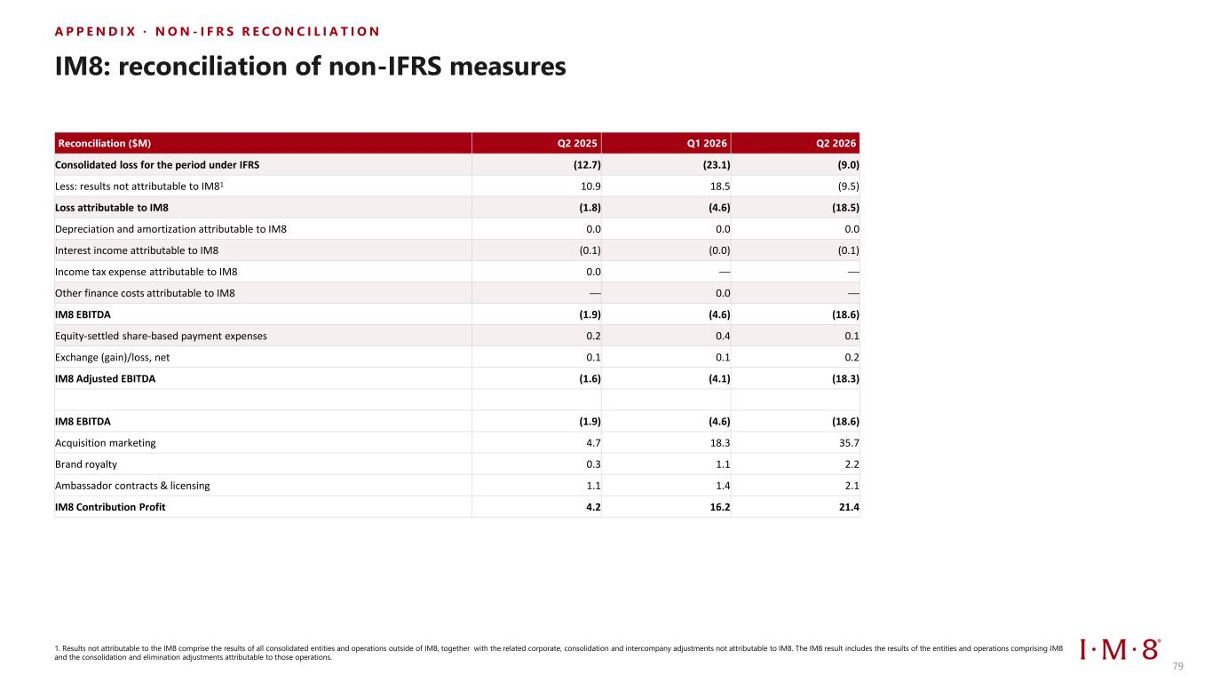
A P P E N D I X · N O N - I F R S R E C O N C I L I A T I O N IM8: reconciliation of non-IFRS measures Reconciliation ($M) Q2 2025 Q1 2026 Q2 2026 Consolidated loss for the period under IFRS (12.7) (23.1) (9.0) Less: results not attributable to IM81 10.9 18.5 (9.5) Loss attributable to IM8 (1.8) (4.6) (18.5) Depreciation and amortization attributable to IM8 0.0 0.0 0.0 Interest income attributable to IM8 (0.1) (0.0) (0.1) Income tax expense attributable to IM8 0.0 — — Other finance costs attributable to IM8 — 0.0 — IM8 EBITDA (1.9) (4.6) (18.6) Equity-settled share-based payment expenses 0.2 0.4 0.1 Exchange (gain)/loss, net 0.1 0.1 0.2 IM8 Adjusted EBITDA (1.6) (4.1) (18.3) IM8 EBITDA (1.9) (4.6) (18.6) Acquisition marketing 4.7 18.3 35.7 Brand royalty 0.3 1.1 2.2 Ambassador contracts & licensing 1.1 1.4 2.1 IM8 Contribution Profit 4.2 16.2 21.4 79 1. Results not attributable to the IM8 comprise the results of all consolidated entities and operations outside of IM8, together with the related corporate, consolidation and intercompany adjustments not attributable to IM8. The IM8 result includes the results of the entities and operations comprising IM8 and the consolidation and elimination adjustments attributable to those operations.

