UNITED STATES
SECURITIES AND EXCHANGE COMMISSION

Washington, D.C. 20549

Form 6-K

REPORT OF FOREIGN PRIVATE ISSUER PURSUANT TO RULE
13a-16 OR 15d-16 UNDER

THE SECURITIES EXCHANGE ACT OF 1934

For the month of May 2026

Commission File Number 001-41401

Prenetics Global Limited

Unit 703-706, K11 Atelier
728 King’s Road, Quarry Bay
Hong Kong

(Address of principal executive office)

Indicate by check mark whether the registrant files or will file annual reports under cover of Form 20-F or Form 40-F. Form 20-F ☒ Form 40-F ☐

EXPLANATORY NOTE

On May 20, 2026, Prenetics Global Limited (the “Company”) issued a press release announcing a multi-year global partnership with Jay Shetty. A copy of the press release is furnished as Exhibit 99.1 to this report on Form 6-K.

 |  |  | EXHIBIT INDEX
Exhibit No. |  |  | Description
99.1 |  |  | Press Release - Prenetics Announces Jay Shetty as IM8 Global Ambassador and Shareholder in Multi-Year Partnership

SIGNATURES

Pursuant to the requirements of the Securities Exchange Act of 1934, the registrant has duly caused this report to be signed on its behalf by the undersigned, thereunto duly authorized.

Prenetics Global Limited

By: | /s/ Danny Sheng Wu Yeung
Name: | Danny Sheng Wu Yeung
Title: | Chief Executive Officer

Date: May 20, 2026

Prenetics Announces Jay Shetty as IM8 Global Ambassador and Shareholder in Multi-Year Partnership

- Multi-year partnership lands as Prenetics’ IM8 raises full-year 2026 revenue guidance to $190 million to $210 million following nearly 6x year-over-year growth in Q1 2026

- Shetty is IM8’s first global ambassador from outside the world of sport

- Joins an equity-aligned roster of David Beckham, Giannis Antetokounmpo, Aryna Sabalenka, Ollie Bearman, and Inter Miami CF (with Lionel Messi)
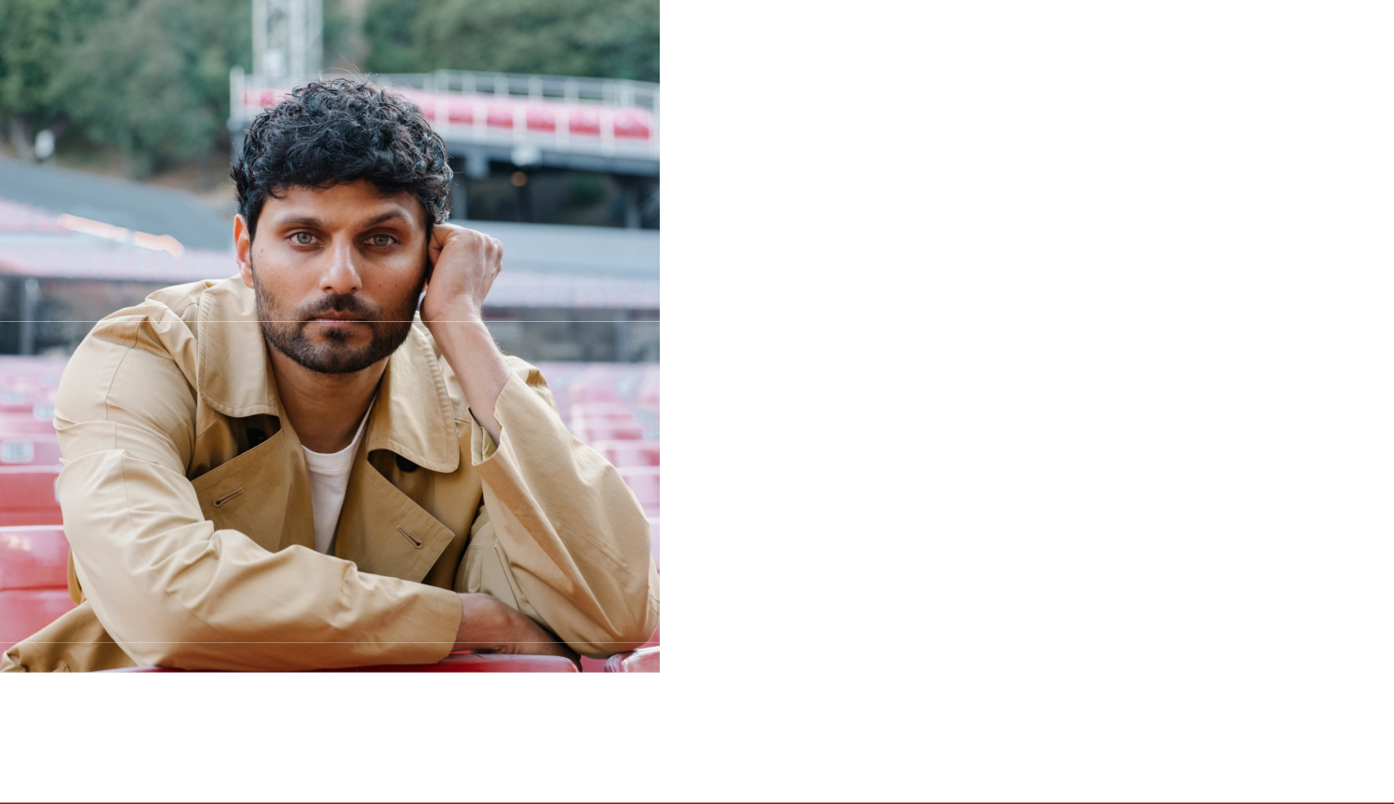

NEW YORK, N.Y., May 20, 2026 (GLOBE NEWSWIRE) — Prenetics Global Limited (NASDAQ: PRE) (“Prenetics” or the “Company”), the parent company of IM8, the premium health and longevity brand co-founded with David Beckham, today announced a multi-year global partnership with #1 New York Times bestselling author and award-winning podcast host of On Purpose, and purpose-driven entrepreneur, Jay Shetty. Shetty becomes Global Ambassador of IM8 and a shareholder in Prenetics, demonstrating his long-term conviction in the brand and the Company.

Shetty becomes IM8’s first global ambassador from outside the world of sport, extending the brand’s reach into the global wellness, mindfulness, and longevity audience he has spent more than a decade building. The partnership formalizes a relationship that began as a customer first: Shetty has used IM8

Daily Ultimate Essentials every morning for nearly a year, on the recommendation of his physician, Dr. Darshan Shah.

“I don’t partner with products — I partner with things I actually use,” said Jay. “IM8 has been part of my daily routine for almost a year. My doctor, Darshan Shah, introduced me to it and what kept me consistent is how I feel: more stable energy throughout the day, sharper focus when I’m recording and writing, and a morning routine that finally feels foundational instead of complicated. Becoming an owner in the business felt like the natural next step.”

Danny Yeung, Co-Founder and CEO of Prenetics and IM8, said: “Jay is our first global ambassador from outside sport, and that was deliberate. He found IM8 through his own doctor and has been a daily user for nearly a year — that’s the only kind of ambassador relationship we’re interested in. Jay reaches over 70 million followers across platforms who genuinely care about how they live, sleep, eat, and think. Bringing him in as a Prenetics shareholder — not just a face — is how we build a brand that lasts decades, not seasons.”

THE PARTNERSHIP

Under the multi-year agreement, Shetty will appear across IM8’s global marketing, content, and product initiatives, and will collaborate with IM8’s Scientific Advisory Board on consumer education in foundational nutrition, sleep, and longevity. He joins a roster of equity-aligned partners — each of whom holds equity in Prenetics — that includes co-founder David Beckham, two-time NBA MVP Giannis Antetokounmpo, World No. 1 tennis player Aryna Sabalenka, Formula 1 driver Ollie Bearman, and Inter Miami CF (with name, image, and likeness rights to a minimum of four players including Lionel Messi).

His combined direct following exceeds 70 million followers and 700 million monthly views across social media platforms, and his podcast On Purpose has over 1 billion listens to date. The partnership reflects IM8’s consistent approach: partners build alongside the founders and share in the long-term value they help create.

For Jay Shetty Partnership media files, please find it here: https://im8health.com/pages/press

DAILY ULTIMATE ESSENTIALS AND BUSINESS MOMENTUM

Shetty’s daily-used product, IM8 Daily Ultimate Essentials, is the brand’s flagship: a single daily scoop delivering 90 science-backed ingredients engineered to replace a cabinet of supplements. Since launching 17 months ago with one product and zero revenue, IM8 now delivers approximately 150,000 servings every day to consumers in 43 countries, with over 60% of revenue generated outside the United States.

On May 14, 2026, Prenetics reported preliminary Q1 2026 IM8 revenue of $33.8 million — nearly 6x year-over-year growth — and raised its full-year 2026 IM8 revenue guidance to $190 million to $210 million. IM8’s May 2026 monthly revenue is tracking at approximately $15.5 million, implying roughly $186 million in annualized recurring revenue.

ABOUT JAY SHETTY

Jay Shetty is a #1 New York Times bestselling author, and host of the On Purpose podcast, widely recognized as one of the world’s leading health and wellness podcasts — with over 1 billion listens to date and was most recently recognized by Spotify as a Top 10 Global Podcast of 2025. He was named to TIME’s 2025 list of the 100 most influential creators.

Across social media platforms, Shetty's direct global community exceeds 70 million followers and over 700 million monthly views

— a deeply engaged audience focused on wellness, mindfulness, and personal growth. As a global bestselling author, award winning podcast host, and purpose-driven entrepreneur, he has built one of the largest communities in personal development worldwide and has partnered with some of the world’s most recognized brands.

ABOUT PRENETICS

Prenetics Global Limited (NASDAQ: PRE) is a leading health sciences company dedicated to advancing human health and longevity. The Company’s flagship consumer brand, IM8, co-founded with David Beckham and trusted by NBA superstar Giannis Antetokounmpo, World No. 1 tennis player Aryna Sabalenka, F1 phenom Ollie Bearman, and Inter Miami CF, is redefining the premium daily nutrition category through science-backed formulations and global brand partnerships. Since its launch, IM8 has become one of the fastest-growing brands in consumer health, surpassing $100 million in annualized recurring revenue within just 11 months of operations, and now ships to 43 countries worldwide.

ABOUT IM8

IM8 is a wholly owned subsidiary of Prenetics (NASDAQ: PRE) and is a premium direct-to-consumer health and longevity brand co-founded with David Beckham. Its flagship product, Daily Ultimate Essentials, is an all-in-one daily nutrition system delivering 90 science-backed ingredients in a single scoop, engineered to replace a cabinet of supplements. Daily Ultimate Essentials is NSF Certified for Sport, non-GMO, vegan, and free from common allergens, artificial flavors, colors, and sweeteners. IM8 is supported by a Scientific Advisory Board including experts affiliated with Cedars-Sinai, NASA, and Mayo Clinic. Learn more at www.im8health.com.

CONTACTS

Media — IM8: press@im8health.com

Investor Relations — Prenetics: ir@prenetics.com

FORWARD-LOOKING STATEMENTS

This press release contains forward-looking statements. These statements are made under the “safe harbor” provisions of the U.S. Private Securities Litigation Reform Act of 1995. Statements that are not historical facts, including statements about the Company’s goals, targets, projections, outlooks, beliefs, expectations, strategy, plans, objectives of management for future operations of the Company, and growth opportunities are forward-looking statements. Our guidance reflects management’s current estimates and assumptions as of the date of this release, is subject to significant risks and uncertainties, and is not a guarantee of future performance. Actual results may differ materially. In some cases, forward-looking statements can be identified by words or phrases such as “may,” “will,” “expect,” “anticipate,” “target,” “aim,” “estimate,” “intend,” “plan,” “believe,” “potential,” “continue,” “is/are likely to,” “guidance,” “outlook,” “forecast,” or other similar expressions. Forward-looking statements are based

upon estimates and forecasts and reflect the views, assumptions, expectations, and opinions of the Company, which involve inherent risks and uncertainties, and therefore they should not be relied upon as being necessarily indicative of future results. A number of factors could cause actual results to differ materially from those contained in any forward-looking statement, including but not limited to: the Company may not be able to maintain and enhance its IM8 business and brand if it suffers negative publicity or fails to maintain a strong base of engaged customers and content creators, or otherwise fails to meet customers’ expectations; the Company’s ability to further develop and grow its business, including new products and services; and its ability to identify and execute on M&A opportunities. In addition to the foregoing factors, you should also carefully consider the other risks and uncertainties described in the “Risk Factors” section of the Company’s most recent registration statement and the prospectus therein, and the other documents filed by the Company from time to time with the U.S. Securities and Exchange Commission. Unless otherwise specified, all information provided in this press release is as of the date of this press release, and the Company does not undertake any duty to update such information, except as required under applicable law. Nothing in this press release constitutes an offer to sell, or the solicitation of an offer to buy, any securities of the Company.

