SEC Form 3
FORM 3 | UNITED STATES SECURITIES AND EXCHANGE COMMISSION
 | Washington, D.C. 20549
 | Washington, D.C. 20549 |  | OMB APPROVAL
 | INITIAL STATEMENT OF BENEFICIAL OWNERSHIP OF SECURITIES
 | INITIAL STATEMENT OF BENEFICIAL OWNERSHIP OF SECURITIES |  | OMB Number: | 3235-0104
 |  |  | Estimated average burden
 | Filed pursuant to Section 16(a) of the Securities Exchange Act of 1934 |  | hours per response: | 0.5
or Section 30(h) of the Investment Company Act of 1940
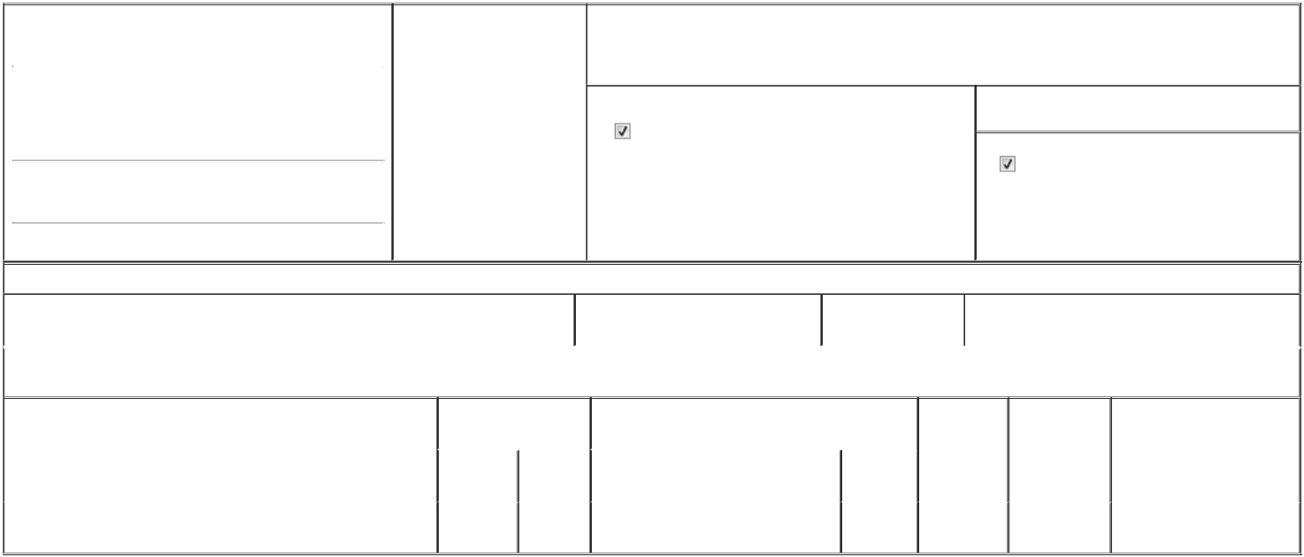

1. Name and Address of Reporting Person* |  |  |  |  |  | 2. Date of Event Requiring
 |  | Leogrande Hudson Blake |  |  |  | Statement (Month/Day/Year)
 |  |  |  |  | 06/04/2026
 |  | (Last) | (First) |  | (Middle)

3. Issuer Name and Ticker or Trading Symbol

Prenetics Global Ltd [ PRE ]

UNIT 703-706, K11 ATELIER

728 KINGS ROAD, QUARRY BAY

(Street)

HONG KONG K3

- Relationship of Reporting Person(s) to Issuer (Check all applicable)

Director | 10% Owner
Officer (give title | Other (specify below)
below) | Other (specify below)

- If Amendment, Date of Original Filed (Month/Day/Year)

- Individual or Joint/Group Filing (Check Applicable Line)

Form filed by One Reporting Person

Form filed by More than One Reporting Person

(City) (State) (Zip)

Table I - Non-Derivative Securities Beneficially Owned

 | 1. Title of Security (Instr. 4) | 2. Amount of Securities Beneficially | 3. Ownership Form: | 4. Nature of Indirect Beneficial Ownership (Instr. 5)
 |  | Owned (Instr. 4) | Direct (D) or Indirect
 |  |  | (I) (Instr. 5)

Table II - Derivative Securities Beneficially Owned

(e.g., puts, calls, warrants, options, convertible securities)

1. Title of Derivative Security (Instr. 4) | 2. Date Exercisable and |  | 3. Title and Amount of Securities Underlying |  | 4. | 5. Ownership | 6. Nature of Indirect Beneficial
 | Expiration Date |  | Derivative Security (Instr. 4) |  | Conversion | Form: Direct | Ownership (Instr. 5)
 | (Month/Day/Year) |  |  |  | or Exercise | (D) or Indirect
 |  |  |  |  | Price of | (I) (Instr. 5)
 |  |  |  | Amount or | Price of | (I) (Instr. 5)
 |  |  |  | Amount or | Derivative
 | Date | Expiration | Title | Number of | Security
 | Exercisable | Date | Title | Shares
Restricted Stock Unit | (1) | 06/04/2032 | Class A Ordinary Share, par value | 24,004 | 0 | D
Restricted Stock Unit | (1) | 06/04/2032 | $0.0015 per share | 24,004 | 0 | D

Explanation of Responses:

- Each Restricted Stock Unit ("RSU"), granted under the Issuer's 2022 Share Incentive Plan, represents a contingent right to receive one Class A Ordinary Share. The 24,004 RSUs vested on June 4, 2026. Subject to continued service, the vested RSUs are settled and delivered in shares in 12 equal monthly installments of Class A Ordinary Shares, beginning on July 4, 2026, and with the full balance of the 24,004 Class A Ordinary Shares being released on June 4, 2027.

Remarks:

Exhibit 24 - Power of Attorney

 | /s/ Stephen Hoi Chun Lo, as attorney- |  |  | 06/15/2026
 | in-fact for Hudson Blake Leogrande
 | ** Signature of Reporting Person |  |  | Date
Reminder: Report on a separate line for each class of securities beneficially owned directly or indirectly.
* If the form is filed by more than one reporting person, see Instruction 5 (b)(v).
** Intentional misstatements or omissions of facts constitute Federal Criminal Violations See 18 U.S.C. 1001 and 15 U.S.C. 78ff(a).
Note: File three copies of this Form, one of which must be manually signed. If space is insufficient, see Instruction 6 for procedure.
Persons who respond to the collection of information contained in this form are not required to respond unless the form displays a currently valid OMB Number.



